Ministry Planner

Table of Contents

Table of Contents | 2
Overview | 3
Mission Statement | 3
User Story | 3
Agile Principles | 3
Database | 3
Wireframe | 5
MVP and Stretch Goals | 14
Trello Link | 14
Calendar | 15

OVERVIEW

Mission Statement

Build a church application demonstrating the use of .NET Framework MVC 5 with n-tier architecture accessing a relational database. The application will be deployed to the web using Mircosoft's Azure Web Services and will be linked to in my Portfolio. The Model classes will control the actions and data of the application domain, the View classes will oversee the display of information, and the Controller classes will interpret the mouse and keyboard inputs from the user and notify the model and/or view to change as applicable. The application will allow a church to maintain data on the church itself, current pastor(s), visitors, and congregation members.

User Story

Pastor Aaron wants a database system that will assist in capturing data on his church so that he may closely track visitors so that he may visit them and discuss if they would like to pursue membership with the church. He also would like to be able to know who is currently a member of the church so that he may keep a close connection with them. Further, he would like to maintain data on the church building so that he can share the information with other churches.

Agile Principles

I will use agile principles in the development of the church app. The project is to be divided into one sprint, with clear outlined goals for each week. At the conclusion of the sprint the product will be demonstrated with a live presentation. At the end of the sprint and presentation I expect to have obtained greater understanding of the development life cycle, and what could have improved the development of the product so as to be developed faster and more effectively. I have created a user story that states how the system should be developed to meet the stated need of the user.

Database
Table 1 (inherits from UserSetup)
Church
ChurchId | int PK
Name | string
Denomination | enum
NumberMembers | int
Phone | string
Email | string
Address | string
City | string
State | enum
Zip | string

Table 2
Base Class
Individual
IndividualId | Int PK
ChurchId | int FK
FirstName | string
MiddleName | string
LastName | string
Email | string
HomePhone | string
CellPhone | string
DateOfBirth | datetime
Address | string
City | string
State | string
Zip | string

Table 3
Pastor (inherits from Individual)
SeniorPastor | bool
AssistantPastor | bool
YouthPastor | bool
SongLeader | bool

Table 4
Parishoner (inherits from Individual)
Officer | bool
OfficerTitle | string

Table 5
Visitior (inherits from Individual)
DateVisited | datetime

Wireframe: (MVP vs Stretch)
Entity Relationship Diagram

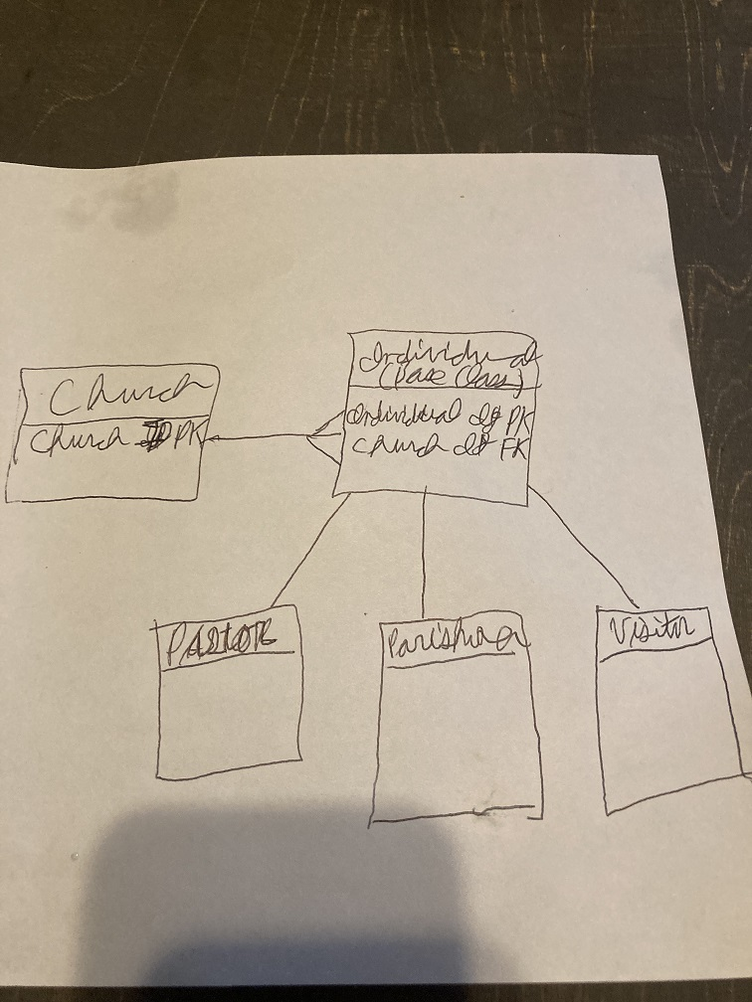

Login
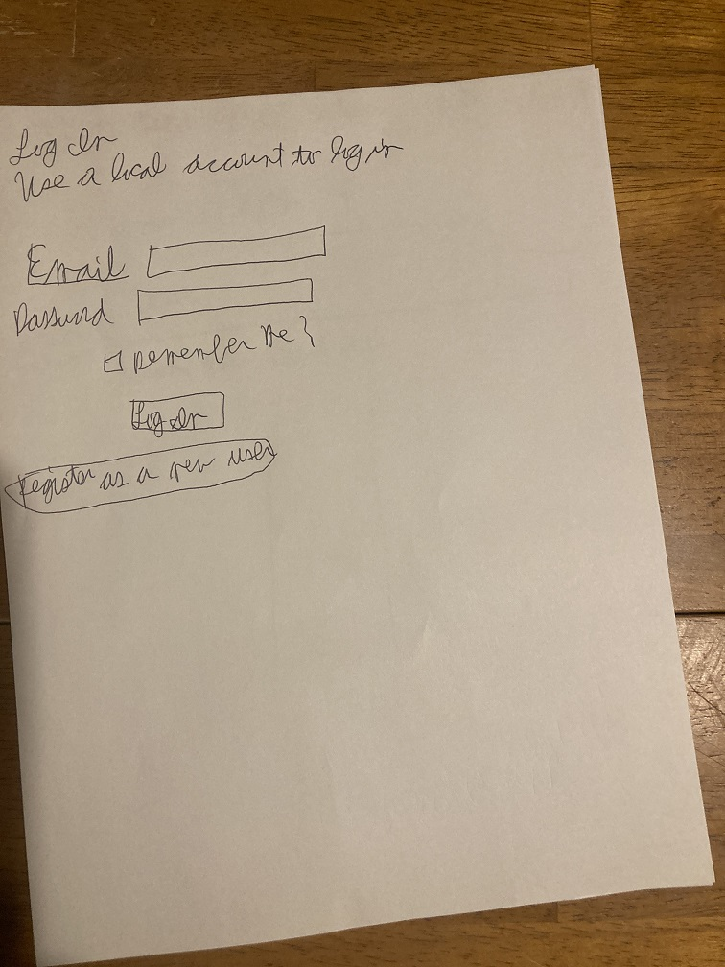

LandingPage
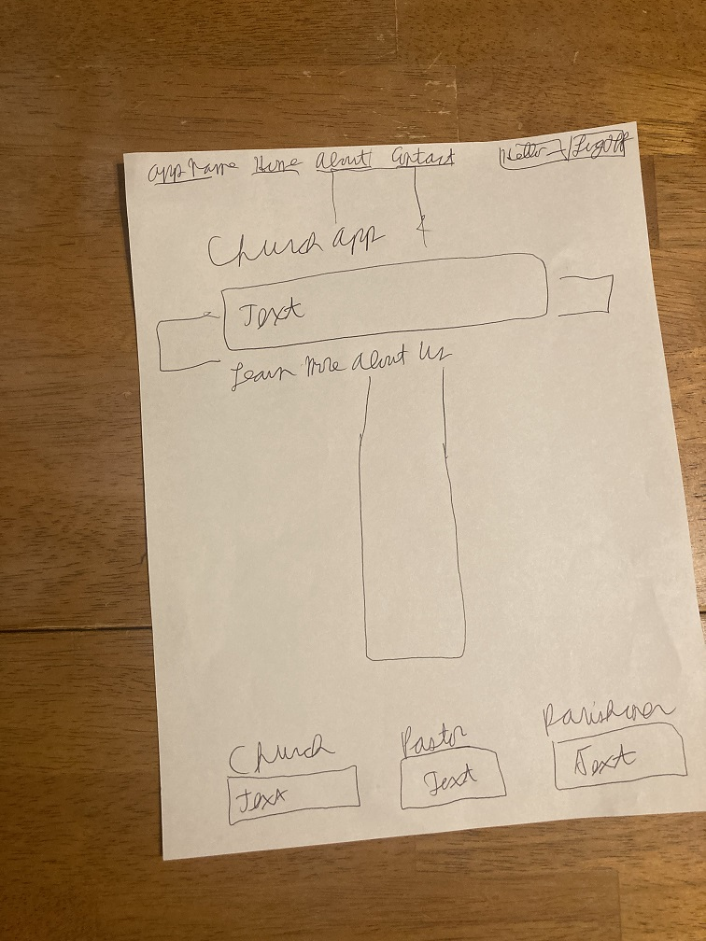
ChurchList
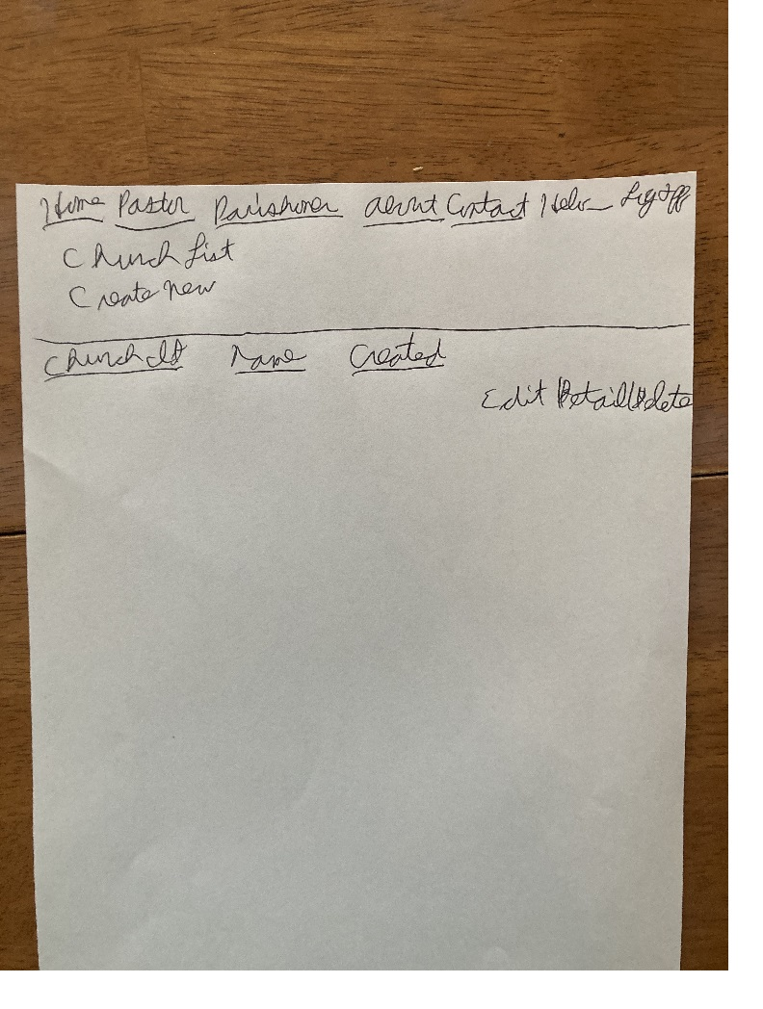

ChurchCreate
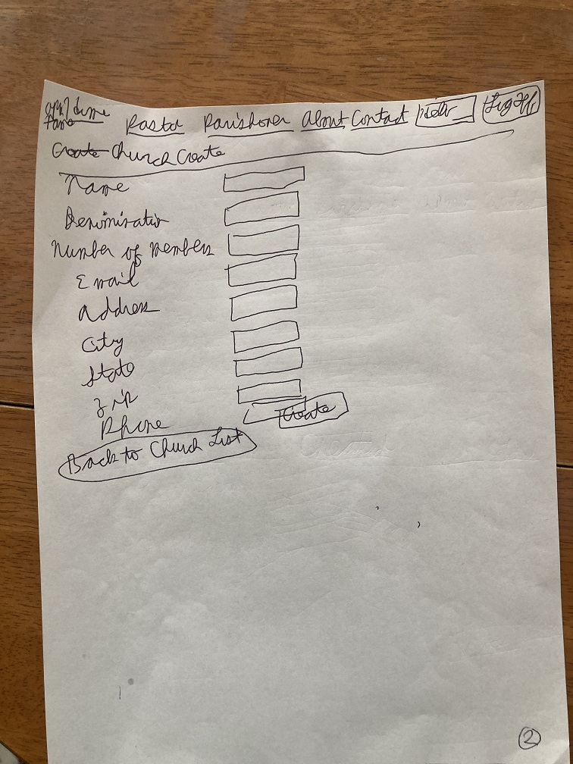
ChurchEdit
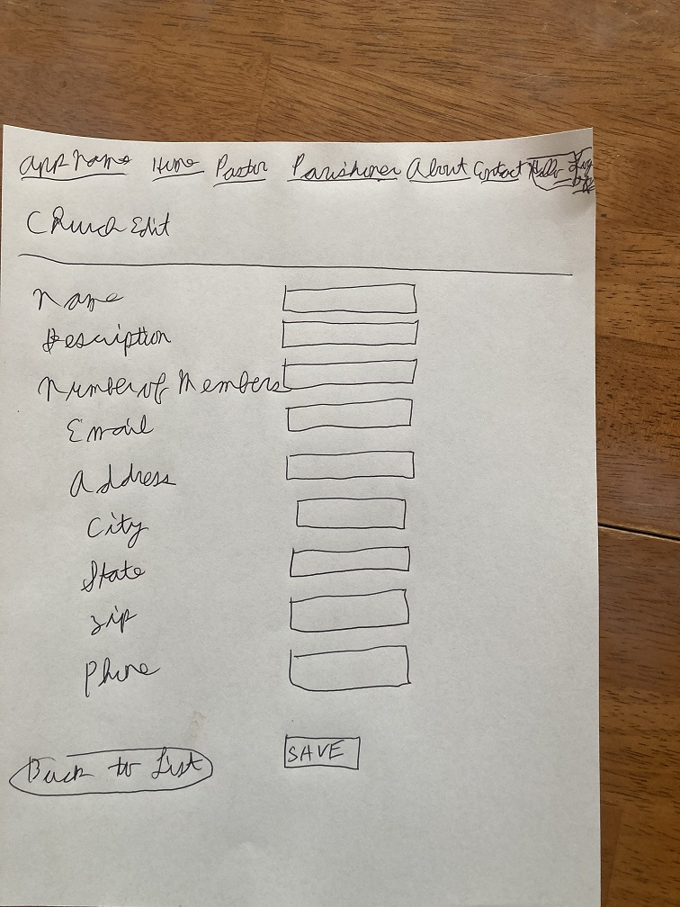

ChurchDetails
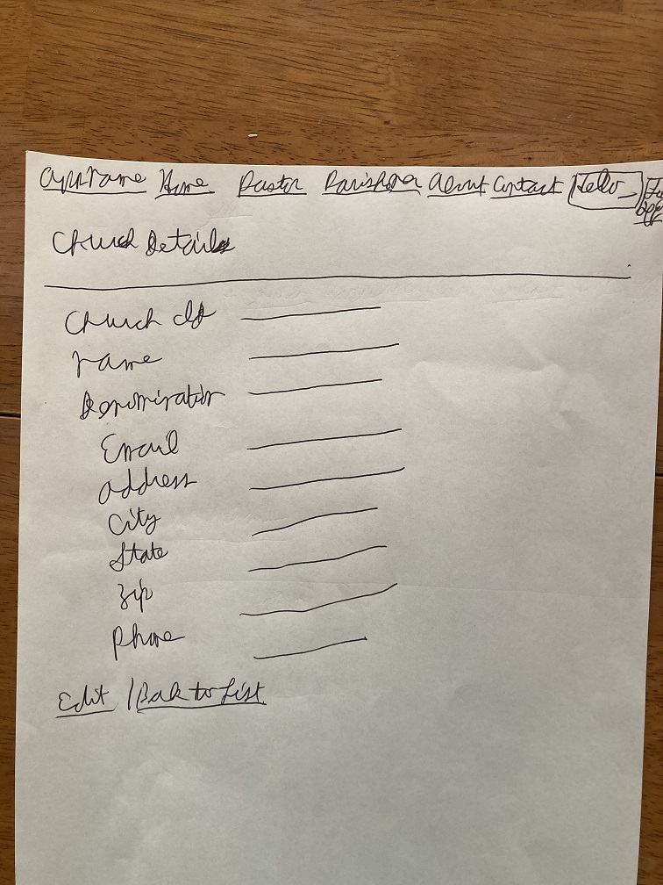
ChurchDelete
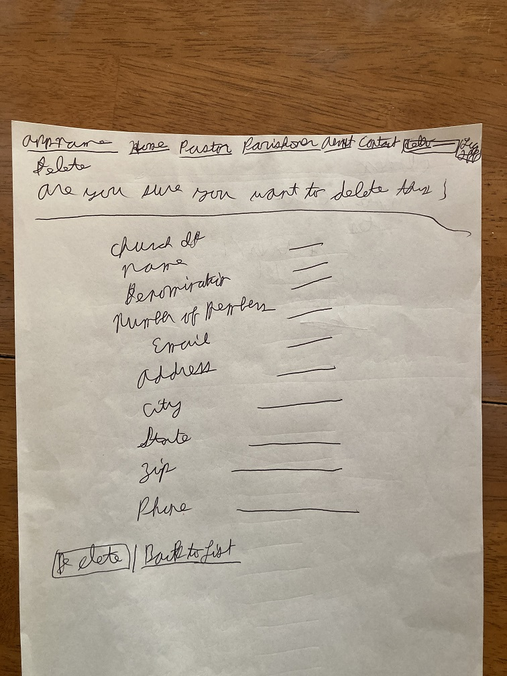

PastorList
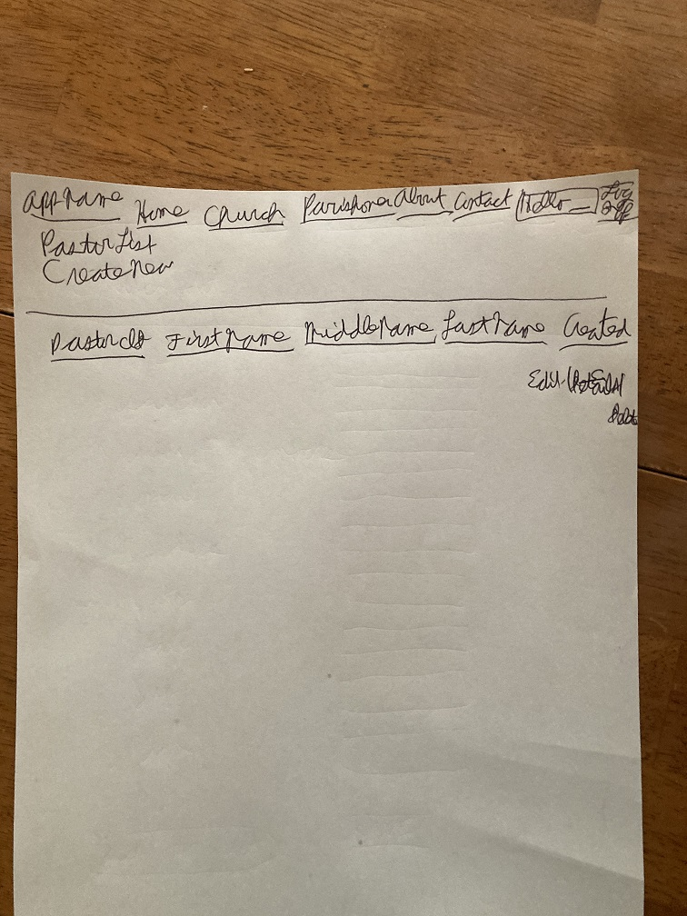
Pastor Create
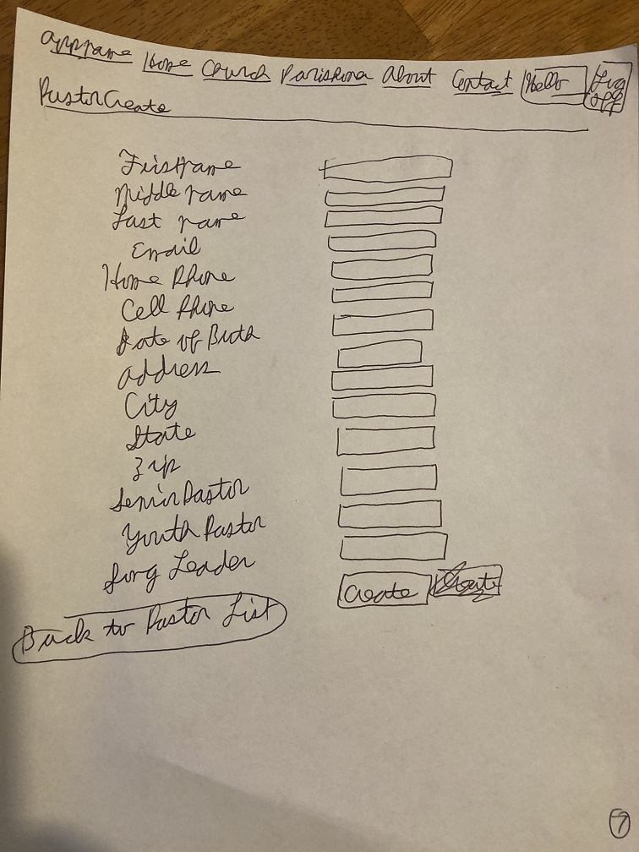

PastorEdit
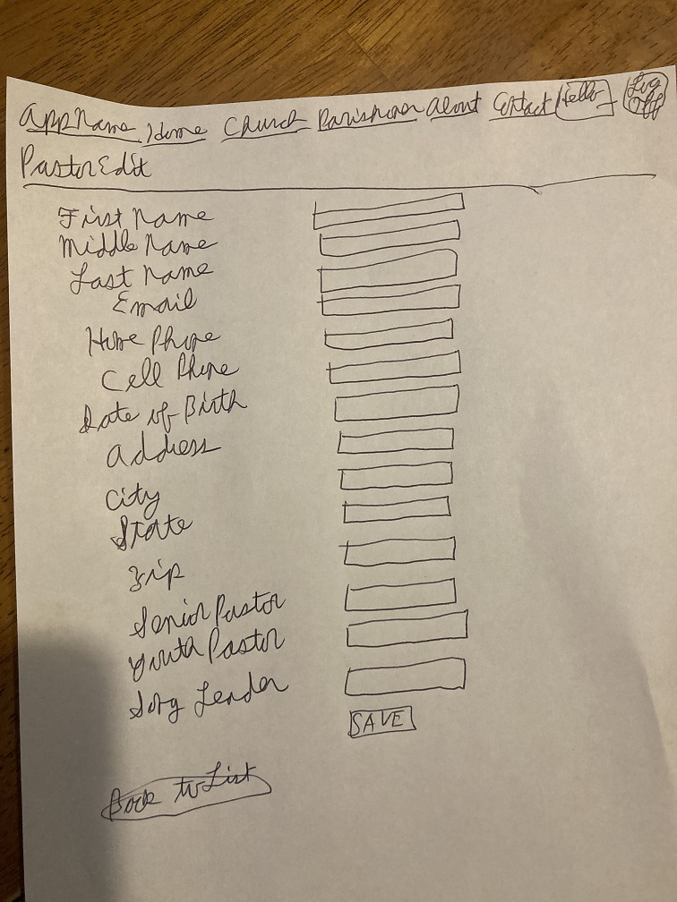
PastorDetails
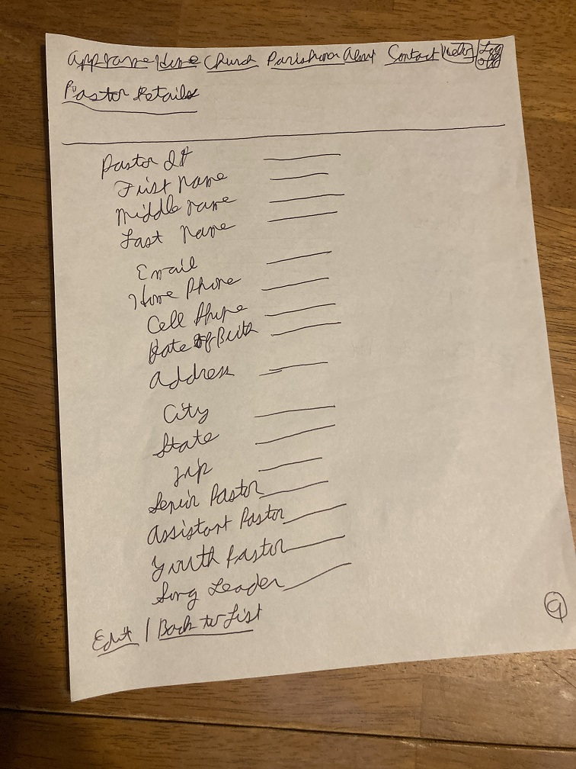

PastorDelete
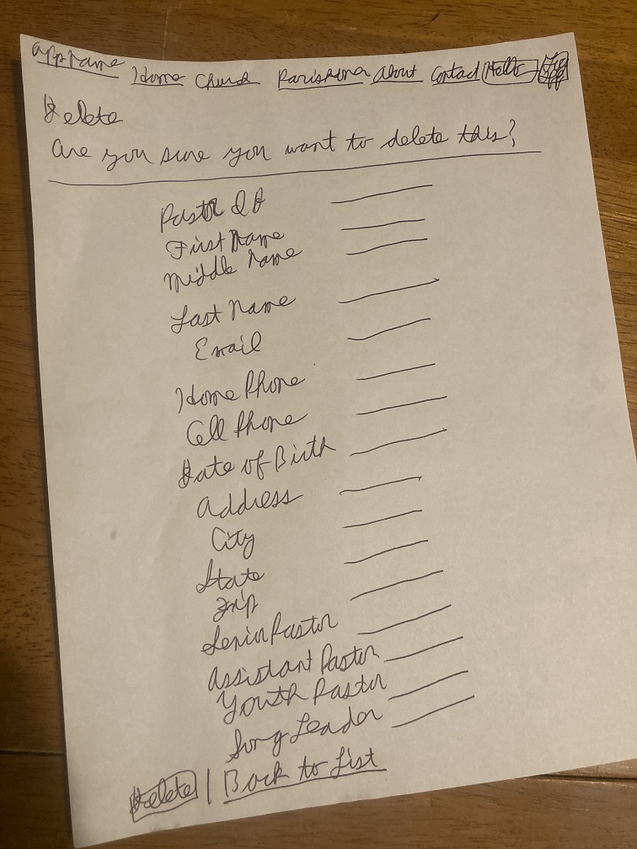
ParishonerList
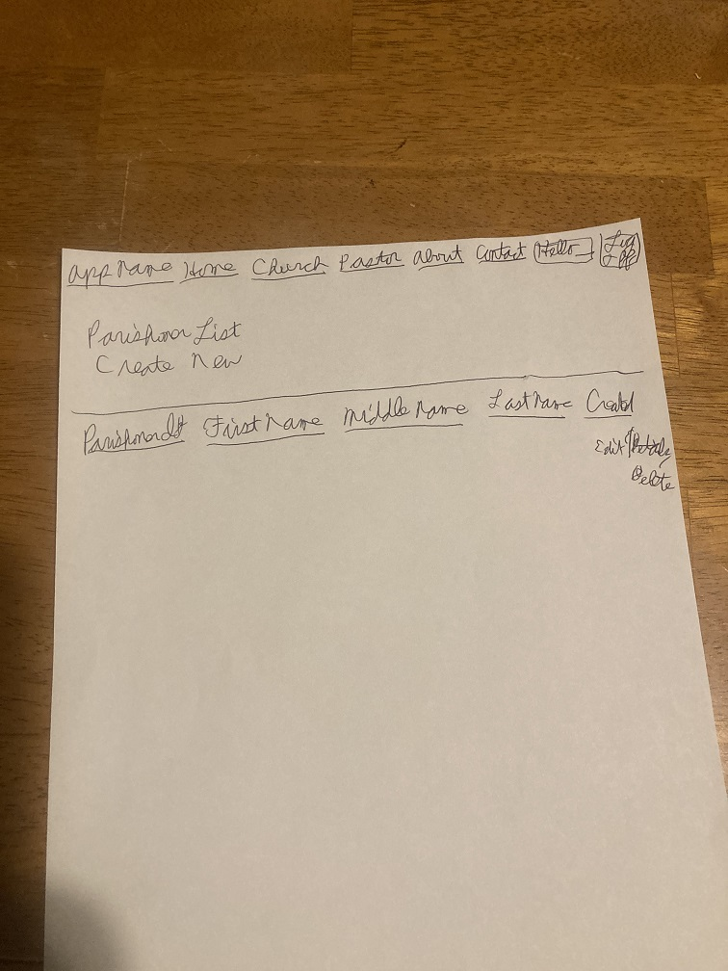

ParsishonerCreate
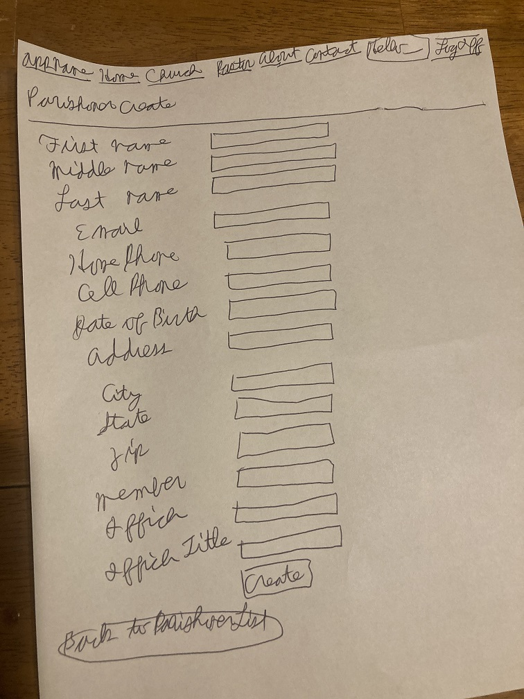
ParishonerEdit
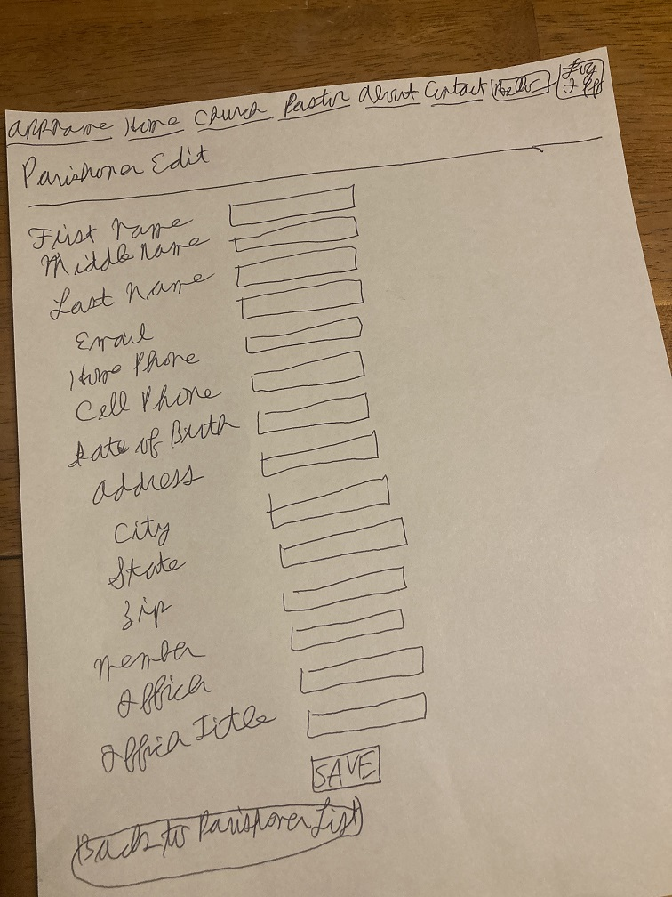

ParishonerDetails
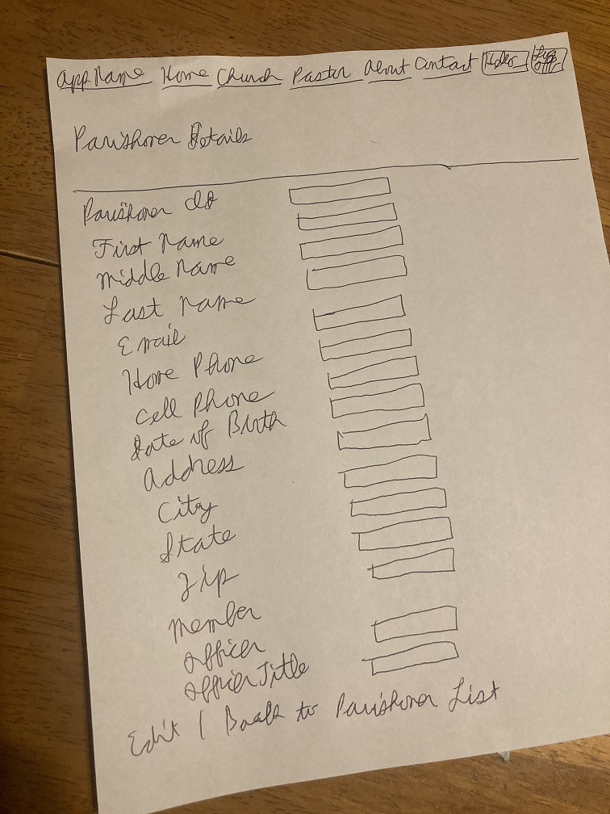
ParishonerDelete
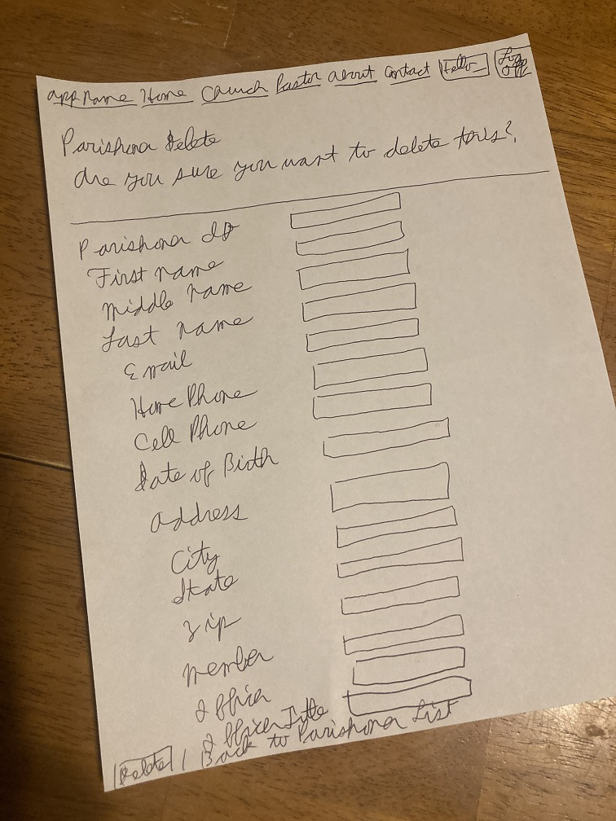

Features

Version 1.0 / MVP / “70%” | Version 2.0 / Stretch Goals
- Create the Data, Model, Service, and Contract Assemblies  - Create Church, Pastor, and Parishoner classes in the Data layer  - Create Create, Detail, Edit, and ListItem classes for each table  - Create Church, Pastor, and Parishoner Controller classes under WebMVC  - Create Views for Create, Delete, Details, Edit, and Index for all tables  - Modify Landing Page | - JavaScript (moving Visual on LandingPage)  - E-mail to be sent based on how many days have passed since visitor visited church  - Running tally of tithe for end of year (Collection)

Trello Link
- ChurchRedBadgeProject | Trello

Schedule
 |  | 30 | 31 | 1 | 2 | 3
Project
Assigned
4 | 5 | 6 | 7 | 8 | 9 | 10
Brainstorm Ideas | Choose Project and  Begin  Planning Doc | Work on Planning  Planning Doc | Work on Planning Doc | Work on Planning Doc and Pitch Project | Research and work on Landing Page
11 | 12 | 13 | 14 | 15 | 16 | 17
 | Set up Git Repository  Scaffold Project  Work on Data assembly | Continue working on Data Assembly  Push to Git | Models Assembly  Push to Git | Models Assembly  Push to Git | Services Assembly  Push to Git
18 | 19 | 20 | 21 | 22 | 23 | 24
 | Services Assembly  Push to Git | Tests Assembly,  Modify Identity Models,  Data Classes, Update Web Config, Database Migrations  Push to Git | Church, Pastor, Parishoner ListItem classes  Push to Git | Contracts Assembly  Push to Git | Contracts Assembly  Push to Git
25 | 26 | 27 | 28 | 29 | 30 | 1
 | Modify Navbar | Create, Delete, Details, Index views for Church, Pastor, and Parishoner | Create, Delete, Details, Index views for Church, Pastor, and Parishoner | Route  Config  Stretch Goals | Stretch  Goals
2 | 3  Stretch Goals | 4  Test App  Correct any errors | 5  Test App  Correct any errors | 6  Test App  Correct any errors | 7  Final Touches  Add Readme | 8  Project due at 9:00 AM
9 | 10 | 11  Project Presentation | 12 | 13  Project Presentation if not presented yet

