|  |  |  |  |
| --- | --- | --- | --- |
| Context | Question | Prediction | Answer |
| Following their loss in the divisional round of the previous season's playoffs, the Denver Broncos underwent numerous coaching changes, including a mutual parting with head coach John Fox (who had won four divisional championships in his four years **as Broncos head coach**), and the hiring of Gary Kubiak as the new head coach. | Who is the head coach of the Broncos? | John Fox | Gary Kubiak |
| In week 10, Manning suffered a partial tear of the plantar fasciitis in his left foot. He set the NFL's all-time record for career passing yards in this game, but was benched after throwing four interceptions in favor of backup quarterback **Brock Osweiler**, who took over as the starter for most of the remainder of the **regular season**. Osweiler was injured, however, leading to Manning's return during the Week 17 regular season finale, where the Broncos were losing 13â€“7 against the 4â€“11 San Diego Chargers, | Who did the Broncos play in the last week of the regular season? | Brock Osweiler | San Diego Chargers |

The extract model does not capture the semantic meaning of the language. Instead, the model output incorrect start and end probabilities influenced by some keywords matched in the question.

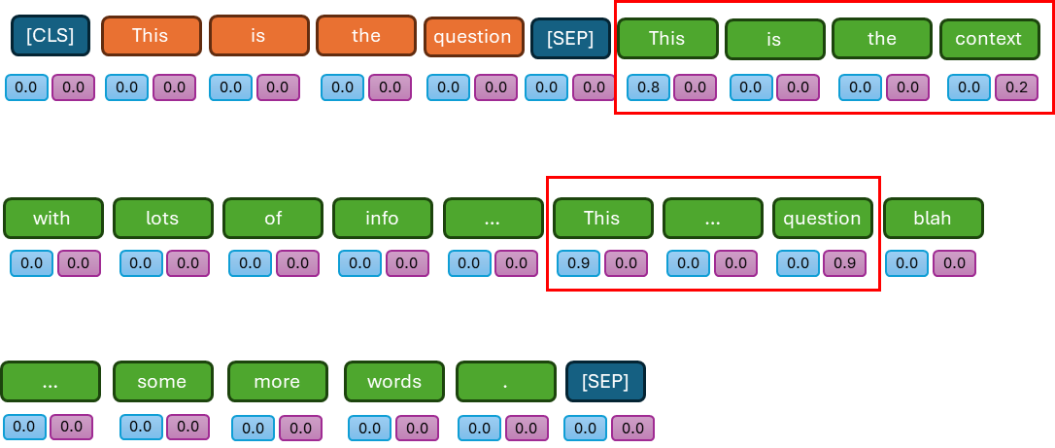

|  |  |  |  |
| --- | --- | --- | --- |
| Context | Question | Prediction | Answer |
| The complexity class P is often seen as a mathematical abstraction modeling those computational tasks that admit an efficient algorithm. This hypothesis is called the Cobhamâ€“Edmonds thesis. The complexity class NP, on the other hand, contains many problems that people would like to solve efficiently, but for which **no** efficient algorithm is **known**, such as the Boolean satisfiability problem, the Hamiltonian path problem and the vertex cover problem. | What complexity class is commonly characterized by unknown algorithms to enhance solvability? | P | NP |

The extract model does not learn the contrast “no ….. known” in the context and fails to correlate “no … known” to “unknown”.

|  |  |  |  |
| --- | --- | --- | --- |
| Context | Question | Prediction | Answer |
| As opposed to broadcasts of primetime series, CBS broadcast special episodes of its late night talk **shows** as its lead-out **programs** for **Super Bowl 50**, beginning with a special episode of The Late Show with Stephen Colbert following the game. Following a break for late local programming, CBS also aired a special episode of The Late Late Show with James Corden. | What show aired on CBS after late local programming? | Super Bowl 50 | The Late Late Show with James Corden |
| The Normans were famed for their martial spirit and eventually for their Christian **piety**, becoming **exponents** of the Catholic orthodoxy into which they assimilated. the Levant, to Scotland and Wales in Great Britain, to Ireland, and to the coasts of north Africa and the Canary Islands. | What religion were the Normans | Christian | Catholic orthodoxy |

The model picks up common words that are closer to the question but ignores less used words.

|  |  |  |  |
| --- | --- | --- | --- |
| Context | Question | Prediction | Answer |
| Starting in 1894, Tesla began investigating what he referred to as radiant energy of "invisible" kinds after …[multiple long sentences]… York Times as saying, "I am in too much grief to talk. What can I say?" Tesla may have inadvertently captured an X-ray imageâ€”predating, by a few weeks, when he tried to photograph Mark Twain illuminated by a Geissler tube, an earlier type of gas discharge tube. | When die Tesla turn his attention to trying to understand invisible radiant energy? | Mark Twain | 1984 |
| In 1542, Luther read a Latin translation of the Qur'an. He went on to produce several critical pamphlets on Islam, which he called "Mohammedanism" or "the Turk". Though Luther saw the Muslim faith as a tool of the devil, he was indifferent to its practice: "Let the Turk believe and live as he will, just as one lets the papacy and other false Christians live." He opposed banning the publication of the Qur'an, wanting it exposed to scrutiny. | What were Mohammedanism and the Turk? | Let the Turk believe and live as he will | Islam |

The model fails to extract information that spans in a long context.