# new bing

## What is new bing

[The new Bing is a search engine that provides you with a single, summarized answer from reliable sources across the web1](https://www.bing.com/new). [You can ask real questions and get complete answers2](https://www.bing.com/?mkt=en-us). It has more powerful functions than any other search engines, such as

What are you looking for?

## Why is new bing a better choice

### effective

(search the full web and provide you with the available link) unlike the traditional engine which may provide quite a lot of ads.

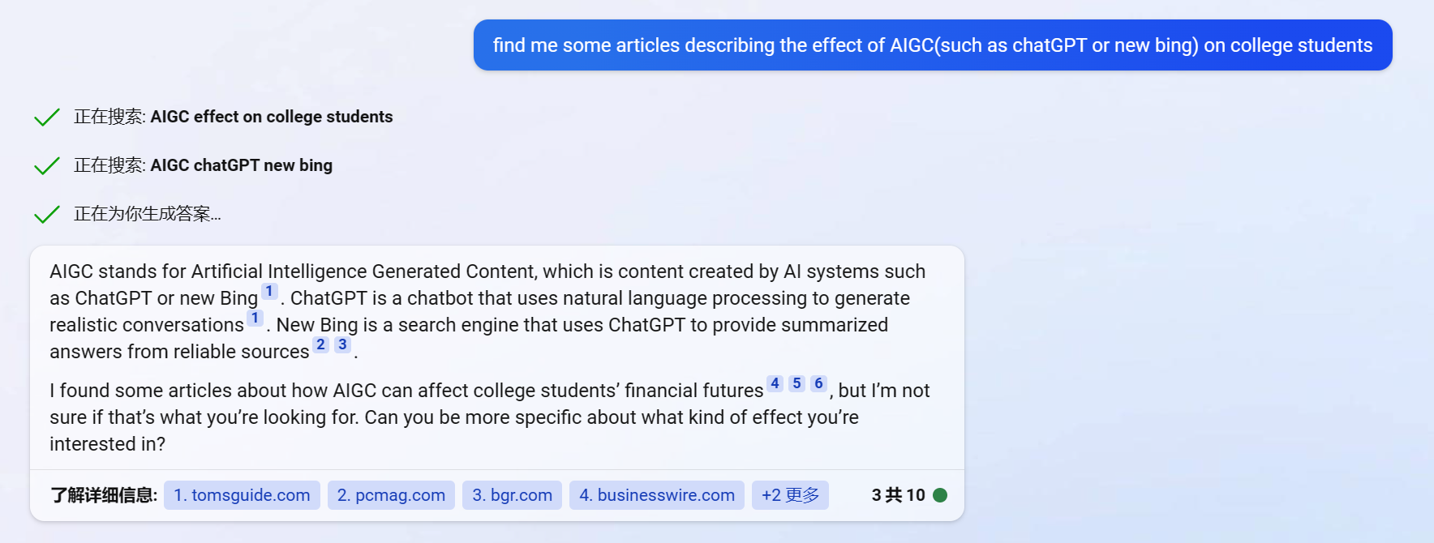

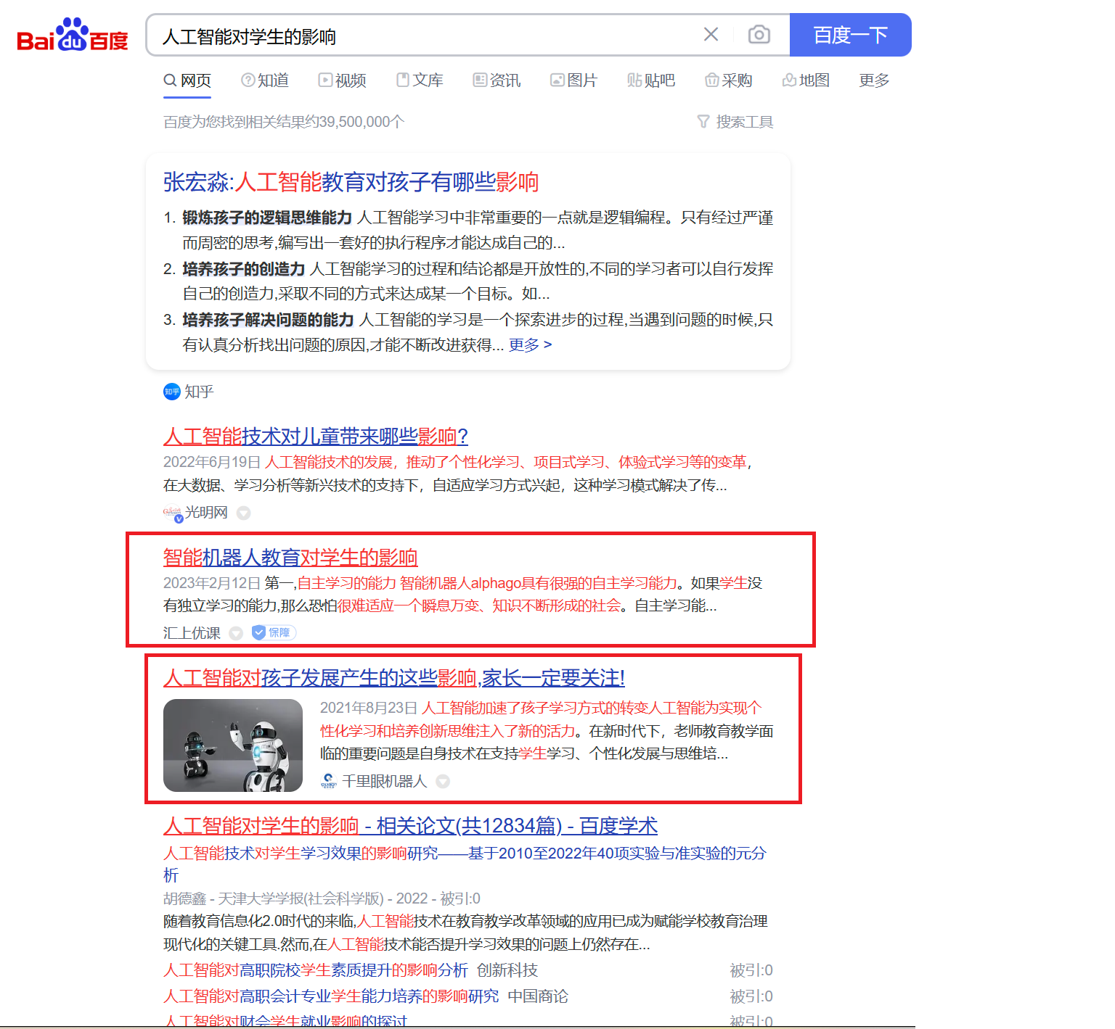

### specific

The ai search the internet based on the meaning rather than the content, which means it knows what you really want.

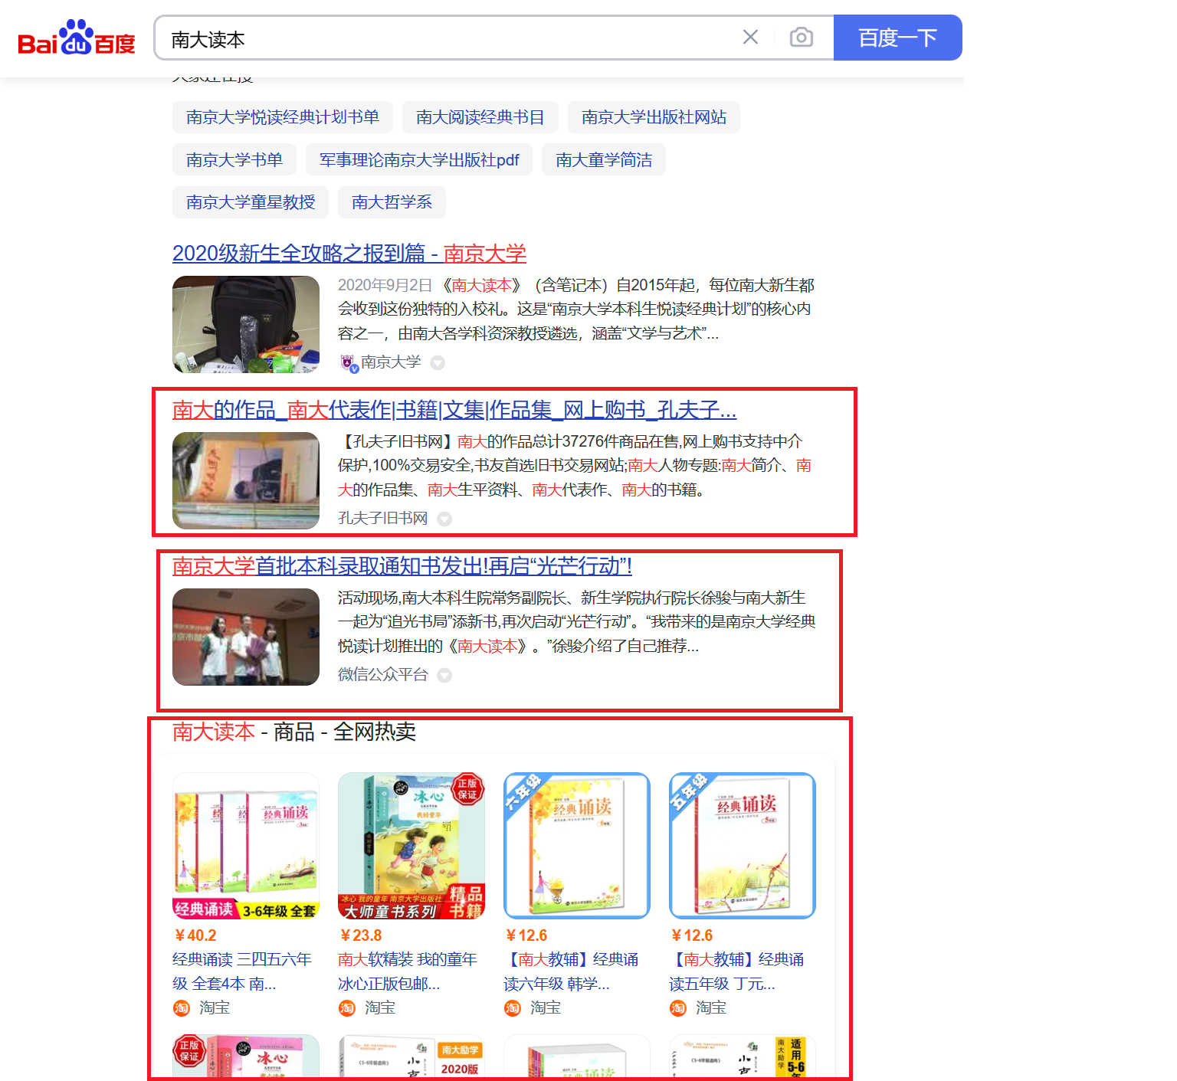



### powerful

it can provide you some message that dose not exist in the cyberspace based on the information existing . It is creative.

给我列一个“关于人工智能对大学生的影响”报告的提纲

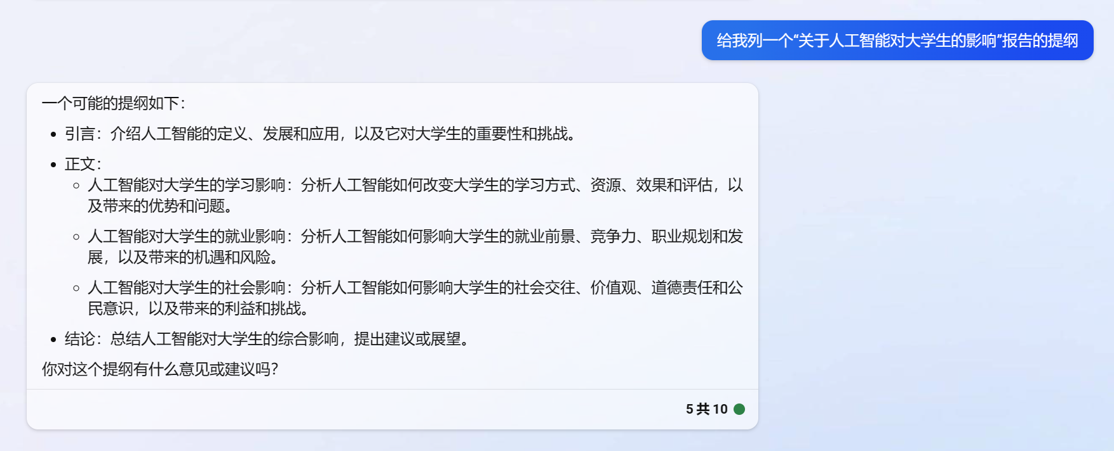

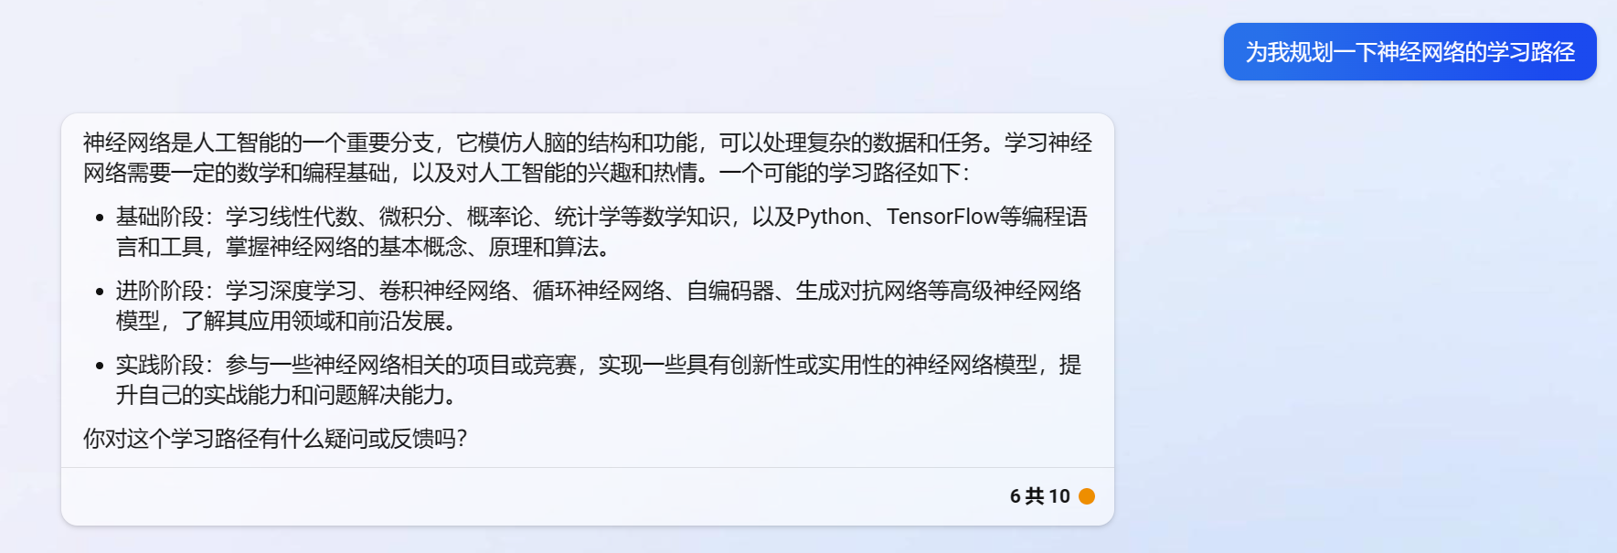

## pictures

