Sequence Tagging

Sequence tagging or labeling commonly refers to a group of related Natural Language Processing (NLP) tasks such as part-of-speech (PoS) tagging, Named Entity Recognition (NER), Multiword Expression (MWE), chunking/shallow parsing, and semantic role labeling/semantic slot filling. All of these tasks can be treated as cases of supervised multinomial classification, in which a tag or label is assigned to some linguistic construction, be it a word (PoS tagging) or a grouping of words referring to some unique entity (NER) such as the Czech Republic.
When neural networks are employed to solve these sequence labeling tasks, it is essential that each input, whether a character or a word, maps to a target label. In order to achieve this, usually some variation of the BIO (Beginning, Inside, Outside) annotation scheme is used. Below the tag for Location can be assigned to either a single or a multiword entity:

Prague is the capital of the Czech Republic
B-LOC O O O O B-LOC I-LOC I-LOC

The presence of the multiword entity is thus signaled by the Inside (I) LOC tag following a same Beginning (B) tag, and all words that do not span any entity are marked as Outside (O). As we will see below in the discussion of multiword expressions (MWEs), there are slight variations of this annotation scheme, but the idea is for the most part the same: every word form in a string of words (text)—instead of some larger linguistic entity– gets its own tag or label.
Current state of the art approaches to sequence labeling use some type of language model (LM), possibly combined with pretrained word embeddings, and for the encoding layer for the downstream labeling task, a bidirectional recurrent neural network (BiRNN), such as the LSTM variety, with a conditional-random field (CRF) decoding layer (Akbik et al 2018, Peters et al 2018). Before discussing these models, I first present some basic RNN architectures.

Recurrent Neural Networks (RNNs)

Recurrent Neural Networks (RNNs) are a type of neural network specialized for processing sequential data such as text Normal vanilla flavored neural networks suffer from two major problems. First they cannot be fed variable length inputs, whether characters, words, or sentences. There are nevertheless workarounds, such padding the sequence with zeros up to some fixed maximum length. Second, they do not share features learned across different sequential positions. In NLP, a word like Eric occurring initially bears no relation to the same word occurring word medially or finally. RNNs can handle sequences of different lengths, and parameter sharing allows them to generalize across different textual positions (Goodfellow et al 2016). Thus they would need separate parameters for each sequential position t in order to recognize that the named entity President Trump (Person) is the same in the following two sentences.

President Trump promises to make America great again.
During his election campaign, President Trump promised to make America great again.

As the name suggests, RNNs compute the current state recursively. The previous state serves as input to the current state, yielding a recurrence such as the following:
h^{t} = f(x^{t}, h^{t-1}; θ). We thus see that each state contains information (features) from all previous states. We can visualize this recurrence better by unfolding it as in the diagram below.

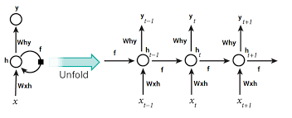

RNNs are thus capable of capturing longer range dependencies than a Perceptron. For instance, a sequence x₁, x₂,...x_{t} is mapped to a state h_{t+1}, which depending on the length of the sequence, will be lossy (Goodfellow et al 2016). A language model, which models the distribution of words in a language and can predict the next word (or character) based on previous words, begins to lose information beyond a certain window size.

Long Short-Term Memory (LSTM)

Long Short-Term Memory (LSTM), along with Gated Recurrent Units (GRUs), are gated RNNs, which employ this specialized gated architecture to control what information is allowed to pass through. As illustrated in the figure below, an LSTM contains a memory cell (c_{t}) which hold the state, an input gate (i_{t}) which controls what new input features are incorporated into the state, a forget gate (f_{t}) which controls which information from the state at the previous time step (c_{t-1}) recursively passes into the state, and an output gate (o_{t}) which can selectively shut off the output of the cell.

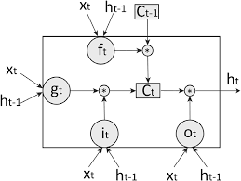

The computations of these gates and cell state are given below.

Note that in the standard LSTM, each gates receives to inputs, the input x_{t} and previous state h_{t-1,} and that the activation of the gates is normally sigmoid σ, but that the activation of the external input gate (g_{t}), which by element-wise multiplication (*) controls what input enters the state, is tanh, as is the final state output by the cell.

Context-Insensitive Word Embeddings

A word embedding (Bengio et al. 2003), also known as a distributed word representation, is a learned representation of text in which words with similar meanings have similar representations. This differs from merely representing a word as a vector containing no semantic features, an idea which has been around for some time. For instance, the representation of vec(Prague) can be obtained arithmetically by vec(Rome) - vec(Italy) + vec(The Czech Republic). One of the advantages of using word embeddings is that they in effect project a discrete high dimensional space of a magnitude of the number of words in the vocabulary to a much more manageable continuous lower dimensional space. Thus a word with a discrete one-hot encoding of dimensionality in the tens of thousands is mapped to a continuous representation encoding normally in the hundreds. Word embeddings (Collobert et al. 2011, Mikolov et al. 2013c) are one of the breakthroughs in NLP in the last fifty years.
There are two basic techniques to embed words , continuous bag of words (CBOW) and skip gram. In the CBOW model, a word is predicted by its context of surrounding words, while in the skip gram model, the process is reversed and the context of a given word is predicted.

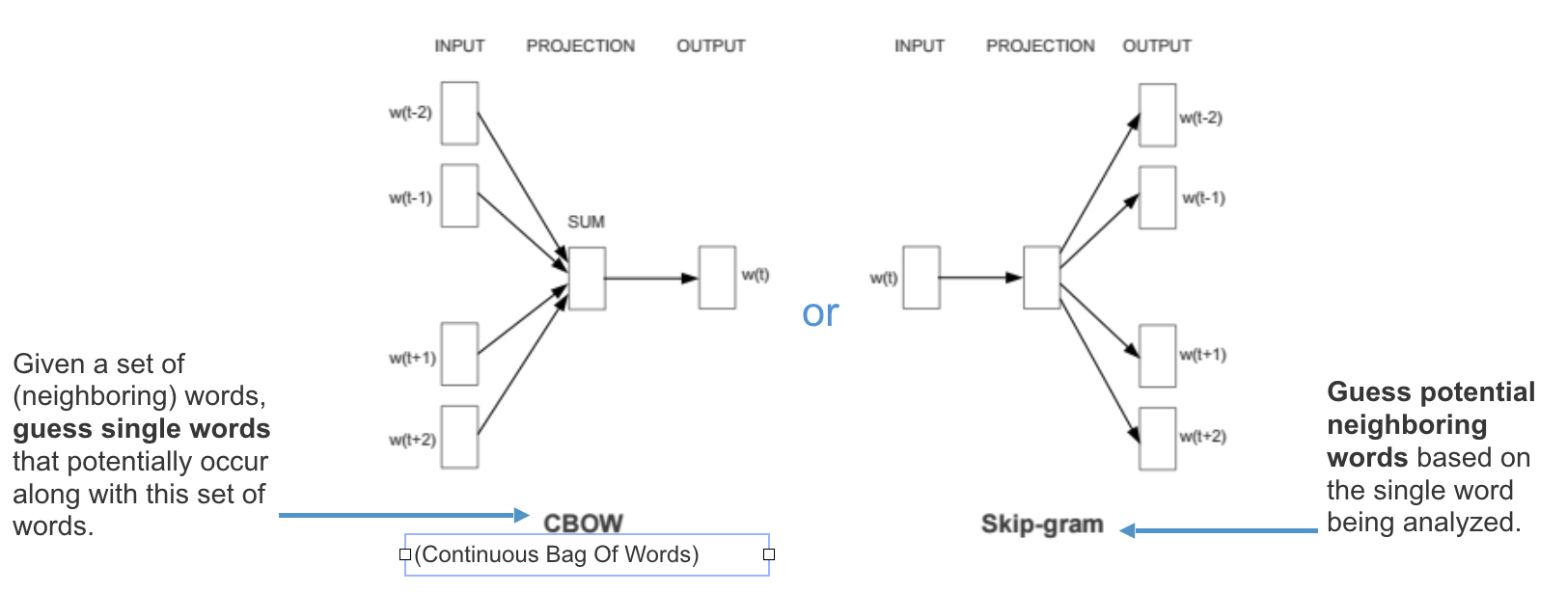

Word2vec can create embeddings using either one of these techniques, and it has been shown that of the two methods the skip gram is the best at capturing word similarity (Mikolov et al. 2013 d). Although pretrained distributed word embeddings such as word2vec, FastText, and GloVe have proven quite useful in modeling the latent semantic and syntactic similarities of words, they suffer the drawback that they do not model how words very frequently have different meanings (polysemy). This is the case because different meanings and representations are collapsed into one final representation. Schutze (1998) is one of the first to identify this meaning conflation deficiency. One of obvious outcome of this is that an NLU system would be less likely at distinguishing these senses. Another perhaps less obvious one is that often unrelated words are pulled toward each other in vector space. For instance, the unrelated word rat and screen are pulled toward one another due to one of the senses of mouse and its closeness to screen (Camacho-Collados et al 2018).

Contextualized Word Embeddings

One obvious solution to the meaning conflation deficiency is to have embeddings for every meaning of a word. Such sense representations or embeddings can be produced either in an unsupervised fashion or with the help of a knowledge base. Unsupervised approaches are favorable because of the lack of KBs, and most make use of clustering, which can lead to unclear semantic mappings and their difficult integration into downstream models (Camacho-Collados et al 2018). Recently an emerging field of research has sought to integrate unsupervised context-sensitive embeddings into downstream tasks. While pretrained word embeddings like word2vec yield one single static representation per word, these contextualized word embedding are sensitive to context and their representation is dynamic, changing according to the context in which the word appears (Melamud et al. 2016, Akbik et al. 2018, Peters et al. 2018).

Context2vec

Like word2vec, context2vec (Melamud et al. 2016) learns both target word and context representations simultaneously, but with a much more robust sentential context.
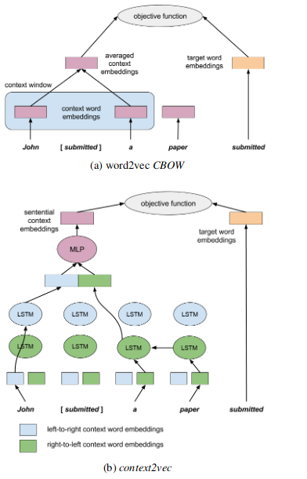

As in figure X, the model uses two separate LSTMs, one for the left-to-right context and one for the right-to-left, with separate parameters and context embeddings. The outputs of each one are then concatenated and thus encapsulate the context, in much the same way as the averaging over context vectors in the word2vec model. This context vector is next fed to a Multilayer Perceptron (MLP) which outputs a representation of the entire sentential context.
Context2vec shares a lot in common with Language Models (LMs). Both generally use BiLSTMs (discuss before) with the objective of predicting the target word based on its context. While LMs, however, are mainly concerned with predicting conditional probabilities of target words based on their histories, the main goal of context2vec is to produce useful context representations of target words. In the next section we discuss LMs in more detail.

Language Models

A statistical language model (LM) is formally a probability distribution over words. Using a LM, one can estimate the probability of observing a particular sentence, e.g. .

Language modeling has applications in speech recognition, machine translation, part of speech tagging, text generation, and information retrieval, among others. Due to the data sparsity problem, the Markov assumption, limiting the history to n-terms, is usually employed in practice, and n-gram probabilities are often computed by maximum likelihood estimation (i.e. counting), followed by smoothing to counteract out of vocabulary (OOV) words. Therefore, by an n^{th} order Markov property, the probability distribution, which is a product of terms predicting the next word given the history, can be approximated by a product conditional probabilities confined to a window of size n (n-gram):

In order to accurately estimate the likelihood of sequences of words, LMs must be trained on a huge amount of data. However, more data leads to more data sparsity, a phenomenon referred to as the ‘curse of dimensionality’ (Bengio et al. 2003). In other words, a sentence at test time may be different from those seen during training. Traditional approaches overcame this problem by stringing together n-grams to build the sentence.
In the last decade, neural LMs (NLMs) have gained popularity because of their ability to alleviate the curse of dimensionality via their use of continuous word representations (embeddings). As has been discussed, the use of word embeddings leads to dimensionality reduction. In an NLM, word embeddings are learned during training. One simply initializes a lookup table randomly and embeds the sequences using this table. The lookup table is a parameter of the network and gets updated like the other parameters during backpropagation. The goal of a NLM is to learn an optimal model . This process is illustrated below. After encoding the input as a word vector (embedding) using the lookup table C, the model maps the input sequence to a conditional probability distribution over all words in the vocabulary for the next word given its history.
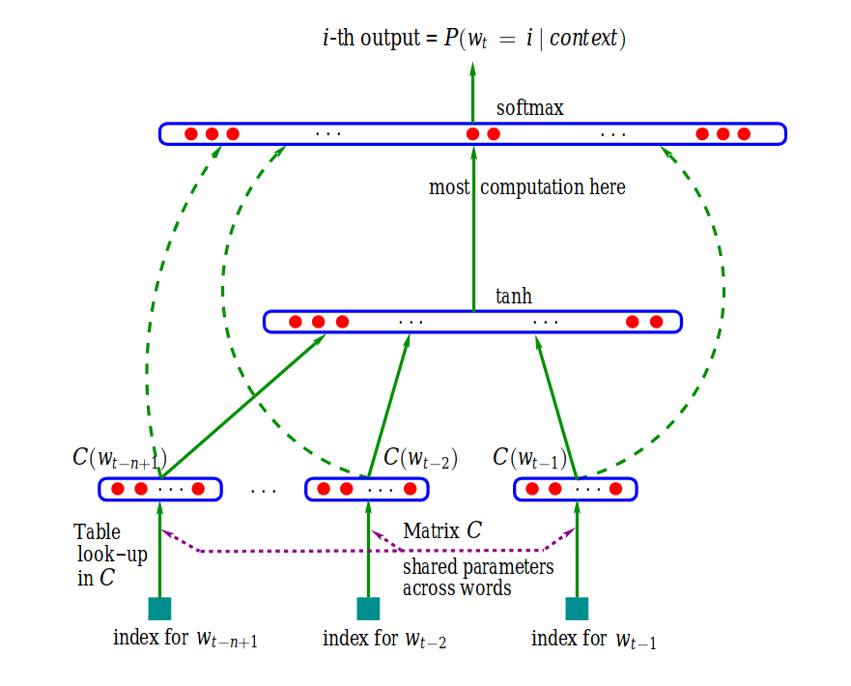Figure 1: Classical Neural LM, from Bengio et al (2003)
Although as we will see below the classical model of Bengio et al (2003) has evolved, its basic components have remained the same, consisting of the following layers:
- Embedding layer: generates the word embedding via multiplication of an index vector by an embedding lookup table
- Hidden layers: produce an intermediate representation of the input, e.g. an LSTM hidden state
- Softmax layer: final layer that yields a probability distribution over words in the vocabulary

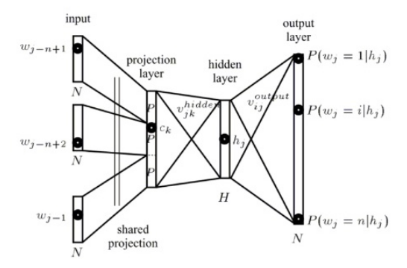Figure 2: Components of a NLM, from Bengio et al (2003)
The way a NLM computes the final probability distribution is also fundamentally the same. The output of the hidden layers, whether classic MLP or the BiLSTM of a modern NLM (see below) approximates Maximum Likelihood Estimation of an n-gram model
via the softmax layer, which computes the following normalized probability.

The unnormalized log-probability (logit) of the final fully connected output layer is , which is the inner product of the context vector h and computed embedding of w_{t,} the column of the weight matrix E of this output layer. This in practice is really a matrix-matrix multiplication of the weight matrix E of the output later, which contains the embeddings of all words in the vocabulary, and the minibatch outputs H of the previous hidden layer(s) for a given time step (in the case of an RNN), i.e. . The softmax squashes this logit z into a probability for word w_{t,} given the context
Using this softmax, it is then possible to compute the loss of the LM, whose objective it is to maximize probability of the whole training data. This can be formalized by maximizing the averaged log probability of the data.

In practice this is searching for the parameters which maximize the log likelihood (Bengio et al. 2003)

Such an architecture can be implemented by MLPs or RNNs. Current RNN LMs outperform n-gram LMs due to their ability to encode long-range dependencies in their hidden states (Graves 2013). In the next section, several recent NLMs are discussed.

TagLM, Peters et al. (2017)
Peters et al. (2017), leveraging a pretrained bidirectional LM, improved on the state of the art for several sequence labeling tasks, NER and Chunking. Its Language Model Augmented Sequence Tagger (TagLM) embeds an input sequence using a combination of character embeddings, pretrained context insensitive word (token) embeddings, and pretrained LM embeddings.

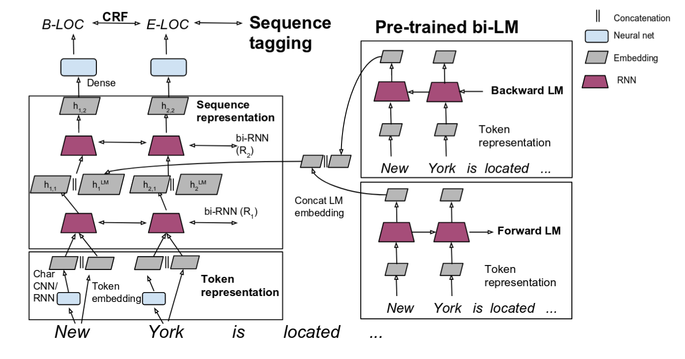

As is depicted above for the task of NER, the model contains several layers or components. In the embedding layer, embeddings over characters are obtained via a RNN or a Convolutional Neural Network (CNN). Using a character RNN for illustration, a character sequence for a word such as cat [‘c’, ‘a’, ‘t’] is fed to a RNN, usually bidirectional (BiRNN), which embeds the context to the left of each character (forward) and to the right (backward). A backward RNN is like the forward variant described above, but from right to left, encoding the word in reverse. The forward and backward outputs representing each word are then concatenated.

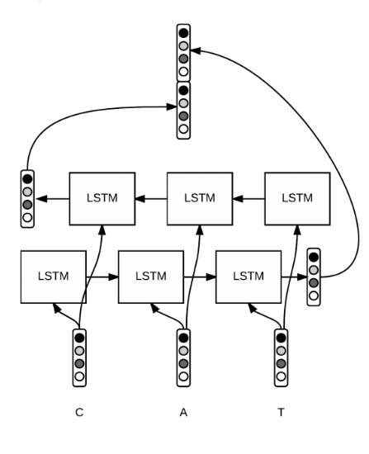

These character-level embeddings are then concatenated with pretrained word embeddings such as word2vec. For instance, York is now represented by the embedding .
The LM component of the model predicts the probability of the input sequence , using another BiRNN, whether BiLSTM or BiGRU. In the forward pass, the history of each token is embedded in the internal state which is output at each step t, until reaching the end of the sequence at which point is output as the final state representing the whole history. This is the forward embedding. Next, the process in repeated but in the opposite direction, , yielding the backward embedding . These embeddings are then concatenated . This embedding is combined with the output from the first BiRNN layer , which is fed to another BiRNN. The outputs of this layer are input to a final dense layer, which is decoded by a CRF. [explain CRF here or before?]
The above model is evaluated using CoNLL 2003 NER and CoNLL 2000 Chunking tasks.

Parameter | Value
character-level embedding (CLE) dimension  BiGRU X 2 state size for CLE  BiGRU X 2 state size for tagger  dropout for each GRU input | 25  80  300  .25
NER

Parameter | Value
character-level embedding (CLE) dimension  Number of CNN filters  CNN kernel size  BiLSTM X 2 state size for tagger  dropout for CLE, each LSTM input and final layer | 30  30  3  200  .50
Chunking

For both of these tasks, the LM employed was trained on around 800, 000 tokens from the One Billion Word Benchmark (Chelba et al. 2013), a data set designed for LMs, for three weeks on 32 GPUs. This LM achieved a test perplexity of 30.0. The hyperparameters of this LM, referred to as CNN-BIG-LSTM is given below.

Parameter | Value
Number of CNN filters  CNN kernel size  BiLSTM X 2 state size for tagger  Projection layer | 4096  ?  8192  1024
CNN-BIG-LSTM LM

,

ELMo

Following on Peters et al. (2017)

Some recent deep learning approaches assign a label to some larger chunk, e.g. Zhai et al (2017).

