1.16 Suppose that we are interested in estimating the number of home runs based on the other numerical variables in the data set. So all the other numeric variables will be our predictors. Investigate whether sufﬁcient variability exists among the predictors to perform PCA.

Answer:

Using all other predictors to estimate model for homeruns:

**proc** **reg** data =baseball_z outest = est_Baseball;

model homeruns = age games at_bats runs hits doubles triples RBIs walks strikeouts bat_ave on_base_pct slugging_pct stolen_bases caught_stealing / stb vif dwProb dw;

output out=reg_BaseOUT

h = lev cookd = Cookd dffits = dffit ;

**quit**;

the result is as follows:

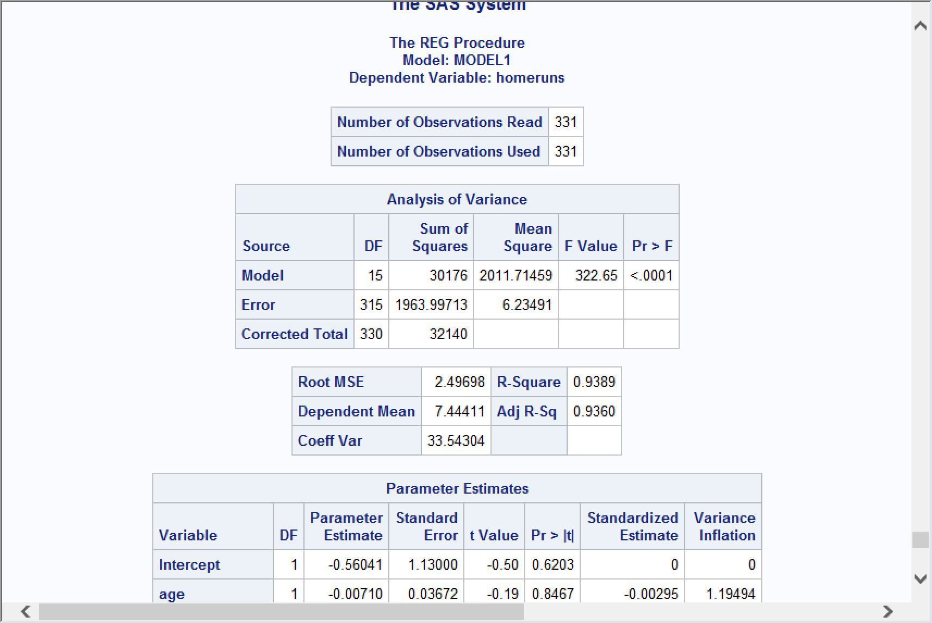

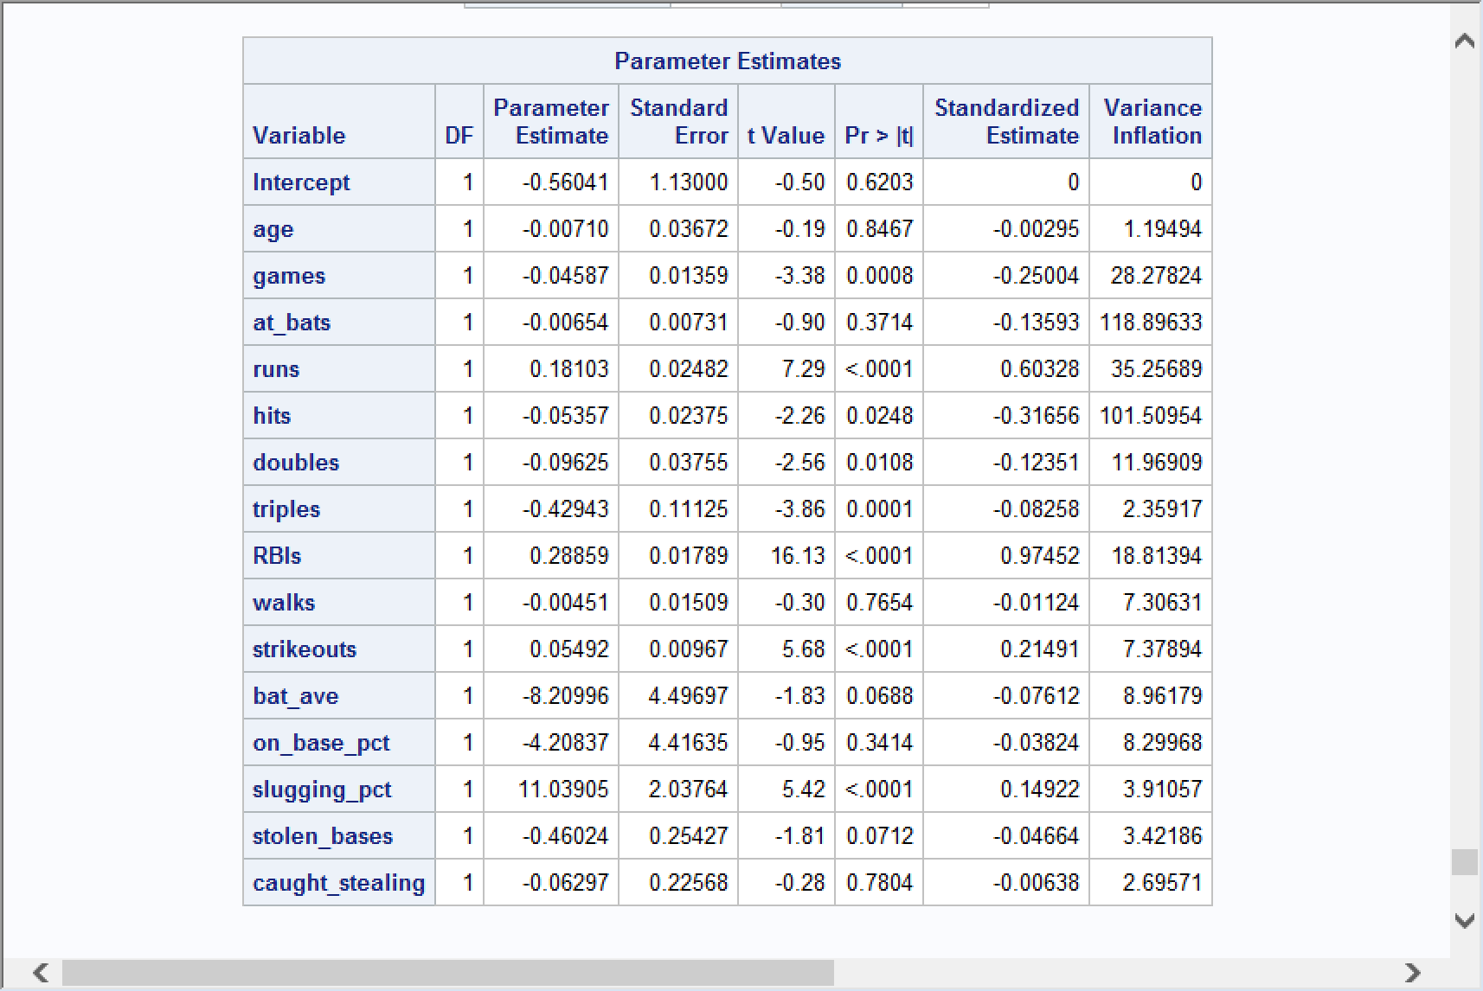

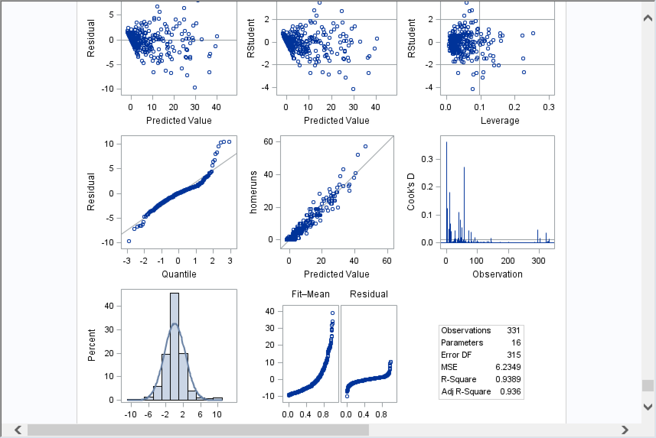

The R-square is 0.9389 . so the variable is sufﬁcient variability exists among the predictors to perform PCA.

1.17 How many components should be extracted?



The runs, RBIs, strikeouts and slugging_pct should be extracted.

1. Answer:

**proc** **princomp** data=baseball_z out=PCA_class_z;

VAR age games at_bats runs hits doubles triples RBIs walks strikeouts bat_ave on_base_pct slugging_pct stolen_bases caught_stealing;

**run**;

1. Choose top 4 :

