1. Build the best multiple regression model you can for the purposes of predicting calories, using all the other variables as the predictors. Don’t worry about whether or not the predictor coefﬁcients are stable.

**proc** **copy** in = sasdata out = work;

select Nutrition;

**run**;

**proc** **reg** data = Nutrition;

model CALORIES = WT_GRAMS PC_WATER PROTEIN FAT SAT_FAT MONUNSAT POLUNSAT CHOLEST CARBO CALCIUM PHOSPHOR IRON POTASS SODIUM VIT_A_IU VIT_A_RE THIAMIN RIBOFLAV NIACIN ASCORBIC CAL_GRAM IRN_GRAM PRO_GRAM FAT_GRAM / stb vif dwProb dw;

OUTPUT OUT= regression

h= lev cookd= Cookd dffits= dffit;

**quit**;

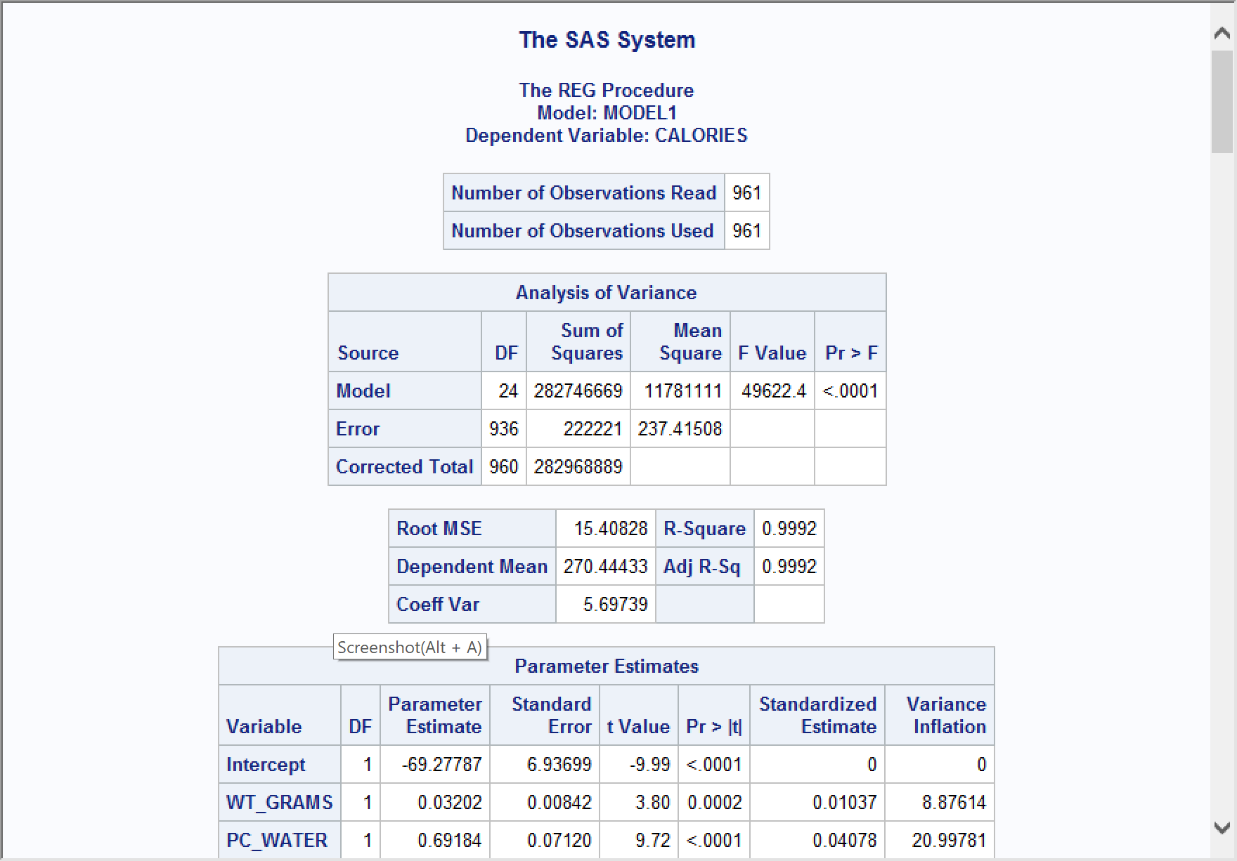

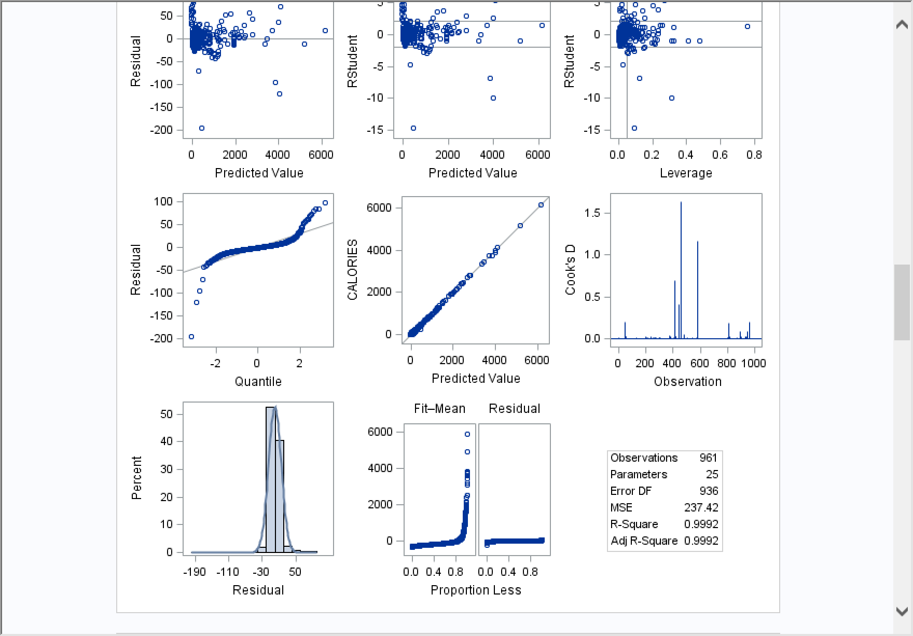

1. Compare and contrast the results from the forward selection, backward elimination, and stepwise variable selection procedures.

Forward: Does not go back ,every step add the variables together.

/*forward:*/

**proc** **reg** data = Nutrition;

model CALORIES = WT_GRAMS PC_WATER PROTEIN FAT SAT_FAT MONUNSAT POLUNSAT CHOLEST CARBO CALCIUM PHOSPHOR IRON POTASS SODIUM VIT_A_IU VIT_A_RE THIAMIN RIBOFLAV NIACIN ASCORBIC CAL_GRAM IRN_GRAM PRO_GRAM FAT_GRAM

/ selection = forward stb vif dwProb dw;

OUTPUT OUT=reg

h= lev cookd= Cookd dffits= dffit;

**quit**;

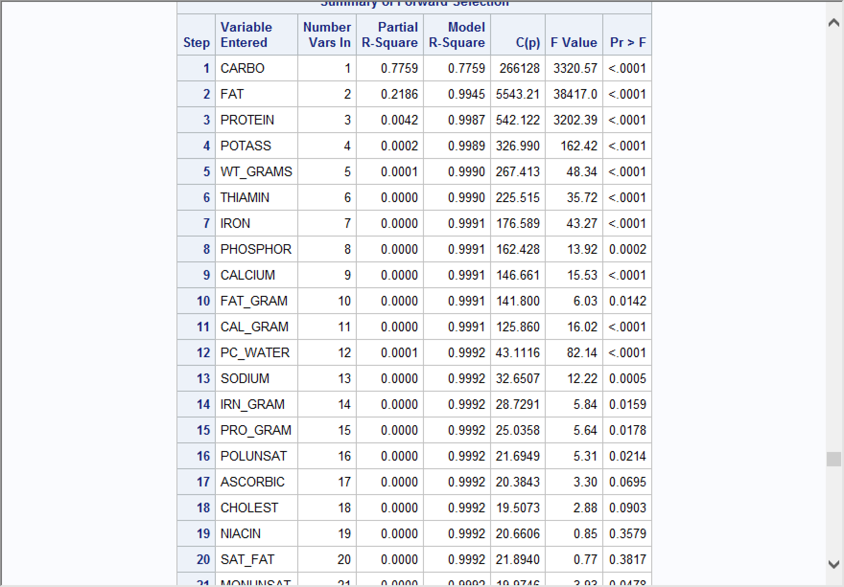

Depending which is least important .20 criterion leads to different results.

/*backward:*/

**proc** **reg** data = Nutrition;

model CALORIES = WT_GRAMS PC_WATER PROTEIN FAT SAT_FAT MONUNSAT POLUNSAT CHOLEST CARBO CALCIUM PHOSPHOR IRON POTASS SODIUM VIT_A_IU VIT_A_RE THIAMIN RIBOFLAV NIACIN ASCORBIC CAL_GRAM IRN_GRAM PRO_GRAM FAT_GRAM

/ selection = backward stb vif dwProb dw;

OUTPUT OUT=reg

h= lev cookd= Cookd dffits= dffit;

**quit**;

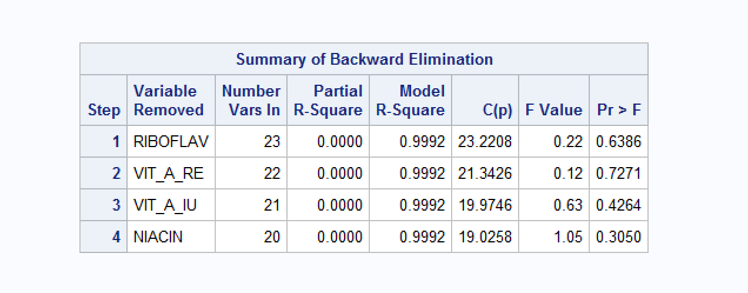

/*stepwise*/

**proc** **reg** data = Nutrition;

model CALORIES = WT_GRAMS PC_WATER PROTEIN FAT SAT_FAT MONUNSAT POLUNSAT CHOLEST CARBO CALCIUM PHOSPHOR IRON POTASS SODIUM VIT_A_IU VIT_A_RE THIAMIN RIBOFLAV NIACIN ASCORBIC CAL_GRAM IRN_GRAM PRO_GRAM FAT_GRAM

/ selection = stepwise stb vif dwProb dw;

OUTPUT OUT=reg

h= lev cookd= Cookd dffits= dffit;

**quit**;

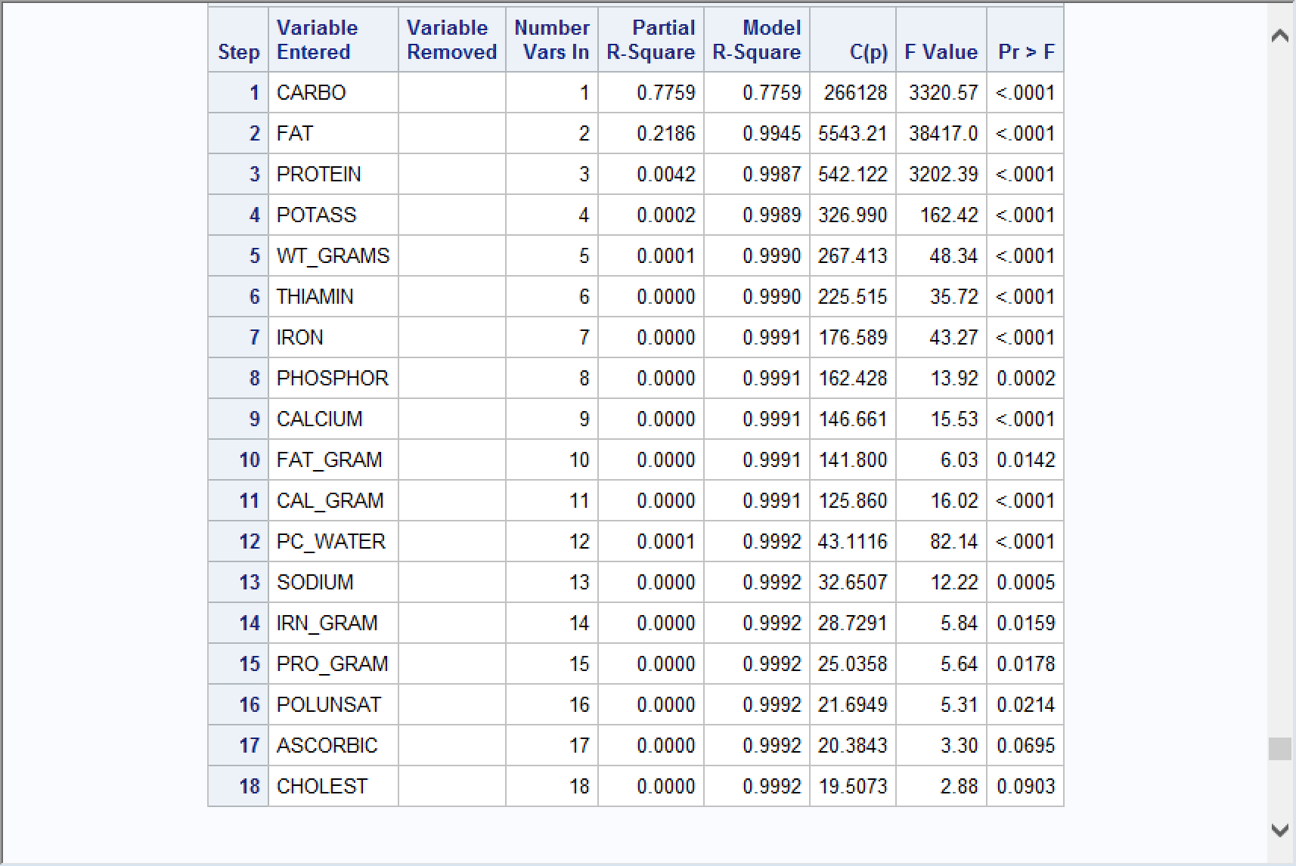

1. Apply the best subsets procedure, and compare against the previous methods.

Best solution if choose one variable , if choose 2 variable….etc

Give the top 5 important variables to predict.

If use pricinple components, they do not know what it is, but by using the best subsets procedure,we can know the relationships between all the variables.

/*BEST*/

**proc** **reg** data = Nutrition;

model CALORIES = WT_GRAMS PC_WATER PROTEIN FAT SAT_FAT MONUNSAT POLUNSAT CHOLEST CARBO CALCIUM PHOSPHOR IRON POTASS SODIUM VIT_A_IU VIT_A_RE THIAMIN RIBOFLAV NIACIN ASCORBIC CAL_GRAM IRN_GRAM PRO_GRAM FAT_GRAM

/ selection = MAXR stb vif dwProb dw;

OUTPUT OUT=reg

h= lev cookd= Cookd dffits= dffit;

**quit**;

