1. Use logistic regression model to the “IBM Employee Attrition V2” dataset in CANVAS to uncover the features that can predict employee attrition. This is a subset of a fictional data set created by IBM data scientists.

Sol:

First, classify the variables.

Set the “attrition = 1” if the label of it is “Yes”, otherwise set it to “0”.

Set the “overtime= 1” if the label of it is “Yes”, otherwise set it to “0”.

And the same classify variable NumCompaniesWorked and TotalWorkingYears and MaritalStatus.

Then run the logistic regression model.

Code:

*-------------------------------------------------------------------------;

* Project : CS 593: hw4 ;

* Developer(s) : Rui li ;

* Comments : code ; ;

*-------------------------------------------------------------------------;

libname sasdata "C:\Users\Eric\Downloads\SAS_DATA";

**proc** **import** datafile= 'C:\Users\Eric\Downloads\SAS_DATA\IBM_Employee_Attrition_V2.csv' out =IBM_Employee_Attrition;

**run**;

**data** IBM_Employee_Attrition2;

set IBM_Employee_Attrition;

if attrition="No"

then V_attrition=**0**;

else V_attrition=**1**;

if overtime="Yes" then V_overtime=**1**;

else V_overtime=**0**;

if NumCompaniesWorked>**3** then V_NumCompaniesworked=**1**;

else V_NumCompaniesworked=**0**;

if TotalWorkingYears > **11** then V_TotalWorkingYears = **1**;

else V_TotalWorkingYears = **0**;

if MaritalStatus="Single" or MaritalStatus="Married" then V_MaritalStatus=**1**;

else V_MaritalStatus=**0**;

**run**;

**proc** **logistic** data=IBM_Employee_Attrition2 ;

class V_NumCompaniesworked(ref='0') TotalWorkingYears(ref='0') V_MaritalStatus(ref='0')/param=ref;

model V_attrition=DistanceFromHome V_overtime V_NumCompaniesworked V_TotalWorkingYears V_MaritalStatus;

**quit**;

Result:

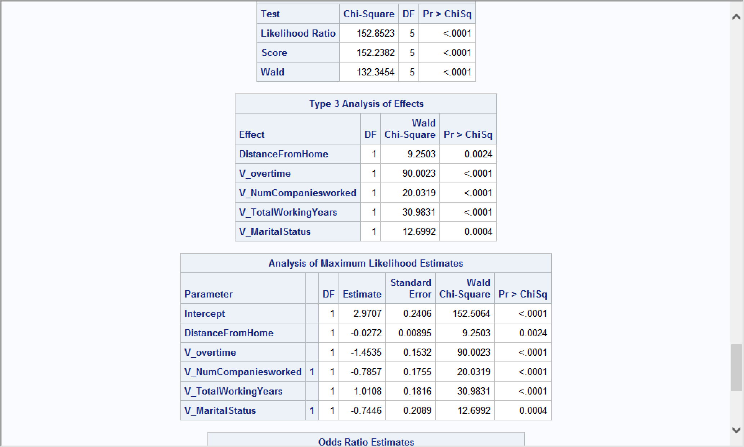

According to the result, all the variables are satisfied by the threshold of P value which “Pr > ChiSq” < 0.05. Therefore DistanceFromHome, Overtime, NumCompaniesworked, MaritalStatus, TotalWorkingYears can predict employee attrition.

1. Calculate the page rank for the following network.

Sol:

Code:

/*PageRank Soluion*/

**data** Arcs;

infile datalines;

input Node $ A B C D E F G ;

datalines;

A 0 1 1 1 0 0 0

B 1 0 0 1 0 0 1

C 0 0 0 0 1 0 0

D 0 1 1 0 0 0 0

E 0 0 0 0 0 1 0

F 0 0 1 0 0 0 0

G 0 1 0 0 0 0 1

;

**run**;

/*get the transition matrix*/

**proc** **sql**;

create table matrix_1 as

select a/sum(a) as x1

,b/sum(b) as x2

,c/sum(c) as x3

,d/sum(d) as x4

,e/sum(e) as x5

,f/sum(f) as x6

,g/sum(g) as x7

from Arcs

;

**quit**;

/*Since there are 7 nodes, the initial vector v0 has 7 components, each 1/7*/

**data** rank_p;

x1=**1**/**7**;

x2=**1**/**7**;

x3=**1**/**7**;

x4=**1**/**7**;

x5=**1**/**7**;

x6=**1**/**7**;

x7=**1**/**7**;

output;

**run**;

**proc** **iml**;

use matrix_1;

read all var{x1 x2 x3 x4 x5 x6 x7} into M;

print M;

use rank_p;

read all var{x1 x2 x3 x4 x5 x6 x7} into rank_p1;

print rank_p1;

rank_p=t(rank_p1);

print rank_p;

rank_p2=M*rank_p;

print rank_p2;

rank_p50=(M\*\***50**)*rank_p;

print rank_p50;

**quit**;

