Eric Mach
DX799: Data Science Capstone
Semester 2
Topic: Predicting Worldwide Energy Generation Trends
Datasets:
Har-Var (2024). Global Renewable Energy Production (2000-2022) [Data set]. Kaggle. https://www.kaggle.com/datasets/shakaal/global-renewable-energy-production-2000-2022/data
Hossainds, B. (2023). Renewable Energy World Wide: 1965~2022: 02 modern-renewable-energy-consumption [Data set]. Kaggle. https://www.kaggle.com/datasets/belayethossainds/renewable-energy-world-wide-19652022?select=02+modern-renewable-energy-consumption.csv
Morgado, K. (2023). US Energy Generation 2001-2022 [Data set]. Kaggle. https://www.kaggle.com/datasets/kevinmorgado/us-energy-generation-2001-2022
Topic Description:
This capstone project attempts to explore and model energy generation trends worldwide, separated by technology types such as renewable vs. non-renewable, and by country. As energy demand has skyrocketed due to the increased investment in artificial intelligence applications, modeling future generation and capacity needs can greatly help both industries and governments plan their buildouts and resources effectively.

Technical Report
Section 1: Executive Summary
The U.S. Energy Information Administration projects energy consumption to increase somewhere between 15% to 57% by 2050 compared to 2022 (U.S. Energy Information Administration, 2023). With the recent exponential demand in AI infrastructure expansion, the World Research Institute compared significantly varying forecasts of data center electricity demand forecasts ranging from nearly 200 Terawatt-hours (TWh) to over 1000 TWh by 2030 (Byrum, Z., Goldsmith, I., 2025). These wide ranges of energy forecasting make it difficult for businesses and governments to plan and allocate resources efficiently. Collectively, these datasets have the potential to provide significant insight into the global shift toward efficient renewable energy sources. Ultimately, this project aimed to model the historical energy mix trends and attempt to forecast energy demand in the future while understanding why existing forecasts vary so broadly. In doing so, highlighting the surging energy generation emphasizes the need for installed capacity expansion to accommodate the increased demand, providing incentive for future investment into both existing energy architectures and emerging alternative energy sources. For this project, three datasets were analyzed relating to renewable and non-renewable energy trends across the U.S. and the world over time. All the selected datasets span a period of at least the beginning of the 21st century until 2022, with one dataset spanning back to 1965. All datasets track energy generation, breaking down the types and methodology that each country/state utilizes as well as how those trends may have changed over time. Exploratory data analysis (EDA) was performed on the datasets to visualize and understand their distribution, context, and historical trends. As expected, energy demand and production have increased dramatically in modern times compared to the 20th century. Afterwards, various types of regression and classification methods were explored in attempts to accurately predict energy generation with varying results. Many methods saw limited applicability in terms of performance, but the best performing model was an ensemble method in the form of a random forest model, which combined multiple weaker learners together to produce a more robust model. Perhaps a more fitting analysis was a time series analysis, which better accounted for the temporal aspects of the trends and was better able to model errors with respect to future energy predictions.
Section 2: Introduction & Problem Definitions
As an industry, energy has seen an exponential boom in demand in just the past few decades. This can be visualized quantitatively in the EDA section below but even anecdotally more of the world has become increasingly dependent on technology from smartphones to laptops to the revolutionary technology that is artificial intelligence. As more of the developing world catches up technologically, electricity and energy demands will continue to grow. Likewise, with the intense investment into AI infrastructure in already developed countries, energy demands are soaring to accommodate the buildout of the new technology. As mentioned earlier, the World Resources Institute collected various estimates for electricity demand for data centers looking forward to 2030. A visualization can be seen below.
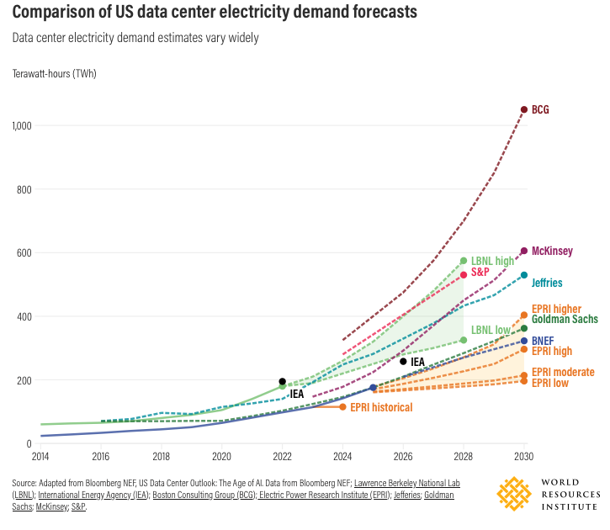
Figure: World Resources Institute Estimates for Data Center Electricity Demand
For context, the highest estimate of 1,050 TWh/year by BCG would represent a quarter of all U.S. electricity generation in 2023. A majority of the estimates fall in the 300 TWh/year to 400 TWh/year range which still equates to 53% to 71% of all of Texas’ net electricity generation for 2024 (Byrum, Z., Goldsmith, I., 2025). The primary goal of this project is to understand energy trends/demand moving forward so that policymakers and investors plan accordingly to accommodate the need for more computing resources. Energy is currently the primary resource bottleneck/constraint to the buildout of AI as even if buildout was accelerated to achieve the lofty forecasts currently set out by the industry hyperscalers, there would not be enough energy to currently power them. For success metrics for regression, the primary success metrics were measured by root mean squared error (RMSE) and R^2. RMSE quantifies the average magnitude of errors between the model-predicted and actual values, and R^2 represents the proportion of the variance in the dependent variable that is predictable from the independent variables. In other words, the R^2 acts as a measure of explained variance, or how well the predictors fit to the outcome variable. For this project, one of the best performing models had a relatively high RMSE but also interestingly had a very high R^2 as will be further discussed in the results section. Due to the scope of this project being focused on forecasting energy demand, classification methods will not be covered nor will clustering methods. Ensemble methods for regression saw the most success due to the non-linearity trend of the data and potential to handle collinearity. A practical limit to all of the datasets was a sparse amount of predictors, as energy generation was mainly split by technology type and country/state.
Section 3: Data Overview
Data Sources: The datasets examined were from Kaggle, an online public repository with thousands of datasets uploaded by its community. The first dataset was provided by the International Renewable Energy Agency (IRENA), offering comprehensive statistics on both renewable and non-renewable energy across regions, sub-regions, and countries between 2000 and 2022 (Har-var, 2024). Similarly, the second dataset strictly tracked renewable energy generation by country/region worldwide from 1965 to 2022 although the direct source was not listed aside from web scraping by the author (Hossainds, 2023). The third dataset tracked monthly energy generation by U.S. state between 2001 to 2022, separated by energy source and type of production (Morgado, 2023). This dataset was adapted from the U.S. Energy Information Administration. Collectively, these datasets can paint a picture of the historical trajectory of traditional and renewable energy sources.
Data Collection: Kaggle allowed for these datasets to be easily downloaded for analysis in a Python Jupyter notebook. Each dataset consisted of one file, so there was no need to combine multiple files from one source.
Data Description: For brevity, subsets of the datasets are shown below to give an idea of summary statistics for the data. Many of the datasets share a similar structure, with energy generation being numerical while parameters such as country/state, technology type, and energy classification are categorical. In the IRENA dataset for example, counts of each parameter match, duplicated records were removed, and blank records were removed. This cleaning was done prior to the dataset’s upload to Kaggle. The dependent variables ‘Electricity Generation’ and ‘Electricity Installed Capacity’ encompass a large range in terms of GWh and MW respectively, ranging from magnitudes of 10^1 to 10^6. Aside from region demographics, the data is also split by producer type and technology types. This gives further insight into how each country has leveraged different types of renewable energy and non-renewable energy over time
Data Dictionary: The IRENA dataset is described below as an example as all of the three datasets had similar structures in terms of variables. Each of the columns had an intuitive nature to their name meaning, with electricity generation and installed capacity being a function of the year, country, and technology type. Technology types are further broken down into subgroups (renewable/non-renewable, oil, natural gas, solar, etc.) with each record of the dataset highlighting each technology subtype’s contribution to electricity generation and installed capacity. Electricity generation is a measure of total energy output measured in GWh, and electricity installed capacity is the maximum amount of electricity that a generating station can produce under ideal conditions. For the purpose of this project and forecasting demand, electricity generation was the target variable for regression. Electricity generation as a category had a mean of 1.441 x 10⁴ GWh, percentile ranges of 1.168 x 10¹ GWh (25%), 2.003 x 10² GWh (50%), 2.385 x 10³ GWh (75%), and a max value of 5.221 x 10⁶ GWh. This large range of values can be attributed to the skewed metrics of developed and underdeveloped countries respectively, as well as the rate at which they have undergone industrialization so far in this century.
Data Quality Assessment: As mentioned earlier, the IRENA dataset was precleaned prior to uploading to Kaggle, and the case was the same with the U.S. and worldwide renewable energy datasets, with no missing values. Zeroes were present but these signaled zero energy production for a particular category, not a null value.
Ethical Considerations: The data from these datasets is not personally identifiable as they were aggregated across countries and states without any links to specific households or communities. The data does not exhibit sampling bias as all countries for the worldwide dataset and all states for the U.S. dataset were accounted for in an equal manner. The data was collected as publicly available through questionnaires from reputable organizations such as IRENA and the U.S. Energy Information Administration.
Section 4: Data Cleaning, Preprocessing, EDA
As mentioned in the data overview, there was not much data cleaning and preprocessing necessary to analyze these datasets. As for feature engineering, the categorical variables such as country/region and technology type/subgroups were encoded using one-hot encoding to include these predictors in the regression analyses. Although categorical, these features are the primary predictors of these datasets aside from the year, and so one-hot encoding created binary columns for each categorical feature to avoid any ordinality bias. Advanced feature engineering was not required as the data was sufficiently split into appropriate categories. A correlation matrix not including the categorical variables can be seen below for the IRENA dataset.
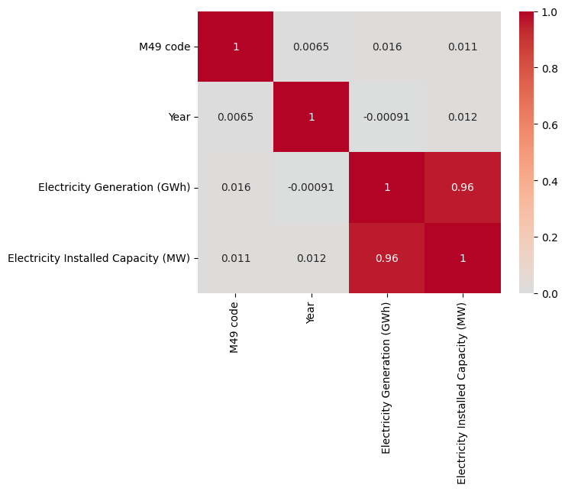
Figure: IRENA Correlation Matrix
Perhaps unsurprisingly, electricity installed capacity is heavily correlated with electricity generation as generation can only go so far as a country’s installed capabilities. Aside from this slight preprocessing, the visualizations and trends found from initial exploration showed interesting trends. The IRENA dataset can be seen below, grouped by different technology types over time.
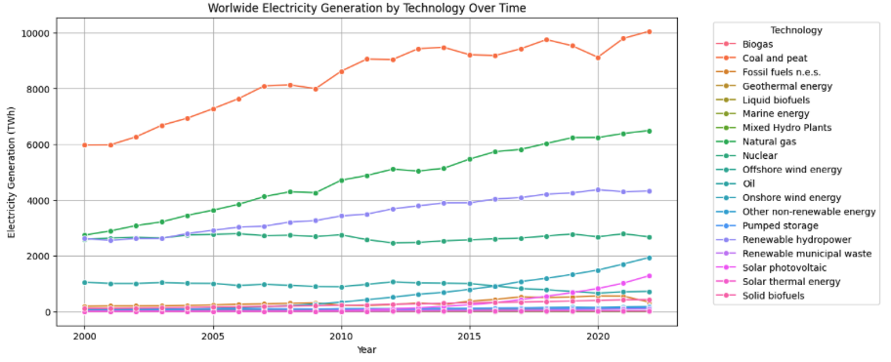
Figure: IRENA Worldwide Electricity Generation by Technology
While coal is still the dominant leader in electricity generation worldwide, there is also rapid acceleration in natural gas and renewable hydropower energy generation. Even looking at coal alone, electricity generation increased by over 50% in the 22 year period signifying the continued prevalence of fossil fuels today. Renewable sources such as hydropower and wind are seeing exponential increases as well, but need time to scale and be adopted more broadly before overtaking fossil fuels. The trend in some of these technology types appear to follow a linear pattern, however, utilizing the worldwide renewable energy dataset paints a different picture for renewable sources. An area plot of total energy generation can be seen below, displaying the distribution of renewable energy generation worldwide from 1971 to 2021.
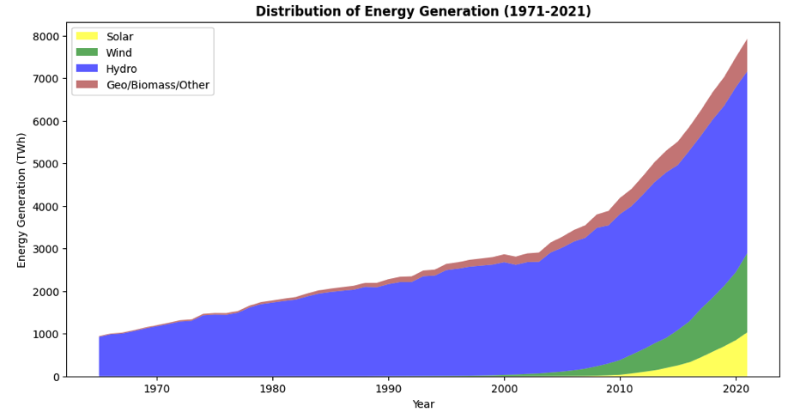
Figure: Renewable Energy Worldwide Area Plot
From 1970 to 2000, there is a steady adoption of renewable energy worldwide, but hydro generation was essentially the sole source of renewable energy for those three decades with very slight contribution of geo/biomass/other generation. However, at the turn of the century, global initiatives focused on clean energy adoption began to take effect in a dramatic fashion. There is a clear significant increase in rate of energy generation at this point, with wind and solar also being added into the mix of methodologies. While wind and solar contributions to global renewable energy production are still dwarfed by hydro, they are increasing at an exponential rate, especially in just the past decade. If current trends hold, the area of the plot will continue to diversify to wind, solar, and perhaps newer renewable sources. Although policy changes and renewable initiatives may be hard to predict in the long run, there is potential for predictability in the smaller scale and shorter term. The U.S. energy dataset allowed for monthly tracking of energy generation, which displayed a cyclical pattern throughout the year.
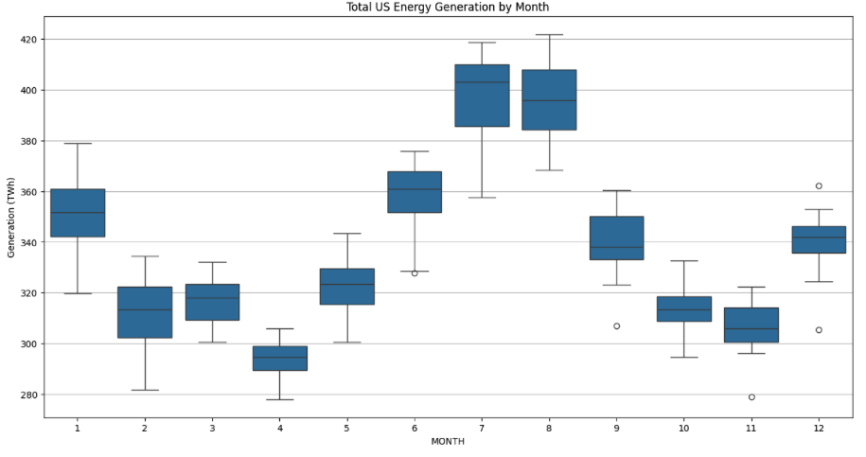
Figure: U.S. Energy Generation 2001-2022 Monthly Data
This monthly data, aggregated over the span of 20 years, shows total U.S. energy generation through the months. As is easily seen, it is quite cyclical, with energy generation peaking in the summer months, which is likely due to increased demand for air conditioning and other cooling applications. This trend can be further broken down to a state level. The boxplots show the interquartile ranges of energy generation but the trend is still apparent throughout the months with very few outliers as denoted by the opaque points outside of the whiskers of the boxes, signifying values greater or less than 3/2 times the upper or lower quartiles. Although intuitive, visualizing quantitative values and distribution spreads of this data aggregated over the last two decades can identify trends, which can help U.S. energy suppliers and grid operators plan future electric grid output to meet the necessary demand. Similarly on a more global scale, individual countries can be examined for their specific energy outputs to model how developing countries may mirror their performance. From the IRENA dataset, Saudi Arabia and Brazil are highlighted below for their fossil fuel and hydropower energy generation respectively.
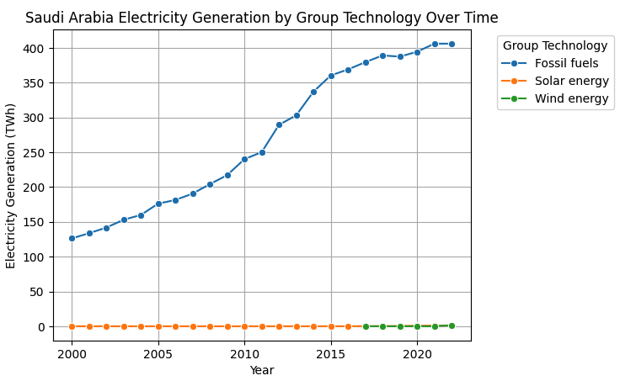
Figure: IRENA Saudi Arabia Electricity Generation
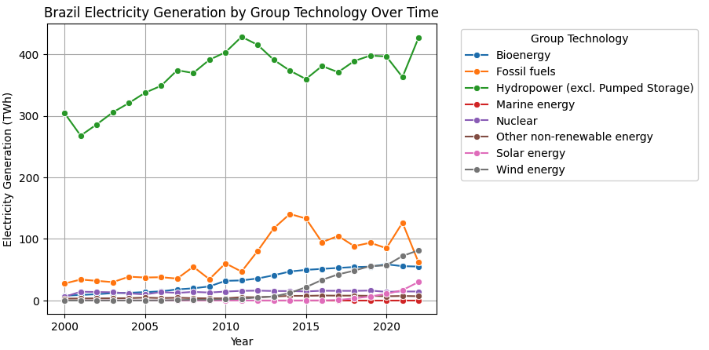
Figure: IRENA Brazil Electricity Generation
These scatterplots show how each country has been able to effectively leverage their natural resources and scale them to meet more demand as time goes on. Case studies such as these countries can be used as guides for underdeveloped countries or regions with similar natural resources in order to model their own energy generation as they build out the proper infrastructure. Together, these visualizations paint the clear trend of increasing energy generation across all aspects, both geographically and by technology type. Some growth is more extreme than others, with renewable energy types often seeing faster growth rates than fossil fuels, likely due to clean energy initiatives enacted by policymakers worldwide. At the same time, on a seasonal basis, there does seem to be a cycle of energy demand, at least in the U.S. that exhibits how energy use changes throughout the year.
Section 5: Modeling/Analysis
Due to the non-linear nature of energy generation trends, ensemble methods were chosen for their adaptability robustness due to combining multiple predictions together.
Gradient Boosting Regressor: Gradient boosting works sequentially by building decision trees that correct the errors made by previous ones. This model was run on the IRENA dataset with the best performing model yielding an R² of 0.984 and an RMSE of 19,094.502 GWh.
Randomized search was used to adjust the hyperparameters as follows: n_estimators (50,100,150), max_depth (3,5,7), and learning_rate (0.05, 0.1, 0.15). The learning rate in gradient boosting controls the contribution of each individual tree to the overall model, scaling down the magnitude of the corrections made by new trees that are added to the ensemble. The number of estimators defined the number of trees or basic learners in the model and max depth defined how deep an individual tree could become. These ranges were chosen experimentally to cover a wide range of possibilities. R² was also added as an additional success metric here to gauge fit and explained variance on top of the MSE/RMSE. Cross validation was also used with three folds for computational efficiency as opposed to an exhaustive complete grid search. Using a traditional 80/20 train test split with multiple cross validation folds allowed for more robust results in terms of performance. The best parameters out of those explored were a learning rate of 0.15, a max_depth of 7, and an n_estimators of 150.
Random Forest: To capture both a global and country-specific perspective, a random forest model was fit to the IRENA dataset. The random forest model is not prone to overfit due to the averaging of multiple individual trees, each trained on subsets of data. It is also able to achieve a higher accuracy than single models due to its multi-model nature, reducing the variance that would be apparent in a single tree. The success metric for these random forests was RMSE, measuring the differences between the predicted and actual values in the model. These were compared with the distributions of the original datasets to determine the scale of the errors. Data was split using 3-fold cross-validation during model training to further reduce overfitting and bias in order to get a more reliable estimate of a model’s performance rather than just a singular train-test split. For hyperparameter tuning, randomized search was used as a computationally efficient way to check combinations of different parameters rather than an exhaustive grid search. The hyperparameters and ranges adjusted were n_estimators or number of trees (between 50 and 500), max_depth or how deep an individual tree can be within the forest (between none and 30 in steps of 5), min_samples_split which defines the minimum number of samples required in a node to split which prevents trees from growing too deep and overfitting (between 2 and 20), and min_samples_leaf which defines the minimum number of samples required per leaf (between 1 and 10). These ranges were chosen as broad way to test multiple different scenarios through randomized search. The best result for random forests on the IRENA dataset yielded a best CV RMSE of 15,386.832 GWh and a test RMSE of 17,695.065 GWh, with parameters of max_depth = 15, min_samples_leaf = 2, min_samples_split = 2, and n_estimators = 97. How the RMSEs changed with respect to the tuning of hyperparameters was also examined through visualizations, as well as the impact of feature on the overall model. These will be further examined in the Results section below.
Time Series Analysis: In order to better model the time aspect of energy generation predictions, a time series analysis was conducted on the IRENA dataset. When deciding what model to apply, it was determined that Holt’s additive trend model would be appropriate as opposed to something like Seasonal Autoregressive Integrated Moving Average or SARIMA. A model like SARIMA is suited for instances with long series for a reliable estimate of autoregressive parameters and when seasonality is present. This dataset has yearly aggregated energy trends, which means there is no seasonality to account for, and each instance only contains about 20 data points per region + technology combination. Additionally, energy generation trends are defined by long-term growth and are driven by policy adoption and capacity expansion as described in the EDA. Holt’s trend can handle these short-term trends with minimal parameterization, whereas SARIMA may exhibit more overfitting and less stability in this specific instance. To evaluate model performance, a rolling forecast (or walk-forward) validation scheme was used to ensure out-of-sample accuracy while preserving the temporal structure of the data. In other words, the first three years of observation were used to fit the model, which then produced the next year forecast and the training window would subsequently expand by one year. The model would be refit and a new step forecast would be generated until all remaining years in the series had a corresponding forecast. Forecasts were then aggregated and evaluated using RMSE. This method of evaluation as opposed to a traditional train-test split ensures that each prediction point only has access to past information and no knowledge leakage of future data, also known as look-ahead bias. By averaging RMSEs over this rolling window, a more robust measure of performance could be achieved when assessing regions and their energy generation by technology type.
Section 6: Results
The success metrics were evaluated on the test splits of the ensemble methods. Between random forests and gradient boosting regression, the random forest had a lower RMSE of 17,695.065 GWh compared to the gradient boosting model. However, this can still be deemed as quite high when looking at the original data distribution, where more than ¾ of the data falls below this error by multiple magnitudes (the 75% range of data falls at 2.385 x 10^3 GWh). This goes to show that even though the gradient boosting model had a high R^2 value, the RMSE is far too high to suggest a fully successful model. First, the question of overfitting comes to mind with such a high R^2. But even with much more restrictive hyperparameters that are meant to control overfitting, such as a lower learning rate, lower max depth, and fewer trees, the resulting scores were still in the high 0.80s across multiple cross validation folds. Secondly, the RMSE seems relatively high to be paired with such a good R^2 performance score. However, upon inspecting the original dataset more closely, it seems that the spread of energy generation is extremely high, with some underdeveloped countries having production numbers in the single digits, while more industrialized nations simultaneously producing numbers in the 5 or 6 digits. Consequently, the RMSE can be misleading due to the variation in the target variable. One of the weaknesses of both ensemble methods is their ‘black box’ nature, as they are not as interpretable as single models, it is difficult to extract much insight out of the final model. Another weakness of the gradient boost model is its sensitivity to outliers, as it builds the model sequentially, meaning outliers may cause it to overemphasize a correction and overfit. Given the immense range of energy generation worldwide and split by country, it may have had trouble generalizing well on this front. Nonetheless, further exploration was performed for the random forest analysis. First, RMSE was visualized across cross-validation folds as there were changes to different hyperparameters to give more insight into the model-training process. Examples of how RMSE changed with respect to the number of trees and max depth can be seen below which signifies how the randomized search selected the best hyperparameters.
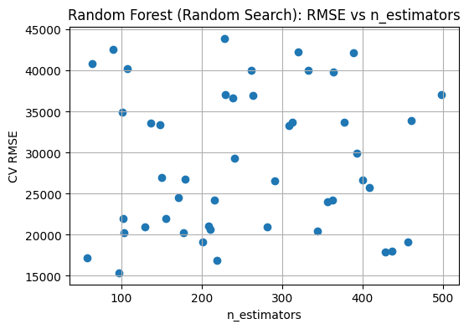
Figure: IRENA Random Forest RMSE vs. Number of Trees
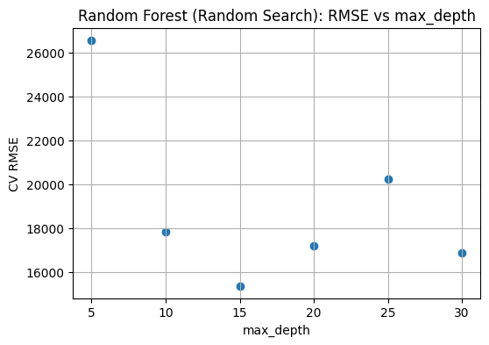
Figure: IRENA Random Forest RMSE vs. Max Depth
Interestingly, while max depth seemed to hit a sweet spot in terms of performance at 15, the RMSE as the number of trees changed had great variation. This displays how combinations of hyperparameters really make a difference as opposed to single changes in a single hyperparameter. 97 trees was the best selected option here, but a similar number of trees in other instances yielded nearly 3x the RMSE. Aside from hyperparameter examination, feature importance was also explored for the random forest. As a reminder, the categorical features were one-hot encoded for input into the model. Perhaps as indicated by the correlation matrix in the EDA, installed capacity was by far the most important predictor.
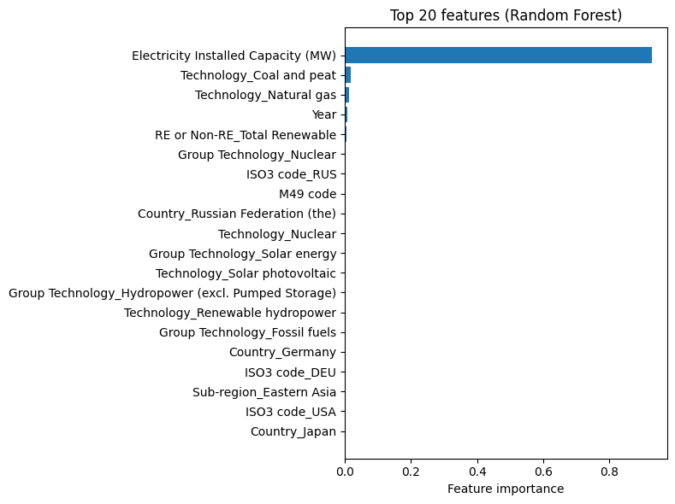
Figure: IRENA Random Forest Feature Importance
Without other major numerical predictors, this is sensical as the technology predictors then fall in order of their general prominence in terms of worldwide generation. This highlights the need for additional parameters that are not so heavily correlated with the target variable itself, especially when all of the other predictors are categorical.
As it pertains to the time series analysis, the following example forecasts are shown below using the IRENA dataset and the Holt additive trend model.
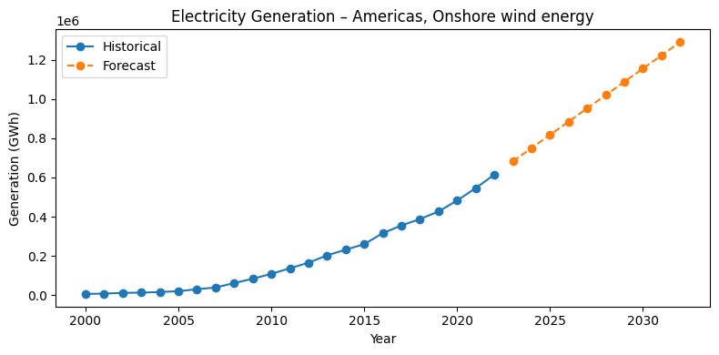
Figure: IRENA Time Series Prediction
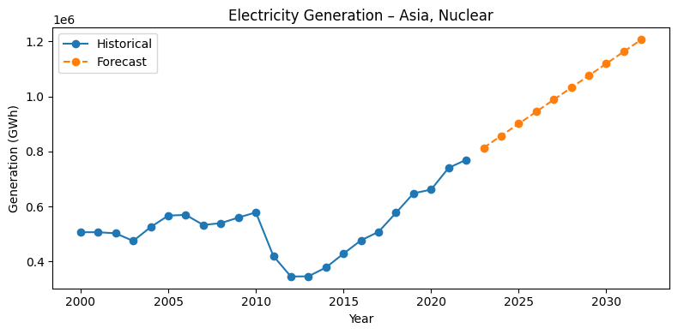
Figure: IRENA Time Series Prediction 2
As explained in the modeling section, the series for this dataset are fairly short and non-seasonal, making this trend model the most appropriate based on the dataset structure. While Asia nuclear energy generation and American wind energy generation have not been completely linear before, a linear prediction trend is the most stable as changes in policy and regulatory shocks cannot be accurately accounted for in future production. For evaluation, a rolling forecast scheme was utilized to continuously fit the model to the data, with the results graphed below. For non-normalized RMSEs, several of the largest categories exceeded an average RMSE of over 20,000 GWh (Coal and peat > 80,000 GWh, Natural gas > 50,000 GWh, etc.), making comparisons between technologies difficult given the difference in scale. The RMSEs were normalized by technology type due to varying production scales across technology types.
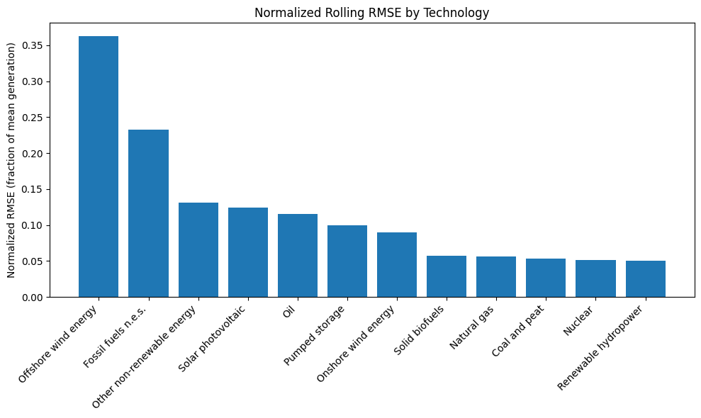
Figure: IRENA Time Series Rolling RMSE
In other words, the RMSE of each technology group was divided by the mean electricity generation for a given region-technology combination. The results of each region-technology grouping were aggregated for each region but kept separated by technology type to observe where the most variation was in terms of generation. This allowed for scale-independent assessment and a relative error metric. High normalized RMSE categories such as offshore wind energy and fossil fuels indicate non-linearities that are not fully captured, perhaps due to policy adjustments or plateauing trajectories. Conversely, low normalized RMSE categories such as renewable hydropower, natural gas, and nuclear indicate stable long-run growth trends driven by capacity additions. These technologies with consistent growth exhibit better performance with this model compared to volatile sectors such as fossil fuels which often sees policy shifts and capacity-retirement changes which can explain the high relative RMSE.
Section 7: Recommendations
Translating the models to actionable insights can likely not be done with the current levels of performance for the ensemble methods. Connecting back to the Introduction section, the RMSE of the best random forest model equates to about 17 TWh of error. For perspective, 17 TWh is enough energy to power a large city or roughly 1.75 million homes in the U.S. for an entire year (Sustainablechoice). An average error of this magnitude in the model predictions is not likely to sway policymakers or businesses into making confident investments or actions given the cost of unnecessary buildout. Suggestions include further hyperparameter tuning to explore more ranges for both random forests and boosting regression, perhaps incorporating grid search instead of random search to find the best possible combination. Additionally, more numeric predictors could aid in regression as the current main predictors are either categorical or highly correlated with the target variable. For time series analysis, different autoregressive models could be explored although the current model provides a good baseline with which to compare, especially in categories with more stable performance metrics as indicated by lower normalized RMSE. Additional years of aggregated data would help in performance, and perhaps monthly data could add additional complexity and allow for seasonality analyses. Given the current predictions in this baseline time series model, new actual generation outputs from 2023-2025 can be compared with the forecasts to determine how accurate the predictions were. However, given the high absolute RMSEs of the non-normalized results for the time series analysis in some of the most major technology categories, there is low confidence in these predictions being able to drive highly impactful decisions in terms of policymaking. As mentioned earlier, data center demands for energy have gone up significantly just in the past few years to support the AI infrastructure buildout. However, these current datasets only cover data generation up until 2022 prior to this immense jump in demand. Additional data on the projected demand of energy can be incorporated into forecasting as well more current data on emerging energy sources such as nuclear which has seen massive investment and interest in recent months and years. These projections can also be incorporated into forecasting to help get a better picture of present-day demand. With adjustments to current regression models and further exploration of different time series models, more reliable predictions should be able to be created leading to more actionable insights on the parts of businesses investing in energy architecture, as well as policymakers who need to plan accurately for future demand to ensure grid operability.
References
Har-Var (2024). Global Renewable Energy Production (2000-2022) [Data set]. Kaggle. https://www.kaggle.com/datasets/shakaal/global-renewable-energy-production-2000-2022/data
Hossainds, B. (2023). Renewable Energy World Wide: 1965~2022: 02 modern-renewable-energy-consumption [Data set]. Kaggle. https://www.kaggle.com/datasets/belayethossainds/renewable-energy-world-wide-19652022?select=02+modern-renewable-energy-consumption.csv
Morgado, K. (2023). US Energy Generation 2001-2022 [Data set]. Kaggle. https://www.kaggle.com/datasets/kevinmorgado/us-energy-generation-2001-2022
U.S. Energy Information Administration (2023). EIA projections indicate global energy consumption increases through 2050, outpacing efficiency gains and driving continued emission growth https://www.eia.gov/pressroom/releases/press542.php#:~:text=Additional%20takeaways%20from%20IEO2023,generation%20throughout%20the%20projection%20period.
Byrum, Z., Goldsmith, I. (2025). Powering the US Data Center Boom: Why Forecasting Can Be So Tricky. World Resources Institute. https://www.wri.org/insights/us-data-centers-electricity-demand#:~:text=Many%20estimates%2C%20however%2C%20put%20data,McKinsey%20S&P%20S&P%20BNEF%20BNEF
Making Sense of Energy Units. Sustainablechoice. https://thesustainablechoice.com/making-sense-of-energy-units/#:~:text=Terawatt%20Hour%20(TWh):%20One,large%20city%20or%20a%20state.

Non-Technical Report
Section 1: Executive Summary
The U.S. Energy Information Administration projects energy consumption to increase somewhere between 15% to 57% by 2050 compared to 2022 (U.S. Energy Information Administration, 2023). With the recent exponential demand in AI infrastructure expansion, the World Research Institute compared significantly varying forecasts of data center electricity demand forecasts ranging from nearly 200 Terawatt-hours (TWh) to over 1000 TWh by 2030 (Byrum, Z., Goldsmith, I., 2025). These wide ranges of energy forecasting make it difficult for businesses and governments to plan and allocate resources efficiently. Collectively, these datasets have the potential to provide significant insight into the global shift toward efficient renewable energy sources. Ultimately, this project aimed to model the historical energy mix trends and attempt to forecast energy demand in the future while understanding why existing forecasts vary so broadly. In doing so, highlighting the surging energy generation emphasizes the need for installed capacity expansion to accommodate the increased demand, providing incentive for future investment into both existing energy architectures and emerging alternative energy sources. For this project, three datasets were analyzed relating to renewable and non-renewable energy trends across the U.S. and the world over time. All the selected datasets span a period of at least the beginning of the 21st century until 2022, with one dataset spanning back to 1965. All datasets track energy generation, breaking down the types and methodology that each country/state utilizes as well as how those trends may have changed over time. Exploratory data analysis (EDA) was performed on the datasets to visualize and understand their distribution, context, and historical trends. As expected, energy demand and production have increased dramatically in modern times compared to the 20th century. Afterwards, various types of regression and classification methods were explored in attempts to accurately predict energy generation with varying results. Many methods saw limited applicability in terms of performance, but intriguing insights were still able to be extracted from the initial EDA, and both regression methods and time series analysis.
Section 2: Introduction & Problem Definitions
As an industry, energy has seen an exponential boom in demand in just the past few decades. This can be visualized quantitatively in the EDA section below but even anecdotally more of the world has become increasingly dependent on technology from smartphones to laptops to the revolutionary technology that is artificial intelligence. As more of the developing world catches up technologically, electricity and energy demands will continue to grow. Likewise, with the intense investment into AI infrastructure in already developed countries, energy demands are soaring to accommodate the buildout of the new technology. As mentioned earlier, the World Resources Institute collected various estimates for electricity demand for data centers looking forward to 2030. A visualization can be seen below.

Figure: World Resources Institute Estimates for Data Center Electricity Demand
For context, the highest estimate of 1,050 TWh/year by BCG would represent a quarter of all U.S. electricity generation in 2023. A majority of the estimates fall in the 300 TWh/year to 400 TWh/year range which still equates to 53% to 71% of all of Texas’ net electricity generation for 2024 (Byrum, Z., Goldsmith, I., 2025). The primary goal of this project is to understand energy trends/demand moving forward so that policymakers and investors plan accordingly to accommodate the need for more computing resources. Energy is currently the primary resource bottleneck/constraint to the buildout of AI as even if buildout was accelerated to achieve the lofty forecasts currently set out by the industry hyperscalers, there would not be enough energy to currently power them. Even aside from the AI infrastructure buildout, properly modeling energy demand is crucial for policymakers and industry executives as they try to plan their resource allocation efficiently. Errors in planning can be costly in both ways, as over-investment in additional capacity will result in wasted resources, and under-investment can result in missed opportunities and failure to meet demand. Therefore, success criteria for this project can be defined as creating models with minimal errors in prediction and the adaptability of the model to new data, or how robust it is. Minimal errors can be defined as the root mean squared error or RMSE which is the square root of the difference between the mean of the model-predicted points and the actual data points.
Section 3: Data Overview
Data Sources: The datasets examined were from Kaggle, an online public repository with thousands of datasets uploaded by its community. The first dataset was provided by the International Renewable Energy Agency (IRENA), offering comprehensive statistics on both renewable and non-renewable energy across regions, sub-regions, and countries between 2000 and 2022 (Har-var, 2024). Similarly, the second dataset strictly tracked renewable energy generation by country/region worldwide from 1965 to 2022 although the direct source was not listed aside from web scraping by the author (Hossainds, 2023). The third dataset tracked monthly energy generation by U.S. state between 2001 to 2022, separated by energy source and type of production (Morgado, 2023). This dataset was adapted from the U.S. Energy Information Administration. Collectively, these datasets can paint a picture of the historical trajectory of traditional and renewable energy sources.
Data Description: The target dependent variable for analysis is Electricity Generation for all datasets, expressed in terms of GWh. Aside from region demographics, the data is also split by producer type and technology types. This gives further insight into how each country has leveraged different types of renewable energy and non-renewable energy over time.
Data Dictionary: The IRENA dataset is described below as an example as all of the three datasets had similar structures in terms of variables. Each of the columns had an intuitive nature to their name meaning, with electricity generation and installed capacity being a function of the year, country, and technology type. Technology types are further broken down into subgroups (renewable/non-renewable, oil, natural gas, solar, etc.) with each record of the dataset highlighting each technology subtype’s contribution to electricity generation and installed capacity. Electricity generation is a measure of total energy output measured in GWh, and electricity installed capacity is the maximum amount of electricity that a generating station can produce under ideal conditions.
Data Quality Assessment: The datasets were cleaned prior to their upload to Kaggle, with no missing values or much feature engineering required in terms of altering variables.
Section 4: Data Cleaning, Preprocessing, EDA
As previously mentioned, there was not much data cleaning and preprocessing required to analyze these datasets. Categorical variables were properly encoded to be numerical for the sake of regression analyses, but otherwise the data was ready to be processed. A key visualization found through initial exploratory data analysis was the growing trend of renewable energy worldwide. The graph below shows the distribution of renewable energy generation over the previous decades.

Figure: Renewable Energy Worldwide Area Plot
From 1970 to 2000, there is a steady adoption of renewable energy. However, at the turn of the century, global initiatives focused on clean energy adoption began to take effect in a dramatic fashion. There is a clear significant increase in rate of energy generation at this point, with wind and solar also being added into the mix of methodologies. While wind and solar contributions to global renewable energy production are still dwarfed by hydro, they are increasing at an exponential rate, especially in just the past decade. If current trends hold, the area of the plot will continue to diversify to wind, solar, and perhaps newer renewable sources. Another key finding through this EDA was the few predictive variables available. Aside from the year, technology typing, and installed capacity, there weren’t many diverse predictive features, as will be further discussed below.
Section 5: Modeling/Analysis
Due to the many instances of non-linear behavior in energy generation, models known as ensemble methods were chosen for regression in addition to time series analyses. These ensemble methods function by creating many small basic learners known as decision trees and either combining many of them into a ‘forest’ or sequentially building the trees to correct errors made by previous ones. To ensure robust models, the data was also split in multiple configurations and test setups so that the models do not overtrain to the behavior of one particular split of data. By adjusting different tunable parameters for these ensemble methods, the best performing model would be defined as the model with the lowest RMSE as defined above. This signifies the lowest overall error with respect to predictions of energy generation. In the case of the ensemble methods, the random forest model yielded the lowest RMSE of 17,695.065 GWh. For the time series analysis, predictions of energy generation were split by region and technology type for interpretability. To ensure a robust analysis in this instance, predictions were sequentially made before the model was refit to the newly predicted data, ensuring future data does not leak into the model and providing an evaluation method to compare predicted data to the actual data for any particular year. After these predictions were made, normalized RMSEs were compared between technology types to show how predictions fared against each other on a relative basis. The normalized error was compared to the large difference in scale in terms of production for these technologies. For example, since coal and peat and natural gas are still dominant energy sources worldwide, their predicted errors are on a much larger scale compared to energy sources with currently less capacity such as offshore wind energy and solid biofuels.
Section 6: Results
The resulting random forest RMSE of 17,695.065 GWh can be deemed quite high when looking at the original data distribution of the IRENA dataset. More than ¾ of the data falls below this error by multiple magnitudes (the 75% range of data falls at 2.385 x 10^3 GWh). As previously mentioned, the issue of scale arises as developed nations can have a far greater energy output for a particular energy type compared to underdeveloped nations for the same year of production. This large variation in the target variable can result in this misleading RMSE. When examining the feature importance as it pertained to the random forest model, installed capacity was by far the dominating factor as seen below.

Figure: IRENA Random Forest Feature Importance
Without other major numerical predictors, this is sensical as the technology predictors then fall in order of their general prominence in terms of worldwide generation. This highlights the need for additional parameters that are not so heavily correlated with the target variable itself, especially when all of the other predictors are categorical.
As it pertains to the time series analysis, the following example forecasts are shown below using the IRENA dataset and the Holt additive trend model.

Figure: IRENA Time Series Prediction

Figure: IRENA Time Series Prediction 2
The Holt additive trend model is a linear model designed to capture monotonic trends, making them more stable in their generalization of new points. As seen in the nuclear data for Asia, energy generation is not always linear, but other time series models are likely to overfit due to the lack of extensive data points per series and lack of seasonality since this is annually aggregated data. In addition, some trends do exhibit steady predictable increases such as the Americas and onshore wind energy, so there were difficulties in finding tradeoffs between finding models that would overfit to a specific trend or be too simple to adapt to new data well. For comparisons of non-normalized RMSEs across technology types, several of the largest categories exceeded an average RMSE of over 20,000 GWh (Coal and peat > 80,000 GWh, Natural gas > 50,000 GWh, etc.), making comparisons between technologies difficult given the difference in scale. The RMSEs were normalized by technology type due to varying production scales across technology types.

Figure: IRENA Time Series Rolling RMSE
In other words, the RMSE of each technology group was divided by the mean electricity generation for a given region-technology combination. The results of each region-technology grouping were aggregated for each region but kept separated by technology type to observe where the most variation was in terms of generation. This allowed for scale-independent assessment and a relative error metric. Technology types with a high normalized RMSE means predictions were subject to higher variance, meaning the Holt model could not accurately capture their behavior, whether due to significant policy changes or intermittent production adjustments. Technology types with a lower normalized RMSE exhibited a more stable growth trend that followed steady capacity additions, not exacerbated in either direction by policy shifts.
These technologies with consistent growth exhibit better performance with this model compared to volatile sectors such as fossil fuels which often sees policy shifts and capacity-retirement changes which can explain the high relative RMSE.
Section 7: Recommendations
Translating the models to actionable insights can likely not be done with the current levels of performance for the ensemble methods. Connecting back to the Introduction section, the RMSE of the best random forest model equates to about 17 TWh of error. For perspective, 17 TWh is enough energy to power a large city or roughly 1.75 million homes in the U.S. for an entire year (Sustainablechoice). An average error of this magnitude in the model predictions is not likely to sway policymakers or businesses into making confident investments or actions given the cost of unnecessary buildout. A significant point of interest in improving these regression models would be to find additional numerical predictors and additional data points, whether that be additional years of aggregated data or more granular data, such as monthly instances. The same can be said for time series analyses in terms of additional data. Aside from this, different time series models could be explored although the current model provides a good baseline with which to compare, especially in categories with more stable performance metrics as indicated by lower normalized RMSE. Given the current predictions in this baseline time series model, new actual generation outputs from 2023-2025 can be compared with the forecasts to determine how accurate the predictions were. However, given the high absolute RMSEs of the non-normalized results for the time series analysis in some of the most major technology categories, there is low confidence in these predictions being able to drive highly impactful decisions in terms of policymaking. As mentioned earlier, data center demands for energy have gone up significantly just in the past few years to support the AI infrastructure buildout. However, these current datasets only cover data generation up until 2022 prior to this immense jump in demand. Additional data on the projected demand of energy can be incorporated into forecasting as well more current data on emerging energy sources such as nuclear which has seen massive investment and interest in recent months and years. These projections can also be incorporated into forecasting to help get a better picture of present-day demand. The success criteria as outlined in the introduction was to create models with minimal error in their predictions, but given the scale of the existing errors, confident predictions cannot be made to drive informed decision-making. With additional data and further exploration of different time series models, more reliable predictions should be able to be created leading to more actionable insights on the parts of businesses investing in energy architecture, as well as policymakers who need to plan accurately for future demand to ensure grid operability.

References
Har-Var (2024). Global Renewable Energy Production (2000-2022) [Data set]. Kaggle. https://www.kaggle.com/datasets/shakaal/global-renewable-energy-production-2000-2022/data
Hossainds, B. (2023). Renewable Energy World Wide: 1965~2022: 02 modern-renewable-energy-consumption [Data set]. Kaggle. https://www.kaggle.com/datasets/belayethossainds/renewable-energy-world-wide-19652022?select=02+modern-renewable-energy-consumption.csv
Morgado, K. (2023). US Energy Generation 2001-2022 [Data set]. Kaggle. https://www.kaggle.com/datasets/kevinmorgado/us-energy-generation-2001-2022
U.S. Energy Information Administration (2023). EIA projections indicate global energy consumption increases through 2050, outpacing efficiency gains and driving continued emission growth https://www.eia.gov/pressroom/releases/press542.php#:~:text=Additional%20takeaways%20from%20IEO2023,generation%20throughout%20the%20projection%20period.
Byrum, Z., Goldsmith, I. (2025). Powering the US Data Center Boom: Why Forecasting Can Be So Tricky. World Resources Institute. https://www.wri.org/insights/us-data-centers-electricity-demand#:~:text=Many%20estimates%2C%20however%2C%20put%20data,McKinsey%20S&P%20S&P%20BNEF%20BNEF
Making Sense of Energy Units. Sustainablechoice. https://thesustainablechoice.com/making-sense-of-energy-units/#:~:text=Terawatt%20Hour%20(TWh):%20One,large%20city%20or%20a%20state.

