Step 1

Build a LEGO derby car
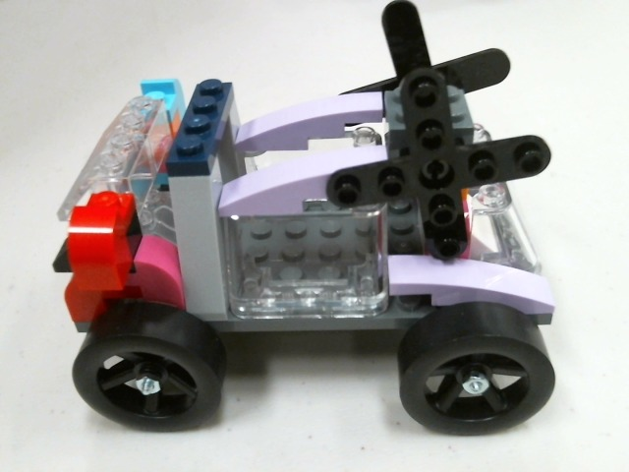
Step 2

Check in online



UtahValleyPinewoodDerby.com
Step 3

Race your car!

Lots more info and live results available at:

UtahValleyPinewoodDerby.com

Rules

- Return all Legos and cars when finished
- Do not cross the rope or cones

