[Your group name] Pinewood Derby

[Location]
[Date] [Time]
Check-in begins 10–20 minutes prior

Car specifications:
- Maximum weight: 5 ounces
- Maximum height: about 6 inches
- Maximum width: 2-3/4”
- Maximum length: 7”
- Leave 3/8” clearance under the car (important!)
- Leave 1-3/4” clearance between wheels
- Graphite is the only allowed lubricant
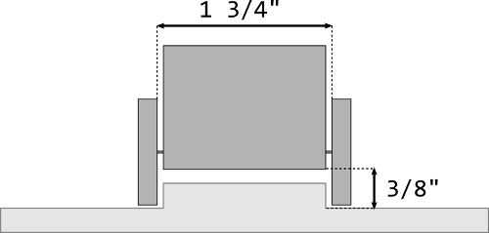

Build instructions:
- Carefully and squarely, drive the provided nails into the slots in the block of wood, then remove them with needle nose pliers. This will make assembling the wheels later much easier.
- Sketch the shape of your design onto the block of wood.
- Gently secure your car with clamps and cut out the design. Use a carving knife to add details. Grown-ups should help with power tools.
- Sand with 120-grit sandpaper until smooth.
- Paint, decorate, add stickers, or even add a driver to your car. Be creative.
- Attach the wheels and weights.

More information: https://utahvalleypinewoodderby.com/participants

