Internal Standard – Oasis

v 1.1 – March 15 2020 – E. Marceau
v 1.2 – July 12 2020
v 1.3 – November 3 2020

Site Configuration Guide

–

User Interface – MATE Panels

User Interface – MATE Tweak

User Interface – Windows

User Interface – Languages

** INCOMPLETE **

MATE Desktop – Panels – Lower

The lower “Panel” is where MATE shows:

- the applet for the “Window List”, which displays icon buttons for making selections to set the active window/application.
- the applet for the “Workspace Switcher”.

If these are ever lost, doing right-click on the lower panel will display a menu. From that menu, select “Add to Panel”, which will display a window with the list of available applets that could be added to the panel:

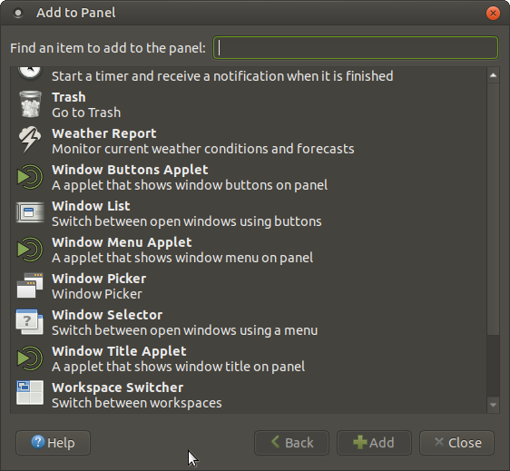
To add any applet, click on the item listed, then click on “+Add”. You can then click on the applet which was added to the panel and right-click to obtain the menu that will allow adjustment of the applets placement on the panel.

MATE Desktop – Panel Applet – Workspace Switcher

To customize the “Workspace Switcher”, right-click anywhere on the switcher icon then select “Preferences” from the options listed. The following will be displayed:

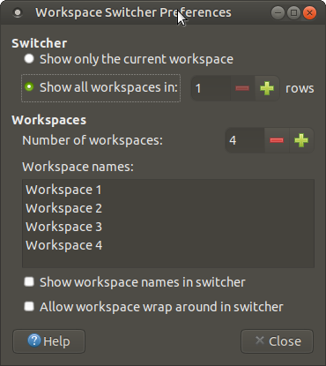

In this pop-up, you can change

- the number of rows,
- the number of workspaces,
- the names assigned to the workspaces, and
- the display and behaviour of the switcher.

MATE Desktop – Panel Applet – Window List

To customize the “Window List”, right-click on the vertical 3-dot at the far left of the applet, as seen here,

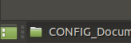
then select “Preferences” from the options listed. The following will be displayed:

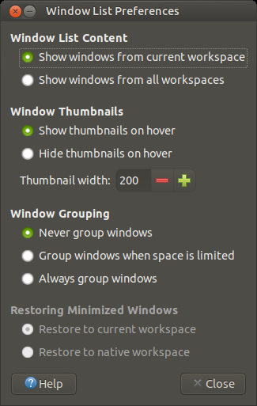

The default settings shown above are usually best left unchanged.

MATE Desktop – Desktop Panels - Upper

The upper “Panel” is where MATE shows:

- (at the far left) the applet for the “Brisk Menu Launcher”, which
displays icon buttons for various system applications, utilities
and preference customization tools.;
- (at the far right) the applet for “Clock” and “About”;
- (next from right) all registered notifiers for various applications,
such as for email or internet status; and
- (all others) applets which open various installed applications.

If these are ever lost, doing right-click on the upper panel will display a menu. From that menu, select “Add to Panel”, which will display a window with the list of available applets that could be added to the panel:

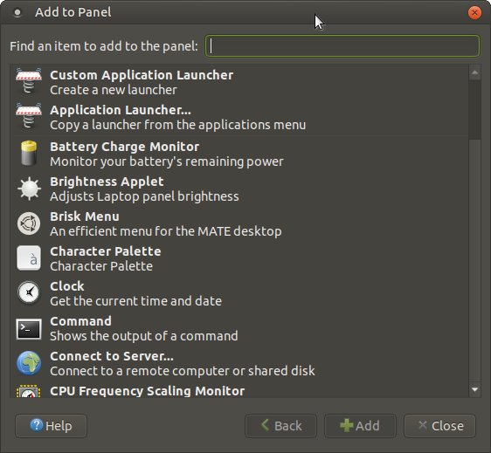
To add any applet, click on the item listed, then click on “+Add”. You can then click on the applet which was added to the panel and right-click to obtain the menu that will allow adjustment of the applets placement on the panel.
For simplicity, we have captured a snapshot of segments of the Upper Panel, so as to give a visual representation of the current customized configuration of that panel.

Far Left:

Middle:

Far Right:

Pop-up Notifications (From Control Panel): New vs Old
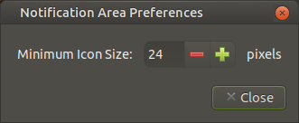
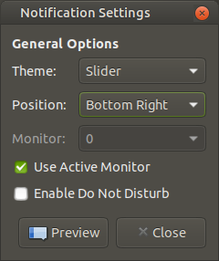

MATE Tweak – Desktop icons

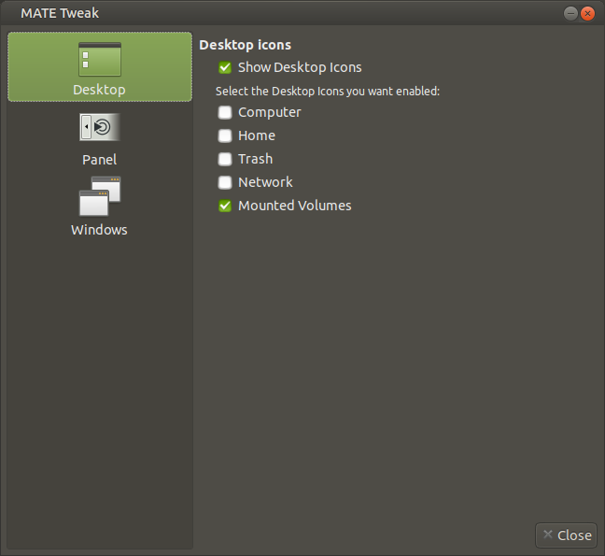

MATE Tweak – Panels

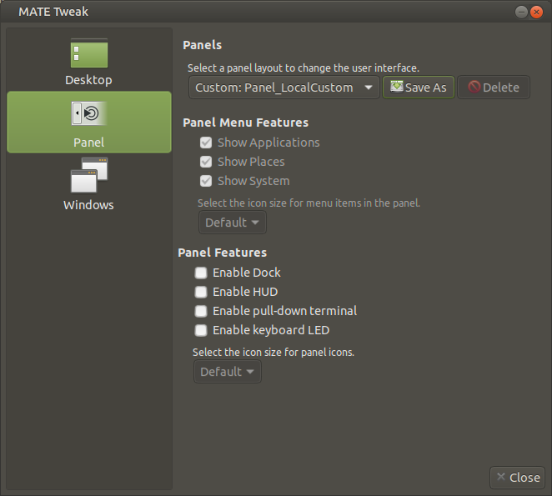

MATE Tweak – Windows

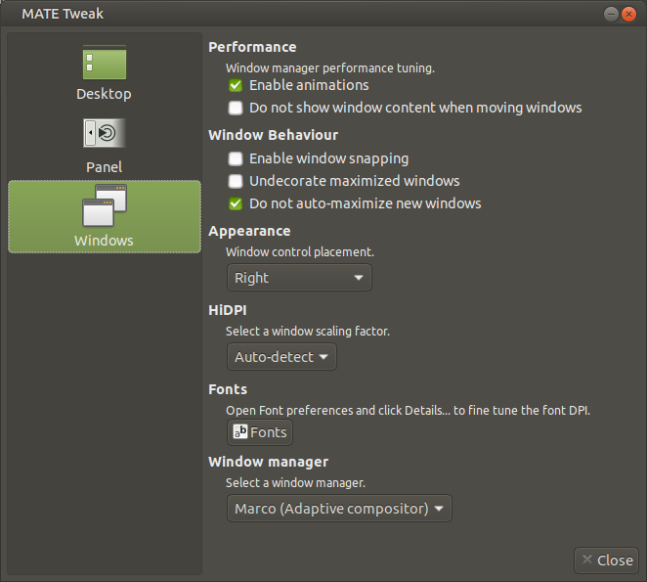

NOTE: Fonts are not managed here. That function is best performed and documented under the Appearance function in the Control Panel.

NOTE: Installation default Window compositor is:

“Marco (Adaptive compositor)”.

Above shows local custom selection.

MATE Desktop – Popup Notifications
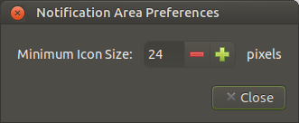
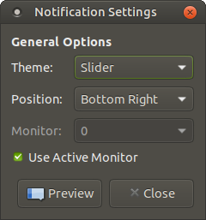
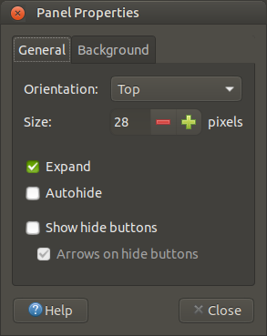
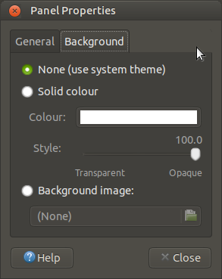

Window Preferences – General

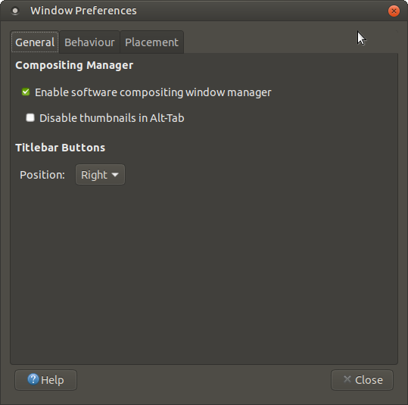

Window Preferences – Behaviour

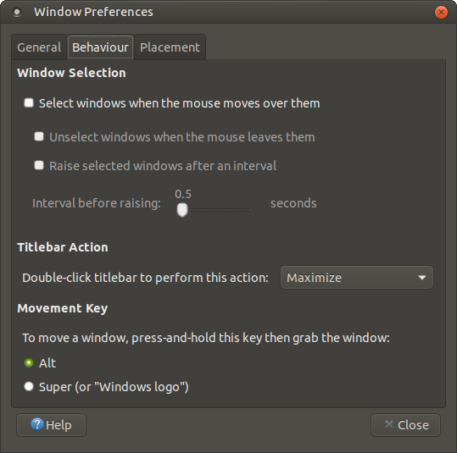

Window Preferences – Placement

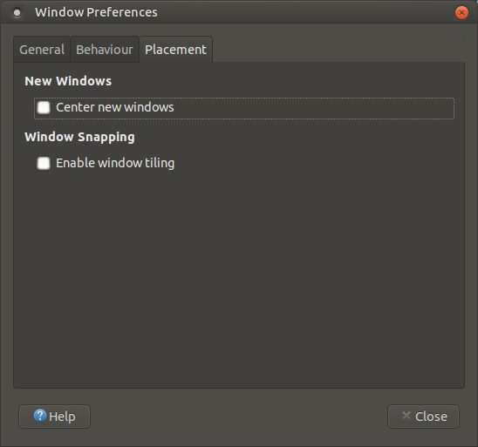

Language Support – Language

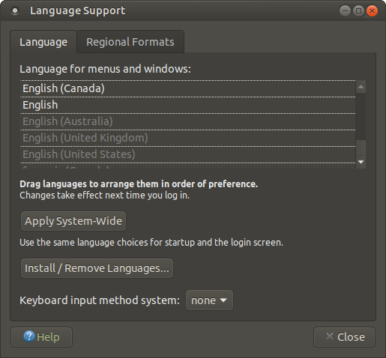

Language Support – Regional Formats

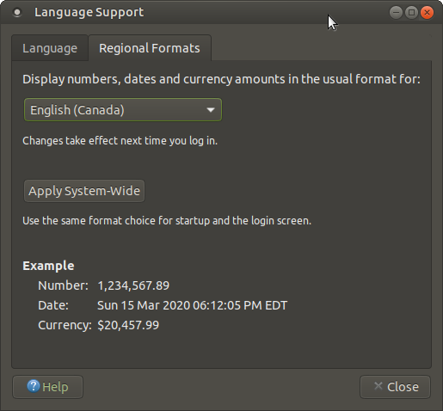

=== END ===

