Internal Standard – Oasis

v 1.0 – June 11 2019 – E. Marceau
v 1.2 – July 3 2020
v 1.3 – November 3 2020

Site Configuration Guide

–

OS Admin – Software & Updates

*** FUTURES: merge with synaptic

Settings – Preferences – Ubuntu Software

IMPORTANT:
The internet connection must be live to ensure that the steps outlined in this process may be completed successfully.

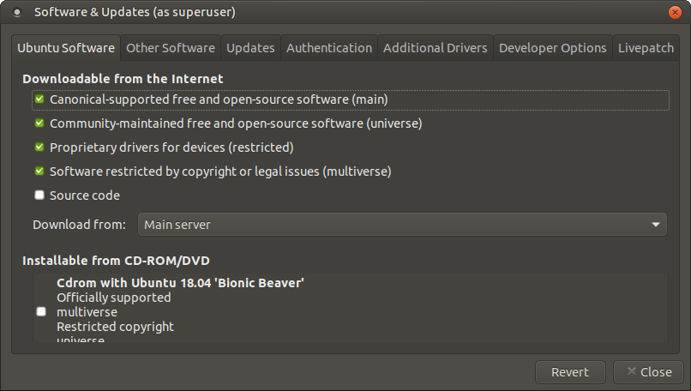

Settings – Preferences – Other Software

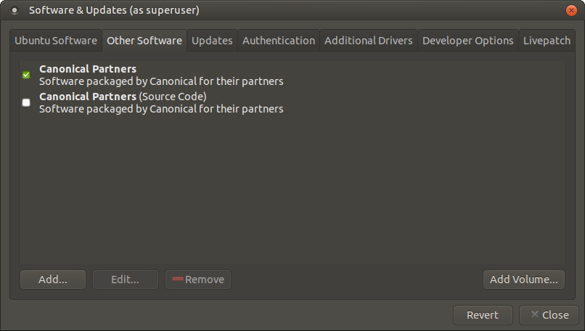

Settings – Preferences – Colour

Ubuntu 20.04 LTS
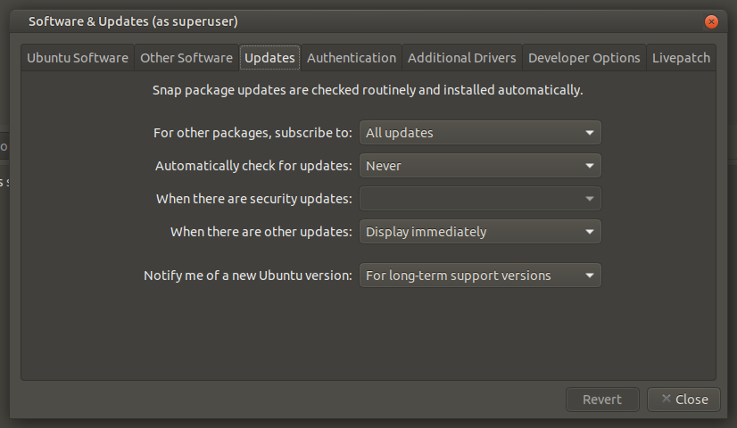
Ubuntu 18.04 LTS
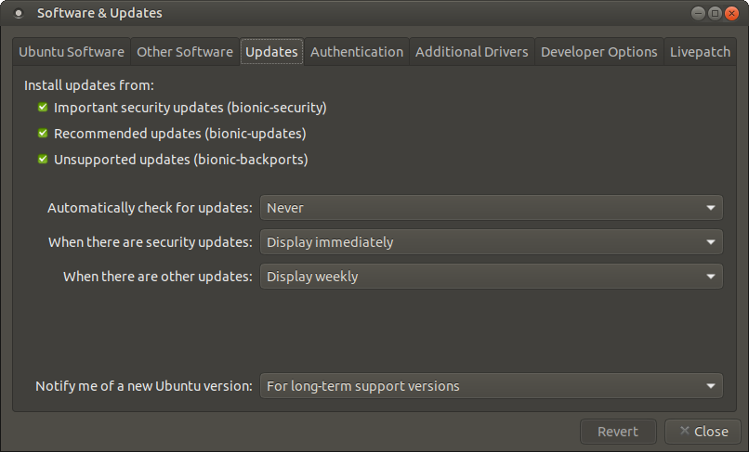

Settings – Preferences – Authentication

Ubuntu 20.04 LTS
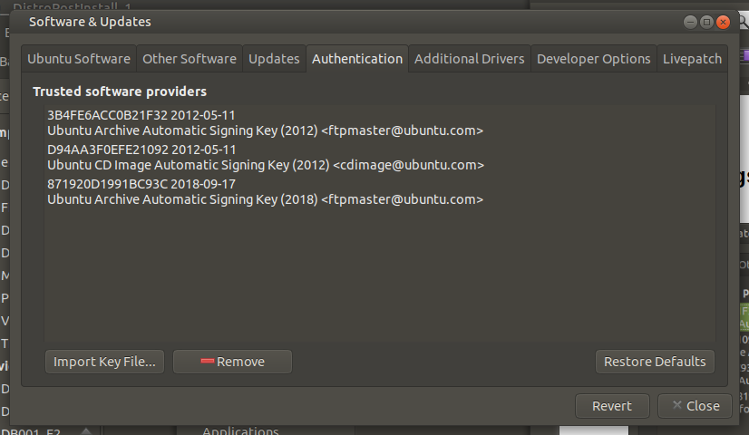

Settings – Preferences – Additional Drivers

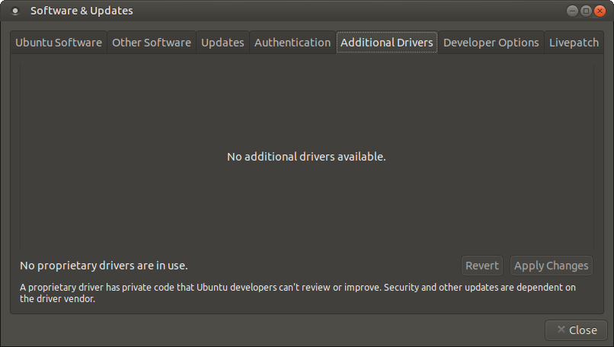

Settings – Preferences – Developer Options

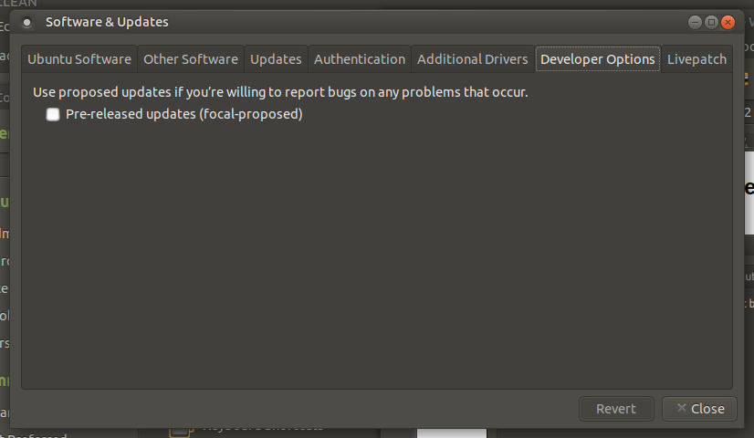
Note: Due to lack of stability, local site policy to never use packages at the “focal-proposed” status.

Settings – Preferences – Livepatch

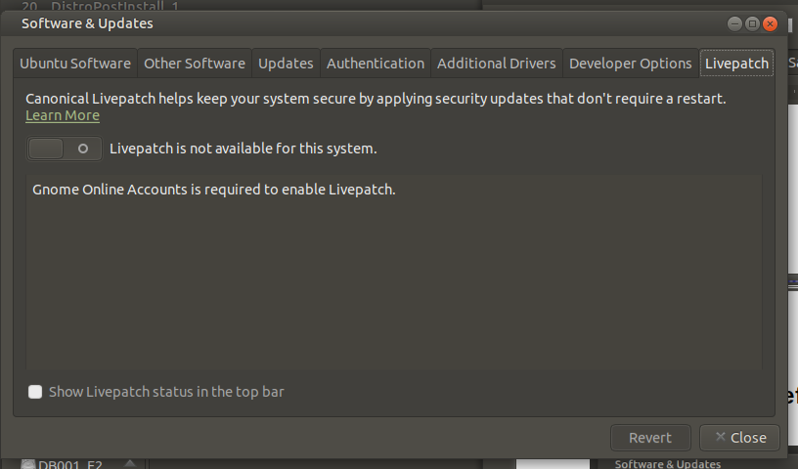

=== END ===

