<<Project Name>>

Project Statement

Version: 1.0
Issued: <<insert date>>
Status: Draft
Approved: No

Amendment History
Version Number | Description of Change | Person Making Change | Date | Reviewed by | Approved by
1.0 | Initial Release

Distribution List
Title
Project Owner
Project Director
Project Manager
Project Stakeholders
PROJECT STATEMENT
TABLE OF CONTENTS
1. Summary 1
1.1. Executive Summary 1
1.2. Primary Success Criteria 1
1.3. External Factors 1
2. Project Description 1
2.1. Project Context 1
2.2. Project Objectives 2
2.3. Project Scope 2
2.4. Assumptions and Constraints 2
2.5. Relationship to Other Projects 2
2.6. Project Risks 2
2.7. Project Impacts 3
2.7.1. Execution Impacts 3
2.7.2. Solution Impacts 3
3. Project Plan 3
3.1. Project Strategy 3
3.1.1. Methodology 3
3.1.2. Deliverable Review Process 3
3.1.3. Quality Process 3
3.2. Project Organization 3
3.2.1. Organization Chart 4
3.2.2. Roles and Descriptions 4
3.3. Project Schedule 6
3.3.1. Work Schedule 6
3.3.2. Reporting and Reviews 6
4. Project Resources 7
4.1. Human Resources 7
4.1.1. Resource Plan 7
4.1.2. Training Plan 7
4.2. Environmental Resources 7
4.3. Other Resources 8
5. Project Deliverables 8

Summary

Executive Summary
<< Summarize the contents of the Project Statement. Identify :
- project name
- key players:
- Project Owner (Who is sponsoring this Project?)
- Project Director (Who will be responsible for determining project success?)
- Project Manager (Who will be responsible for executing the project?)
- Technical Lead (if appropriate)
- Business Lead (if appropriate)
- Project essence - salient points for the overall project
- Major project phases (if phased)
- Major project deliverables (List between 5 and 10 of the most critical deliverables)
- Top-Level Project Schedule (Start and End Date for each Phase and Planned date for major milestones)
- Top-Level Project Budget (Cost estimates in dollars and/or person-days by phase)
- Major Benefits the project will deliver – three to five of the most important>>

Primary Success Criteria
<< List primary goals to be met for the project to be judged a success. Include 3 or 7items expressed as results or effects perceptible to and measurable by the user. Be sure to identify constraints that may be critical such as delivery date or cost ceiling. >>

External Factors
<< List those items outside the direct control of the Project Director, Project Manager and Technical Lead or Business Lead, but that need to meet specific conditions such as resources being available at a specified time or foundation documents meeting measurable quality factors for the project to meet Primary Success Criteria. These items will be monitored throughout the project and escalated as issues if they may influence or impact the project’s ability to meet expectations. >>

Project Description
<< Outline the project business solution. >>

Project Context
<< Situate the project -- identify the context of the project...ie. Why is the project is being initiated? Include historical items of major interest. Often this is the problem or situation that caused this project to be initiated. Describe the required outcome in business terms in two or three sentences. >>

Project Objectives
<< Detail the objectives of the project. Objectives should be
- Directly achieved as a result of this project; and,
- Quantitative (observable and measurable).
Specify (where possible, in numerical terms) exactly what the project will deliver and what benefits will derive. >>

Project Scope
<< Detail the boundaries within which the project will operate or within which the solution will be developed. Limit the reach and impact of the project and its solutions. State what areas the project will and will not cover. Document features or functions that are to be included in the product or service to be delivered. Identify the major work elements that must be done in order to deliver the product or service. Reference any previous requirements statements previously developed and signed off by the client. >>

Assumptions and Constraints
<< This section lists and describes any assumptions under which the project is being executed (eg. the availability of business resources) as well as any constraints which may effect any of the events of the project, such as the technology or client environment. Constraints are factors that will limit the team’s options. Assumptions are factors that, for planning purposes, will be considered to be true, real or certain. It is important to identify these up front as they need to be validated and all those involved in the project made aware of them. Be sure to include all relevant External Influencing Factors (Section 1.3) and Project Scope items (Section 2.3) >>

Relationship to Other Projects
<< Identify the relationships of this project to other initiatives. Include other projects being undertaken by the client organization or by external organizations. Describe in detail the relationship to each of these projects. Include: schedule dependencies; technical dependencies; resource dependencies; etc… Note, some items from External Influencing Factors (Section 1.3); Project Scope (Section 2.3) and Assumptions and Constraints (Section 2.4) will most probable appear again in this Section. >>

Project Risks
<< Describe risks and exposures relating to the project (eg. tight timetables, introduction of new technology). Address how these specific risks will be managed. Be sure to include an estimate of the Probability of the risk occuring and an estimate of the impact on the Project should the risk occur. These items will form the baseline for the Risk Management activities for the Project. >>

Project Impacts

Execution Impacts
<< Describe all major impacts that executing this project may have on the organization including existing projects, current plans and budgets. Detail impacts on the Project Owner’s business plans including the impact on the Project Owner’s resources. >>

Solution Impacts
<< Outline expected long-term impacts the solution once the project is completed should have on the Project Owner’s resources - ie. human resources, head counts, accommodations, equipment, user skills, procedures, training etc.. Although covered in more detail as a project deliverable - this section is to give an indication of what is in store for the organization as a result of this project. >>

Project Plan

Project Strategy
<< Describes the fundamental approach to successfully delivering this project. Is it phased? Will the implementation be “big bang?” Will the implementation be phased? Will there be more than one system operating concurrently for a certain period of time? Is the project a “fix” to a current system? Is it a replacement to a current system? Is it a totally new system or application? >>

Methodology
<< What methodology will be used to execute the project? Is it a RAD? Will a prototyping approach be used and if so how will the number of sessions be controlled. Will the project employ a P+ coach? Will the project employ a Pilot team approach to “trail blaze” certain parts of the solution ? etc. >>

Deliverable Review Process
<< Describe how project deliverables will be reviewed and signed off. Include who; how long; and, change procedures. >>

Quality Process
<< Define the Quality Management that will govern this project. Identify who will be the Quality Manager for the project. Identify which deliverables will specify the quality management responsibilities and authorities of the other project. >>

Project Organization
<< Tailor the following sections. Note that the titles that appear in the diagram should match up with the Role Descriptions which follow the diagram and the Roles used in 4.1 Human Resources .>>

Organization Chart
<<Double click on this Powerpoint chart to fill in the name and tailor it to suit the organization for this project>>
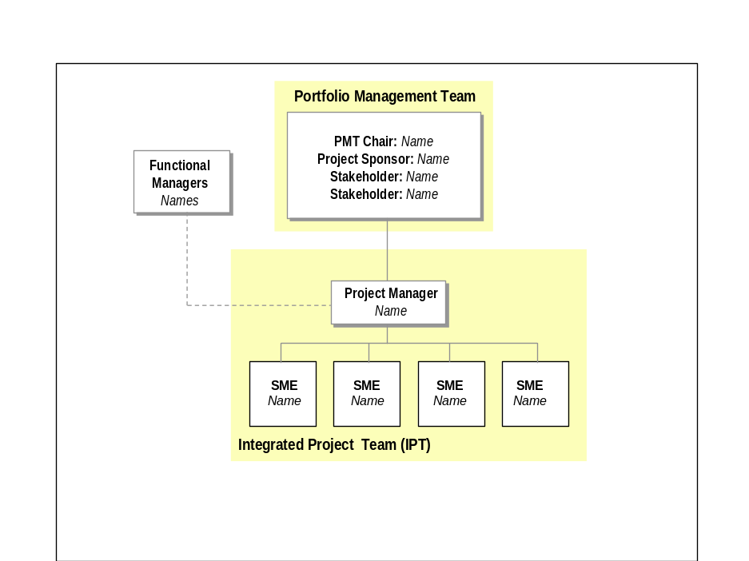

Roles and Descriptions
Portfolio Management Team
The Portfolio Management Team (PMT) determines the overall objectives and scope of the project, resolves conflicts if they arise, and accepts the project deliverables. The responsibilities of the PMT include: <<The following list provides an indication of the types of responsibilities which may be applicable to this role. Add, change or delete as required>>:
- Sign-off on the scope of the project as documented in the Project Statement;
- Review and external (formal and contractual) signs-off on all project deliverables;
- Resolving issues escalated by the Project Manager or Project Sponsor - escalating items to the Steering Committee as required;
- Resolving Change Requests with the Project Sponsor and endorsing those resolutions to be raised for tabling at the Steering Committee;
- Responsibility for the project budget;
- Accountability for realising the benefits of the project; and
- Communicating progress/directions of the project to the Organization.
Project Sponsor
The Project Sponsor will have overall responsibility for the success of the project and will ensure the quality of all deliverables. The responsibilities of the Project Sponsor include: <<The following list provides an indication of the types of responsibilities which may be applicable to this role. Add, change or delete as required>>:
- Gaining BDP approvals (Opportunity, Definition & Close-Out) from the PMT;
- Providing internal project/deliverable sign-off and acceptance;
- Internal approval of changes to project scope and budget;
- Reviewing project status reports;
- Providing direction and guidance on project related issues, including helping to resolve those that are beyond the authority of the Project Manager;
- Facilitating the project team’s access to key resources outside of those controlled by the project;
- Providing advice and guidance to the project team;
- resolving the day-to-day issues brought to his attention by the Project Manager - escalating to the ProjPMTwhen required;
- Ensuring the project has access to sufficient resource to adequately staff the project phases;
- Internal sign-off project deliverables;
- Resolving potential Change Requests differences between the PMT and the Project Manager.
Project Stakeholders
The Stakeholders will monitor the conduct of the project and provide guidance to the PMT and the Project Sponsor/Manager. The Stakeholders will facilitate resolution of any problems or issues. The Stakeholders authorize and approve project deliverables – though, this is in practice delegated to the PMT. The responsibilities of the Stakeholders include: <<The following list provides an indication of the types of responsibilities which may be applicable to this role. Add, change or delete as required>>:
- Reviewing progress of project against plan;
- Reviewing financial status of project (actual to budget);
- Acknowledging the PMT’s approval of project deliverables;
- Assisting in mitigating project risks;
- Managing the dependencies of this project with other projects;
- Ensuring, where required, effective vendor management;
- Reviewing issues raised and agreeing action plans for their resolution;
- Continual monitoring the applicability of project benefits; and
- Approving Change Requests that adversely affect COST, SCHEDULE or anticipated BENEFITS.
Project Manager
The responsibilities of the Project Manager include: <<The following list provides an indication of the types of responsibilities which may be applicable to this role. Add, change or delete as required>>:
- Responsible for the timely and satisfactory completion of the Project;
- Reporting to the Project Sponsor on a regular basis;
- Reviewing all project deliverables;
- Managing the project budget;
- Facilitating the project team’s progress in the analysis and production of the project deliverables;
- Managing all project issues;
- Reporting project status, financials and risks;
- Establishing the Project Statement;
- Obtaining sign-off of all project deliverables;
- Managing the Project Team;
- Organising deliverable reviews;
- Ensuring the project team follows project standards;
- Maintaining the Project File;
- Managing all day-to-day issues - escalating to the Project Sponsor/PMT when required; and
- Raising Change Requests.

Integrated Project Team Members

Project Schedule

Work Schedule
<<Tailor the following table to reflect the number of phases, resources and weeks involved. Change Wk1, Wk2 etc to show the date of the weeks, or months as appropriate. Align the time periods boxes (ie the grey areas in the table) for each phase/resources to the appropriate weeks/months by clicking on the Drawing Icon, and either create new boxes or click on any of the existing boxes to move or re-size.>>

 | Project Phases/Milestones  (or resources if more applicable) | Wk 1 | Wk 2 | Wk 3 | Wk 4 | Wk 5 | Wk 6 | Wk 7 | Wk 8 | Wk 9 | Wk 10
1 | Phase 1 description/Resource Name
2 | Phase 2 description
3 | Phase 3 description
4 | Phase 4 description
5 | Phase 5 description
6 | Phase 6 description

Reporting and Reviews
Monthly Status Reports
During the project, the Project Manager will prepare a monthly project status reports. The Project Status Report is the prime vehicle for project monitoring, reviews and formal communication between all parties. The Monthly Project Status Report is an Internal Deliverable posted by the Project Manager and reviewed by the Project Sponsor & PMT.
PMT Meetings
The PMT will meet <<monthly/quarterly/annually>> and is the prime decision and issue resolution forum. All Project Status Reports will be tabled prior to meetings of the PMT. Formal minutes from all PMT meeting decisions and associated action items are required. The minutes are to be created by the PMT and must be approved by all members of the PMT and posted in the BDP Log.

Project Resources

Human Resources
<<Use the following sections. The roles that appear in this table should match the roles as described in the Project Organization document/section 3 above>>

Resource Plan
Role | Number of resources/ Name | Start Date | End Date | Percentage Utilization | Organization

Training Plan
<<Options for training plan are:>>>
No specific training requirements have been identified to complete this project.
<<OR>>
To meet the specific requirements for skills to complete this project, the following training is required:
<<Name of resource - name of training>>

Environmental Resources
<<Use either the following statement or tailor the subsections and words, as applicable.>>
No particular environmental resources have been identified for this project.
<<OR>>
Project Accommodation Requirements
<<List as required>>
PC Requirements
<<List as required>>
Printer Requirements
<<List as required>>
Photocopying Requirements
<<List as required>>
Fax Requirements
<<List as required>>
Other Requirements
<<List as required>>

Other Resources
Travel and Accommodation Requirements
<<List as required>>
Relocation Requirements
<<List as required>>

Project Deliverables

ID | Deliverable Name | Frequency | Author | Reviewer | Approver
01 | Project Statement | Project Conception with update at Project Initiation and as required. | Project Manager | Project Director | Project Owner
02 | Project Budget | Project Initiation update as required. | Project Director | Project Owner | Steering Committee
03 | Project Schedule | Project Initiation update as required. | Project Manager | Project Director | Project Owner
04 | Status Report(s) | Monthly | Project Manager | Project Director | Project Owner
05
06
07
08
09
…

