 | Quality Standards
Gating - Short Guide
UNCONTROLLED COPY
Refer to Electronic File for Definitive Version
Document Reference Number: | is/04-01
Issue Number: | 01-03

Owning Organization: Information Services
Issue Date: 18-Dec-97

Copyright © Nortel 1997
Distribution: IS staff through access to electronic file at http://47.100.67.54/
Requests for change to this document should be sent to the owning organization, giving details of the proposed change and the reason for making the change.
Document Control Sheet(s)
Gating - Short Guide
Document Reference: | is/04-01 | Issue Date: |  | 18-Dec-97
Issue Number: | 01-03 | Effective Date: |  | as above
Compliance: | Guidance | Review Period: |  | 12 Months
Security: | No Classification | Status: |  | Draft
Distribution: | No Restriction

Author: | Melvin Steele, IS
Contributors: | IT Quality Councils
Owning Organization(s): | Information Services
Other Organizations Affected:
Authorizer:

Change/Review/Approval History
Updated Issue Number Name/Date | Reviewed  Initials/Date | Authorized  Initials/Date | Changes
01-03 mes/18-Dec-97 | CH |  | Doc. Based on ges/04-01, change  due to re-org.
01-02 jmh/27-Jun-97  mes/30-Jun-97 |  | Dave MacPhee | Apply GES Documentation Standard format to this document. Add reference to overview template & PRISM system.
01-01 mes/25-Mar-97 | GES QC | D.MacPhee | Gate review process added (action for GES QC approval)
01-00 mes/21-Feb-97 |  |  | Minor changes from cabinet review
00-04 mes/03-Feb-97 | ESS Cabinet |  | Gate representation and exit tightened
00-03 mes/30-Jan-97 | ESS in Audio  3-Feb-97 |  | Initial feedback incorporated
00-02 mes/24-Jan-97 | +ESS Team  Jan 1997 |  | Owner/template and other changes
00-01 mes/15-Jan-97 | MJW/SB/RN |  | Updates and replaces ess/01-20 and ess/01-21 (QSD0009)

Table of Contents
Section 1- Preface
1.1 Summary
1.2 Purpose
1.3 Scope
1.4 References
Section 2 - Introduction
Section 3. - Gating - Overview
3.1 What is Gating?
3.2 Why Gate a Project?
3.3 Roles & Responsibilities
3.4 The Project File
3.5 Where To Start?
Section 4 - Gate Details - Quick Reference
4.1 Gate 0
4.2 Gate 1
4.3 Gate 1a (& 1b)
4.4 Gate 2
4.5 Gate 3
4.6 Gate 4
4.7 Gate 5
Section 5 - Gate Review/Approval Process

Section 1- Preface

1.1 Summary
This document describes the gating process as applied within IT.

1.2 Purpose
The purpose of this document is to present a simplified version of Corporate Gating, using IT terminology and practices, and to act as an introduction (section 3) or refresher guide (section 4) to employees involved in projects that should be gated. Suggestions exist in Section 5 for the gate review/approval process.

1.3 Scope
This document is derived from earlier issues that applied to members of GES, now in IS or GPN Services groups, collectively refered to here as “IT”. It applies to those involved with projects/programs, in particular, Project Managers, Quality Primes, and review team members.
This document does not replace the Corporate Gating Process. If sufficient detail cannot be found here, the reader must refer to higher/corporate level documentation (additional corporate procedures apply for software projects - see references).

1.4 References
For additional information, reference the following documents:
- EMIS, Enterprise Management Information System at http://47.100.67.54/
- aqms/01-01 Quality Manual
- aqms/01-06 Development and Support Services
- aqms/02-06 Creating and Reviewing Documents
- Templates, Project templates defined for use within product groups for the specific type(s) of project they deal with can be found from the EMIS under “templates” at http://47.100.67.54/template.html
Corporate/IS References:-
- Corporate/Business Solutions Gating, A Nortel program sponsored by IS
at http://47.126.17.17/gate/gating.shtml
Handbook, Client Guide, templates & other material are available at http://47.126.17.17/gate/gating_docs.shtml
[or FTP/Fetch from the Nashville Server (47.158.0.16)
login: wise
password: anonymous
Path: 5_IS_Processes_Procedures/Gating]
- Corporate Standard, 1520 (replacing CS136.00) Gate Deliverables Manual
see list at http://47.118.128.228:8080/standards/docs/index1.html
- Renaissance Keep up to date with latest project management practices at http://47.201.0.75:8080/renaissance/

Enterprise Networks & GPN Services References:-
- PRISM the GPN Services Project Reporting System at http://47.173.32.36:8080/gesquality/projects.html
- GPN Services Project Overview Template can be found via the PRISM Web page at http://47.173.32.36:8080/gesquality/projover.ppt
- GPN Services Project Index, Lists of projects and sponsors in GPN Services at
http://47.173.32.36:8080/gesquality/97gesprojects/gating_summary.html
- GPN Services New Product Introduction at
http://47.173.32.36:8080/gesquality/97gesprojects/npi/
- Enterprise Networks, New Product Introduction Process at
ftp://47.158.0.16/DOCUMENTS/PRIVATE.NPI/NPI.Process.Issue.2.0
/Process.documentation/
File: RTF.NPI.doc.2.0.txt
[or FTP/Fetch from above path from the Nashville Server(47.158.0.16)]
login: anonymous
Path: DOCUMENTS/PRIVATE.NPI/NPI.Process.Issue.2.0
/Process.documentation
File: RTF.NPI.doc.2.0.txt]

Section 2 - Introduction
Most activities in IT fall into three categories.
- Regular activities that support ongoing service. These are described by specific EMIS documents.
- Projects - IT management require all projects be gated.
IT projects can usually be classed into the following types:
TYPE | DESCRIPTION
Alignment | Introduce standard services to existing customers
Development | Verify/justify new technology, systems and services
Process Improvement | Re-engineer processes to improve service
New Business Integration | Introduce standard services to new customers
New Product Introduction | Introduce new services to the service portfolio
When complete, all projects require process and procedural documents be registered in the EMIS as part of the deliverable to implement the new service routinely as described in Section a) above.
The production and maintenance of controlled documents can also be completed with a gating approach (see aqms/02-06).
- Maintenance activities - continuing service with minimum/no impact to the customer.
This may involve special planning as part of a key process (e.g. major moves or network planning), or be a reaction to short-term situations. A decision not to use formal gating under these circumstances is part of the management process.
In all activities, general principles of project/change management are expected to be followed (agree customer requirements, involve stakeholders, make & keep records etc. etc.).

Section 3. - Gating - Overview

3.1 What is Gating?
Gating is a quality checkpoint process that occurs at the end of each phase of development in a project or program. Known for some time as “Quality Gating”, it is now renamed “Business Solutions Gating”.
All Phase deliverables come under review as part of each “Gate” so that the project can “pass” (cleanly or conditionally) to the next Phase. If, at the Gate Review deficiencies in the required Phase deliverables, the project team must go back to address these and reschedule the Gate Review.
Stages of Gating
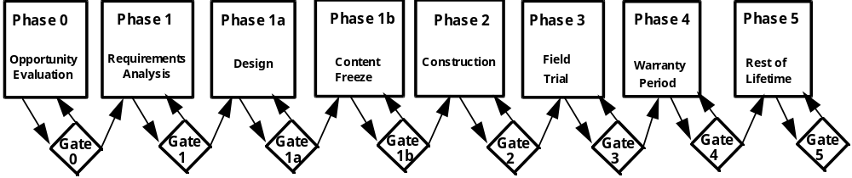
A quality check, known as a Gate Review, must occur at the end of each Phase with the project team members and the executive stakeholders.
Implementation of the Gating Process is not intended to be rigid but should follow the basic defined steps with defined pass/fail criteria. (N.B. Phases 1b and 5, and Gates 1b and 5 are optional additions to the present corporate set.)

3.2 Why Gate a Project?
Several reasons exist why IT should use gating for projects:
- Project management improves quality of the deliverables.
- Structured documentation and formal communication provides a forum to communicate highlights and issues to upper management.
- Customer requirements and expectations are clearly understood by all parties (particularly the cost and timing that the customer is prepared to accept). The project life cycle is also better understood.
- Gating assures that all stakeholders are included in decision making and agree with and understand the project and its implications for them.
- Partnerships are fostered with the customers through their role as systems owners and their responsibility for some deliverables.
- Development and maintenance costs are reduced since,
- Projects out of control are prevented from continuing to the next phase of development
- Detailed planning and analysis are required in the first 3 phases preventing rework later.
- Gating positions us to conform to Corporate and international quality standards such as ISO 9000.

3.3 Roles & Responsibilities
The Project Manager is appointed by the Cabinet Member to run the project. The Project Manager is responsible to the stakeholders for effective coordination, planning and management of the project and for applying appropriate management processes.
The Project Manager has responsibility for the following:
- Reviewing budgets against the business case with the Director
- Identifying and securing resources
- Managing day-to-day running throughout the project’s life cycle
- Developing the project file
- Defining and assigning additional roles
Projects may require a number of sub-projects. Each sub-project will have a prime who is responsible to the Project Manager. Each prime will have responsibilities as agreed with the Project Manager.
Project Primes have responsibility for the following,
- Understanding the Gating Process and procedures
- Promoting and supporting Gating within IT
- Establishing gating levels and procedures commensurate with the project size and complexity
- Assisting the core team and stakeholders to understand the gating process and its application
- Participating in Gate reviews (and facilitate if required)
- Performing pre-Gate Quality Assessments
For terms and descriptions of other specific roles that may be appointed, reference the overview section of the corporate document (found at the URL http://47.126.17.17/gate/handbook_06.shtml).

3.4 The Project File
The “Project File” refers to an electronic folder accessible through Netscape or ftp that, contains or leads to all related project material: Examples of items to include on the “Project File” include, but are not limited to, the following::
- The Project Quality Plan
- The gating records - These include the gating “templates” which are completed and updated throughout the project along with updates of the project plan.
- Items supporting or referenced from the above (e.g. gate review slides, minutes, decisions etc. - or a record of location within a controlled source - sufficient to locate these)
- E-mail records, or other form of voting data, from each member of the gate review team supporting recorded gating decisions
The folder can be on any suitable server that is FTP accessible via the location listed in an IT project index (see references). Permissions will be set to require passwords if appropriate to the project.

3.5 Where To Start?
First ,determine the magnitude of the project. The correct level of gating must be applied, the project team established, the gating review teams established and the actual gates defined (e.g. combine gates 0 & 1?).
Determine if your group already has a defined template established for the type of project you are undertaking.
If not, see if other groups have put templates in the EMIS for a similar type of project.
Templates are checklists of generic project items and, when complete, become gating records.
If specific templates are not in use, start with the GPNS/IS generic set in the EMIS.
Can you use or adapt one of these to best suit your project?
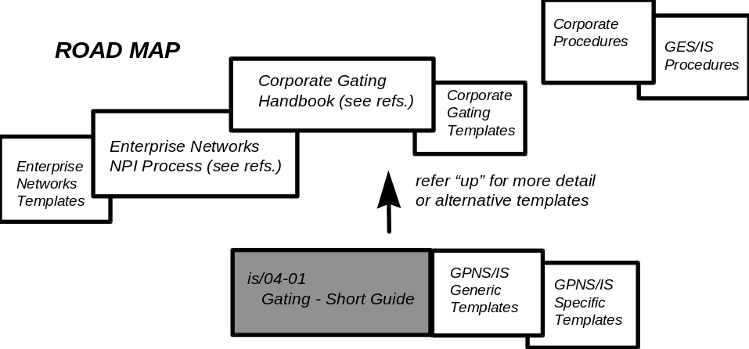
Be aware that although specific templates save you preparation time, they are not necessarily complete for your exact purpose. Review the template you propose to use against
- The notes on gate details in the next section
- Related GPNS/IS processes
- Any additional project guidance material in higher/corporate level documentation - as appropriate to the level of template you propose to use (see references)
Draft material used in later gates may need revision due to findings in earlier gates.
Make changes to deliverable lists with extreme caution, since the schedule and other commitments may be invalidated by the inclusion of additional deliverables after the initial commitment has been made. This is especially important after Gate 1, since that gate typically commits large amounts of resources for the following design/construct/acquire/test phase.
If a particular template you develop is seen to have good re-use value, put it in the EMIS !
Submit a title and project file address via your Quality Prime so that it goes into the project index.

Section 4 - Gate Details - Quick Reference

4.1 Gate 0
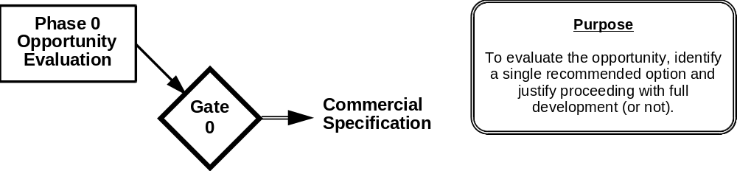

Key Players  Budget holder  - Accept case & set evaluation budget  - Appoint project manager  Customer & Client Manager  - Nortel/external initial customer contact  - Initial requirements  - future protocol  Project Manager  - Identify/secure & review resource needed to deliver evaluation | Key Deliverables  Business  - Business Case ( Cost/Benefit Analysis - see GES and corporate templates for this)  - List of stakeholders, resources & targets for next phase  - Commercial/User Requirements  Technical  - Current system/process analysis  - System context & objectives  - Conceptual model of proposed system  - Technical feasibility results  - Recommended solution and costs  Project Management  - Project file, overview and project plan  - Defined deliverables, representation & pass criteria of next phase
- Major Activities  - Determine cost effectiveness  - Determine user requirements  - Analyse current system/process  - Define system context & objectives  - Construct & document conceptual model  - Determine technical feasibility  - Recommend solutions and costs  - Establish a project file | Processes Followed  - New Business Evaluation  - Project Gating
At the beginning of Gate 0, the budget holder judges the case for evaluation. A budget is established based on the likelihood of initial and further development being funded from the customer, and based on marketing, other information and the directly expressed business need. The budget holder, or appropriate Group Manager, will also appoint a Project Manager and initial project team.
Project team members work to clarify, agree and document the initial requirements (with marketing, account managers etc. as appropriate) such as project scope, protocol for levels and routes of GPNS/IS and customer contact etc.

4.2 Gate 1
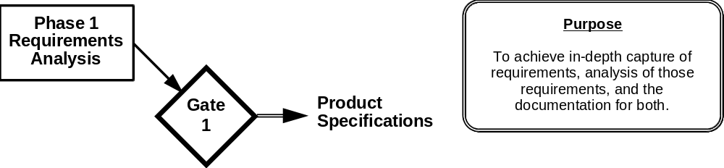

Key Players  Account management  - Further Nortel/external customer contact  - Requirement details  - expected service levels & pricing  Project Manager  - Coordinate resource activities/impacts needed to deliver analysis  - Review project budget with GES director  Development Prime/System Analyst(s)  - Analyse details | Key Deliverables  Business  - Updated cost/benefit study  - CFAs  - List of stakeholders, resources & targets for next phase  Technical  - System requirements document  - Conceptual model of system  - Data conversion and integration plan  - General system design  - User acceptance & system test/benchmark plans  Project Management  - Updated project file and project plan  - Confirm deliverables for this phase and define deliverables, representation & pass criteria of the next phase
- Major Activities  - Update cost/benefit study  - Determine detailed system requirements  - Determine data conversion requirements  - Define complete conceptual model  - Construct the general system design  - Draft User Acceptance & System Test plans  - Update the project file | Processes Followed  - New Product Development  - Project Gating
After evaluating the opportunity, the exact requirements needed to meet all deliverables are identified and the feasibility established. Details are gathered to enable specification of the expected level of service, IT operational requirements, and who will provide what, (which includes identifying the requirements on each IT product group and on the customers).
Identify everything that is needed to bring out all the end-to-end issues - from basic models, through hardware and software to training, service registration and billing. Impacts, real and potential, are considered with estimates of consequences and further requirements for avoidance.

4.3 Gate 1a (& 1b)

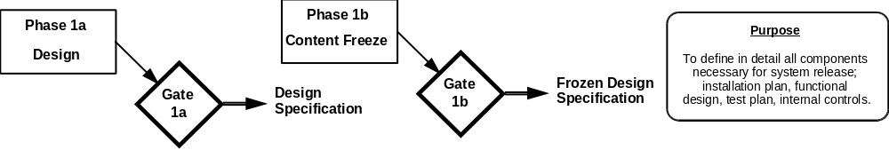
Key Players  Project Manager  - Coordinate resource activities/impacts needed to deliver design  - Review project budget with IT director  Development Prime/  System Designer(s)  - Service design details  - Service introduction issues | Key Deliverables  Business  - Quality targets for gate 3 confirmed/redefined  - Metrics for business effectiveness defined  - List of stakeholders, resources & targets for next phase  Technical  - Release installation plan  - System design specifications  - Initial test results available and reviewed  - Finalised System Test plan  - Internal Controls Design  - Process Requirements  - Draft user and training materials completed & reviewed  Project Management  - Updated project file and project plan  - Confirm deliverables for this phase and define deliverables, representation & pass criteria of the next phase
- Major Activities  - Plan & document the release installation  - Construct system design specifications  - Finalise System Test plans  - Document Internal Controls  - List of stakeholders/resources and targets for next phase | Processes Followed  - New Product Development  - New Product Introduction  - Project Gating
After specifying the requirements and estimating impacts, a system design is performed to verify the planning assumptions and confirm technical feasibility. Identify impacts.
A Gate 1B may be useful as a gate to mark a “content freeze” (sometimes combined with Gate 2). This gate (additional to present IS/corporate set) is to determine that the design implementation is complete, feature development is frozen and individual system modules have been tested.
Gate 1b has particular value when supplier testing is needed on a formal basis.
Only those stakeholders who have an interest in this phase of the project need to attend the review.
Testing is often done in a "Test Environment/Captive Office" or other well controlled environment internal to the supplier, but which is designed to emulate the end user conditions as closely as possible.

4.4 Gate 2

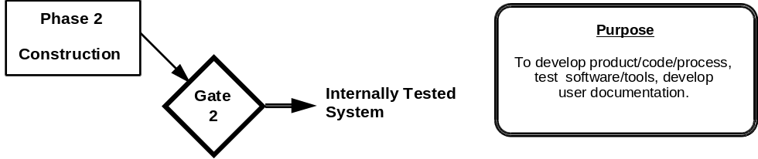
Key Players  Project Manager  - Coordinate resource activities/impacts needed to deliver tested system  - Review project budget with IT director  Development Prime/System Designer(s)  - Service test environment details  - Non-impact (to production service) issues  Service/Quality Primes  - Test as simulated user - provide feedback  - Review/proposed user documentation | Key Deliverables  Business  - Numbers of users, configurations and sites  - Quality targets for successful field trials  - Metrics recorded and available to metrics prime  - List of stakeholders, resources & targets for next phase  Technical  - Designed system (e.g. Code,unit and functional tests)  - Approved system documentation  - User documentation for installation/reference  - Finalised User Acceptance Test plan - Field trial readiness  - Computing/Network Comm. Benchmarks  - Training material finalised  Project Management  - Updated project file and project plan  - Confirm deliverables for this phase and define deliverables, representation & pass criteria of the next phase
- Major Activities  - Code and test  - Prepare system documentation  - Prepare user documentation  - Finalise the User Acceptance Test plan  - Establish Benchmarks | Processes Followed  - New Product Development  - New Product Introduction  - Project Gating
Construct and test the design within IT, and limit potential and known impacts (identified in Phases 1a and 1b) as much as possible (e.g. by selective or out of hours testing). IT employees act as users to provide feedback on the service/project - these employees evaluate user-interface, proposed user and IT documentation, usefulness of project/service, etc..

4.5 Gate 3
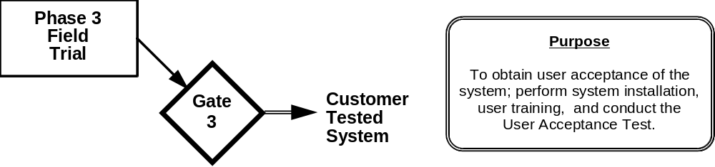
Key Players  Project Manager  - Coordinate resource activities/impacts needed to deliver customer tested system  - Review project budget with IT director  - Review billing mechanisms  Development Prime/  System Designer(s)  - Service introduction/registration details  - Impacting test issues - environment controls | Key Deliverables  Business  - Confirm numbers of users, configurations and sites  - Metrics that confirm quality targets  - Confirm/redefine metrics for business effectiveness  - List of stakeholders, resources & targets for next phase  Technical  - Installed system  - Support staff & trial users trained  - Successful system test  - User acceptance of system  - Approved User Documentation & Guide  - Tested Internal Controls  - Tested Computing/Network Communications  - System Management & Delivery processes defined  Project Management  - Updated project file and project plan  - Maintenance management file  - Confirm deliverables for this phase and define deliverables, representation & pass criteria of the next phase
- Major Activities  - Install system, migrate data, train users etc.  - System test in operational setting  - Do User Acceptance tests & get Service Level approval  - User acceptance/review of guides etc.  - Obtain approval for system process documentation  - Conduct internal controls, computing/network communication tests  - Update project file  - Establish a maintenance management file | Processes Followed  - New Product Development  - New Product Introduction  - Project Gating
Having constructed a system and completed controlled internal testing, a field trial is conducted with a small customer population (usually a selected customer sub-set registered, but not yet billed, for evaluation of the system). The field trial takes place under controlled conditions that minimise adverse impact.
At this stage the helpdesk is informed about potential calls, roll out dates and provision for their training. During this phase, the development prime acts as the service point of contact for all related calls from participants in the field trial’s customer business.

4.6 Gate 4
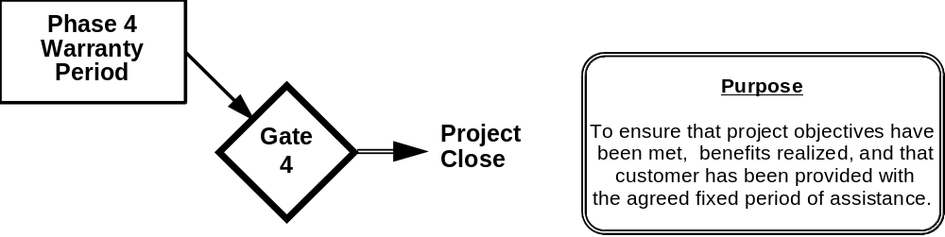
Key Players  Project Manager  - Coordinate resource activities/impacts needed to deliver customer tested system  Service/Quality Prime  - In-service quality evaluation  - Production process monitoring  - Customer feedback and service-satisfaction monitoring | Key Deliverables  Business  - Metrics that confirm customer satisfaction  - Metrics that confirm business effectiveness  - Contract renewal completed (ongoing service)  Technical  - Trained end-users  - System evaluation  - Customer Feedback  - Decommisioning process defined  Project Management  - Updated maintenance management file  - Closed project file (unless gate 5 planned)  - Confirm deliverables for this phase and define deliverables, representation & pass criteria of the next phase
- Major Activities  - Evaluate the system  - Document Customer Feedback  - Update maintenance management file  - Close out the project file (unless gate 5 planned) | Processes Followed  - Service Delivery  - Service Management  - Project Gating
Gate 4 completes the standard gating process. All testing is complete, and the serivce/project is ready for general release and use.
The deliverables have completed controlled release (during Gate 3 - Field Trial) and will affect a steadily increasing numbers of users. In the case of a product or service, registration and billing may also be affected. The (now trained) helpdesk will have fielded sufficient routine product/service related calls, and have the expertise which can be re-used under renewed contracts with the existing customers, or new contracts.
Feedback must be obtained about the overall quality of the deliverables throughout the warranty period, from existing users and from the first impressions of new users. Determine if additional training for users, help desk and/or second-level help desk is necessary for contract extension or for new contracts.
New business, or repeat business for existong customers, may just be a repeat of this phase if no new issues exist. Any decommissioning issues are known, documented and (were practical) tested.

4.7 Gate 5
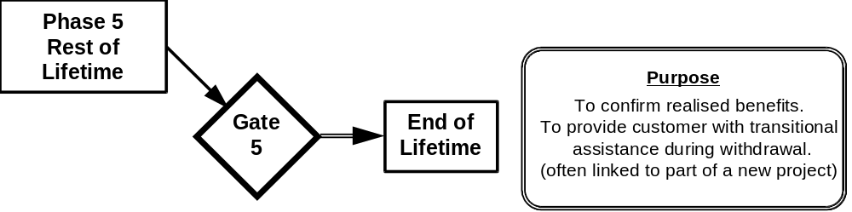
Key Players  Project Manager  - Coordinate resource activities/impacts needed to withdraw customer system  Service/Quality Prime  - Post-service quality evaluation  - Production process close-down  - Customer feedback and service-satisfaction monitoring | Key Deliverables  Business  - Metrics that confirm customer satisfaction  - Metrics that confirm business effectiveness  - Decommissioning complete  Technical  - “Graceful” withdrawal of system, support etc.  - Customer transition phase (part of new project)  Project Management  - Closed maintenance management file  - Closed project file  - Confirm deliverables for this phase and define deliverables, representation & pass criteria of the next phase
- Major Activities  - Evaluate overall system benefits  - Communicate,implement system withdrawal  - Close out maintenance management files etc.  - Close out the project file | Processes Followed  - Service Management  - Project Gating  - System Decommissioning
N.B. This gate is additional to the present IS/corporate gating process. It may be useful to signify final removal of all instances of service/product, or where end-of-lifetime differs from end-of-warranty, (e.g., due to a different ongoing lifetime support organisation than original service or product provider).

Section 5 - Gate Review/Approval Process
The Gate Review/Approval Process is the successful result of each phase in gating. The process flow charted below represents the gate review. It can be applied equally within an IT Product Group, by group cabinet, or at the GPNS/IS-wide level by Quality Councils.
Each gate is completed with an official Gate Approval/Review. This review is attended by all team members and the project executive stakeholders. Once determined all criteria is met for a specific gate, the gate is approved and passed.
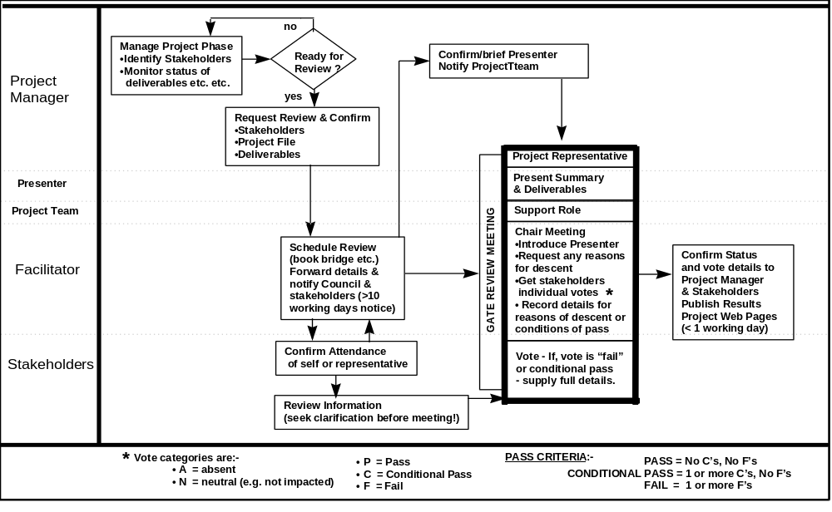
Figure 1 - Gate Review & Approval Process

