eService Support
3C Database

Version 01 Issue 01— Draft — Mar 2002




3C Service Performance Program

As the communications market evolves, customers require equipment distributors to provide expertise and support throughout a system's lifecycle. Because communications systems are a business' backbone, customers require assurances that the service vendor is properly qualified to support their environment. The 3C Service Performance Program officially recognizes the expertise of distributors who offer the highest level of support by certifying their Competency, Capacity and Capability, while supporting their efforts to improve quality.

"Communications systems are the lifeblood of any business. The risk associated with a communications system failure is so great that companies cannot afford to risk trusting their systems' performance to just anybody," said Shirley Scarborough, director of service partnerships for Nortel Networks. "The 3C Service Performance Program gives customers the assurance that by focusing on Competency, Capacity and Capability, certified service providers have a service and support organization designed around meeting the customer's business needs."

In order to meet 3C Service Performance Program requirements, service providers must establish that they have the:

- Competency through staffing technicians with the proper skill sets and training;

- Capability to deliver the service resources by demonstrating that they have the necessary processes and technology in place to quickly identify and resolve issues;

- Capacity to provide adequate qualified support to their customers by having a minimum number of certified Meridian 1 experts aligned to their installed base.

By meeting these requirements, distributors demonstrate to their customers that they can provide a safety net of services that will keep their communications systems in the best possible operating condition. The 3C Service Performance Program provides a number of benefits to its participants, which are designed to ensure that customers receive the highest level of support possible.

3C Architecture

The 3C database resides on a server physically located in Brampton, Pillar JJ36. Access within the Nortel Corwan.

The 3C group controls administration of the DB through a web site. The web application is driven by VB Script and IIS web server running on WinNT4.0, Server SP6a. The general interface for the database is located at http://studiontc.ca.nortel.com/3cdatabase/asp/servicep/Reports3c.html. The administration interface can be accessed by contacting Laura Barrett.

http://studiontc.ca.nortel.com/3cdatabase/asp/ServiceP/3C/Admin_3C.html

3C Database

The database contains the following information about 3C certified companies: General Info, Personnel Info, Company Audits, Tests Results, Certifications, Contacts, and Benefits Funds. The database is implemented in Microsoft Access and is running on an NT 4.0 Server. View the diagram 2.0 for information on the database schema.

Diagram 2.0 - 3C Database Schema

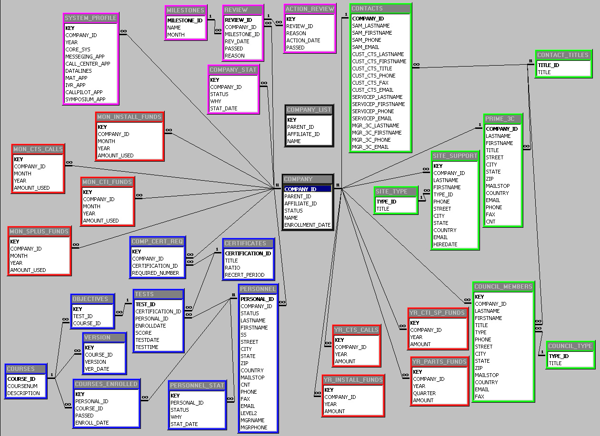

Server Management

- To login to the 3C Server use the administrative login: administrator.
- The 3C Database is located in C:\datasources\3Cdatabase
- No shared folders other than the database FTP directory
- The VB web scripts are located in D:\websites\3Cdatabase\asp
- Backups: The database is backed-up using a cron tab. It makes a daily and weekly back-up of the 3C database. It makes a daily and biweekly backup of the VB scripts. The backup is a tape back up using Veritas software. Increment daily, full weekly, four week rotation.
- Usual Problems: If the web interface takes to long to execute web reports or gets hung, the usual resolution is to restart the server. (not the web server!)
- Primary contact for 3C Server is Laura Barrett ESN 445-6204

