Internal Standard – Oasis

v 1.0 – June 11 2019 – E. Marceau
v 1.1 – November 14 2019
v 1.2 – July 13 2020

Site Configuration Guide

–

Synaptic

** Update for UM 20.04 INCOMPLETE **

Reference Information

/etc/lsb-release:
DISTRIB_ID=Ubuntu
DISTRIB_RELEASE=18.04
DISTRIB_CODENAME=bionic
DISTRIB_DESCRIPTION="Ubuntu 18.04.2 LTS"
/etc/os-release:
NAME="Ubuntu"
VERSION="18.04.2 LTS (Bionic Beaver)"
ID=ubuntu
ID_LIKE=debian
PRETTY_NAME="Ubuntu 18.04.2 LTS"
VERSION_ID="18.04"
HOME_URL="https://www.ubuntu.com/"
SUPPORT_URL="https://help.ubuntu.com/"
BUG_REPORT_URL="https://bugs.launchpad.net/ubuntu/"
PRIVACY_POLICY_URL="https://www.ubuntu.com/legal/terms-and-policies/privacy-policy"
VERSION_CODENAME=bionic
UBUNTU_CODENAME=bionic
/etc/issue.net:
Ubuntu 18.04.2 LTS

Settings – Preferences – General

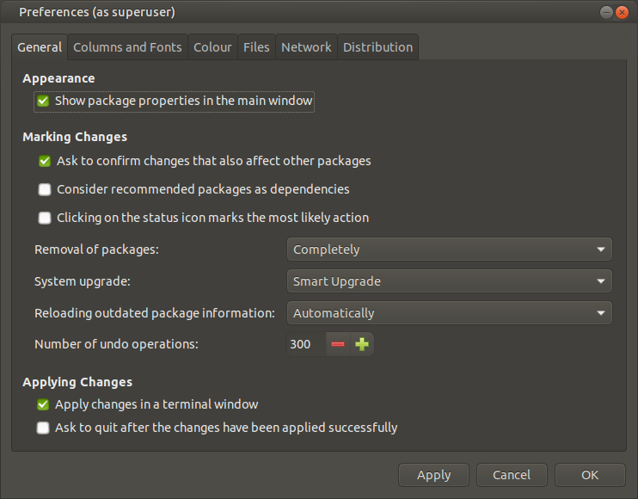
To confirm the required setting, the file “/etc/apt/apt.conf.d/99synaptic” will contain the line:
APT::Install-Recommends "false";

The file “/etc/apt/apt.conf.d/99synaptic” was renamed as “/etc/apt/apt.conf.d/98synaptic”.

This file should ONLY be managed by the Synaptic interface to avoid conflict or mis-configuration.

Note this can be overriden by 99local, which contains related settings:
APT::Install-Recommends "false";
APT::Install-Suggests "false";
APT::Install-Suggests "0";
APT::Install-Recommends "0";

Settings – Preferences – Columns and Fonts
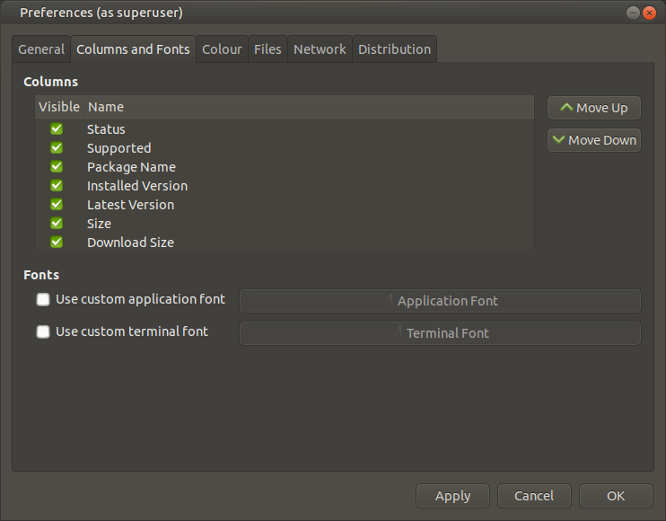
Last field selected at bottom of above list (not shown) is “Description”.

Default Application Font: Sans Regular / 10
Default Terminal Font: Monospace Regular / 10

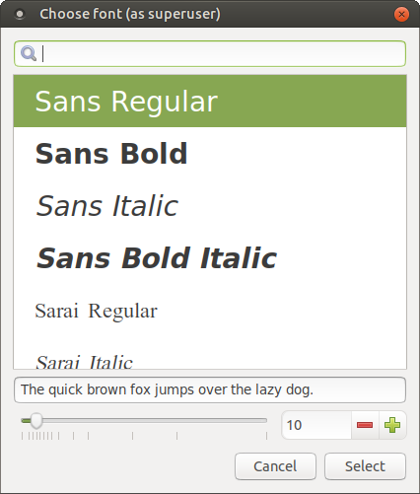
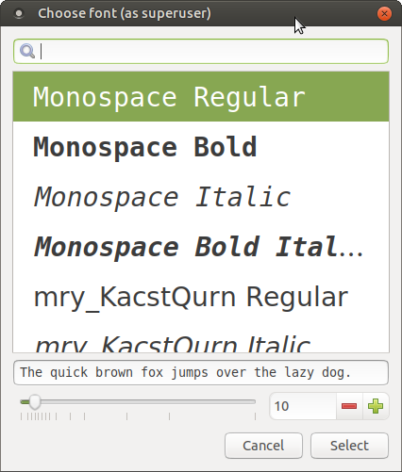

Settings – Preferences – Colour

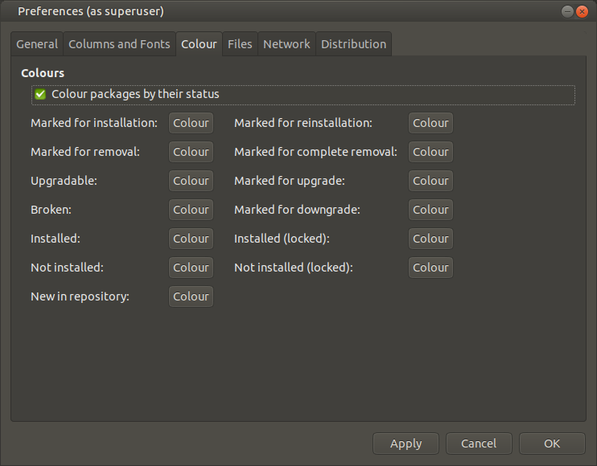

Settings – Preferences – Files

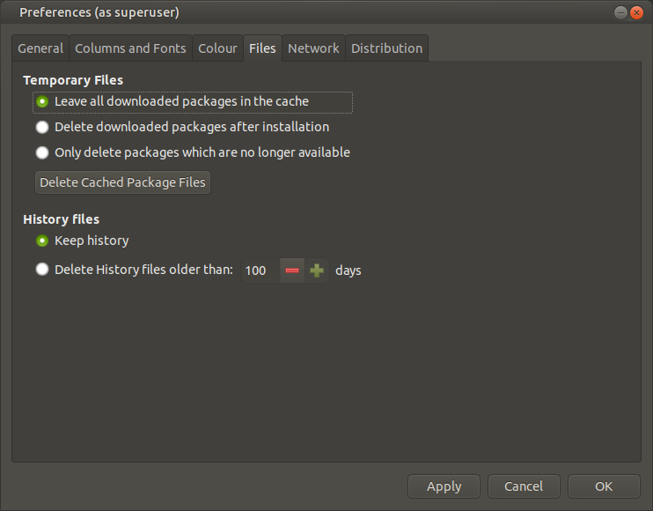

Settings – Preferences – Network

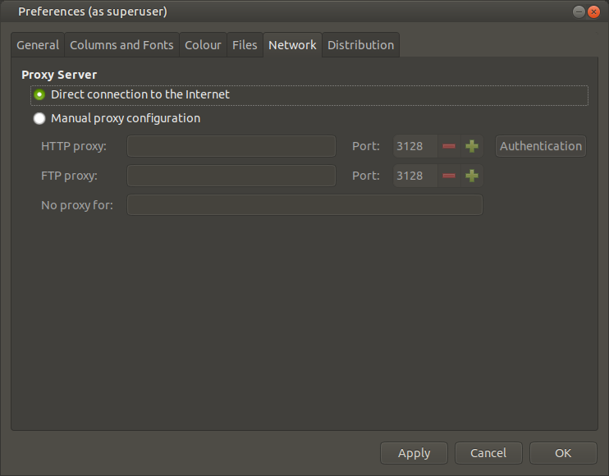

Settings – Preferences – Distribution

Click on selection “Always prefer the highest version”.

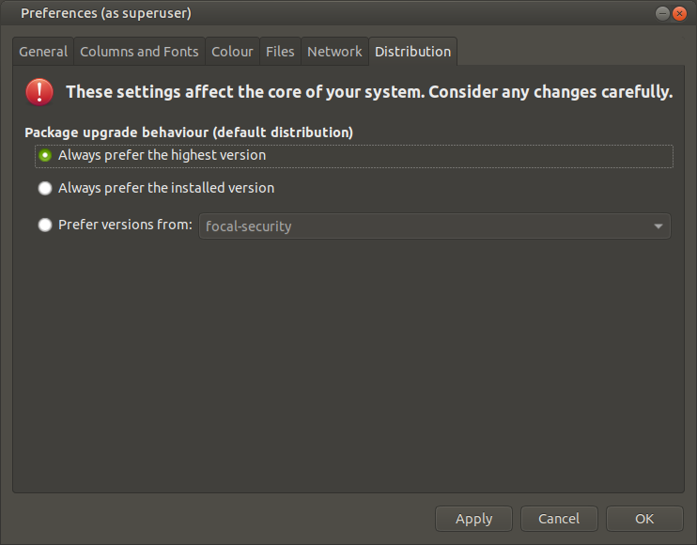

Note: Drop-down next to “Prefer versions from” per following order:
- [codename]-security
- [codename]-updates
- [codename]-backports
- [codename]

Settings – Repositories – Ubuntu Software

Note: Synaptic stores and uses the list of specified distro lists in the following file:
/etc/apt/sources.list (see listing of contents in Appendix I)

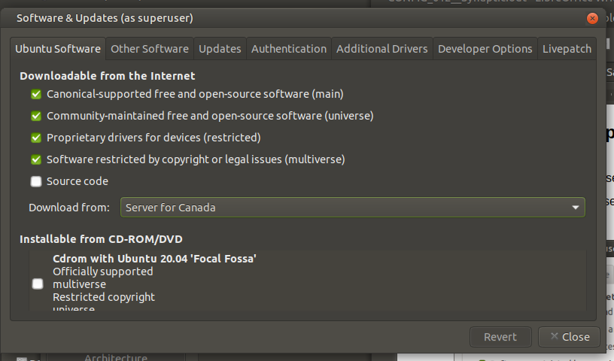

Settings – Repositories – Other Software

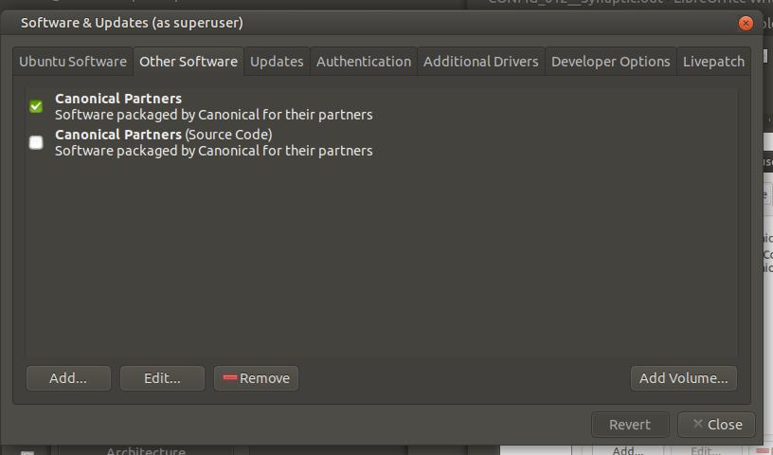

Settings – Repositories – Updates

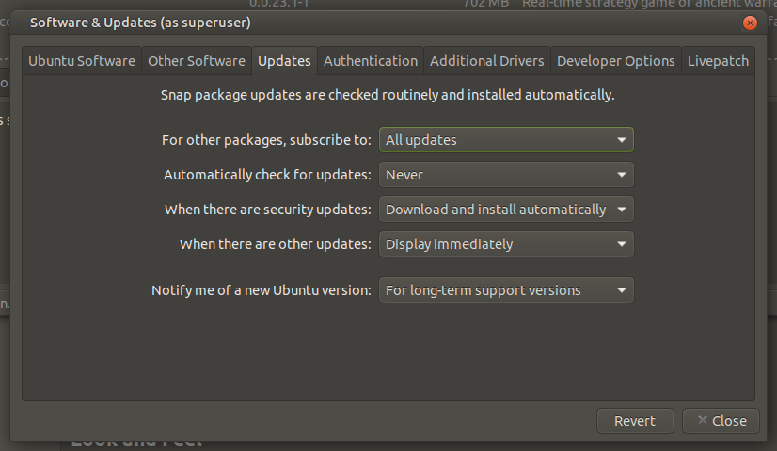

Settings – Repositories – Authentication

Ubuntu 20.04 LTS
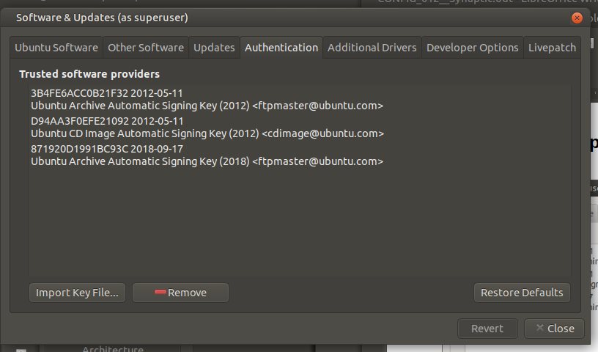
Ubuntu 18.04 LTS
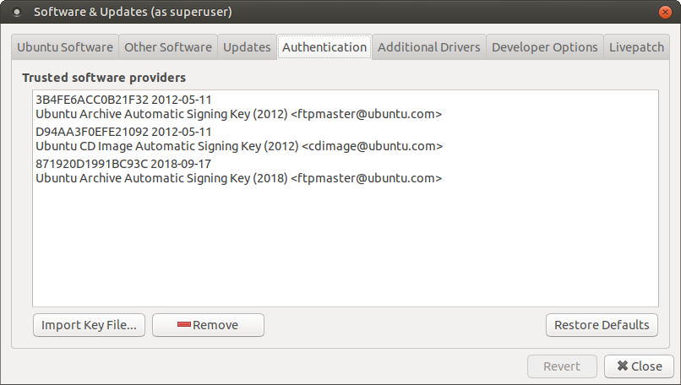

Settings – Repositories – Additional Drivers

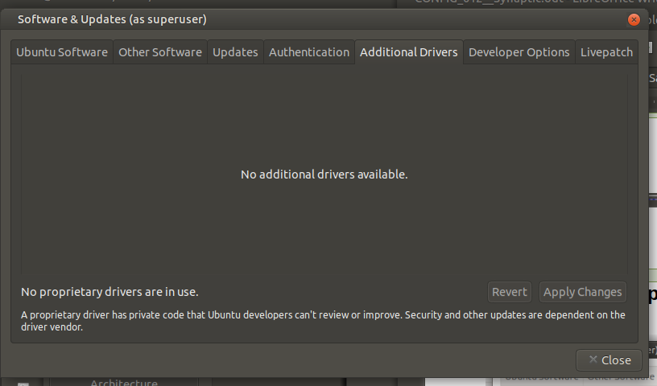

Settings – Repositories – Developer Options

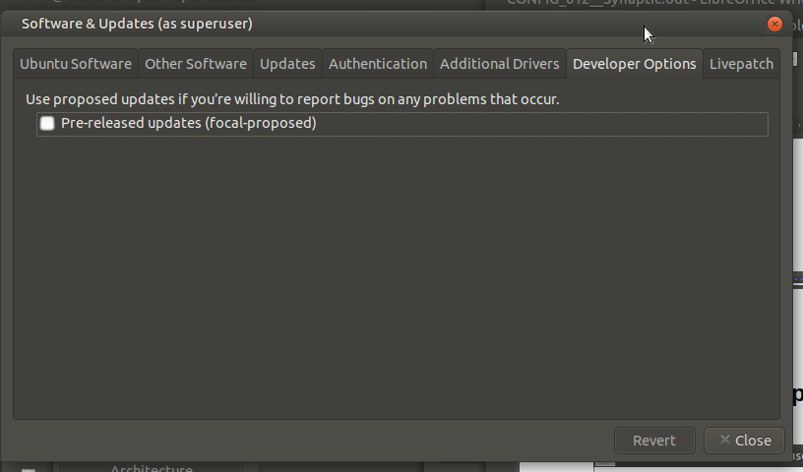

Settings – Repositories – Livepatch

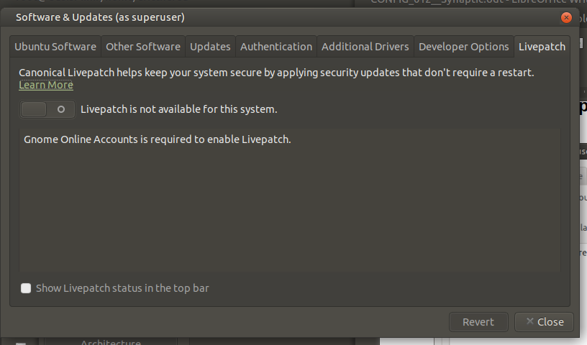

APPENDIX I

root:~# cat /etc/apt/sources.list

# deb cdrom:[Ubuntu-MATE 20.04 LTS _Focal Fossa_ - Release amd64 (20200423)]/ focal main multiverse restricted universe

# See http://help.ubuntu.com/community/UpgradeNotes for how to upgrade to
# newer versions of the distribution.
deb http://ca.archive.ubuntu.com/ubuntu/ focal main restricted
# deb-src http://ca.archive.ubuntu.com/ubuntu/ focal main restricted

## Major bug fix updates produced after the final release of the
## distribution.
deb http://ca.archive.ubuntu.com/ubuntu/ focal-updates main restricted
# deb-src http://ca.archive.ubuntu.com/ubuntu/ focal-updates main restricted

## N.B. software from this repository is ENTIRELY UNSUPPORTED by the Ubuntu
## team. Also, please note that software in universe WILL NOT receive any
## review or updates from the Ubuntu security team.
deb http://ca.archive.ubuntu.com/ubuntu/ focal universe
# deb-src http://ca.archive.ubuntu.com/ubuntu/ focal universe
deb http://ca.archive.ubuntu.com/ubuntu/ focal-updates universe
# deb-src http://ca.archive.ubuntu.com/ubuntu/ focal-updates universe

## N.B. software from this repository is ENTIRELY UNSUPPORTED by the Ubuntu
## team, and may not be under a free licence. Please satisfy yourself as to
## your rights to use the software. Also, please note that software in
## multiverse WILL NOT receive any review or updates from the Ubuntu
## security team.
deb http://ca.archive.ubuntu.com/ubuntu/ focal multiverse
# deb-src http://ca.archive.ubuntu.com/ubuntu/ focal multiverse
deb http://ca.archive.ubuntu.com/ubuntu/ focal-updates multiverse
# deb-src http://ca.archive.ubuntu.com/ubuntu/ focal-updates multiverse

## N.B. software from this repository may not have been tested as
## extensively as that contained in the main release, although it includes
## newer versions of some applications which may provide useful features.
## Also, please note that software in backports WILL NOT receive any review
## or updates from the Ubuntu security team.
deb http://ca.archive.ubuntu.com/ubuntu/ focal-backports main restricted universe multiverse
# deb-src http://ca.archive.ubuntu.com/ubuntu/ focal-backports main restricted universe multiverse

## Uncomment the following two lines to add software from Canonical's
## 'partner' repository.
## This software is not part of Ubuntu, but is offered by Canonical and the
## respective vendors as a service to Ubuntu users.
deb http://archive.canonical.com/ubuntu focal partner
# deb-src http://archive.canonical.com/ubuntu focal partner

deb http://security.ubuntu.com/ubuntu focal-security main restricted
# deb-src http://security.ubuntu.com/ubuntu focal-security main restricted
deb http://security.ubuntu.com/ubuntu focal-security universe
# deb-src http://security.ubuntu.com/ubuntu focal-security universe
deb http://security.ubuntu.com/ubuntu focal-security multiverse
# deb-src http://security.ubuntu.com/ubuntu focal-security multiverse

# This system was installed using small removable media
# (e.g. netinst, live or single CD). The matching "deb cdrom"
# entries were disabled at the end of the installation process.
# For information about how to configure apt package sources,
# see the sources.list(5) manual.
root:~#

=== END ===

