Internal Standard – Oasis

v 1.1 – March 15 2020 – E. Marceau
v 1.2 – July 13 2020

Site Configuration Guide

–

User Interface – Monitor

** INCOMPLETE **

Settings – Preferences – General

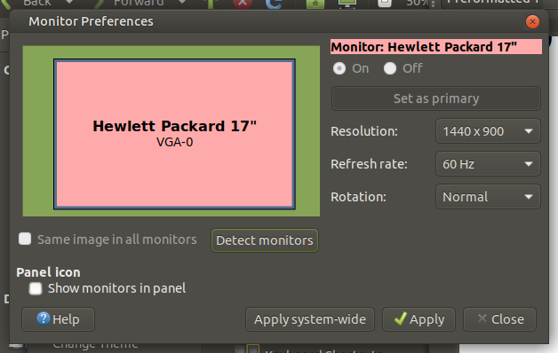

FUTURES

Xrandr and tuning parameter settings.

Driver-Level Customization for Display (USE CAUTION)

NOTE – Screen Tearing is version dependent, those with later
drivers having less problems.
As per reference
https://learnubuntumate.weebly.com/screen-tearing-on-amd-graphics.html

the fix for Ubuntu MATE is as follows:

mkdir -p /etc/X11/xorg.conf.d/

create file “20-radeon.conf” with following contents:
Attempt 1:
Section "Device"
Identifier "Radeon"
Driver "radeon"
Option "TearFree" "on"
EndSection

Attempt #2:
Section "Device"
Identifier "Radeon"
Driver "radeon"
Option "TearFree" "on"
Option "DRI" "3"
Option "AccelMethod" "glamor"
EndSection

Fix for KDE is per same reference:

Define KDE environment variable: export __GL_YIELD=USLEEP

=== END ===

