Internal Standard – Oasis

v 1.0 – June 11 2019 – E. Marceau
v 1.2 – July 15 2020
v1.3 – November 3 2020

Site Configuration Guide

–

OS Admin – File Management

Settings – Preferences – Views

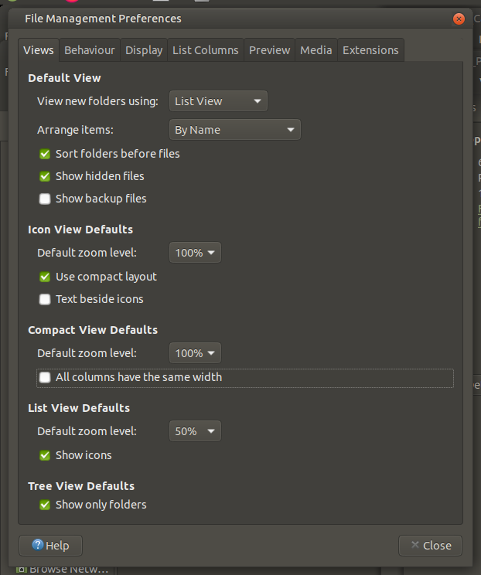

Settings – Preferences – Behaviour

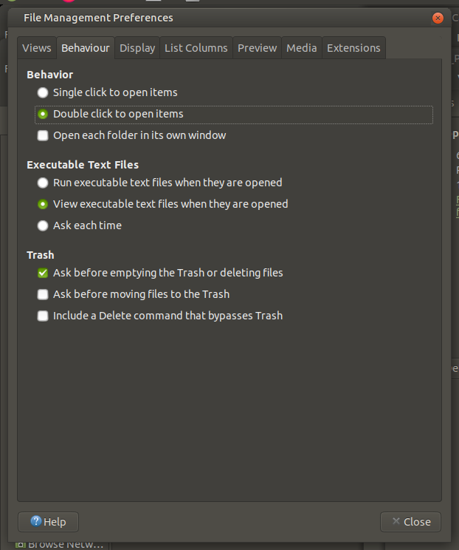

Settings – Preferences – Display

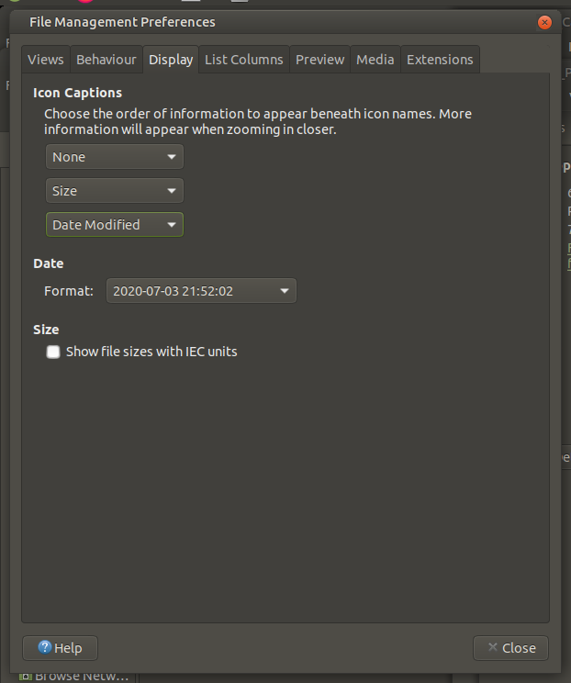

Settings – Preferences – List Columns

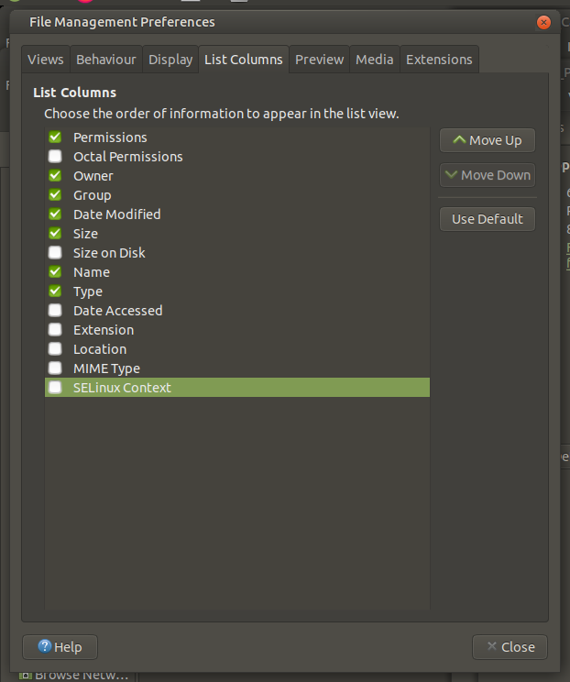

Settings – Preferences – Preview

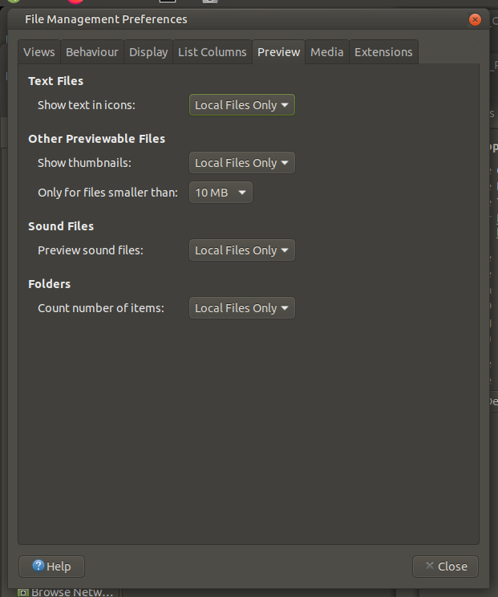

Settings – Preferences – Media

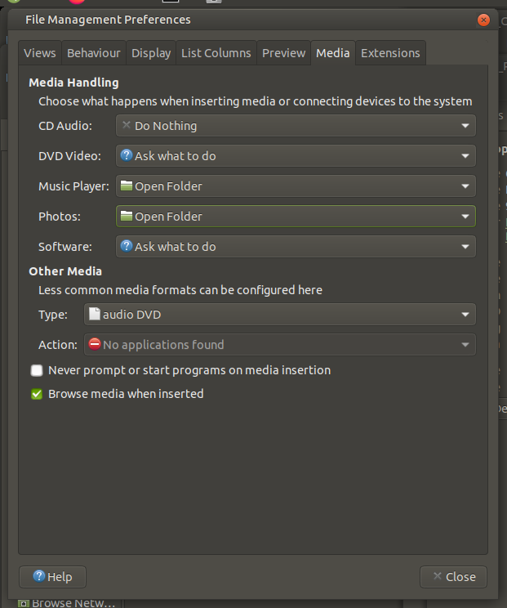

Settings – Preferences – Extensions

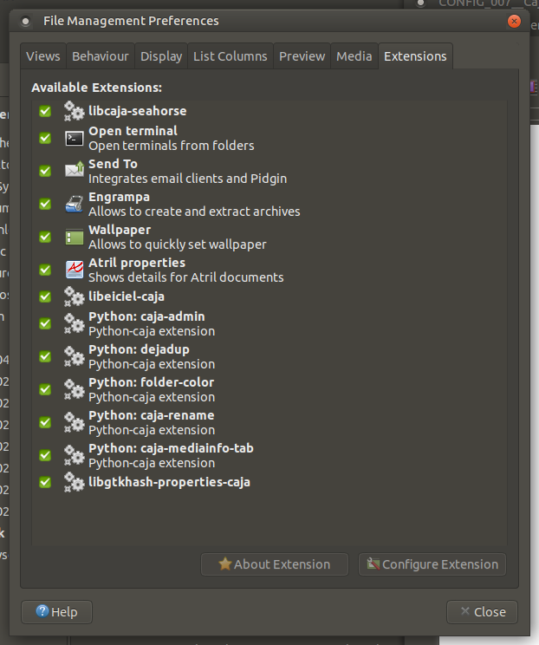

=== END ===

