Internal Standard – Oasis

v 1.1 – March 15 2020 – E. Marceau
v 1.3 – July 15 2020
v1.4 – November 3 2020

Site Configuration Guide

–

User Interface – Appearance

User Interface – Screensaver

User Interface – Terminal

Appearance – Theme

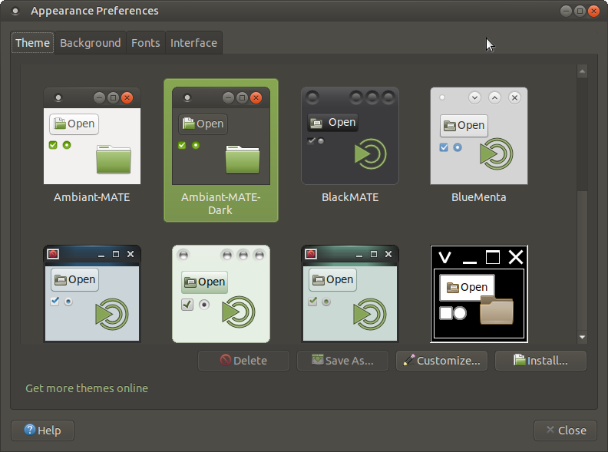
Note: The site standard theme selection is one of the standard themes:

“Ambiant-MATE-Dark”.

Appearance – Background

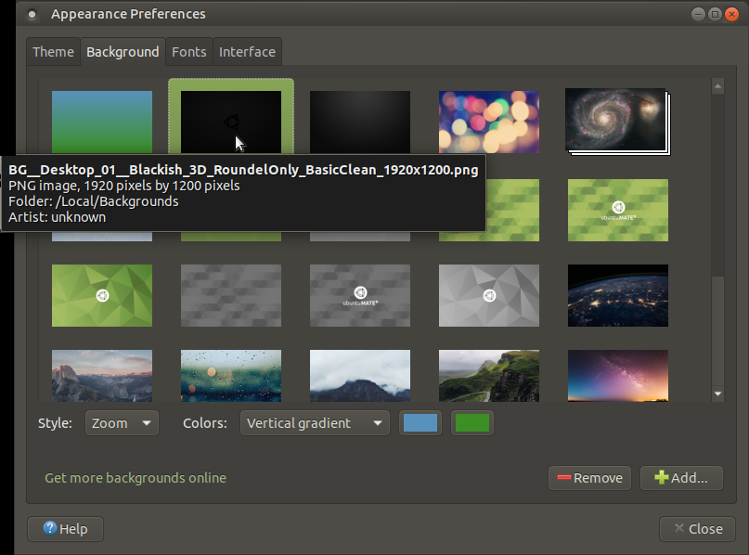

Note: Full pathname to local custom background is:

“/Local/Backgrounds/BG__Desktop_01__Blackish_3D_RoundelOnly_BasicClean_1920x1200.png”

Appearance – Fonts

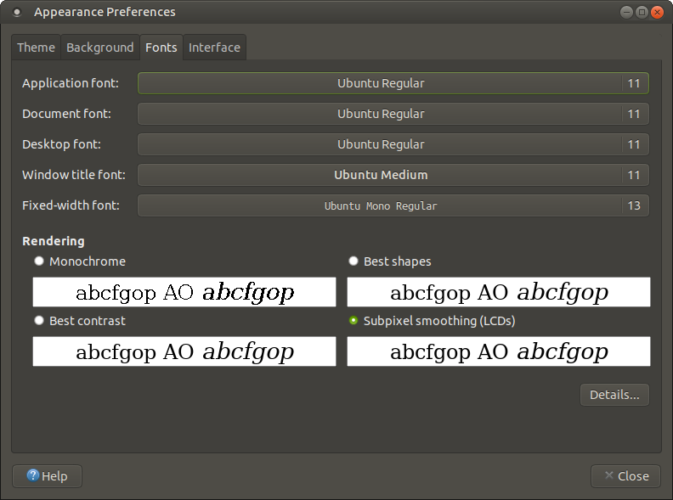

Appearance – Interface

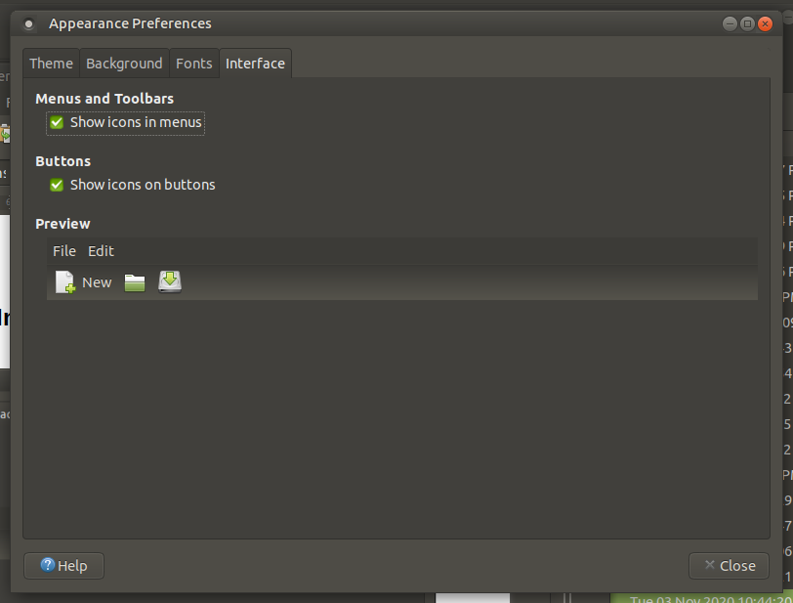

User Interface – Screensaver

Screensaver – Preferences
At install time for new distro, the default preferences are per the below:

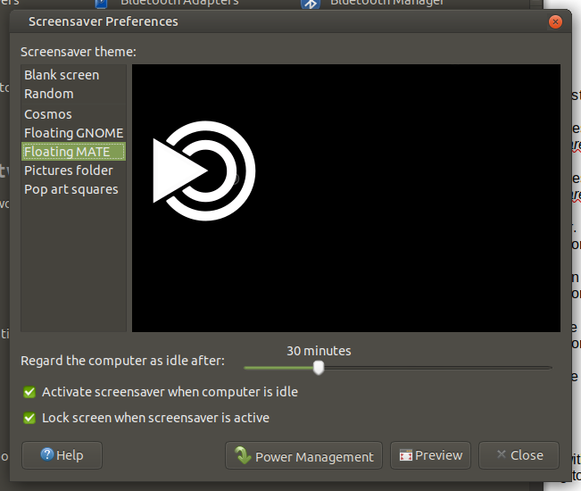
Un-check both options: “Activate screensaver ...” and “Lock screen when ...” .
Click on “Blank screen”. The window will now show as follows:

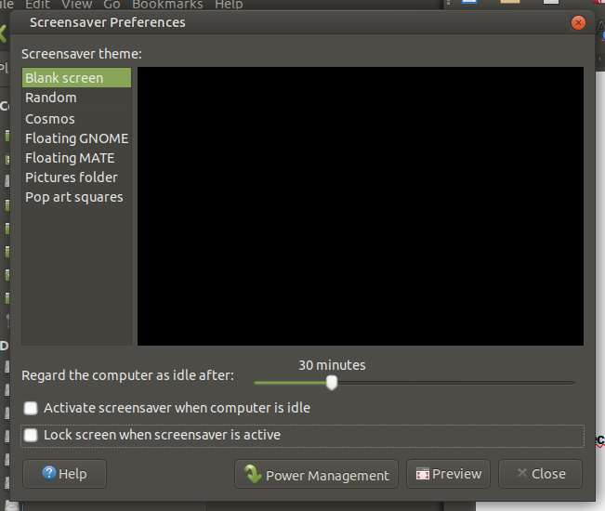

User Interface – Terminal

Terminal – Profiles

From the Menu line, choose “Edit” then “Profiles”, and the following pop-up will display:

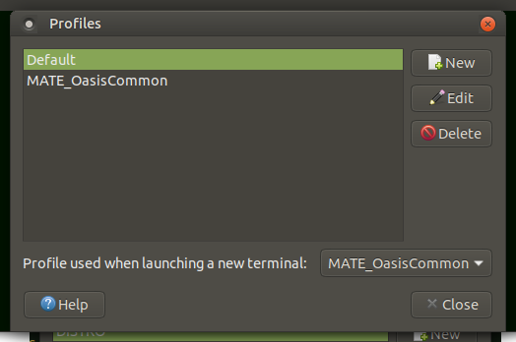
Click on “New”, assign a name to the new Preferences profile you will be creating. By following the steps below, the new profile will be assigned permanent preferences.

Terminal – General

Update to show following standard for Oasis site:

Font: Monospace Regular 11
Columns: 150
Lines: 16

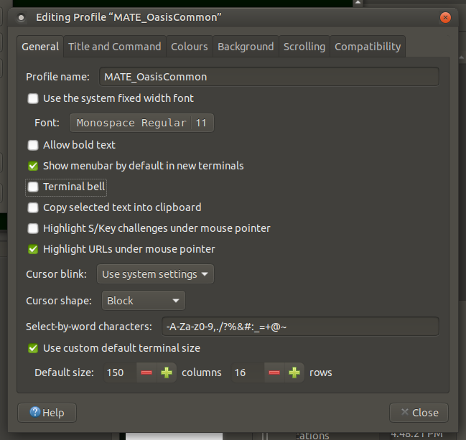

Terminal – Title And Command

Update to show following standard for Oasis site:

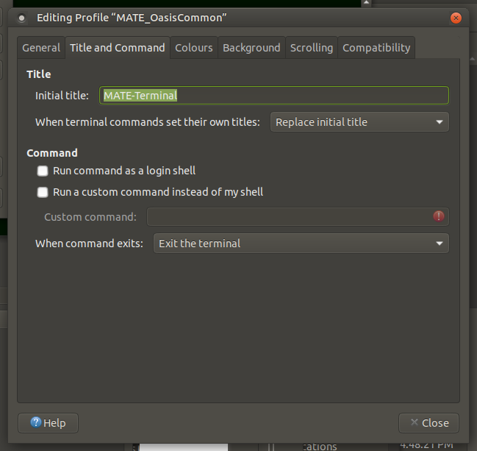

Terminal – Colours

Update to show following standard for Oasis site:

Background code: #001000
Text colour code: #F0D080 / #E4CF88 / #AAAAAA
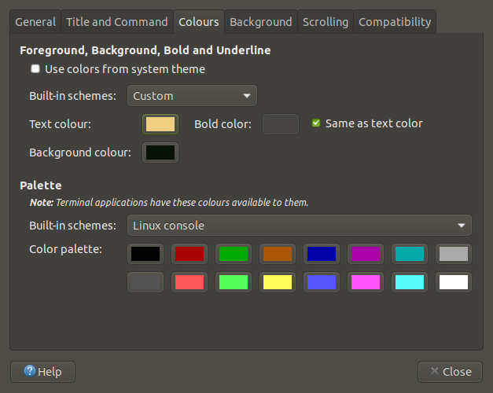
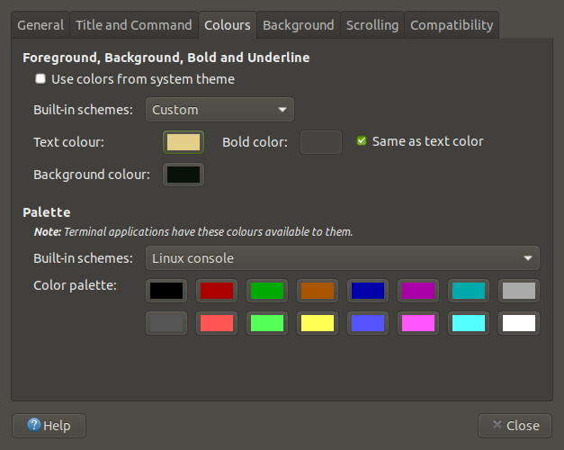
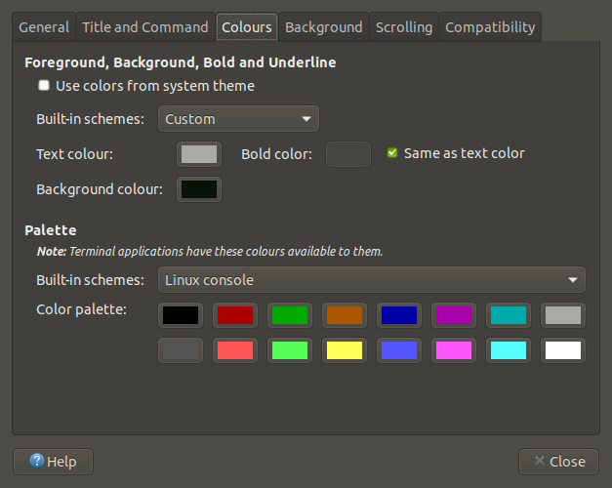

Terminal – Background

Update to show following standard for Oasis site:

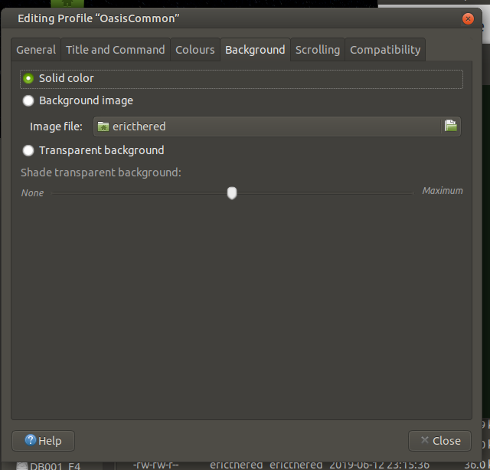

Terminal – Scrolling

Update to show following standard for Oasis site:

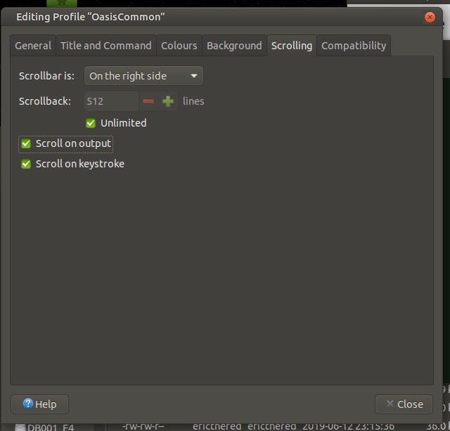

Terminal – Compatibility

Update to show following standard for Oasis site:

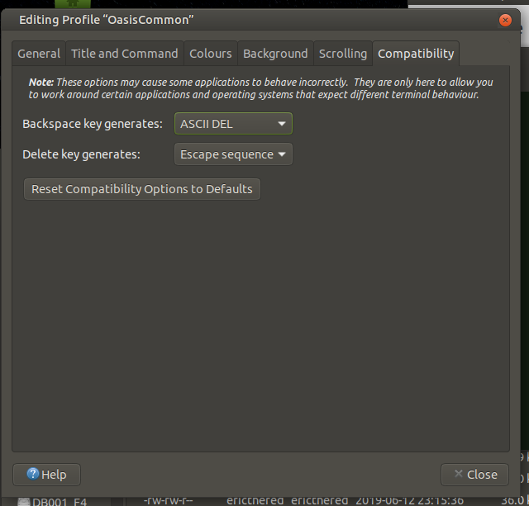

=== END ===

