DRAFT v2.3

IT Architecture Standard - Oasis

Distro Installation Sequence and Customization

Note: This is a work in progress.

ToDo:
Split package and process items per
(a) Baseline Functionality,
(b) Expanded Functionality, and
(c) Checkboxes for noting completion of steps.
This last item could instead be in form of a separate spreadsheet.
Install Common Baseline Operating System

Phase IA – Baseline Operating System Install
- Choose Linux distribution of choice for installation: Ubuntu MATE
Note: Selection criteria and weighting of factors for decision will be found in Appendix I
- BEFORE attempting to install of distro ...
a) print copy of all guidance documents referenced in this document, or have available on a USB drive,
b) as extreme precaution, open computer casing and unplug power from all drives except that which is intended as target for the distro installation, and
c) close computer casing and power-up your computer.
IMPORTANT – Perform power-up now.
WARNING – DO NOT OPEN Firefox or Thunderbird until it specified in the steps outlined below that it is safe to do so.
- (Select) When pop-up offers “Try or Install” options, choose “Try”
- Use Gparted to configure disk with desired partition setup, along with partition labels. Refer to guidance document outlining site standards/preferences for disk partitioning:
        - Create new GPT partition table
        - First partition as swap; if only disk assign size 4GB, less 1MB reserved for boot partition header
        - Partition all remaining per site standards:
(one for / [150 GB], one for /tmp[tbd], others as appropriate).
        - Assign same label to both Partition Name and Partition Label
        - IMPORTANT: Choose align to cylinder
Once all completed, close Gparted.
- IF NOT DOING fully-offline install from DVD, ensure that your access to the internet is fully wired, ready and your computer is plugged into it.
- Double-click on desktop icon which shows label “Install UbuntuMATE”
- (Select) Install distro (without live updates): normal installation
- IF NOT DOING fully-offline install from DVD, (Select) Install third-party S/W for graphics and H/W, and additional media fonts
- When installation reaches the step for disk partitioning, choose “Alternate Layout” and complete all necessary steps, then proceed with installation.
(FUTURES: Consider pwgen for initial password)
- When installation is complete, reboot the system before re-attaching hard drives which were unplugged.
IMPORTANT – Perform reboot now.
Phase IB – Baseline Operating System Install
- After reboot, obtain report of KERNEL parameters for virgin installation:
OS_Admin__PostInstall_ReportKernelParameters.sh
- Obtain report of open network interfaces and exposure status on various ports:
OS_Admin__VerifyDetailsOfNetwork_Public.sh
OS_Admin__VerifyDetailsOfNetwork_Private.sh
- Disable internet interface, from GUI using icon at upper-left corner of screen.
If not available, use the ‘ifdown enp2s0’ command.
- [TBD] GENERATE PWD: gpg --gen-random --armor 1 14 OR pwgen 14 2
- Update “/etc/default/grub” to contain the following modifications to suppress OS probe & IPv6 service startup during BOOT (add parameter to existing list):
GRUB_CMDLINE_LINUX_DEFAULT="ipv6.disable=1"
GRUB_DISABLE_OS_PROBER="true"
- If IPv6 not suppressed by the above change to GRUB boot, create
“/etc/sysctl.d/98-local.conf” to contain the following modifications to suppress IPv6 for Desktop usage context:
net.ipv6.conf.all.disable_ipv6 = 1
net.ipv6.conf.default.disable_ipv6 = 1
- Restrict access from internet and restrict access for root by performing sequence of tasks. Refer to document:
CONFIG_009__PrivilegeLockoutSettings.odt
- Generate a report of the installed package list using:
OS_Admin__PostInstall_PackageListSnapshot.sh --DISTRO
- Identify exposures from current content of ‘/etc/passwd’ by running script:
OS_Admin__ReportEtcPwdLoginRisk.sh
- Review systemd process tree for anything out of place or suspect:
OS_Admin__ShowSystemdUnitProcessTree.sh

- Ensure/set various system parameters according to locally defined standards.
Refer to documents: CONFIG_001__UI_Keyboard.odt
CONFIG_002__UI_Monitor.odt
CONFIG_003__UI_SystemClock.odt
CONFIG_004__UI_LoginWindow.odt
CONFIG_005__UI_MATE-Tweak.odt
CONFIG_006__UI_Appearance.odt
CONFIG_007__Caja_FileManagement.odt
CONFIG_008__UserSettings.odt
CONFIG_011__SoftwareAndUpdates.odt
FUTURES: mechanism to assign unique BG/colour to each workspace.
- Create file “/etc/apt/apt.conf.d/99z_local” with the following lines:
APT::Install-Suggests "0";
APT::Install-Recommends "0";
- Create host-specific partition mount points and “/etc/fstab” entries.
Create host-specific partition mount points using the script:
Devices__PostInstall_MakeDirMountPoints.sh
TBD: post-install__00r__CreateMountPoints_OasisMega2_BackupHost.sh
IMPORTANT: The above script expects the following script to be in the PATH:
Devices__ReportDiskParts.sh
To create a report providing the line entries for other partitions not on the new DISTRO installation BOOT drive, use the following command:
Devices__ReportDiskParts.sh --fstab
You can then choose which line pairs you wish to add to the “/etc/fstab” for your new installation.
FUTURES: Review other mount options (i.e. defaults,umask=0000,uid=10000 ).

- Configuration for Secure DNS and TLS 1.3 functionality
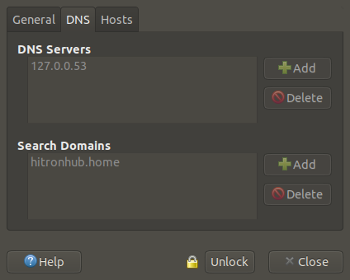
In the browser’s URL address box, enter ‘about:config’ . This will present a box to enter which of the advanced settings to modify. For TLS 1.3, the following two parameters must be updated to show the specified values:
network.trr.mode 3
network.security.esni.enabled true
At install, the default values for DNS (127.0.0.53, hitronhub.home) reported in the Network window are as follows:
The Secure DNS function can be enabled by defining the correct set of values.
For each of “DNS Servers” and “Search Domains”, first “Unlock” to make changes, then delete the current settings, then replace those by
149.112.121.30, 149.112.122.30 (1.1.1.1, 1.0.0.1), and
family.canadianshield.cira.ca
respectively.
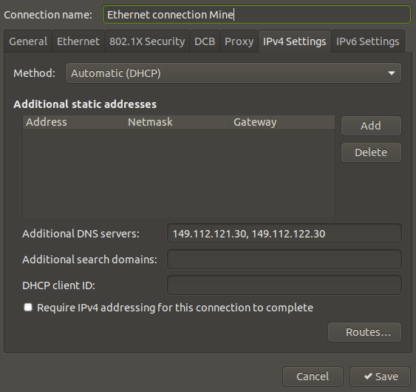
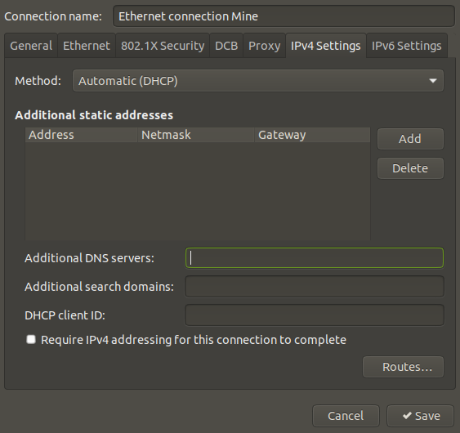
Next, in the “Network Connections” screen, go to the IPv4 tab, which will show no mention of other hosts under “Additional DNS Servers”, per the below:
Update that field with the values “149.112.121.30, 149.112.122.30”, provided by the Canadian site
https://www.cira.ca/cybersecurity-services/canadian-shield/configure:
- To identify current DNS lookup fallback sequence, enter the following command:

root@OasisMega1:~# systemd-resolve --status
Global
LLMNR setting: no
MulticastDNS setting: no
DNSOverTLS setting: no
DNSSEC setting: no
DNSSEC supported: no
DNSSEC NTA: 10.in-addr.arpa
16.172.in-addr.arpa
168.192.in-addr.arpa
17.172.in-addr.arpa
18.172.in-addr.arpa
19.172.in-addr.arpa
20.172.in-addr.arpa
21.172.in-addr.arpa
22.172.in-addr.arpa
23.172.in-addr.arpa
24.172.in-addr.arpa
25.172.in-addr.arpa
26.172.in-addr.arpa
27.172.in-addr.arpa
28.172.in-addr.arpa
29.172.in-addr.arpa
30.172.in-addr.arpa
31.172.in-addr.arpa
corp
d.f.ip6.arpa
home
internal
intranet
lan
local
private
test

Link 2 (enp2s0)
Current Scopes: DNS
DefaultRoute setting: yes
LLMNR setting: yes
MulticastDNS setting: no
DNSOverTLS setting: no
DNSSEC setting: no
DNSSEC supported: no
Current DNS Server: 149.112.121.20
DNS Servers: 149.112.121.20
208.67.222.222
DNS Domain: ~.
hitronhub.home

- Restructure ${HOME} sub-directories on non-root partition using script:
OS_Admin__PostInstall_UserHomeDirRestructure.sh
- [Placeholder] Configuration for Video/DVD-Related Devices
TBD
- [Placeholder] Deploying firewall tools and architecture
TBD
- [Placeholder] More Firewall
TBD

- Open the Software Boutique from the system menu to install “Synaptic”.
After installing Synaptic, update settings with preferences.
Refer to document: CONFIG_012__Synaptic.odt
Ensure to update the document with any new preferences relating to features that are modified or introduced in the new distro.
- Open Synaptic and perform following steps:
a) Re-load package list
b) Mark all upgrades
c) Apply upgrades
d) From command line, run “update-grub”
- Consider doing a refresh (or captured iteration snapshot) of installed package list using:
OS_Admin__PostInstall_PackageListSnapshot.sh

IMPORTANT – Perform reboot now.
Phase IC – Baseline Operating System Install
- Confirm the presence of Ubuntu core packages expected to be part of the new installation (or install as required):
ufw (OK)
lshw (OK)
fdisk (OK)
gdisk (OK)
parted (OK)
gnome-disk-utility (for gnome-disks) (OK)
x11-xserver-utils (for xrandr, xvidtune) (OK)
x11-utils (for xvinfo, sdpyinfo) (OK)
pciutils (for lspci) (OK)
util-linux (for dmesg) (OK)
TBD conntrack (OK)
- Confirm the presence of other packages expected to be part of the new installation (or install as required):
gufw (OK)
ifupdown (for ifup/ifdown) (OK)
net-tools (for ifconfig, netstat) (TBD) (ifup/ifdown vs ifconfig IFACE)
mesa-utils (for glxinfo) (OK)
mesa-utils-extra (OK)
ubuntu-restricted-addons (OK)
xserver-xorg-core (for gtf, cvt, Xorg,X) (OK)
* clamav (OK; security)
* clamav-base (OK; security)
* clamav-docs (OK; security)
* clamav-freshclam (OK; security)
* clamav-testfiles (OK; security)
* clamtk (OK; security)

- From Synaptic, install the following security-oriented utility packages:
nmap (OK; security) self-scan for security
nmapsi4 (OK; security) GUI for nmap
nmap-common (OK; security) (FUTURES: psad ???)
tcpdump (OK; security)
rkhunter (OK; security)
chkrootkit (OK; security)
lynis (OK; security)
clamscan (OK; security)
?? clamdscan (OK; security) scan incoming mail attachments
?? clamav-milter (OK; security)
libclamav9 (OK; security)
libclamunrar9 (OK; security)
unhide (OK; security)
unhide.rb (OK; security)
magicrescue (OK; security) verify raw disk
sanitizer (OK; security) Thunderbird???
umit (OK; security) GUI for nmap
sophos (OK; security; server) on-demand scan
?? netdata (OK; security; server)

- Using Synaptic, install (APT-related for package management):
apt-doc (OK)
aptitude (OK)
aptitude-common (OK)
aptitude-doc-en (OK)
apt-rdepends (OK)
apt-offline (OK)
apt-offline-gui (OK)
- Install other APT-related for package mgmt (TO BE INVESTIGATED):
Distro|Installed|PackageName
n|n|apt-dpkg-ref
y|y|apt-clone
n|n|apt-file
n|n|apt-config-auto-update
n|n|apt-src
n|n|apt-show-source
n|n|apt-show-versions
n|n|apt-mirror
y|n|apt-listchanges
y|n|dselect|***DANGEROUS***
n|n|apt-build
- Install other packages providing useful tools:
ipstate (OK)
ifupdown-extra (OK)
ifscheme (OK)
netfilter-persistent (OK)
iptables-persistent (OK)
ipset-persistent (OK)
fail2ban (OK)
ubuntu-restricted-extras (OK)
libdvd-pkg (for libdvdcss2) (OK)
Refer to: help.ubuntu.com/community/RestrictedFormats/Playing DVDs
Run: Devices__libdvd-pkg_PostInstall.sh
libdvdnav7/libdvdnav4 (OK)
libdvdread7/libdvdread4 (OK)
gparted (OK)
hwinfo (OK)
inxi (OK)
fbset (OK)
radeontop (OK)
vbetool (OK)
- Intall the following packages (Editors – Plain Text):
vim-gtk3 (OK)
vim-scripts (OK)
vim-editorconfig (TBD)
libgtkspell0 (OK)
colordiff (OK; defer)

- Install the following packages (for Video/DVD-related devices):
regionset (OK)
soundconverter (OK)
transmageddon (OK)
libavcodec-extra (OK)
libdvdnav4 (OK)
libdvdread4 (OK)
libdvd-pkg (OK)
libdvdcss2 (OK) (videolan.org)
libdvdcss-dev (OK) (videolan.org)
(run) dpkg-reconfigure libdvd-pkg
ubuntu-restricted-extras (OK)
dvdbackup (OK) (see script: DVD movie backup)
dvdbackup-dbg (OK)

ubuntu-defaults-builder (OK; TBD)

handbrake (OK; defer) (command-line equiv)

IMPORTANT – Perform reboot.
- Initiate basic firewall by running:
ufw --force enable

Phase II – Restoring Baseline Pre-Installation Data
- TBD - Define way to
a) backup, and
b) restore
ALL personalization/local/custom settings.
- Restoring Shared/Standardized Process/Data Files
Restore backup files:
(FUTURES: “/LO” will become root of all local custom data)
/Local -> /Local
/Locator -> /Locator
/Oasis -> /Oasis
/OasisBin -> /OasisBin
/OasisCommon -> /OasisCommon
/LO_Templates -> /LO_/Templates

(arrange for functional usage of
ln -s /LO_Templates /usr/lib/libreoffice/share/template/common/Local )

- Restoring Personal Profile/Data Files (Version incompatibilities ???)
Restore user-specific directories (including data files and profiles) from previously saved backup image:
${HOME}/.mozilla
${HOME}/.thunderbird
${HOME}/.profile
${HOME}/.bashprofile
${HOME}/.cshrc
${HOME}/.bashrc
${HOME}/.bashrc-local
${HOME}/( vim-related profile/preferences )

Firefox and Thunderbird - ONLY AFTER completing the above step, is it safe to start either of these applications. Otherwise, the system will create a new set of files, leading to confusion.
IMPORTANT – Perform reboot.

Phase III – Local Customization – Common Baseline
- Mount backup drive
- Locate “/Local” and execute (review)
00_NewDistroPostInstall_PrimarySequence.sh (RE-VISIT actions)
- OS-related profiles from backup:
- update fstab with host-specific customizations
- /etc/default/*
- /etc/grub.d/* (BEWARE: not directly portable to host other than original host)
- /boot/grub/* (BEWARE: not directly portable to host other than original host)
- fonts for console ???
- fonts for Grub theme (Default? | Custom?) ???
- Grub themes (Default? | Custom?) ???
- Install Customization Guidance – Appearance
NOTE: There are documented issues with customization of Themes.
Apparently, issue stems from system/application developers
trying to deploy unique Look & Feel as selling features.
(AppleOS standards vs Windows/Linux variability)
- Theme options: install & select ???
- Icon options: install & select ???

Phase IIIb – Local Customization – Common Base – Documentation Update
- Capture snapshots of settings/tabs for refresh of
“Install Customization Guidance” reference documents.
(may be deferred, but not indefinitely)
This step is here only as reminder if updating the documentation guides
was not already done as the modifications were being performed.
- Abstraction-Level Customization for Display
From Synaptic, install the following packages:
ubuntu-mate-default-settings (OK)
vs debian-mate-default-settings (TBD)
gnome-tweak-tool (OK)
gnome-tweaks (OK)
unity-tweak-tool (OK)
dconf-editor (OK)
gnome-control-center (TBD; conflict with MATE ?)

- From Synaptic, install the following packages:
gimp-data-extras (OK)
gimp-gutenprint (OK)
gimp-help-en (OK)
gimp-plugin-registry (OK)
gutenprint-doc (OK; defer)

Phase IV – Local Customization – Software Package Management Tools

Apply following process sequence to download and keep local image of every package used for OS build:
archives=”twin” ( *** Update all references to be replaced by “twin”)

mkdir /${archives}.BACKUP
mkdir /${archives}.IMPORT
ln -s /${archives}.BACKUP /var/cache/apt/${archives}.BACKUP
ln -s /${archives}.IMPORT /var/cache/apt/${archives}.IMPORT

scan_DebianPackageInstall.sh
packages_DebianDownloadOnly.sh -d
packageCache_AptBackup.sh
scan_DebianPackageCacheArchives.sh

Review, edit & run:
FIL=”scan_DebianPackageCacheArchive.list.installed.multivers”
grep \^rm ${FIL} | sed s+/archives+/archives\.BACKUP/+ >${FIL}.BAK
run: ${FIL}.BAK

Specifics to Web Navigation/Browsing
Phase Va – Local Customization – Basic Communications – Web Browser
Firefox
In Firefox, set following defaults:
Download target: ${DOWNLOADS}/00__UnSorted_PreTriage
Tag default search engines: Google, Yahoo. (Europe ???)
Customize browser settings: (TBD)

From Synaptic, install the following packages (references appnr.com, help.ubuntu.com):
xul-ext-self-destructing-cookies (OK)
xul-ext-colorfultabs (OK)
adobe-flashplugin (OK; defer)
firefox-launchpad-plugin (OK; defer)
firefox-dbg (OK; defer)
youtube-dl (OK; defer) command line, not plugin
pepperflash (TBD) 826616, “Canonical Partners Enabled’
video-without-flash (TBD)
flashplugin-installer (X)

From Firefox, install the following add-ons or extensions:
PDF Mage (OK)
Print Friendly & PDF (OK)
Video Download Helper (OK) (mp3)
Easy Youtube Video Downloader Express (OK) (mp4)
Bookmarks Organizer (OK)
Fontface Ninja (OK)
Web Developper (OK)
Feedbro (OK; defer)
Quant (OK; defer)
WOT (Web of Trust) (TBD)

Phase Vb – Local Customization – Basic Communications – Desktop eMail
Thunderbird
From Synaptic, install the following packages:
thunderbird-dbg (OK; defer)
enigmail (OK; defer) comments forprecursor steps

Phase VI – Local Customization – Extended Communications Platform
[a] Peer-to-Peer Tools
From Synaptic, install the following packages:
transmission (OK) (client, customize default settings)
sharutils (OK)
quassel-client (OK; defer) (IRC client)
quassel-data (OK; defer)
novachat (TBD) ***
xchat (OK; defer)
xchat-common (OK; defer)
hexchat-common (OK; defer)
hexchat (OK; defer)
hexchat-otr (OK; defer)
weechat (TBD)
chatzilla for firefox (TBD)
hexchat-plugins (TBD)

[b] Internet/XML – End-Use Tools
From Synaptic, install the following packages:
csstidy (OK; defer)
btcheck (OK; defer)
handbrake (OK; defer) (dvd backup)
httrack (OK; defer)
httrack-doc (OK; defer)
webhttrack (OK; defer) (website downloader/duplicator)
webhttrack-common (OK; defer)
torbirdy (TBD)
feed2imap (TBD)
gnome-online-miners (TBD)
changetrack (TBD)
bugs-everywhere (TBD)
console-conf (TBD)
gmerlin (TBD)

[c] Internet/XML – S/W Infrastructure Tools
css2xslfo (OK; defer)
clonezilla (TBD)
fetchmail (TBD)
fetchmailconf (TBD)

Specifics to Environment – MATE GDM
Phase VII – Local Customization – Look and Feel Components

GUI Formatting Tools
From Synaptic, install the following packages:
fonts-ubuntu-console (OK)
font-manager (OK)
gnome-font-viewer (OK)
fontypython (OK; defunct; ubuntu-adoption)
fontmatrix (OK; defunct; defer)
fonts-oxygen (OK; defer)
opcion (OK; defer)
scribus (OK; defer)
libftgl2 (OK; development)
freetype2-demos (OK; development)

GUI Management Tools
From Synaptic, install the following packages:
mozo (distro; instead of alacarte)
menulibre (OK; defer)

GUI Language Support
From Synaptic, install the following packages:
hunspell-en-us (distro; OK)
hyphen-en-us (distro; OK)
mythes-en-us (distro; OK)
dict (OK)
thunderbird-locale-en-gb (OK)
libreoffice-lightproof-en (OK)
libreoffice-help-en-gb (OK)
libreoffice-help-en-us (OK)
libreoffice-L10n-en-gb (OK)
libreoffice-L10n-en-za (OK)
libfreetype6 (OK)
iamerican-insane (OK)
ibritish-insane (OK)
hunspell-en-au (OK)
hunspell-en-ca (OK)
hunspell-en-gb (OK)
hunspell-en-nz (OK)
hunspell-fr (OK)
hunspell-fr-comprehensive (OK)
hyphen-en-gb (OK)
hyphen-en-ca (OK)
hyphen-fr (OK)
mythes-en-au (OK)
mythes-fr (OK)
wamerican-insane (OK)
wbritish-insane (OK)
wcanadian-insane (OK)
pstoedit (OK)
librepaper-utils (defunct; OK)

Phase VIII – Local Customization – Content Creation and Publication
Editors – Plain Text
From Synaptic, install the following packages:
emacs (OK; defer)
wxhexeditor (OK; defer)
vim-syntastic (OK; defer)
vim-tabular (X)
powerline (X)
cream (X)

<<< BREAK POINT >>>
Publishing Tools
From synaptic, install the following packages:
ebook2epub (OK)
ebook2odt (OK)
ebook-tools-dbg (OK; coding; defer)
calibre (OK; from original developper only)
calibre-bin (OK; from original developper only)
convlit (OK)
gpdftext (OK)
okular (OK)
okular-backend-odp (OK)
okular-backend-odt (OK)
okular-extra-backends (OK)
okular-mobile (OK)
pluma-doc (OK)
epub-utils (OK)
dbtoepub (OK; defer)
xfce4-notes (OK; defer)
abiword (TBD)
poppler-utils (TBD)
xpdf / xpdfreader (TBD)
vilistextum (TBD)

Graphics Capture/Import Tools
From synaptic, install the following packages:
imagemagick-6-doc (distro; already installed)
flameshot (OK)
gnome-screenshot (OK; defer; development)
spectacle (OK; defer; development)
Kazam (OK; defer; screen recorder)
shutter (TBD; large number of dependencies)
lookit (TBD; non-ubuntu)
screengrab (TBD)
deepin-screenshot (TBD)
gtk-vector-screenshot (X)

Graphics Editing/Manipulation Tools
From Synaptic, install the following packages:
exiv2 (OK)
posterazor (OK) (creates PDF)
photoprint (OK)
photocollage (OK; defer)
wallch (OK; defer)
darktable (OK; defer)
luminance (OK; defer; for HDR)

Graphics Viewing/Display Tools
From Synaptic, install the following packages (review and choose):
mirage (OK; defer)
ristretto (OK; defer)
gwenview (OK; defer; collections)
nomacs (OK; defer; network shared view)
shotwell (TBD; import duplicates)
eyeofgnome (X)
totem (X)

Multimedia Tools
From Synaptic, install the following packages:
gstreamer1.0-gl (OK; distro)
gstreamer1.0-plugins-base (OK; distro)
gstreamer1.0-plugins-base-doc (OK; distro)
gstreamer1.0-plugins-good (OK; distro)
gstreamer1.0-plugins-good-doc (OK; distro)
gstreamer1.0-plugins-bad (OK)
gstreamer1.0-plugins-bad-doc (OK)
gstreamer1.0-plugins-ugly (OK)
gstreamer1.0-plugins-ugly-doc (OK)
audacity (OK) (audio track editor)
easytag (OK)
promoe (OK) (play, winamp/xmms)
asunder (OK) (rip)
flac (OK) (play)
mediainfo (OK)
mediainfo-gui (OK)

silan + replaygain (OK; TBD)
streamtuner2 (OK; TBD)
youtube-dl (OK; TBD) vs Firefox plugin

audacious (OK; defer) (play, winamp/xmms)
audacity-data (OK; defer)
mpv (OK; defer)
gnome-mpv (OK; defer) renamed as “celluloid”,
MATE repl VLC
gmusicbrowser (OK; defer; music library browser)
clementine (OK; defer; large number of dependencies)
mencoder (OK; defer)
openshot (OK; defer) (video editor)
showq (OK; defer; development) (music)
smplayer (OK; defer) use smtube for YouTube dl
tomahawk (OK; defer; development)
apcupsd (OK; defer; server)
emby/google+ (OK; defer)
professional client private pointcase system
exfalso (X)

System Administration Functionality Deployment
Phase IXa – Local Customization – Device Administration Tools - eMedia
(placeholder for e-Media related, i.e. digital/optical disks, etc.)

Phase IXb – Local Customization – Device Administration Tools – Physical Output
(placeholder for devices generating physical ouput: plotter, tape, etc.)

From synaptic, install the following packages for printer-related devices:
cups (OK)
printer-driver-cups-pdf (OK)
ghostscript-doc (OK; defer)
ghostscript-dbg (OK; defer)
cpdb-backend-cups (OK; defer; server)
cups-tea4cups (OK; defer; server)

Driver-Level Customization for local printer: Canon ImageCLASS MF3010
All printer support information is available at:
https://asia.canon/support/imageCLASS%20MF3010/model

Driver for the printer is obtained by downloading from the following:
https://asia.canon/en/support/0100924010

Downloaded driver bundle was renamed to
linux-UFRII-drv-v510-uken-07_2020-02-18.tar

At this point, be sure to unplug the printer’s USB cable.
Create the following directory:
linux-UFRII-drv-v510-uken

Then, extract the Canon-supplied driver bundle into that directory.
From inside that directory, run the script called
install.sh .

At the end, the script will open a pop-up window for the CUPS printer setup. Close that pop-up.

Then, plug in the MF3010’s USB cable. This will trigger the computer’s
CUPS demon to review the new device and configure that correctly,
presenting a pop-up for the new device. From that pop-up, click on
“Print Test-page” to confirm all is working as expected.

At this point, the printer driver installation is complete.

Phase IXc – Local Customization – Device Administration Tools – Physical Input
From Synaptic, install the following packages for digitizing/scanning devices
(SCANNER: missing customization guidance)
sane (OK)
xsane (OK)
xsane-common (OK)
libsane-extras (OK)
xsane-dbg (OK; defer; coding)
sane-dbg (OK; defer; coding)

Driver-Level Customization for local scanner: Canon ImageCLASS MF3010
Complete all steps in the previous section for the MF3010 printer.

The SimpleScan utility can then be used to capture the image of the
“Test-page”. Attempting that scan will confirm that the scanning
function is operational.

From Synaptic, install the following packages for fax-related devices:
(FAX: missing customization guidance)
efax (OK; defer; server)

Phase IX – Local Customization – Service Administration Tools
Review the following security-oriented utility packages for adoption/banning:
clamassassin (OK; security; defer)
xdiagnose (OK; security; defer)
ssh-askpass (OK; security; defer; server)
quota (OK; security; defer; server)
ksystemlog (OK; security; defer; server)
bmon (OK; security; defer; server)
ipv6toolkit (OK; security; defer; server)
zenmap (OK; security; server)
f-prot (TBD; security; defer)
amavisd-new (TBD; security; defer; server)
roger-router (TBD; possible ePhone dial-out route)

(placeholder for Process Operations: continuity, archiving, recovery)
From Synaptic, install the following management-oriented utility packages:
aide-common (OK; defer; server)
bleachbit (OK; defer; server)
distroshare (OK)
aptoncd (OK; defer; development)
top (distro; OK)
lshw-gtk (OK)
ntp (OK)
ntp-doc (OK)
diffuse (OK) merge tool
rcs (OK)
rcs-blame (OK)
unrar (OK)
htop (OK)
atop (OK)
iotop (OK)
psutils (OK)

systemd-bootchart (OK; defer; troubleshooting)
durep (OK; defer; server) req config, vs dutree
isag (OK; defer; server) stats, works with sar/sysstat
linkchecker (OK; defer; development)
meld (OK; defer; development)
unburden-home-dir (OK; defer; development)
devscripts (OK; defer; development)
dist (OK; defer; development)
customdeb (OK; defer; development)

uck (TBD; defer) ubuntu customization kit
vtop (TBD; defer)
unetbootin (TBD; defer) system backup

Server-Mode Functionality Deployment
Phase X – Local Customization – Database File/Service Management
From Synaptic, install the following packages:
libreoffice-mysql-connector (OK; defer)
libreoffice-report-builder (OK; defer)

Phase XI – Local Customization – System/Service Dashboard Tools
From Synaptic, install the following packages:
collectd (OK; defer)
collectd-core (OK; defer)
gnuplot (OK; defer)
{other}

Phase XII – Local Customization – Web Services Management
From Synaptic, install the following packages:
???

Specifics to Environment – MATE GDM
MATE
ubuntu-mate-wallpapers-bionic (OK; distro)
ubuntu-mate-wallpapers-common (OK; distro)
mate-icon-theme (OK; distro)

xfce4-goodies (OK; defer; MATE compatible?)
xfce4-screenshooter (OK; defer; MATE)

mate-backgrounds (OK; defer)
ubuntu-mate-wallpapers-complete (OK; defer)
ubuntu-mate-wallpapers-legacy (OK; defer)
ubuntu-mate-wallpapers-utopic (OK; defer)
ubuntu-mate-wallpapers-vivid (OK; defer)
ubuntu-mate-wallpapers-wily (OK; defer)
ubuntu-mate-wallpapers-xenial (OK; defer)
ubuntu-mate-wallpapers-yakkety (OK; defer)
ubuntu-mate-wallpapers-zesty (OK; defer)
ubuntu-mate-wallpapers-artful (OK; defer)

mate-sensors-applet-nvidia (TBD; defer)

ubuntu-mate-welcome (TBD; defer)
mate-core (TBD; defer)
mate-desktop-environment (TBD; defer)
mate-desktop-environment-extra (TBD; defer)
mate-desktop-environment-extras (TBD; defer)
mate-icon-theme-faenza (TBD; defer)
fonts-materialdesignicons-webfont (TBD; defer; development)
mate-common (TBD; defer; development)
mate-settings-daemon-dev (TBD; defer; development)
oem-config-slideshow-ubuntu-mate (TBD; defer; development)
ubiquity-slideshow-ubuntu-mate (TBD; defer; development)
ubuntu-mate-lightdm-theme (TBD; defer; development)
ubuntu-mate-live-settings (TBD; defer; development)

debian-mate-default-settings (TBD)
grub2-themes-ubuntu-mate (TBD)

mate-user-share (X)
mate-user-share-common (X)
materia-gtk-theme (X)

Specifics to Environment – Xfce GDM
Xfce
xfce4-goodies (OK; defer; Xfce)
xfce4-screenshooter (OK; defer; Xfce)

Specifics to Environment – Gnome GDM
Gnome
???
???

Appendix I – URLs for Reference Sites
Community
Linux in Canada
Usenix Legacy; SOUPS 2015; SOUPS Ottawa
Linux Ottawa
LINUX User Group HOWTO
The Linux Documentation Project
Wikipedia – Linux User Group
GTA LUG
Planet Ubuntu
cloudage

webupd8.org
linuxappfinder.com
linuxcertif.com
appnr.com
ubuntuforums.org
www.frenode.net
omgubuntu.co.uk
scienceblogs.com
howtoubuntu.org
unixmen.org
stateofthemap.org
conference.libreoffice.org
www-ubuntu-user.com
gpl-violations.org
en.communtu.org
clamav.org
us.pycon.org
www.doitwithdrupal.com/blog
www.smart-developer.com/subs
www.socremo.com

News
www.ubuntu-user.com
www.opensourceweek.ca
www.onlinux.ca
microway.com
www.libregraphicsmeeting.org
www.linux.org/groups/
member.fsf.org
www.penguicon.org
www.usenix.org
www.texaslinuxfest.org

Ubuntu
help.ubuntu.com
wiki.ubuntu.com
www.ubuntu.com
www.ubuntu.com/support
qa.ubuntu.com

Debian
*

MATE
*

Publications
*

S/W Industry Affiliates
*

Appendix II - Pre-Install Disk Preparation Sequence

(see separate document for contents of Appendix II)

Appendix II - Pre-Install Disk Preparation Sequence

If you have preferences for disk partitioning which are difference from distribution standards, you need to create those before proceeding with the installation step.

If necessary, boot from a Live distro for UbuntuMATE, select the “Try Ubuntu” mode, then open Gparted from the applications menu. The following will be presented:

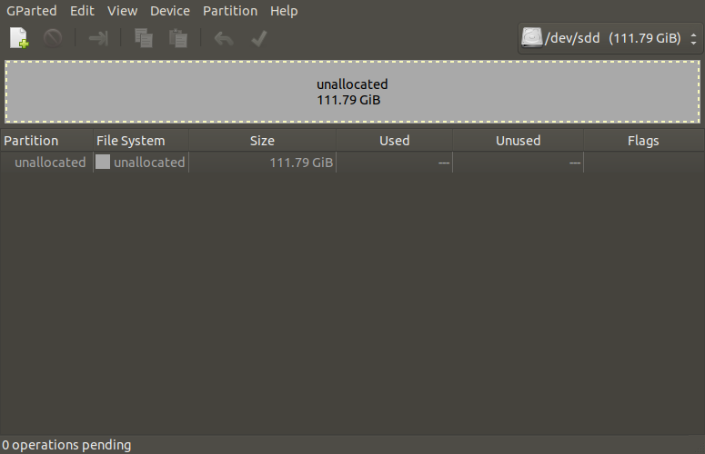

The first step is to ensure there are no legacy disk formatting table so, even if there are partitions listed on the device intended for the new distribution install, it is assumed that none of those are required and the old partition table will be flushed.

(Understandably, if you have other intentions, then you likely don’t
need to follow this step.)

Under the “Device” menu option, choose “Create Partition Table”. The following window will pop-up.

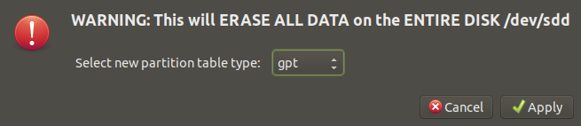
Here, select the “gpt” option for the “Gparted Partition Table” format, then click on “Apply”. Gparted will show you the entire data space on the selected drive as one large non-allocated space.

For performance reasons, it is deemed preferred to have SWAP closest to the start of the disk, thereby closest to the installed operating system. We will create that first.

Under the “Partition” menu option, choose “New”. The following window will pop-up.

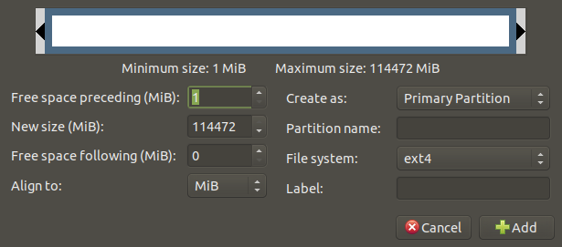
Here, we see Gparted has reserved 1 Mbyte for the Boot sectors on the physical device. We will leave that as is. In this case we want 2 Gbyte for swap. Since all computers prefer multiples of 2 for numbers, this will be entered as 2047, which is the round 2048 Mbyte less the 1 Mbyte reserved for the Boot sectors. Next, we choose alignment to “Cylinder”, choose “linux-swap” for filesystem type, and lastly assign a label. Here we prefer to assign the same label to both “Partition name” and “Label” fields, reducing some confusion when working with other commands. Given that this is linux and we are using GPT, it is best to limit ourselves to “Primary Partition”, for desktops.

A useful convention is to use a numeric identifier for the device “DB004”, a letter to designate filesystem type (“S” for swap), and a digit for the precedence of that partition in the list of assignments for that filesystem type on the device (“1” for first). Doing all that looks as follows:
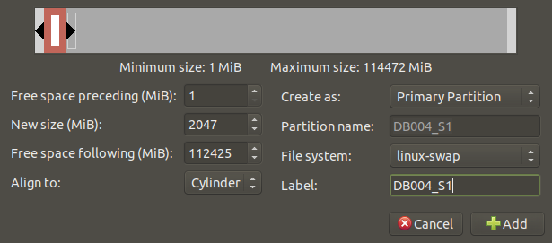
Click on the “Add” button and Gparted has captured the request. To have Gparted apply that to the disk, you will see that a green checkmark is not visible at the top, near the “Partition” menu option. Clicking on that will display the following warning:

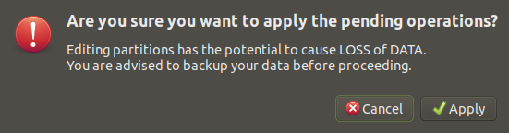
If not happy with what has been submitted and pending, it is best to click “Cancel”, exit Gparted and start from scratch. Here we are OK to proceed, so click on “Apply”.

The following window will pop-up, giving a status of completion of the partition requested:

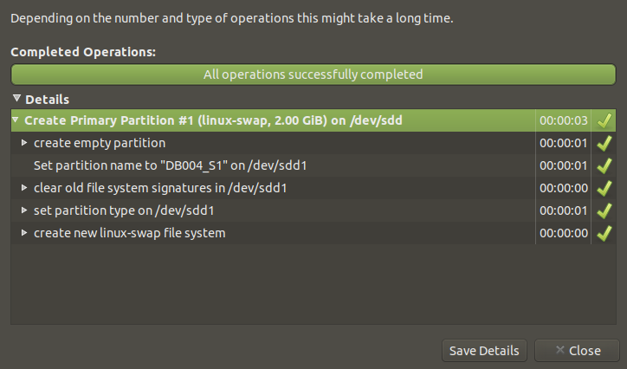
You can look at the details of each step in the creation by clicking on the left-side expander icons. It is recommended that you save the creation details for later reference in trying to repair or recover partitions on a damaged disk. For that reason, the log file containing the details should be kept on a disk other that that which was formatted, and possibly on USB for safekeeping and portability. After clicking on “Close”, the main Gparted screen will be updated to show as follows:

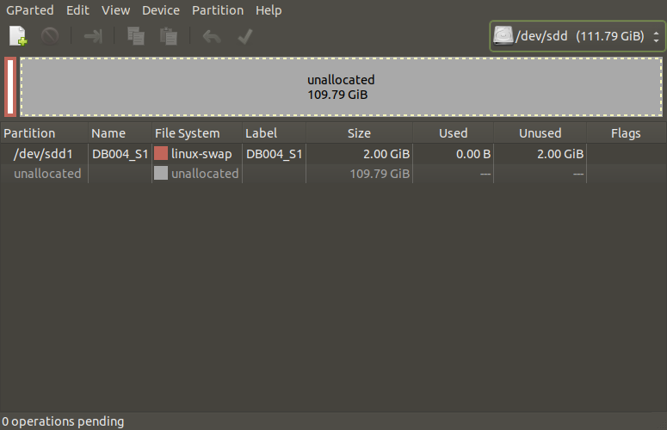
The new partition is now listed and its placement is highlited by the coloured block at the left end of the bar representing the partition locations on disk. Next we do similarly for the data partition which will become the root partition of the new system, using:

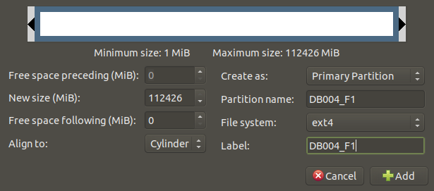

In this case, we used “F” for data filesystem in the partition nomenclature. Repeating the steps used for the swap space, we see the actions reported by Gparted as follows:

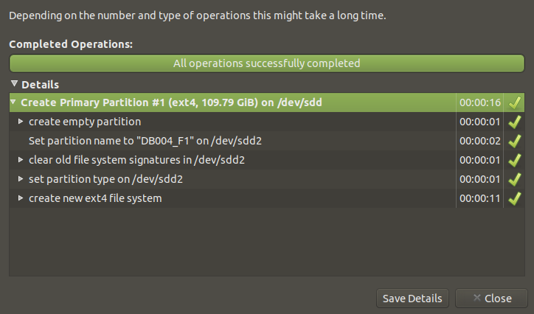

Gparted shows our new partition as follows:

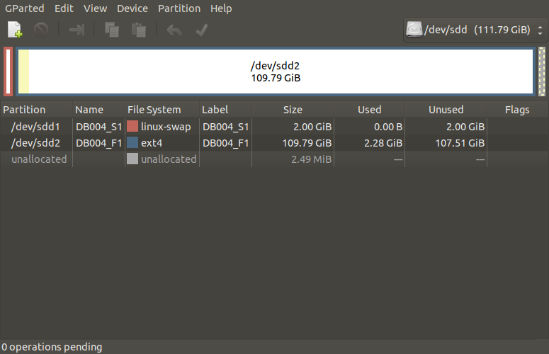
Lastly, we need to right-click on the intended root partition (DB004_F1) and choose the option “Manage flags”. On the pop-up window, click next to “boot”. You will see that the OS has built-in logic to also add the check next to “esp”.

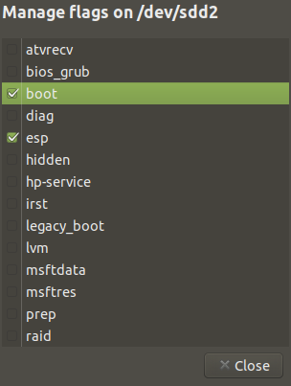
Click on “Close”, and Gparted now presents us with the disk setup which is ready for the installation of the new UbuntuMATE OS:

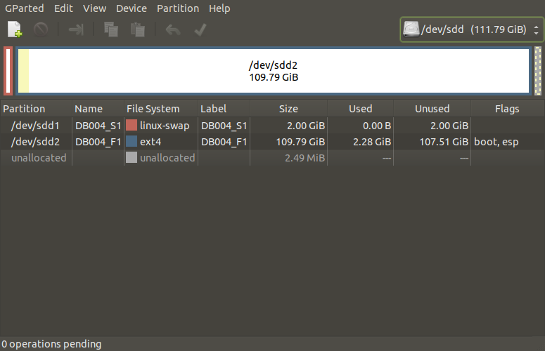
The selected flags are now also visible under the “Flags” column.
If the target disk has been re-assigned from a previous usage, there may be need to have the filesystem “repaired” in that any bad blocks need to be identified and and replaced by new blocks from those found the the “unallocated” portion of the disk, which was intended for that purpose.

Appendix III - Modification of /etc/ssh/ssh_config

This file must be modified to ensure proper level of security is implemented.

Step 1: Keep an image of the installation version:

cp -p /etc/ssh/ssh_config /etc/ssh/ssh_config.DISTRO

Step 2: Create local master copy for making changes:

cp -p /etc/ssh/ssh_config /etc/ssh/ssh_config.OasisMini

Step 3: Update contents of /etc/ssh/ssh_config.OasisMini by adding the following lines at the bottom of the file:

####################################################################
###
### Custom settings for OasisMini
###
####################################################################

### Group 1 - Restrictive
PermitRootLogin no ## OasisAdmin
ForwardAgent no ## OasisAdmin
ForwardX11 no ## OasisAdmin
ForwardX11Trusted no ## OasisAdmin

### Group 2 - Permissive
AllowUsers nonexistent ## OasisAdmin

####################################################################
###
### END OF FILE
###
####################################################################

Step 4: Update contents of /etc/ssh/ssh_config by overwriting it as follows:

cp -p /etc/ssh/ssh_config.OasisMini /etc/ssh/ssh_config

Appendix III
Topic 1
package 1 (OK; defer)
package 2 (OK; defer)

Topic 2
package 1 (OK; defer)
package 2 (OK; defer)

Topic 3
package 1 (OK; defer)
package 2 (OK; defer)

Appendix IV
Topic 1
package 1 (OK; defer)
package 2 (OK; defer)

Topic 2
package 1 (OK; defer)
package 2 (OK; defer)

Topic 3
package 1 (OK; defer)
package 2 (OK; defer)

