Internal Standard – Oasis

v 1.1 – March 15 2020 – E. Marceau
v 1.2 – July 3 2020

Site Configuration Guide

–

User Interface – System Clock

Network Time Synchronization - NTP

It is “best practice” to keep computer clocks synchronized with a refefence clock on designated “time servers” that offer that service on the internet.
To achieve that, we must first install the following packages:
Under Ubuntu 20.04 LTS:
  - systemd-timesyncd .
Once installed, there is no longer any need to worry about the computer clock being accurate.
To ensure that functionality is in fact activated, you follow the steps in the next section.

Things are not as simple with 18.04 LTS. For that the related packages are:
  - ntp and
  - ntp-doc .
You are referred to those documents for further guidance on how to implement time sync.

Installation Tweak for Timezone Pointer

For the system to recognize “Ottawa” as a location for setting time, enter the following sequence of commands at the command line prompt:
cd “/usr/share/zoneinfo/America” ; ln -s ./Toronto ./Ottawa

FUTURES: create file for each Capital of Canada’s provinces and the Country
Existing files for:
- Vancouver (vs Victoria)
- Edmonton (vs Calgary ?)
- Regina
- Winnipeg
- Toronto (vs Ottawa)
- Montreal (vs Quebec)
- Halifax (vs Moncton/Fredericton, Charlottetown)
- St-Johns
- Whitehorse
- Yellowknife
- Iqaluit

Settings – Preferences – Time and Date

To ensure Network Time Synchronization with a reference clock visible on the internet, go to the Control Center, then click on
“System Clock”

For Ubuntu 20.04 LTS
This distro now has pre-installed NTP functionality as a systemd service and activated to work in sync with the Time Zone selected during the installation. This is seen as follows:
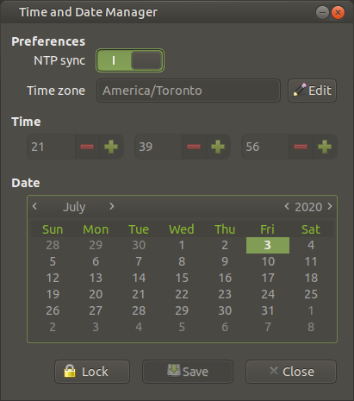

For Ubuntu 18.04 LTS
If the date function has not been locked for synchronization with an internet-based time-server, the following will appear:
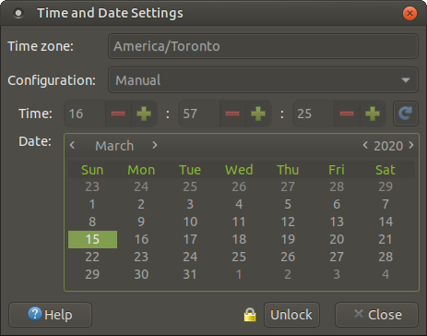
If that is the case,
- click on “Unlock”,
- next to “Configuration”, select “Keep synchronized with internet servers”, then
- click on “Lock” to secure the setting.
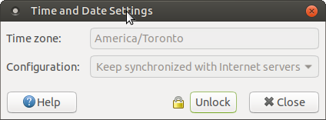
=== END ===

