Internal Standard – Oasis

v 1.1 – March 15 2020 – E. Marceau
v 1.2 – July 3 2020
v1.3 – November 3 2020

Site Configuration Guide

–

User Interface – Login Window

Preferences – Appearance

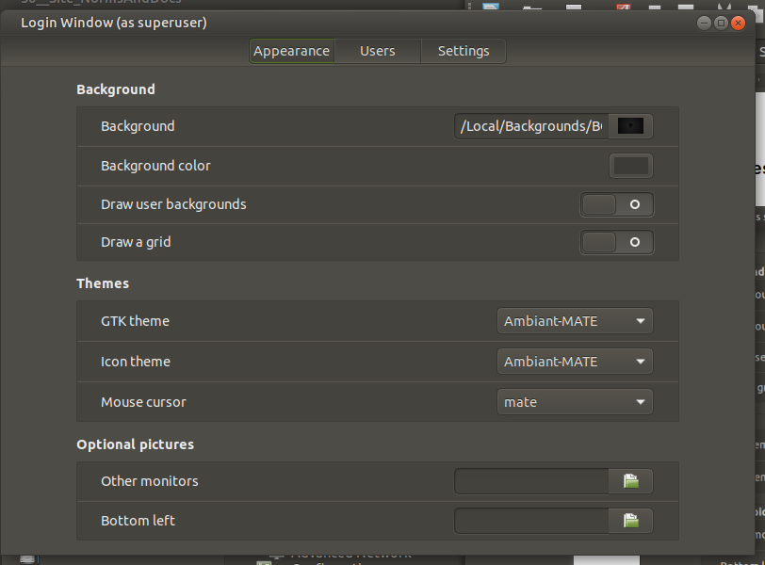
Note: The default login background at distro installation is:

“/usr/share/backgrounds/ubuntu-mate-common/Green-Wall-Logo-Text.png” .

To change the default, click on the image icon next to “Background”, then navigate to the folder:

“/Local/Backgrounds”

From the items listed, select following file for background:

“BG__Login_00__Ubuntu-MATE_WordMark_Modified_1440x900.png.

Settings – Preferences – Background

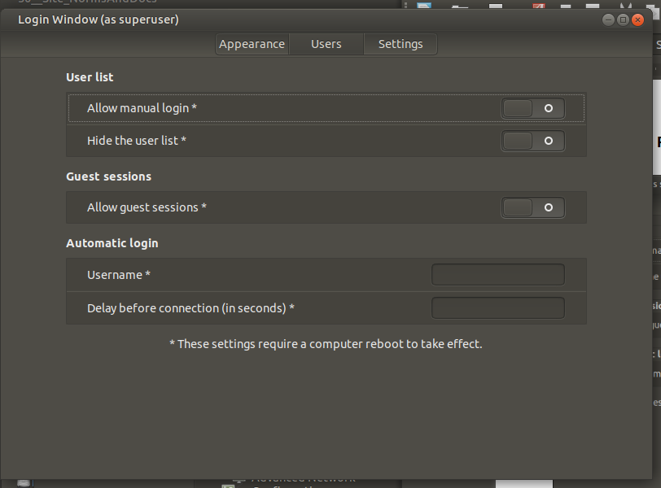

Settings – Preferences – Settings

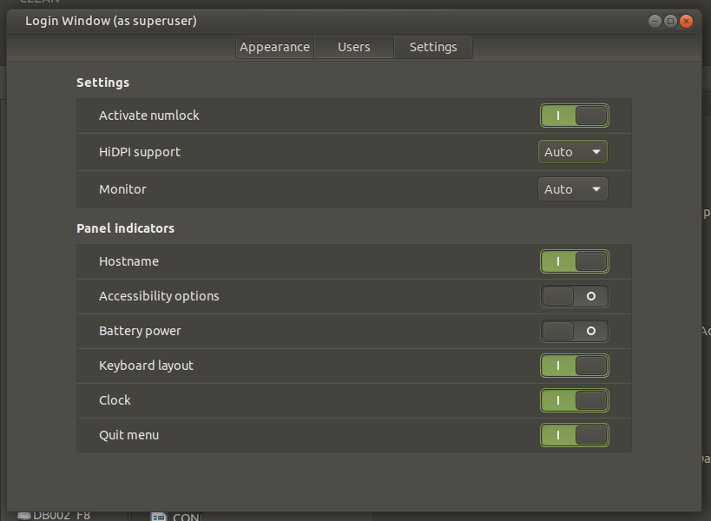

NOTE: Before being able to select the “Activate numlock” option, you must install the package “numlockx”.

=== END ===

