Internal Standard – Oasis

v 1.1 – March 15 2020 – E. Marceau

Site Configuration Guide

–

OS Admin – Startup Applications

Settings – Preferences – Startup Programs
At distro install, the default is to have a check mark in the box next to “Update Notifier”, as seen below:
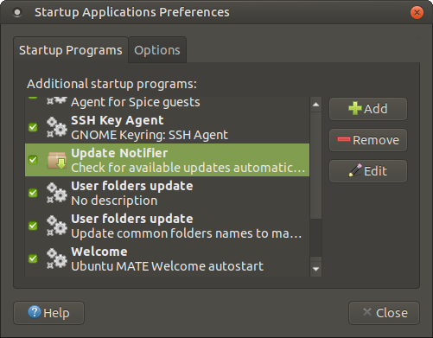
Click on that check mark to remove it, as seen below, in order to disable the “Update Notifier”:

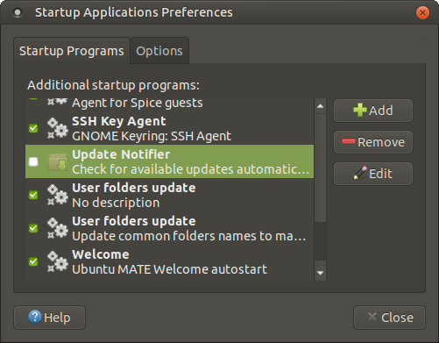
Similarly, click on the check mark next to “Screensaver” in order to disable that function:

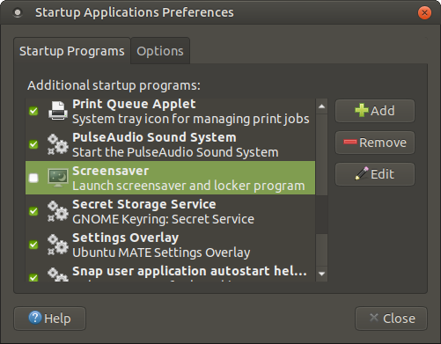

Settings – Preferences – Options

To ensure that the next login session starts fresh, and does not present applications with open files as left at the end of the last session, click on the check mark next to “Screensaver” in order to disable that function:

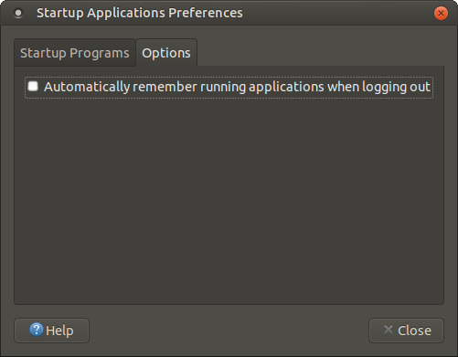

=== END ===

