Internal Standard – Oasis

v 1.1 – March 15 2020 – E. Marceau
v 1.2 – July 3 2020
v1.3 – November 3 2020 – PENDING

Site Configuration Guide

–

OS – User Settings

This needs to be populated with proper images that have already been captured.

Users Settings – User Name

Open “Users Settings”, select the user from choices listed in the upper left box, then click on “Change” at the top right. This will give the window where the user’s name entered at the DISTRO installation can be selected, then deleted, then saved/committed. The system will now use the userid as the user’s name, as seen in the below image:

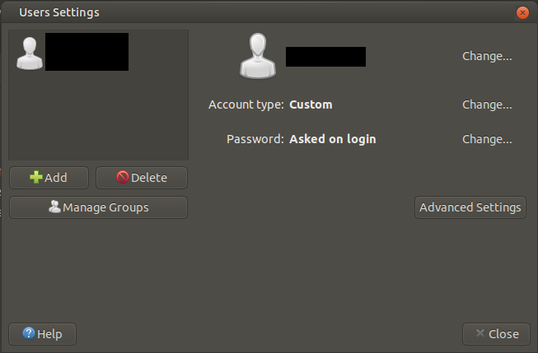

Users Settings – Contact Information

On the screen for the same user, by clicking on “Advanced Settings”, a new pop-up gives access to modify other properties and privileges for that user.

On the “Contact Information” tab, it is suggested that you enter the name of the “organization” that you have assigned to yourself, as seen in the example below:

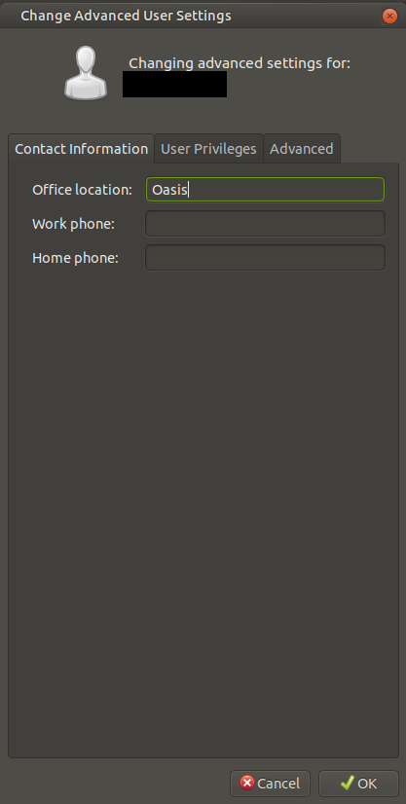

Users Settings – User Privileges

On the “User Privileges” tab, you can change other privilege settings for the same user as per this example:

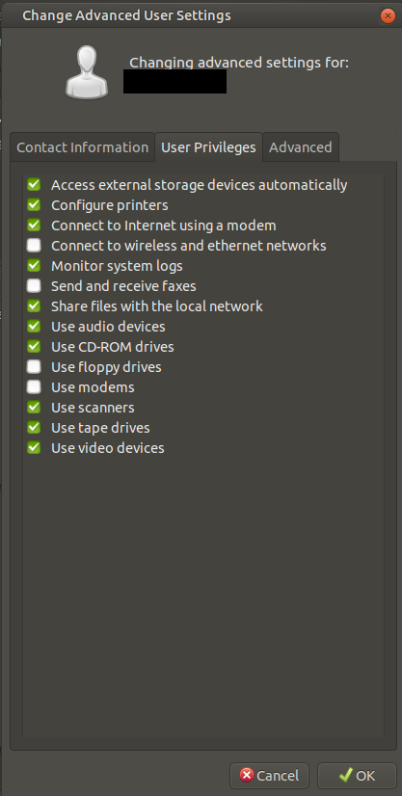

Users Settings – Advanced

On the “Advanced Settings” tab, system access can be disabled for any user, accept the designated privileged Administrator user. This tab can also be used to modify the shell that is assigned to the user at login.

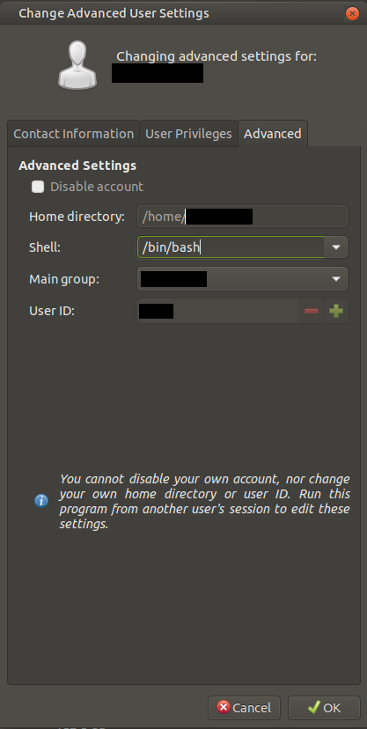

Users Settings – tbd

=== END ===

