Internal Standard – Oasis

v 1.1 – March 15 2020 – E. Marceau
v 1.2 – July 3 2020
v1.3 – November 3 2020

Site Configuration Guide

–

User Interface – Keyboard

Settings – Preferences – General

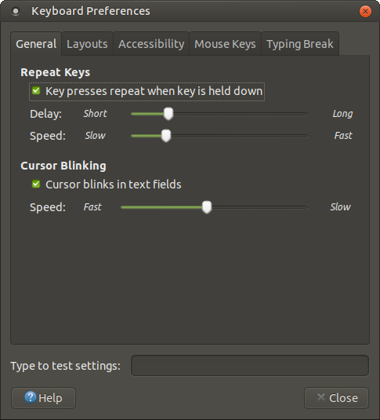

Settings – Preferences – Layouts

Click on the button next to “Keyboard Model”, then choose the following for the specific keyboard layout:
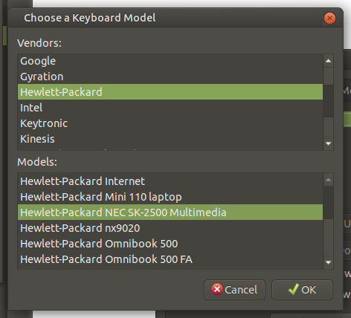

After clicking on OK, the “Layouts” tab will update to show as follows:
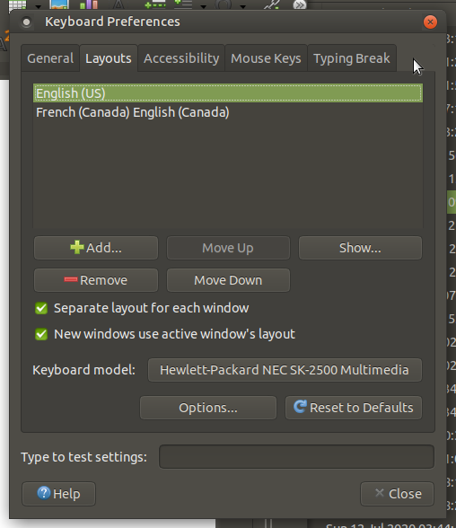

Settings – Preferences – Accessibility

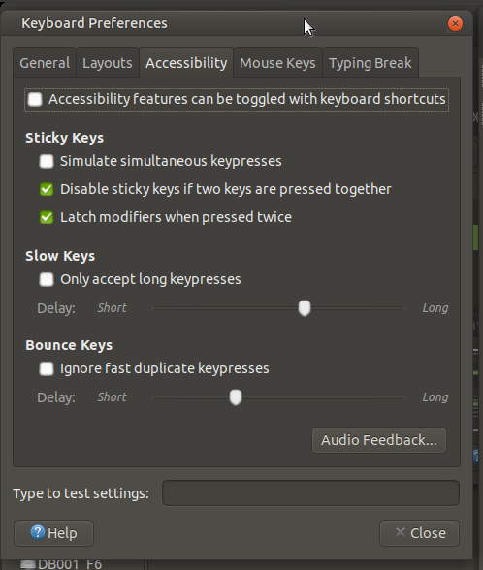

Settings – Preferences – Mouse Keys

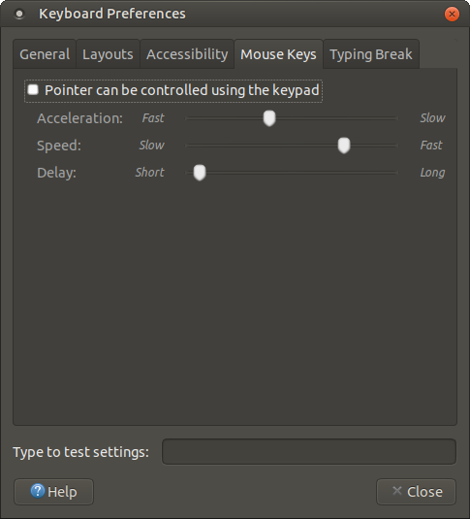

Settings – Preferences – Typing Break

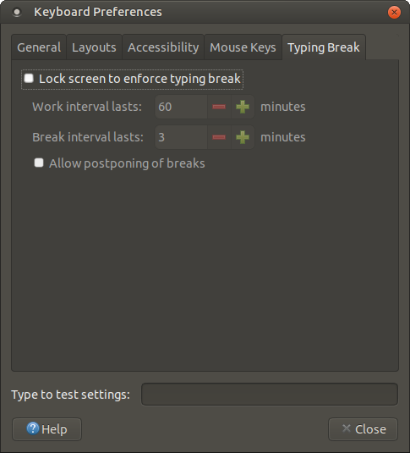

=== END ===

