Stephie and Eric’s Wedding Keychain Keepsake
Thank you for celebrating our special day with us! It’s our pleasure to share this keepsake gadget with the people who have inspired, supported, and helped shape who we are today. This interactive, custom-made keychain displays a bright grid of LED lights and features simple animations and games.
Power Switch
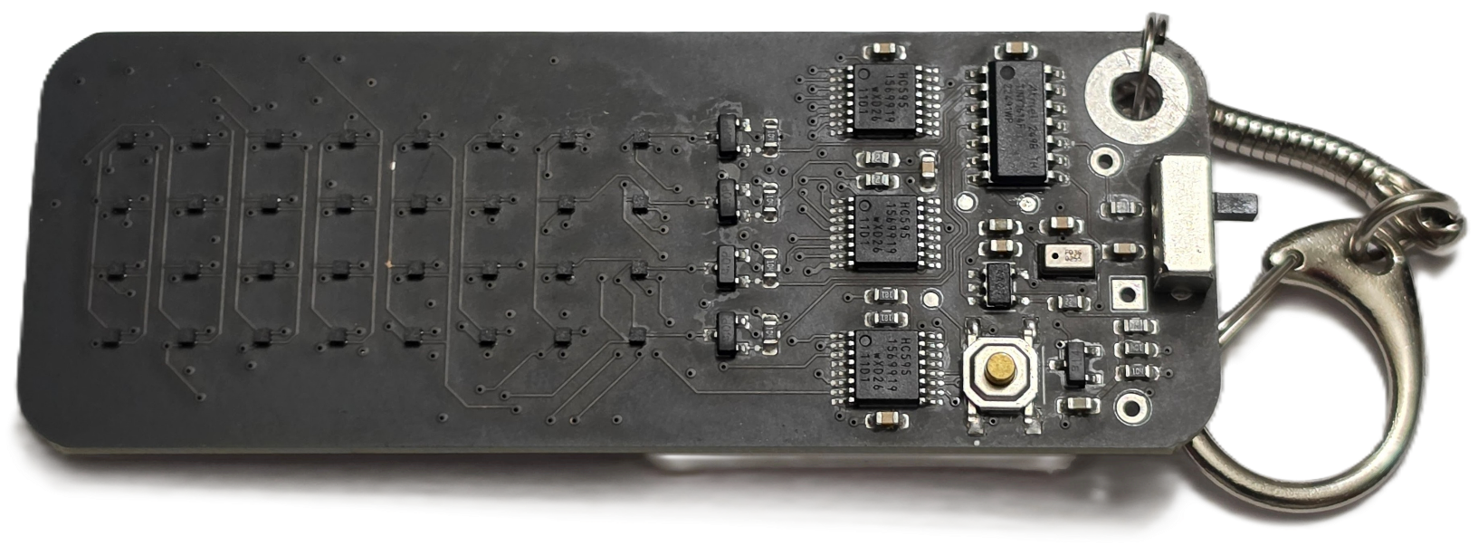
Tactile Push Button
8 x 4 LED Matrix
How to Start
Fully remove the keychain from its enclosure. Power it by sliding down the switch on the right side. The LED matrix will light up and start in either Animation mode or Game mode. You interact with the keychain using the tactile push button on the bottom right edge of the circuit board, using either single-presses or by holding the button down.
How to Use
Hold the button down to switch between modes.
Game Mode  Dodge is an endless runner arcade survival game. You are a space shuttle traveling through the solar system, and you must evade space debris before it collides into you.  Single-press the button to steer your rocket in the opposite direction to dodge obstacles. |  | Animation Mode  Single-press the button to cycle through the animations  - Tunnel  - Swipe  - Rainbow  - American Flag  - Candle
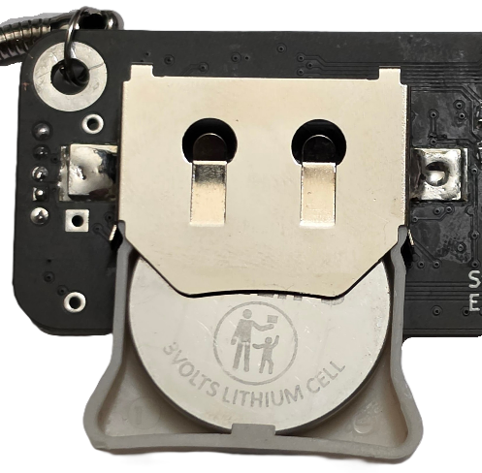 | Replacing the Battery  This keychain is powered using a CR2450 battery. It is attached on a sled for easy removal.  Take note of the orientation of the battery. Do NOT reverse the polarity. When replacing it, be sure to place the button’s belly (-) flat on the circuit board, as shown on the left.
For the Nerds  This entire project is free and open sauce. It includes all PCB design and CAD enclosure files configured for manufacture and FDM printing. |  | 

