Workshop #2: The energy sector
ENST 320
Spring 2023
Instructions:
- Save a copy of this document to your own Drive so that you can edit it.
- You may work on this with others, but your answers must be your own, typed manually by you.
- For each question, replace the “Your code/answer/plot goes here” line with your response. (For plots, you can take a screenshot of your plot from R).
- When you are done, save your doc as a PDF then submit via this form.
Note that submissions will be assessed using this rubric.

(1) Your name:
Your answer goes here.

(2) “Library” packages
Show the code needed to load the following packages for use in your R session. Make sure these lines of code work when you run them. If any of these packages are not installed on your R account, install them and show the code for how you did so.
- dplyr
- ggplot2
- readr
- tidyr
- plotly
- gapminder
Your answer goes here.
# Answer key
library(dplyr)
library(ggplot2)
library(readr)
library(tidyr)
library(plotly)
library(gapminder)

“Read in” the data
In this workshop we will use a massive energy consumption database maintained by the International Renewable Energy Agency. This dataset is publicly available online.
Use the code below to read in this dataset and rename its columns.
url <- 'https://raw.githubusercontent.com/ericmkeen/sewanee_esus/master/02_energy_sector/electricity_generation.csv'
# Read in dataset
energy <- read_csv(url, skip=2)
# Rename columns
names(energy) <- c('country', 'technology', 'grid', 'year', 'electricity')
# Ensure `electricity` column is treated as numeric values
energy$electricity <- as.numeric(energy$electricity)

(3) View your data
Show the code you would use to view this entire dataset within a new tab in R.
Your answer goes here.
# Answer key
energy %>% View

(4) Get unique countries in data
Show the code to view the unique values in the country column.
Your answer goes here.
# Answer key
energy$country %>% unique

Sources of energy

(5) Plot annual energy use by source for United States
Show the code you would need to filter this dataset to the "United States of America’, then plot annual trends in energy use, displaying energy source in a different color. Provide a screenshot of your plot.
Your code goes here.
Your screenshot goes here.
# Answer key
usa <- energy %>% filter(country == 'United States of America')
ggplot(usa,
aes(x=year,
y=electricity,
color=technology)) +
geom_line()
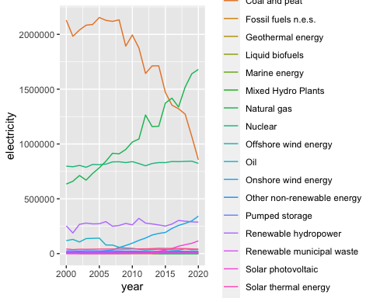

(6) Total energy use by United States (all sources)
Now plot the TOTAL energy consumption by the USA in each year. Do this by grouping all of the energy sources together for each year. On your plot, use a line graph that also has points for each year.
Your code goes here.
Your screenshot goes here.
# Answer key
usa_total <-
usa %>%
group_by(year) %>%
summarize(total = sum(electricity, na.rm=TRUE))
ggplot(usa_total,
aes(x=year,
y=total)) +
geom_line() +
geom_point()
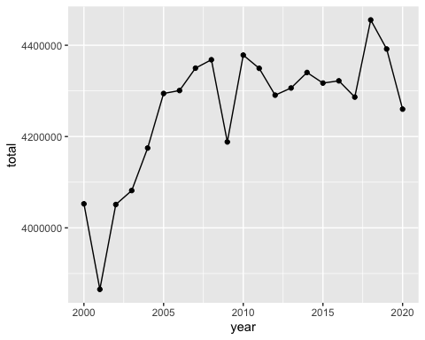

(7) How would you explain the downward blips in 2001, 2009, and 2020?

Your answer goes here.

# Answer key
# 9/11, Great Recession, and COVID

(8) Total energy use by United States & China
Producea similar plot as the previous prompt, this time including BOTH the USA AND China.
Your code goes here.
Your screenshot goes here.
# Answer key
top_two <-
energy %>%
group_by(country, year) %>%
summarize(total = sum(electricity, na.rm=TRUE)) %>%
filter(country %in% c('United States of America', 'China'))
ggplot(top_two,
aes(x=year,
y=total,
color=country)) +
geom_line() +
geom_point()
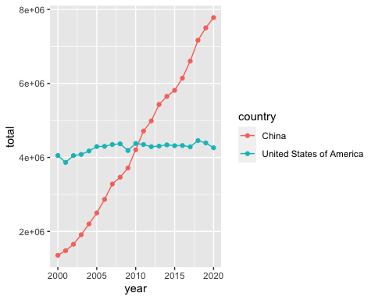

(9) In what year did China surpass the USA in energy use, and in what year do you expect China to double US energy use?

Your answer goes here.

# Answer key
# 2010/2011 and 2022

(10) Find the top 10 energy consumers in 2020.
Show the code you would use to return the names of the top 10 energy-consuming countries and save the result in an object namd top_ten.
Your code goes here.
Your screenshot goes here.
# Answer key
top_ten <-
energy %>%
filter(year == 2020) %>%
group_by(country) %>%
summarize(total = sum(electricity, na.rm=TRUE)) %>%
arrange(total) %>%
tail(10) %>%
pull(country)
top_ten
## [1] "France" "Germany"
## [3] "Republic of Korea" "Brazil"
## [5] "Canada" "Japan"
## [7] "Russian Federation" "India"
## [9] "United States of America" "China"

(11) Plot energy use over time for those top 10 countries.
Your code goes here.
Your screenshot goes here.
# Answer key
energy10 <-
energy %>%
group_by(country, year) %>%
summarize(total = sum(electricity, na.rm=TRUE)) %>%
filter(country %in% top_ten)
ggplot(energy10,
aes(x=year,
y=total,
color=country)) +
geom_line() +
geom_point()
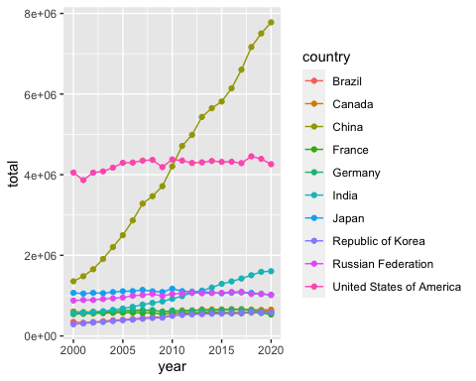

(12) Changing focus from country-by-county production to technology: plot global annual use of each energy technology.
Your code goes here.
Your screenshot goes here.
# Answer key
by_source <-
energy %>%
group_by(technology, year) %>%
summarize(total = sum(electricity, na.rm=TRUE))
ggplot(by_source,
aes(x=year,
y=total,
color=technology)) +
geom_line() +
geom_point()
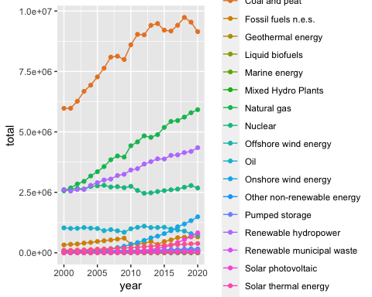

The rise of renewable energy
Let’s focus on some of the top renewable energy sources. Use the code below to create an object with the names of four technologies we will focus on.
four_renewables <-c('Solar photovoltaic',
'Onshore wind energy',
'Offshore wind energy',
'Biogas')

(13) Plot global trends in the use of these 4 renewables over time.
Your code goes here.
Your screenshot goes here.
# Answer key
renewables <-
energy %>%
group_by(technology, year) %>%
summarize(total = sum(electricity, na.rm=TRUE)) %>%
filter(technology %in% four_renewables)
ggplot(renewables,
aes(x=year,
y=total,
color=technology)) +
geom_line()
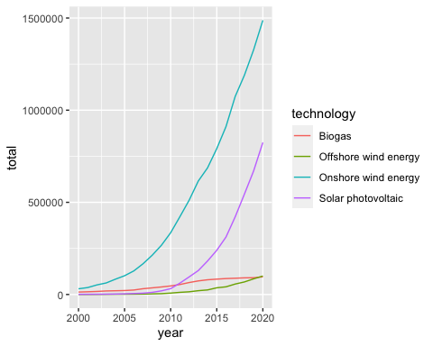

(14) Plotting area instead of lines
To plot these data a different way, use geom_area() instead of geom_line(). (Also: in your aes() argument, change color to fill):
Your code goes here.
Your screenshot goes here.
# Answer key
ggplot(renewables,
aes(x=year,
y=total,
fill=technology)) +
geom_area()
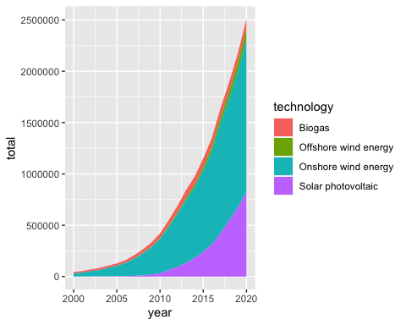

(15) Which two types of renewable energy have experienced the most growth in the past two decades?

Your answer goes here.

(16) National share of renewable energy by country
Now let’s look at all forms of renewable energy together (setting aside hydropower for now, since it has some complicated environmental impacts on rivers). The code below will show you a graph of trends in renewable energy use, in which each line represents a single country.
# Identify which technologies are renewable
(energy_sources <- energy$technology %>% unique)
## [1] "Solar photovoltaic" "Solar thermal energy"
## [3] "Onshore wind energy" "Offshore wind energy"
## [5] "Renewable hydropower" "Mixed Hydro Plants"
## [7] "Pumped storage" "Marine energy"
## [9] "Solid biofuels" "Renewable municipal waste"
## [11] "Liquid biofuels" "Biogas"
## [13] "Geothermal energy" "Coal and peat"
## [15] "Oil" "Natural gas"
## [17] "Nuclear" "Fossil fuels n.e.s."
## [19] "Other non-renewable energy"
(renewable_sources <- energy_sources[c(1, 3, 4, 8, 9, 10, 11, 12, 13)])
## [1] "Solar photovoltaic" "Onshore wind energy"
## [3] "Offshore wind energy" "Marine energy"
## [5] "Solid biofuels" "Renewable municipal waste"
## [7] "Liquid biofuels" "Biogas"
## [9] "Geothermal energy"
# Create the dataset to use for plotting
shares <-
energy %>%
# Create a new column indicating Renewable or Non-renewable
mutate(type = ifelse(technology %in% renewable_sources, 'Renewable', 'Non-renewable')) %>%
# Join the gapminder dataset to the energy dataset, to get continent info
left_join(gapminder %>% select(country, continent)) %>%
group_by(continent, country, year) %>%
# Determine the share of each country's energy use that comes from renewables
summarize(total = sum(electricity, na.rm=TRUE),
renewable = sum(electricity[type=='Renewable'], na.rm=TRUE),
share = renewable/total) %>%
filter(!is.na(continent))
# Plot it
ggplot(shares,
aes(x=year,
y=share,
group = country)) +
geom_line() +
facet_wrap(~continent)
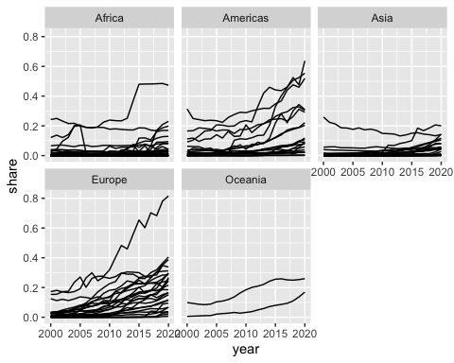

Now use the ggplotly() command to make this into an interactive graph that shows you details as you hover your mouse cursor over each country’s line.
Your code goes here.

# Answer key goes here
ggplotly()

(17) For each continent, which country currently uses the highest share of renewable technology in its energy mix?

Your answer goes here.

(18) Rank the top 5 countries leading the world in converting their energy mix to renewables.

Your answer goes here.

Cost of energy production
Let’s bring in one more dataset: trends in the cost of energy sources over time. This dataset is maintained by Our World in Data.
Use this code to read in the dataset:
url <- 'https://raw.githubusercontent.com/ericmkeen/sewanee_esus/master/02_energy_sector/levelized-cost-of-energy.csv'
costs <- read_csv(url)

(19) Show column names of costs.
Your code goes here.
# Answer key
costs %>% names
## [1] "country" "year" "source" "cost"

(20) View the costs dataset.
Your code goes here.
# Answer key
costs %>% View

(21) Make a simple point plot of cost trends.
Plot annual energy costs (y axis) by year (x axis), color-coding by source. To make your plot prettier, make your points translucent by adding alpha=0.4 inside your geom_point() command.
Your code goes here.
Your screenshot goes here.
# Answer key
ggplot(costs,
aes(x=year,
y=cost,
color=source)) +
geom_point(alpha=.4)
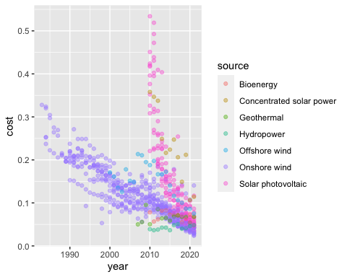

(22) Why are there multiple points for each source in each year?
View the data in order to figure out why.
Your answer goes here.
# Answer key
# Because there are data for multiple countries in each year

(23) Add a smooth line
To better visualize the trends in cost for each energy source, let’s add smoothed regression lines to your plot. To do so, add this line to your ggplot() code:
+ geom_smooth(se=FALSE)
Your code goes here.
Your screenshot goes here.
# Answer key
ggplot(costs,
aes(x=year,
y=cost,
color=source)) +
geom_point(alpha=0.4) +
geom_smooth(se=FALSE)
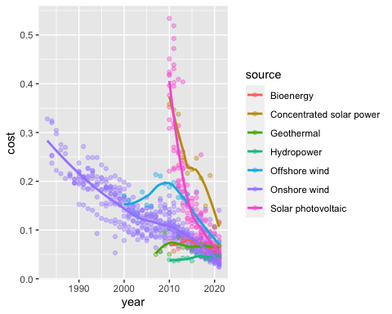

(24) Enhance the style of your plot.
Remember that the overall design of your ggplot() can be changed by adding theme_minimal() to your plot. Also update the axis labels to read “Year” and “Levelized cost of energy”.
Your code goes here.
Your screenshot goes here.
# Answer key
ggplot(costs,
aes(x=year,
y=cost,
color=source)) +
geom_point(alpha=0.4) +
geom_smooth(se=FALSE) +
xlab("Year") +
ylab("Levelized cost of energy") +
theme_minimal()
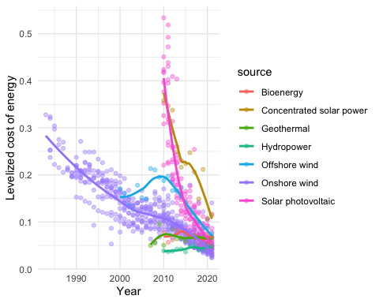

(25) Add horizontal lines indicating the normal range of fossil fuel prices.
To help the reader get a sense of how the coss of these renewable energy sources compare to conventional fossil fuel prices, we can add horizontal lines that indicate the typical price range of non-renewable fuels. The command for adding a horizontal line is …
+ geom_hline(yintercept = XX, lty=2, size=1, alpha=.3)
Add this to your ggplot() command twice – once for the lower limit of fossil fuel prices (0.05), and once for the upper limit (0.18). Replace the XX with the prices in the previous sentence.
You can also annotate your plot with text explaining what those horizontal lines indicate. The command for that is …
+ annotate('text', x=XX, y=XX, label='Price range of fossil fuels', alpha=.4, size=3)
All you need to do is add this to your ggplot() command then select x and y values for the two XX placeholders above. This may require trial and error – keep revising your x and y values until the annotation is placed perfectly on your plot.
Your code goes here.
Your screenshot goes here.
# Answer key
ggplot(costs,
aes(x=year,
y=cost,
color=source)) +
geom_point(alpha=0.4) +
geom_smooth(se=FALSE) +
xlab("Year") +
ylab("Levelized cost of energy") +
theme_minimal() +
geom_hline(yintercept = 0.18, lty=2, size=1, alpha=.3) +
geom_hline(yintercept = 0.05, lty=2, size=1, alpha=.3) +
annotate('text', x=1987, y=0.06, label='Price range of fossil fuels', alpha=.4, size=3)
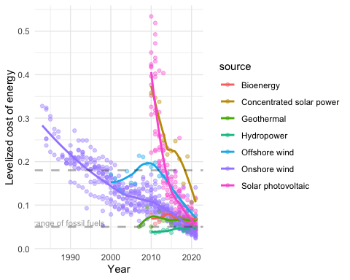

(26) Which renewable sources are currently just as affordable as typical fossil fuels?
Your answer goes here.
# Answer key:
# All of them.

(27) When did solar become as affordable as typical fossil fuels, and when would you expect it to become more affordable than fossil fuels?
Your answer goes here.
# Answer key:
# Solar was not comparably affordable until 2014, and it should have surpassed the affordability range of fossil fuels in 2022.

(28) Design your own plot!
Use the energy dataset or the costs dataset to produce a plot of your own focus and design. It can use whichever columns you wish, and as many countries as you wish. Make your plot beautiful, and give it a title to make it clear what you are showing.
Your code goes here.
Your screenshot goes here.

