Workshop #6: Mapping injustice
ENST 320
Spring 2023
Instructions:
- Save a copy of this document to your own Drive so that you can edit it.
- You may work on this with others, but your answers must be your own, typed manually by you.
- For each question, replace the “Your code/answer/plot goes here” line with your response. (For plots, you can take a screenshot of your plot from R).
- When you are done, save your doc as a PDF then submit via this form.
Note that submissions will be assessed using this rubric.

(1) Your name:
Your answer goes here.

(2) “Library” packages
Show the code needed to load the following packages for use in your R session. Make sure these lines of code work when you run them. If any of these packages are not installed on your R account, install them and show the code for how you did so.
- dplyr
- ggplot2
- leaflet
- sf
- viridis
Your answer goes here.

# Answer key
library(dplyr)
library(ggplot2)
library(leaflet)
library(sf)
library(viridis)

The SEPHER dataset
Our goal today is to explore and map the relationship between social and environmental injustice. To do so we will draw upon Columbia University’s famous SEPHER dataset (see related publication here). This dataset summarizes socioeconomic demographics, housing status, and exposure to environmental risks (e.g., tornadoes, wildfires, flooding, etc.) for every census tract in the United States (see maps of those tracts here).
This is dataset is enormous: for each census tract (there are about 86,000), the SEPHER dataset contains over 1,600 variables for every year from 2000 to 2016. It’s a goldmine!
To make this dataset more manageable, Ezell has filtered it down to only 174 variables in the year 2016 only. You can load that filtered dataset with the following code:
load(url('https://github.com/ericmkeen/sewanee_esus/blob/master/08_mapping_injustice/SEPHER_2016.rds?raw=true'))
Check out your “Environment”, and you should see a new data object named sepher. Here’s what the first six rows of the first 10 columns should look like:
sepher[1:6, 1:10]
## # A tibble: 6 × 10
## FIPS NAME PAREN…¹ COUNTY POPUL…² POVER…³ PCT.R…⁴ MEDIA…⁵ MEDIA…⁶ MEDIA…⁷
## <chr> <dbl> <chr> <chr> <dbl> <dbl> <dbl> <dbl> <dbl> <dbl>
## 1 01001020… 201 AUTAUG… AUTAU… 1948 5.12 27.3 719 61838 149100
## 2 01001020… 202 AUTAUG… AUTAU… 2156 20.0 40.6 805 32303 97900
## 3 01001020… 203 AUTAUG… AUTAU… 2968 7.36 28.1 738 44922 110600
## 4 01001020… 204 AUTAUG… AUTAU… 4423 1.43 16.9 1095 54329 134700
## 5 01001020… 205 AUTAUG… AUTAU… 10763 7.76 46.5 959 51965 174300
## 6 01001020… 206 AUTAUG… AUTAU… 3851 5.58 22.4 784 63092 122800
## # … with abbreviated variable names ¹​PARENT.LOCATION, ²​POPULATION_2016,
## # ³​POVERTY.RATE_2016, ⁴​PCT.RENTER.OCCUPIED_2016, ⁵​MEDIAN.GROSS.RENT_2016,
## # ⁶​MEDIAN.HOUSEHOLD.INCOME_2016, ⁷​MEDIAN.PROPERTY.VALUE_2016
Every row is a census tract. To understand what each column means, load & View this key:
load(url('https://github.com/ericmkeen/sewanee_esus/blob/master/08_mapping_injustice/key_sepher.rds?raw=true'))
# That code saves a dataframe named `key`.
key %>% View
This dataset allows you to explore the correlation between socioeconomic factors, housing status, and environmental risk across the United States.

(3) Produce a scatterplot displaying the relationship between the percent-whiteness of a community (column PCT.WHITE_2016) and its poverty rate (column POVERTY.RATE_2016).
Your code goes here.
Your screenshot goes here.
# Answer key
ggplot(sepher, aes(y=POVERTY.RATE_2016,
x=PCT.WHITE_2016)) +
geom_point(alpha=.1) +
labs(title = 'More whiteness, less poverty')
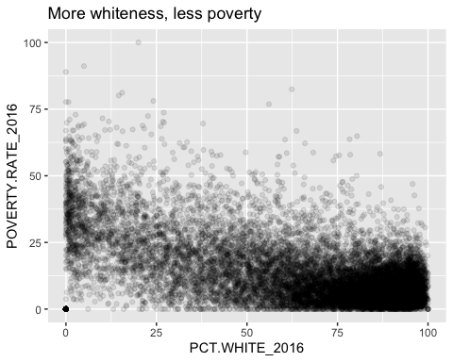

(4) Produce a plot comparing the distribution of environmental risk exposure (RISK_SCORE) across census tracts in California (CA) vs. Florida (FL). Note that state abbreviations are in the column ST_ABBR.
Your code goes here.
Your screenshot goes here.
# Answer key
ggplot(sepher %>% filter(ST_ABBR %in% c('CA', 'FL')),
aes(x=RISK_SCORE,
fill=ST_ABBR)) +
geom_density(alpha=.4)
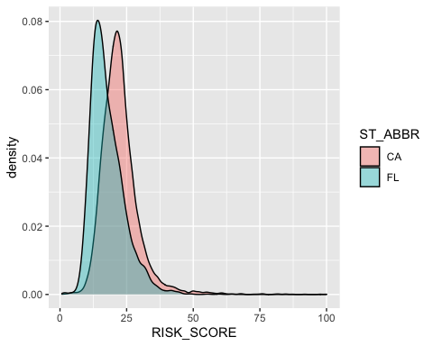

(5) Produce a plot that explores the relationship between environmental risk exposure (RISK_SCORE) and median household income (MEDIAN.HOUSEHOLD.INCOME_2016).
Your code goes here.
Your screenshot goes here.
# Answer key
ggplot(sepher, aes(y=RISK_SCORE,
x=MEDIAN.HOUSEHOLD.INCOME_2016)) +
geom_point(alpha=.1)
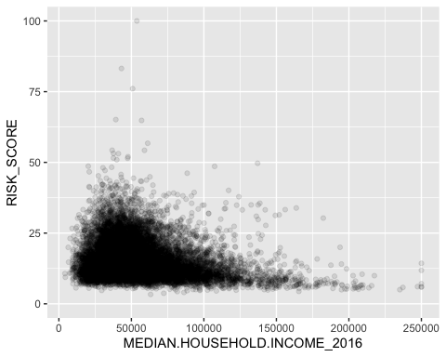

(6) Devise your own justice-related question and make a plot that answers it
Your question goes here.
Your code goes here.
Your screenshot goes here.

Mapping census tracts
Here is a dataset with census tract polygons for mapping.
load(url('https://github.com/ericmkeen/sewanee_esus/blob/master/08_mapping_injustice/census_tracts.rds?raw=true'))
After running that code, your Environment should have a dataset named tracts. That dataset is known as a sf object, which refers to the package (sf) that is used to work with spatial data in R. Check out the head of the dataset:
tracts %>% head
## Simple feature collection with 6 features and 10 fields
## Geometry type: MULTIPOLYGON
## Dimension: XY
## Bounding box: xmin: -88.1923 ymin: 30.24061 xmax: -85.72531 ymax: 33.75778
## Geodetic CRS: NAD83
## ST STATE ST_ABBR STCNTY COUNTY FIPS
## 1 01 ALABAMA AL 01015 Calhoun 01015981901GID
## 2 01 ALABAMA AL 01015 Calhoun 01015981902GID
## 3 01 ALABAMA AL 01015 Calhoun 01015981903GID
## 4 01 ALABAMA AL 01097 Mobile 01097003605GID
## 5 01 ALABAMA AL 01097 Mobile 01097990000GID
## 6 01 ALABAMA AL 01117 Shelby 01117980000GID
## LOCATION AREA_SQMI Shape_STAr
## 1 Census Tract 9819.01, Calhoun County, Alabama 24.2438650 0.0061048652
## 2 Census Tract 9819.02, Calhoun County, Alabama 34.6467143 0.0087524304
## 3 Census Tract 9819.03, Calhoun County, Alabama 13.9262756 0.0035077366
## 4 Census Tract 36.05, Mobile County, Alabama 0.7322996 0.0001798744
## 5 Census Tract 9900, Mobile County, Alabama 0.0000000 0.0005360645
## 6 Census Tract 9800, Shelby County, Alabama 13.6364786 0.0035017378
## Shape_STLe geometry
## 1 0.33940003 MULTIPOLYGON (((-86.01308 3...
## 2 0.42045900 MULTIPOLYGON (((-86.01713 3...
## 3 0.33016369 MULTIPOLYGON (((-85.78514 3...
## 4 0.06072482 MULTIPOLYGON (((-88.1911 30...
## 5 0.10537987 MULTIPOLYGON (((-88.05235 3...
## 6 0.42317535 MULTIPOLYGON (((-86.78292 3...
That final column, geometry, contains all the data that R needs to know in order to add polygons to a map. But you can still treat this as a dataframe that you can filter, mutate, etc.
To learn how to map, let’s filter the data to just a single state, since trying to plot the entire dataset at once might crash your computer:
cali <- tracts %>% filter(STATE == 'CALIFORNIA')
Now add these California census polygons a ggplot() using a new geom, geom_sf():
ggplot(cali) +
geom_sf()
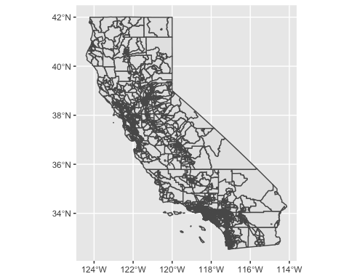

Join SEPHER and census tract data together
Use the following code to join the sepher and tracts datasets together:
mr <- left_join(tracts, sepher, by='FIPS')
Now you have census tract polygon details associated with all of your socioeconomic/environmental data.

Make a “chloropleth”
A chloropleth is a map in which polygons are color-coded according to data.
To make your first chloropleth, let’s filter our dataset down to Tennessee:
mr_tn <- mr %>% filter(STATE == 'TENNESSEE')
Now let’s color-code Tennessee’s census tracts by their per-capita income:
ggplot(mr_tn,
aes(fill=E_PCI_2016)) +
geom_sf(color=NA) +
labs(title='Per-capita income by census tract')
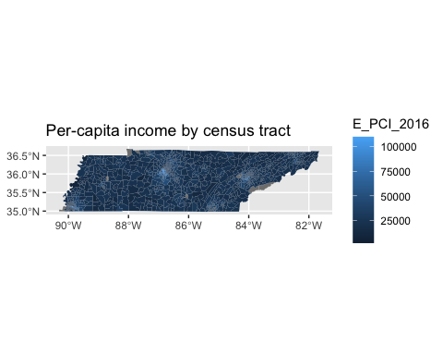
Note that we added color = NA to the geom_sf() call to get rid of thick borders around the census tracts.
These tracts are being color-coded according to a default color scale in ggplot(), but you can specify other color scales thanks to the viridis package:
ggplot(mr_tn,
aes(fill=E_PCI_2016)) +
geom_sf(color=NA) +
scale_fill_viridis(option='magma')
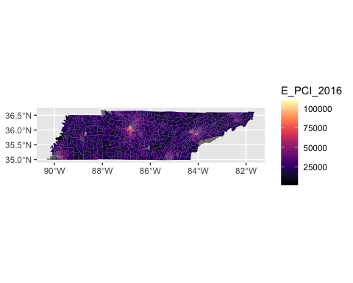

(7) Create a chloropleth map of a state of your own choice, color-coded according to an environmental risk variable of your choice.
Your code goes here.
Your screenshot goes here.
# Example answer
mr_cali <- mr %>% filter(STATE == 'CALIFORNIA')
ggplot(mr_cali, aes(fill=RISK_SCORE)) +
geom_sf(color=NA) +
labs(title='FEMA risk score')
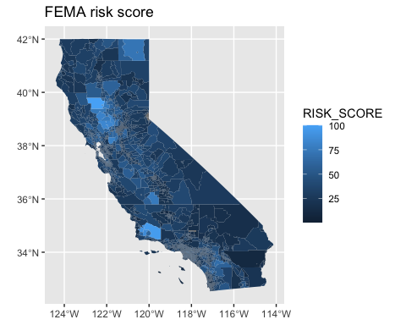

Manually define your map range
You can also crop the census tract data to a range of your choice. For example, you could use this code to crop data to show all census tracts within 1/2 a degree of Sewanee,
# Sewanee's LAT/LON
x <- -85.92
y <- 35.2
# Crop your tracts
socu <- st_crop(mr,
xmin = x - 0.5,
ymin = y - 0.5,
xmax = x + 0.5,
ymax = y + 0.5)
ggplot(socu,
aes(fill=POPULATION)) +
geom_sf() +
geom_point(aes(x=x, y=y),
color='orange',
size=3)
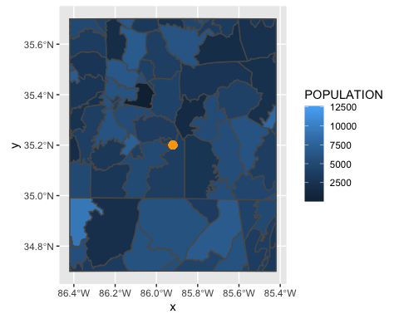

(8) Create a chloropleth map of census tracts in and around the U.S. city of your own choice.
Your code goes here.
Your screenshot goes here.

Air quality
Ezell also downloaded a dataset from the EPA that estimates cancer risk for each census tract based upon air quality. Load that dataset with this code:
load(url('https://github.com/ericmkeen/sewanee_esus/blob/master/08_mapping_injustice/cancer_risk.rds?raw=true'))
Your environment should now have an object named air.
Join the air dataset to your mr dataset.
mra <- left_join(mr, air, by='FIPS')

(9) Produce a plot that displays the relationship between a census tract’s whiteness (PCT.WHITE_2016) and its cancer risk (cancer_risk). Set the y-axis range to 0-70.
Your code goes here.
Your screenshot goes here.
ggplot(mra,
aes(x=PCT.WHITE_2016,
y=cancer_risk)) +
ylim(0, 70) +
geom_point(alpha=.1)
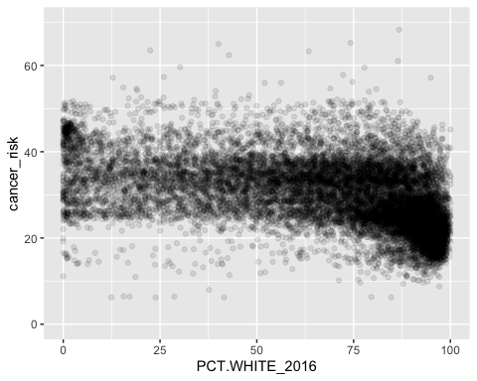

Let’s explore those variables in a different way. Create a new column that categorizes each census tract as very white or less white based on a PCT.WHITE_2016 threshold of 0.5.
You can do this pretty easily using an ifelse statement. Here’s how it works:
mra <- mra %>%
mutate(whiteness = ifelse(PCT.WHITE_2016 > 0.5,
'more white',
'less white'))

(10) Before we plot anything, filter the dataset to rows where whiteness is not NA and cancer_risk is less than 100.
Your code goes here.
# Answer key
mra <- mra %>% filter(is.na(whiteness) == FALSE, cancer_risk < 100)

(11) Now compare the two whiteness categories using a boxplot (use geom_boxplot()).
Your code goes here.
Your screenshot goes here.
# Answer key
ggplot(mra,
aes(x=whiteness, y=cancer_risk)) +
geom_boxplot()
