Whale-ship collision forecast for Gitga’at First Nation waters

Spatially and temporally explicit

METHODS

**Study area**

Figure MAP.

**Vessel data**

*AIS-transmitting vessels*

*Small vessels*

*Tanker simulations*

Data processing

Decide upon geographic strata with representative vessel behaviors

**Fin whale analysis**

*Whale density* – Within the context of a shipping impacts assessment, whale density (whales per km2) represents the probability that a whale will co-occur in the same square-km as a vessel. We estimated fin whale density from design-based line-transect sampling surveys during June-September in 2013-2015, in which standard distance sampling methodologies (Buckland et al. 2001) were used to survey marine mammals aboard a 12m motorsailer (see Keen et al. 2021, Keen et al. 2017, or Keen 2017 for detailed methods). This effort (3,330 km of trackline surveyed within the KFS; Table LTA) yielded 45 fin whale detections with valid trackline distance estimates and associated sighting conditions. Fieldwork revealed stark variation in the distribution of fin whales within the fjord system (Fig. SITS), causing us to use a stratified framework for our density analysis (Fig. STRATA).

To estimate density from these sightings, we estimated the detection function using standard methods (Miller et al. 2019) with the R package Distance (citation). To optimize model fit, a half-normal model key was used (Gerrodette citation) and the furthest 10% of sightings were excluded (truncation distance 2.0 km). The base model was compared to additional models in which Beaufort sea state, year, and geostratum were added as covariates in a forward stepwise procedure (after Barlow 2016 and Bradford et al. 2021): each candidate covariate was added to the model one at a time, the model’s AIC score was compared to the base model, and the model with the lowest AIC was kept for the next round of model-fitting. Covariates were added until the AIC no longer improved, and all models within 2 AIC of the lowest were considered best-fitting. If multiple models were best-fitting, the most parsimonious (i.e., fewest parameters) was kept, since these models were developed for prospective predictions.

The detection function was then passed to a density surface modeling routine (R package `dsm`; citation), in which transect effort was chopped into discrete 5km segments (n=712) and the number of whales counted in each segment was modeled based upon latitude, longitude, and several candidate covariates in a generalized additive model (GAM) framework. The distribution family for this model was chosen from three standard options (quasi-poisson, negative binomial, and tweedie) using quantile-quantile and residual plots. In the case of fin whales, candidate covariates were limited to fixed physiographic features -- mean seafloor depth along the transect, the range in seafloor depths within 1 km of the transect, and geographic area (5 levels; adopted from Keen et al. 2021) – since (i) sightings were too few to model seasonal-spatial trends, and (ii) previous research has not found strong evidence of broad changes in fin whale distribution within the fjord system (Keen et al. 2018, Keen et al. 2021). These covariates were added with spline smoothing in a forward stepwise model fitting procedure, as described above. The best-fitting model was used to estimate density for a 1-km2 grid.

Variance in our estimates of the detection function and density surface was estimated using a bootstrapping routine with 1,000 iterations (adapted from Bradford et al. 2021 and references therein). In each iteration, survey segments were re-sampled with replacement, the detection model was re-fit, as was the density surface model, and the density surface was predicted and saved. This process resulted in 1,000 bootstrapped density estimates, which were distributed around the original best estimate, for each 1-km2 grid cell.

*Seasonal abundance trends* – The survey effort underpinning these density estimates were temporally coarse and limited to late June – early September, and therefore cannot be used to assess seasonal changes in whale abundance. To estimate seasonal trends, we used daily surveys carried out between early May- late October in 2017-2021 from Fin Island Research Station, a shore-based platform located on the proposed tanker route near the center of our study area (Figure MAP).

Survey methods are detailed in Keen et al. (2021); briefly, a team of trained observers conducted 20-minute scans for marine mammals and vessel traffic on an hourly basis between 0700 and 1200 and between 1600 and 2000, with additional midday scans as glare and wind permitted. The 220-degree vantage from Fin Island, with approximately 200 km2 of central Squally Channel in view (Figure MAP), was surveyed using a combination of 25-power tripod-mounted Big Eyes ([www.bigeyes.ca](http://www.bigeyes.ca)), 20-60x tripod-mounted spotting scope ([www.zeiss.com](http://www.zeiss.com)), and 7x50 handheld Fujinon binoculars. Effort and sighting conditions were documented with detail, and only scans with > 10 km visibility were used in this analysis (Table FIRS-EFFORT).

Biweekly fin whale counts from 2017-2021 (n=45) were used to model relative fin whale abundance as a function of time of year using a Bayesian negative binomial regression (no priors) with survey effort as an offset. The model was built with 10 Monte Carlo Markov Chains of 10,000 iterations each (R package `rstanarm`, Goodrich, Gabry, Ali, Brilliman, 2018). This regression provided a posterior distribution of predicted whale counts for each biweekly period from May to October (Fig POSTERIORS-FIN). The spread of each distribution represents a combination of the variability in fin whale abundance and the uncertainty inherent to our sampling during that biweekly period.

This procedure yielded scaled posterior distributions for May to October, but fin whales have been documented within Gitga’at waters during all months of the year (Hendricks et al. 2021; Keen et al. 2021). Based on those records and the authors’ collective field experience in this study area, we approximated the relative abundance of fin whales for November – April as follows: we estimated November abundance to be 20% of the October posterior, December to be 20% of November abundance, and January to be 20% of December abundance. Likewise, April abundance was 20% of May abundance; March was 20% of April abundance; and February to be the mean of January and March abundance (Fig. POSTERIORS-FIN).

These posteriors were then scaled such that their mean value between June 1 and September 1 (the seasonal window of line-transect sampling effort) was equal to 1.0. In this way, the posteriors could then be used to scale the density surface such that it reflected our best-available spatially-explicit estimate of fin whale in Gitga’at waters within any given month.

*Close-encounter rate –* Rates of close-encounter, i.e., the fraction of square-km co-occurrences that lead to an imminent collision, were estimated using the simulation method presented in detail in Keen et al. (2022). Briefly, iterative simulations were used to determine the fraction of times in which a vessel of a certain size and speed and a whale of a certain size, speed, and travel pattern overlap in horizontal space and time within a circular 1-km2 area under a null expectation of no avoidance. With each iteration, vessel and whale size/speed parameters are randomly sampled from parameter distributions defined by prior research (Table PARAM-FIN), so that the resulting distribution of encounter rate estimates successfully captures the variability inherent to the process.

Since size and speed distributions for a vessel class tend to vary by region, month, and diel period (i.e., day or night), as can speed and travel patterns for whales, spatially-explicit encounter-rate distributions must be prepared separately for each class-species-region-month-diel scenario. To accommodate this, each transit that occurs during a given scenario (e.g., nighttime in July) contributes a set of values (length, beam, and speed) for every 1-km2 grid cell intersected by the transit, such that the vessel parameter distribution represents a spatially explicit expectation. The close-encounter rate distribution was prepared for each scenario using 100 iterations, in which each iteration used 100 simulation runs to estimate the probability of a close encounter.

*Surface rate* – text

(Table PARAM-FIN)

*Avoidance rate* – text

(Table PARAM-FIN)

*Lethality rate* – text

(Table PARAM-FIN)

*Shipping impacts –* The above analyses were then synthesized into shipping impact predictions for each vessel class-species-month-diel scenario. For each scenario, the following stochastic routine was carried out XX,XXX times: The grid cells transited by vessels in this scenario were identified. For each of those grid cells, a whale density was randomly drawn from its distribution of bootstrapped density estimates. If this density was larger than a randomly drawn value from a uniform distribution between 0 and 1, a co-occurrence event was logged. In that event, a second random-uniform value was compared to a random draw from the scenario’s encounter rate distribution to test for a close encounter. The same method was used to test for surface co-occurrence, avoidance, and lethality. This process was repeated for each grid cell, and the sum of each event type (co-occurrence, close encounter, etc.) was stored.

The result of this procedure is a posterior distribution of the predicted number of square-km co-occurrence events, close-encounters, surface overlap events, collisions, and mortalities for a given vessel class-month-diel scenario. Once this distribution is calculated for all such scenarios, predicted impacts are summarized for various scenario groups as needed (e.g., annual vs. monthly impacts, daytime vs nighttime imapcts, etc.).

*Potential Biological Removal*

**Humpback whale**

Table LTA. Effort and sightings summary for line-transect sampling.

Plot LTA-SITS. Sightings used in LTA analysis.

Plot LTA-EFFORT. Effort used in LTA analysis.

Table FIRS-EFFORT.

Plot AIS.

Fig POSTERIORS-FIN.

**RESULTS**

Table DETFUNK. For fin whale and humpback whale.

Fin

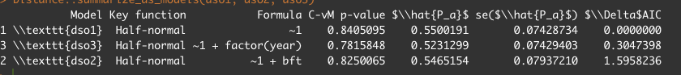

Table DSM

Fin

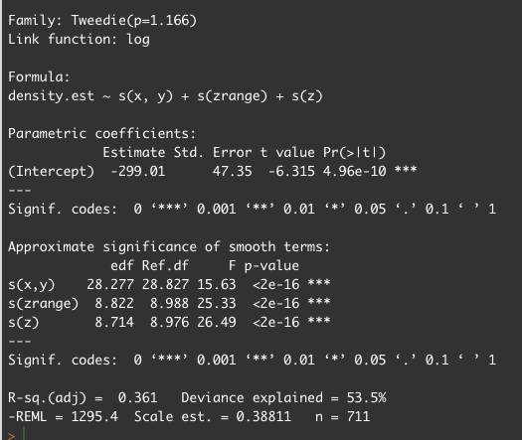

Second-best model:

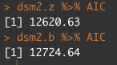

Plot DETFUNK. For fin whale and humpback whale.

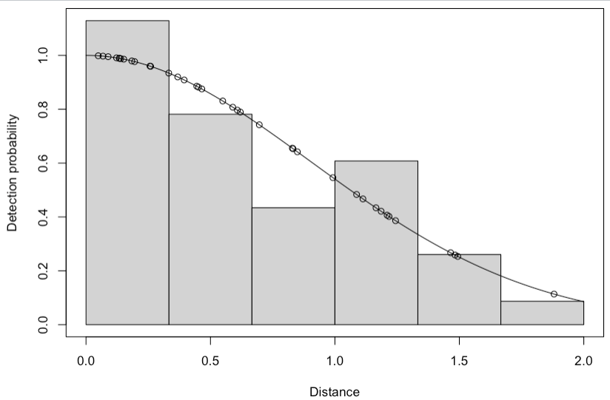

*Seasonal abundance trends* – text

*Encounter rates*

*Surface rates*

*Avoidance*

*Lethality*

**Humpback whale analysis**