目录

Dev Environment Setup 1

Import SmartPutty Project into Intellij 1

User Manual 3

1. Start Program: 3

2. Create Session: 4

3. Open session: 5

4. Edit session: 5

5. Delete session: 6

6. Operation Sessions: 7

7. Reload session: 7

8. Clone session: 7

9. Transfer files: 8

10 access vnc: 8

Tips: 9

How to connect to AWS with pem key. 9

# Dev Environment Setup

## Import SmartPutty Project into Intellij

Make sure the JDK home is set to your own JAVA_HOME

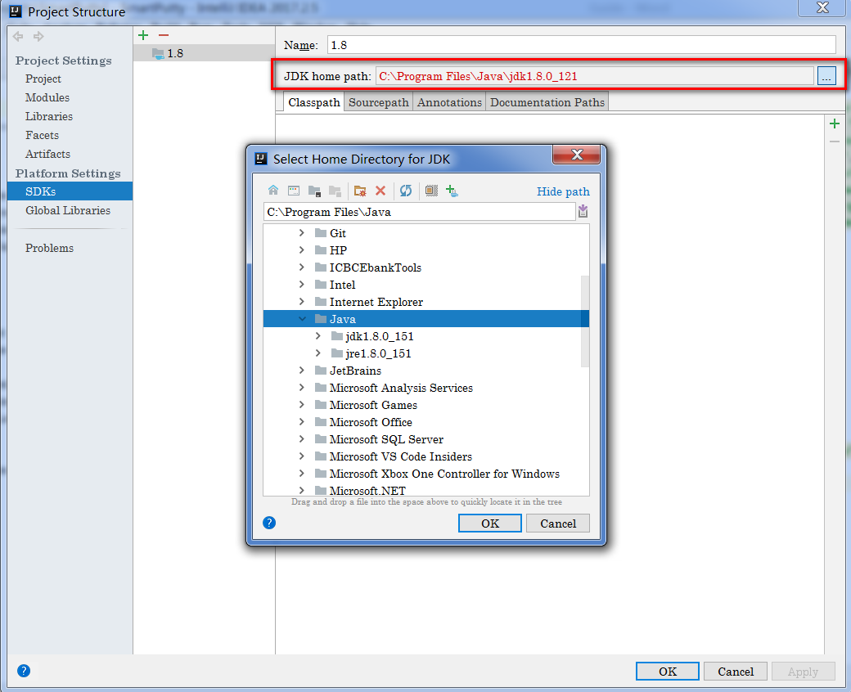

Rebuild project with intellij and then execute ‘MainFrame’ as following

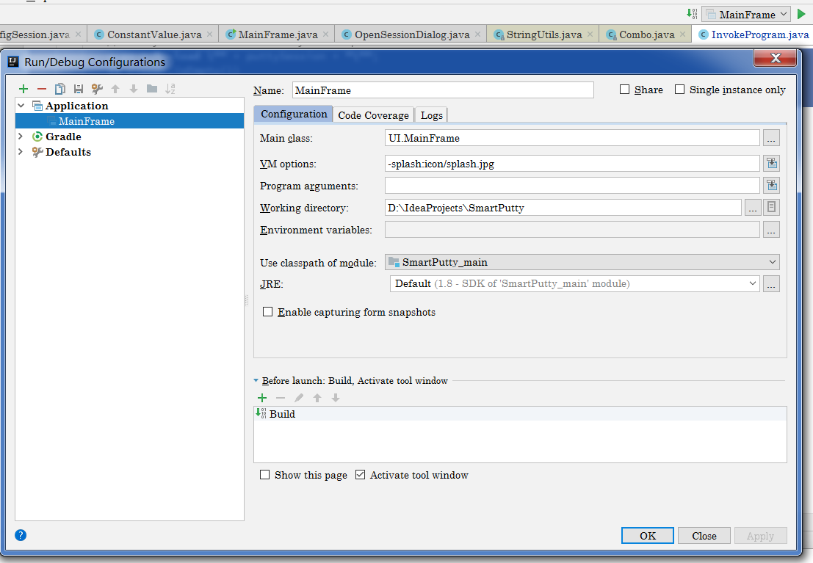

# User Manual

SmartPutty for windows platform provides rock-solid terminal emulation for computing professionals, raising productivity with advanced session management and a host of ways to save time and streamline repetitive tasks. SmartPutty provides secure remote access, file transfer, and VNC access.

### 1. Start Program:

Extract SmartPutty.zip to local disk , then double click "SmartPutty.exe" to run this application.

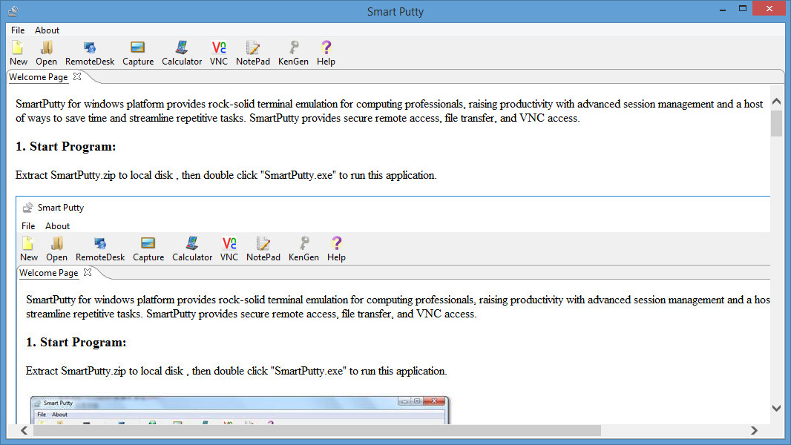

### 2. Create Session:

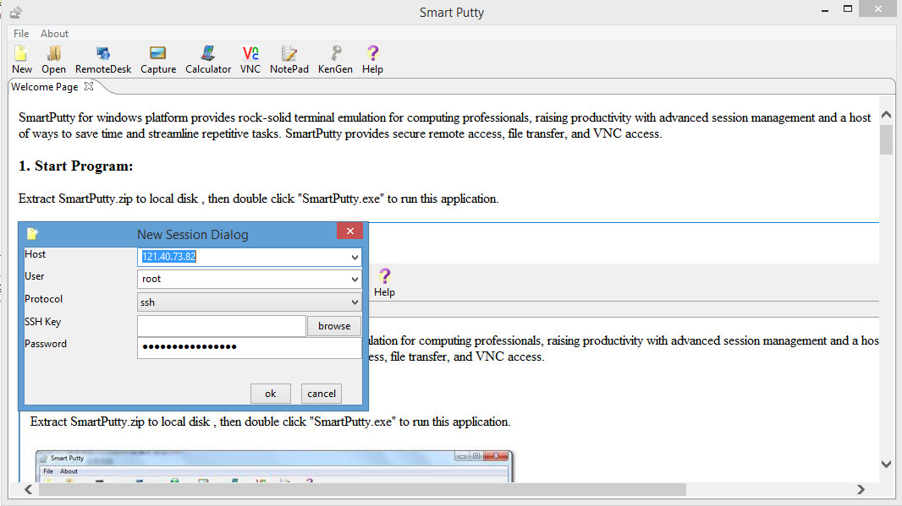

### 3. Open session:

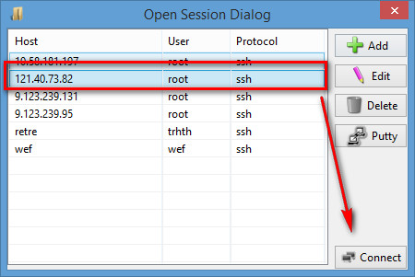

### 4. Edit session:

Select one row to modify the session information like following:

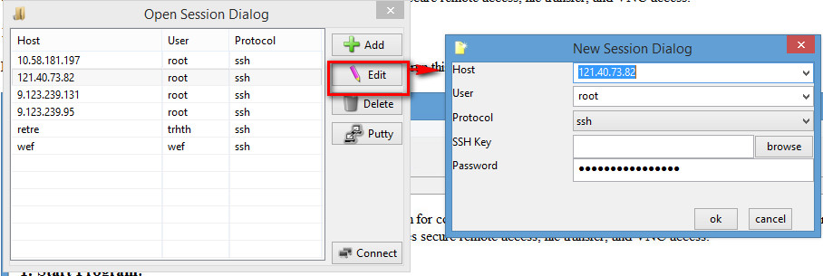

### 5. Delete session:

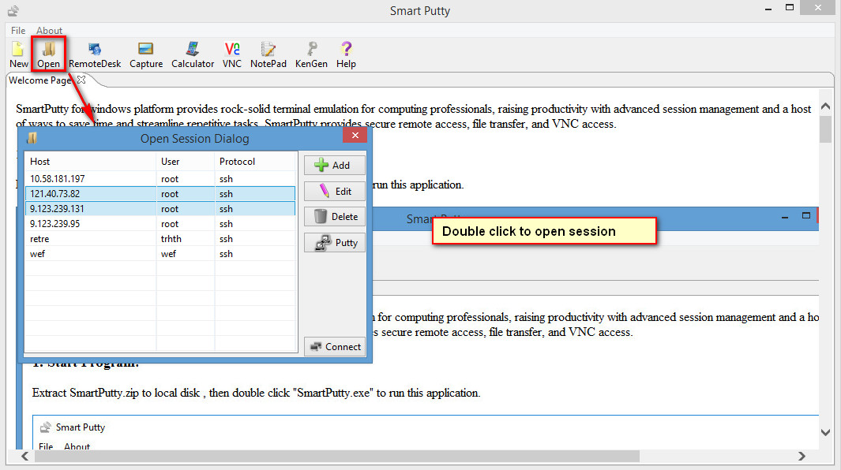

### 6. Operation Sessions:

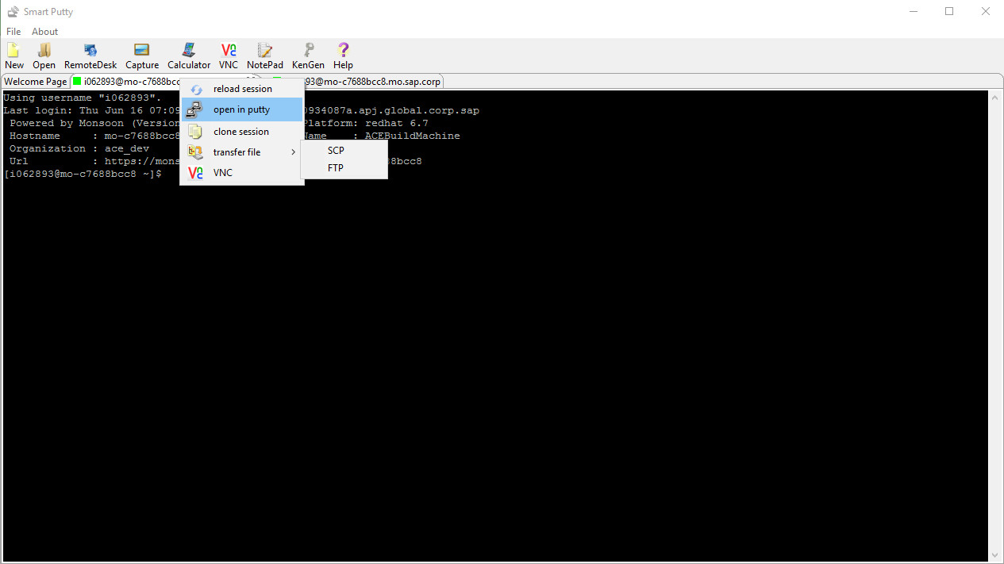

### 7. Reload session:

If current session tab encount some network problem, you can reload session. It will reconnect to dest host.

### 8. Clone session:

If you are suppose to open more than one tabs to a certain host, just clone session tab.

### 9. Transfer files:

You can transfer files between remote machine and local machine, by scp or ftp. Just right click tab and choose the way you want to use. Suppose we choose SCP, the following window will come out for you to drag file between 2 machines.

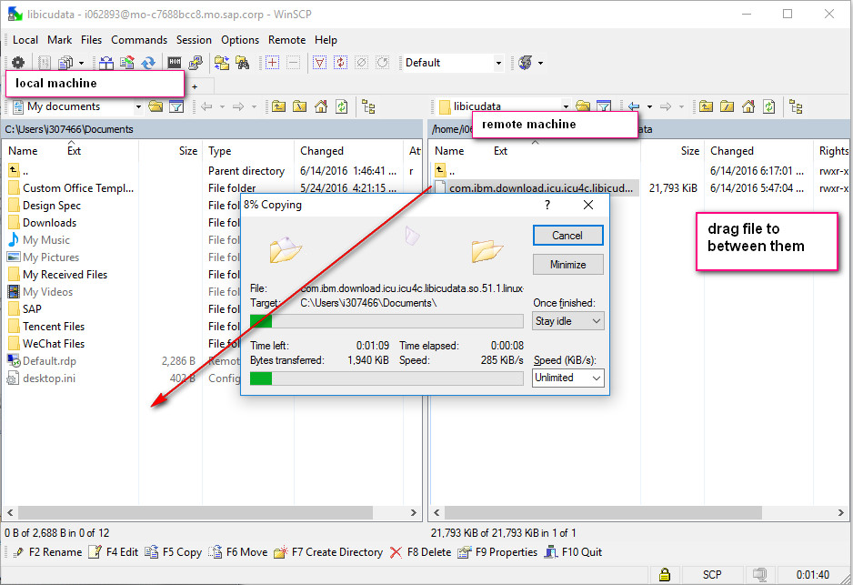

### 10 access vnc:

If remote server has installed VNC server, then you can open it by right click the host tab and choose "VNC" item. Then remote Linux UI will come out to your eyes.

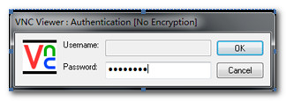 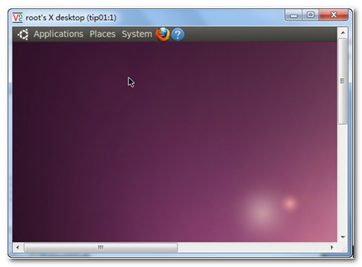

# Tips:

## How to connect to AWS with pem key.

Using the keygen function to convert pem file into ppk which putty only support ppk. Then config as login key as following. Use the session to login to AWS EC2

