**ECE230 Active Light Tracking in Two Dimensions**

**Jonathan Wampler and Eric Morse**

**Introduction**

We are going to create an active light sensing device that indicates the direction of an IR light source in 180 degrees on a horizontal axis as well as 180 degrees on a vertical axis. The purpose of this project is to maximize the possible energy collected by a solar panel by indicating the direction of the sun on the horizon. In our case we will be using an infrared LED and photo transistor in order to mimic the sun in a room full of light.

**Objectives and specifications** (include quantitative targets)

* Actively update pointer code for motor direction
* Point in the direction of the most light
* Detect if no light source is available

**Conceptual design description**

* Active light tracking light source through servo motors and photo-resistive sensors
* Use PIC16F887 microcontroller

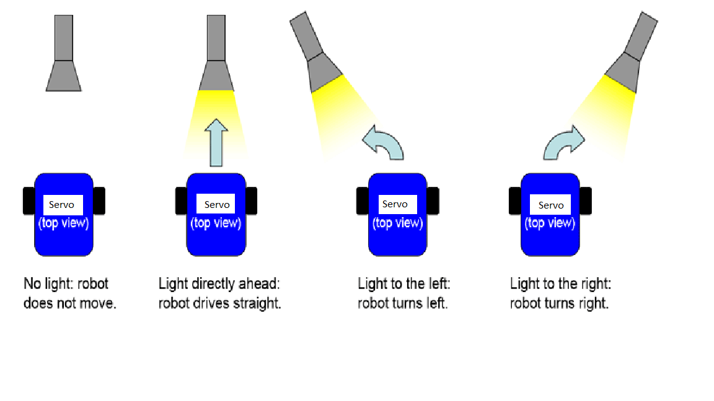

**Tasks and Priorities**

* Develop System Architecture
  + Assign Ports, timers and interrupts
* Create hardware Schematic for design
* Develop Software
  + ATD photo-resistor code
  + Interrupts
  + Pointer code
  + PWM
* Build project
* Test and debug

|  |  |  |  |
| --- | --- | --- | --- |
| **Budget** |  |  |  |
| Quantity | Part | Description | cost |
| 1 | PIC16f887 | controller for program | Acquired |
| 2 | Servo | motor to indicate light direction | Acquired |
| 1 | breadboard | used for prototyping | Acquired |
| 4 | photo resistors | indicates light intensities | Acquired |
| undefined | Misc. Parts | wires, resistors, enclosures | TBD |

|  |  |  |  |  |  |  |  |  |  |  |  |  |  |  |  |
| --- | --- | --- | --- | --- | --- | --- | --- | --- | --- | --- | --- | --- | --- | --- | --- |
| **Schedule** | M | T | W | R | F | S | SU | M | T | W | R | F | S | SU | M |
| Tasks | 4 | 5 | 6 | 7 | 8 | 9 | 10 | 11 | 12 | 13 | 14 | 15 | 16 | 17 | 18 |
| Draw schematic | X | X |  |  |  |  |  |  |  |  |  |  |  |  |  |
| gather parts |  | X |  |  |  |  |  |  |  |  |  |  |  |  |  |
| develop system Architecture |  | X | X | X |  |  |  |  |  |  |  |  |  |  |  |
| ATD |  |  |  | X | X | X | X | X |  |  |  |  |  |  |  |
| PWM |  |  |  | X | X | X | X | X |  |  |  |  |  |  |  |
| Interrupts |  |  |  |  |  | X | X | X | X | X |  |  |  |  |  |
| Pointer Code |  |  |  |  |  | X | X | X | X | X |  |  |  |  |  |
| Assemble Parts |  |  |  |  |  |  |  |  |  | X | X |  |  |  |  |
| Testing Debugging |  |  |  |  |  |  |  |  |  | X | X | X | X | X |  |
| Final Presentation |  |  |  |  |  |  |  |  |  |  |  |  | X | X | X |