**Subject: Results for Lab2**

**From: Eric Morse and Rahul Das**

**Date: 12/5/2018**

**PART A: Designing and Implementing a Discrete-Time Filter**

1) Include the output of **check_filter.m** below, showing your filter matches that of the Simulink model here.

2) nfilt = 3

3) hp_freq = 2.5





**PART D: Determining the Initial Scaling**

4) Include your open loop control results (figure from **plot_results.m**) here.

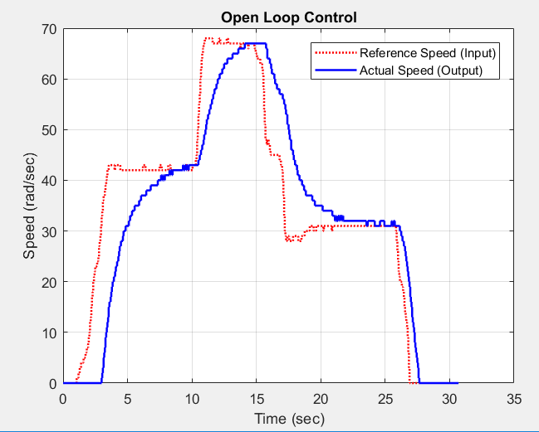

**PART E; On-Off (Bang-Bang) Control**

5) Include your initial results for u = 0.2*DUTY_CYCLE (using the pot as the reference signal) here.

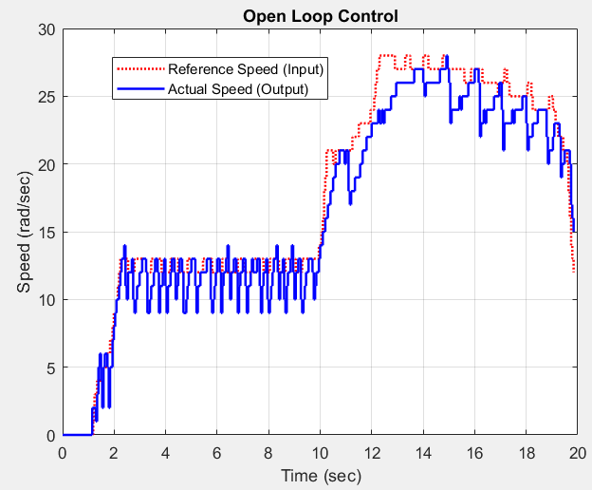

6) Fill in the following table

|  |  |
| --- | --- |
| **Control Effort** | **Maximum Speed (radians/sec)** |
| u = 0.2*MAX_DUTY | 33 |
| u = 0.3*MAX_DUTY | 53 |
| u = 0.4*MAX_DUTY | 68 |
| u = 0.5*MAX_DUTY | 77 |
| u = 0.6*MAX_DUTY | 90 |
| u = 0.7*MAX_DUTY | 98 |

7) Include your results for u = 0.2*DUTY_CYCLE with programmed step inputs here.

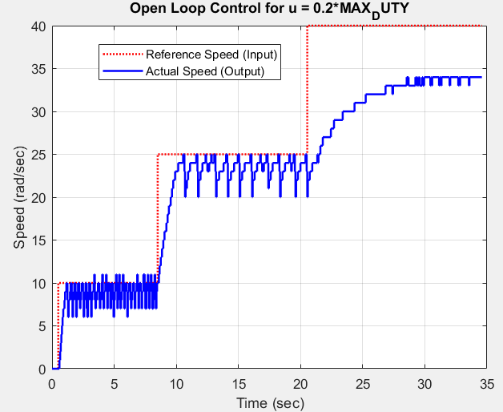

8) Include your results for u = 0.5*DUTY_CYCLE with programmed step inputs here.

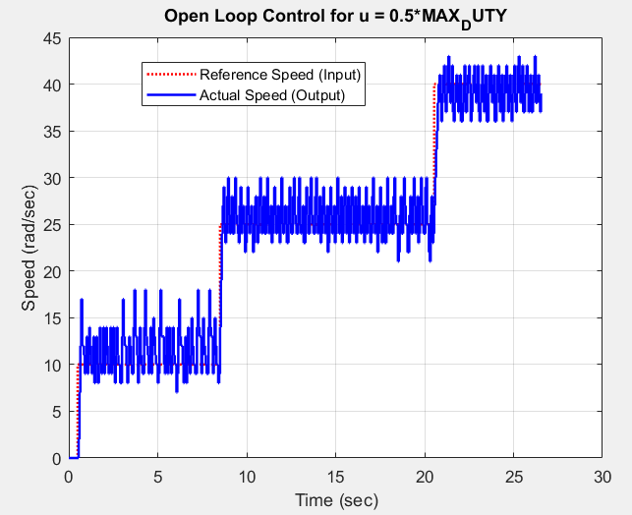

**PART F: Proportional Control**

9) Include your results for kp = 1.0 here.

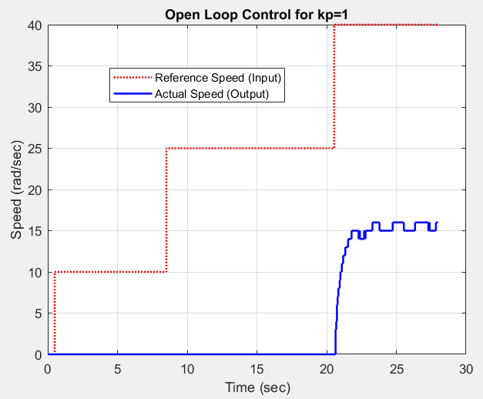

10) Include your results for kp = 5.0 here.

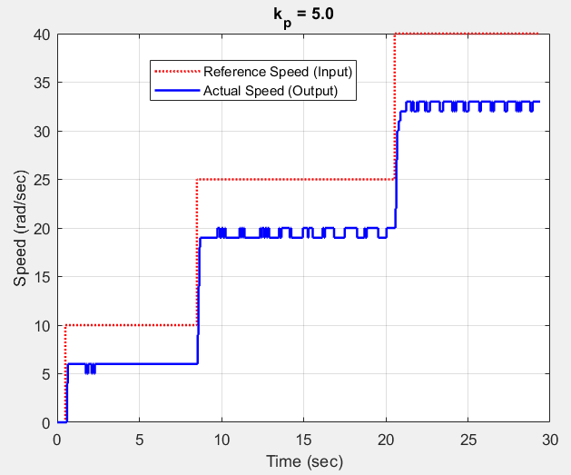

11) Include your results for kp = 10.0 here.

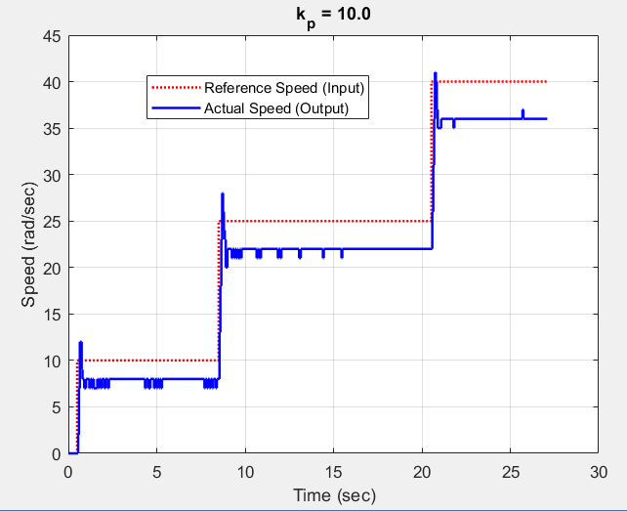

**PART G: Proportional Control with Scaling**

12) Include your results for the reference scaling here. The output (speed of the wheel) should match the reference (the desired input) in the middle plateau. Be sure the value of kp and the reference input is indicated somehow.

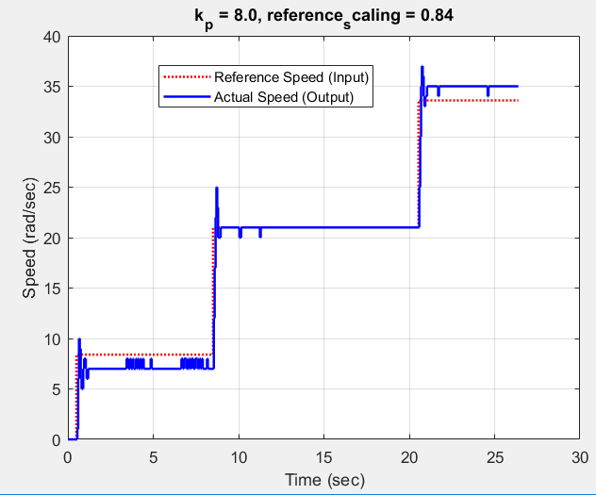

**PART H: Even More Proportional Control**

13) Include your results for tracking the input coming from the pot here. You should have at least three plateaus, and give the system enough time to try and reach steady state.



14) Write down your wheel number here:

Wheel #9