**Subject: Results for Lab4**

**From: Eric Morse and Rahul Das**

**Date: 12/19/2018**

**PART B: Integral Control**

1. Include the output of **DT_PID_driver.m** for ki = 0.2, showing your model output and the measured output for a step of 75 radians/sec. The control effort will likely be out of phase as time goes on.



2) The estimated percent overshoot is: 3%

3) The estimated settling time is:6 seconds

4) Include the output of **DT_PID_driver.m** for ki = 0.4, showing your model output and the measured output for a step of 75 radians/sec. The control effort will likely be out of phase as time goes on.



5) The estimated percent overshoot is: 6%

6) The estimated settling time is: 6 seconds

**PART C: PI Control**

7) Include the output of **DT_PID_driver.m** for your PI controller designed using sisotool, showing your model output and the measured output for a step of 75 radians/sec. The control effort will likely be out of phase as time goes on.



8) The estimated percent overshoot is: 0%

9) The estimated settling time is:8 seconds

10) Include a screen shot of sisotool, showing root locus plot, step response plot, and control effort plot.

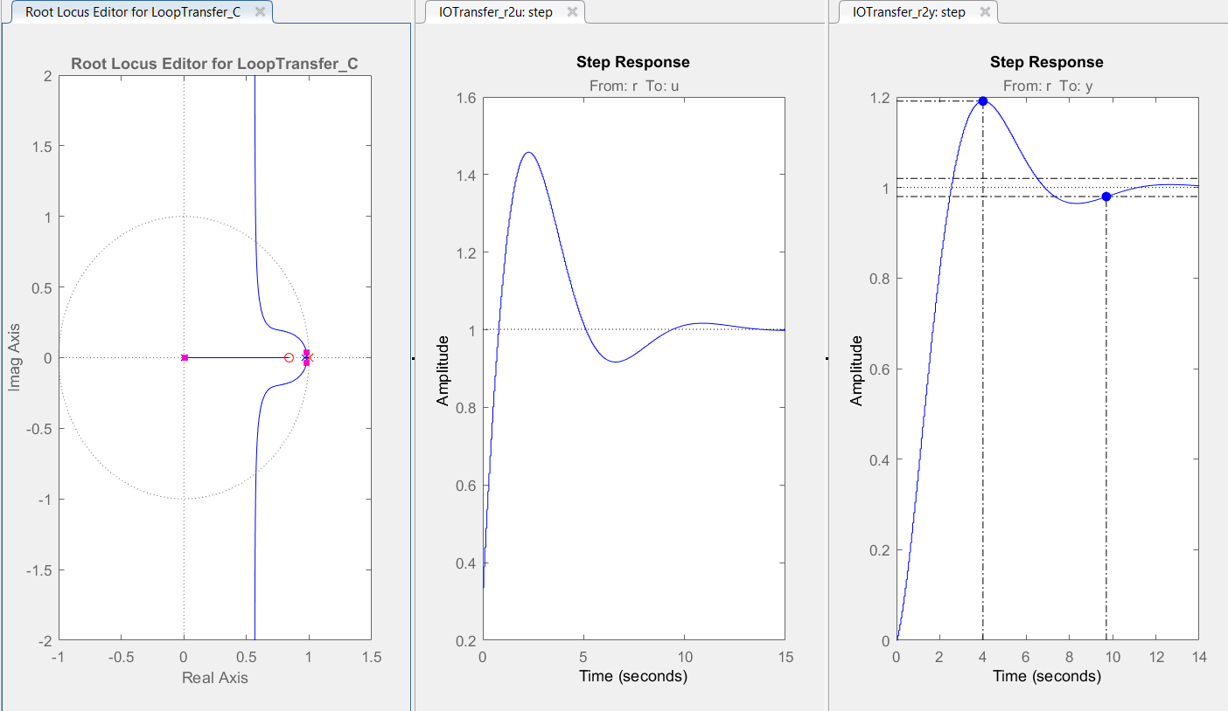

11) Include the output of **PT_PID_driver.m,** showing your model output and the measured output when the input is the pot using the parameters for the PID tuner that you determined from sisotool.



12) Include the output of **DT_PID_driver.m** for your PI controller designed using the PID Tuner, showing your model output and the measured output for a step of 75 radians/sec. The control effort will likely be out of phase as time goes on.



13) The estimated percent overshoot is: 0%

14) The estimated settling time is:10 seconds

15) Include a screen shot of the PID Tuner, showing (at least) the step response plot and control effort plots.

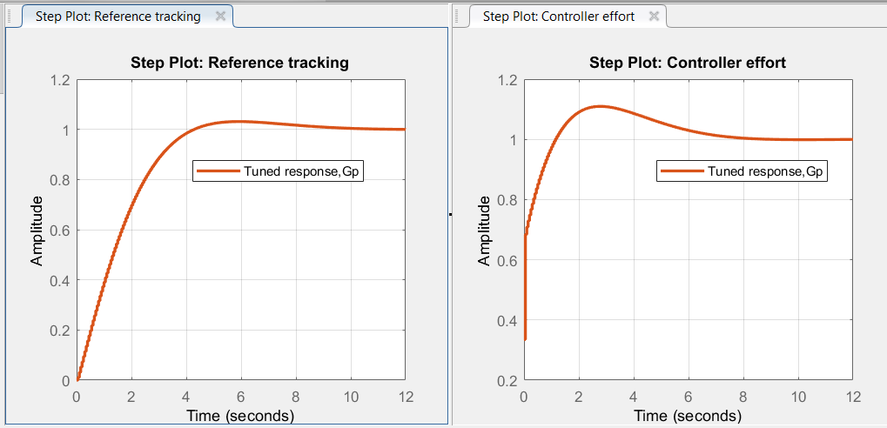

16) Include the output of **DT_PID_driver.m,** showing your model output and the measured output when the input is the pot using the parameters for the PID tuner that you determined from the PID Tuner.



.

**PART D: PD Control**

17) Include the output of **DT_PID_driver.m** for your PD controller, showing your model output and the measured output for a step of 75 radians/sec.



18) Include the output of **DT_PID_driver.m** for your PD controller, showing your model output and the measured output when the input is from the pot.



**PART E: PID Control**

19) Include the output of **DT_PID_driver.m** for your PID controller, showing your model output and the measured output for a step of 75 radians/sec.



20) Include the output of **DT_PID_driver.m** for your PID controller, showing your model output and the measured output when the input is from the pot.

