**Subject: Results for Labs 5 and 6**

**From: Eric Morse and Rahul Das**

**Date: 1/9/2019**

**PART A: System Identification APP**

1. Include a screen capture of the estimated transfer function.

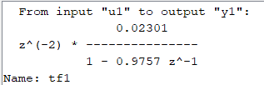

2) Include a screen capture comparing your models predicted response and the measured response (for the validation data, response2s).

Allowing the delay to vary



1. Include a screen capture of the estimated transfer function.

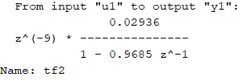

4) Include a screen capture comparing your models predicted response and the measured response (for the validation data, response2s).

Fixing the delay with two poles and one zero



1. Include a screen capture of the estimated transfer function.

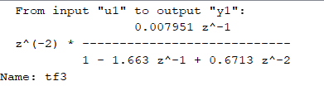

6) Include a screen capture comparing your models predicted response and the measured response (for the validation data, response2s).

Comparing the model to response3s and response4s





7) Include a screen capture comparing the three models’ responses to response3s.

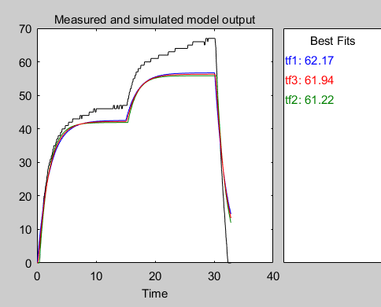

8) Include a screen capture comparing the three models’ responses to response4s.

Using response4s for constructing the model

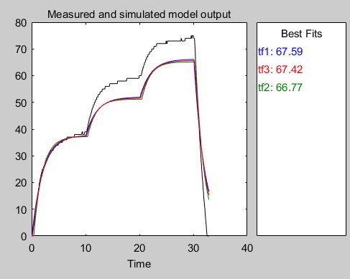

9) Include a screen capture of the estimated transfer function (one pole, no zeros, fixed delay one more than you assumed in lab).

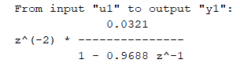

10) Include a screen capture comparing your models predicted response and the measured response (for the validation data, response3s).

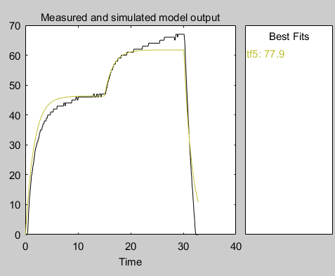

11) Include a screen capture comparing the models response to response2s.

Using response1s, response3s, and response4s for constructing the model

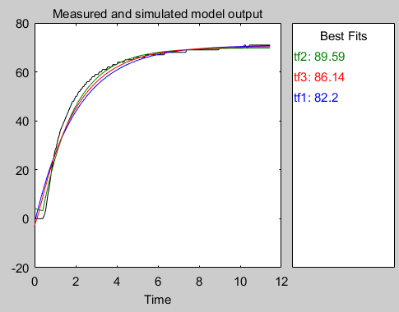

12) Include a screen capture of the estimated transfer function.

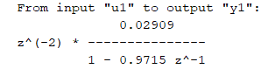

13) Include a screen capture comparing your models predicted response and the measured response (for the validation data, response2s).

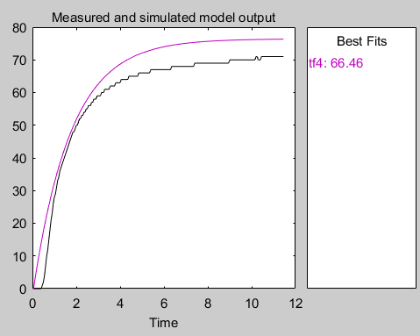

**PART B: Simulink’s Parameter Estimation**

14) Summarize the parameter estimation here

|  |  |  |
| --- | --- | --- |
| **Input** | **Estimate of C** | **Estimate of c** |
| response1 | 0.030092 | 0.96764 |
| response2 | 0.0392 | 0.9572 |
| response3 | 0.042106 | 0.95901 |
| response4 | 0.043903 | 0.95683 |
| Average | 0.038825 | 0.96017 |

15) Include the plot of using reponse1s to estimate the parameters, and then running the **DT_Openloop_driver.m** with these values and an input of response2s.



16) Include the plot of using reponse2s to estimate the parameters, and then running the **DT_Openloop_driver.m** with these values and an input of response3s

.

17) Include the plot of using reponse3s to estimate the parameters, and then running the **DT_Openloop_driver.m** with these values and an input of response4s.



18) Include the plot of using reponse4s to estimate the parameters, and then running the **DT_Openloop_driver.m** with these values and an input of response1s.



**PART C:Simulink’s Response Optimization**

19) Include a screen shot showing the Response Optimization plot.

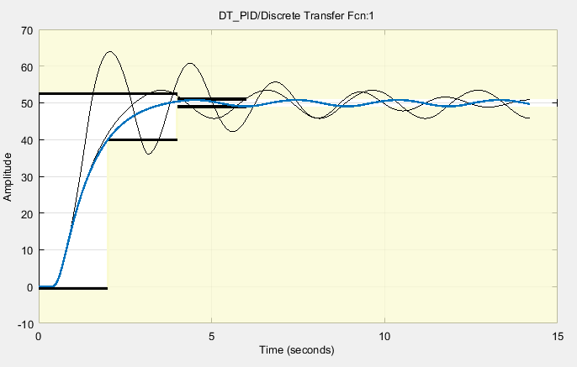

20) Include a screen shot after running your system with the new parameters and then running **DT_PID_driver.m**. Your model and real system response should be fairly close.



**PART D: Introduction to Robust Control**

21) Include a screen shot of the Plot Model Response figure, showing the results for your system with uncertainty.

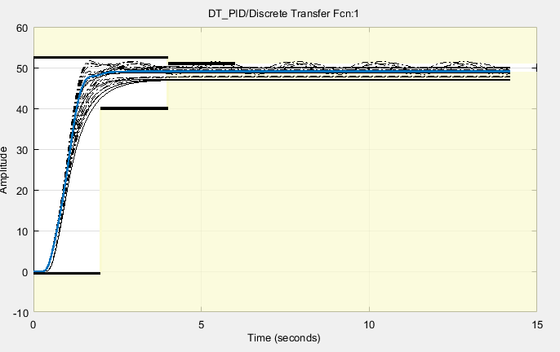

22) Did you system converge to a solution?Yes

23) Include a screen shot after running your system with the new parameters and then running **DT_PID_driver.m**. Your model and real system response should be fairly close.

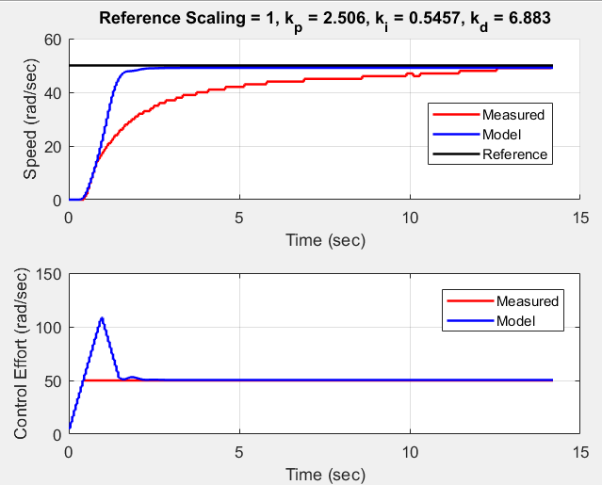

**PART E: Signal Tracking**

24) Include a screen shot of the Plot Model Response figure, showing the results for your system tracking the reference signal with three plateaus.

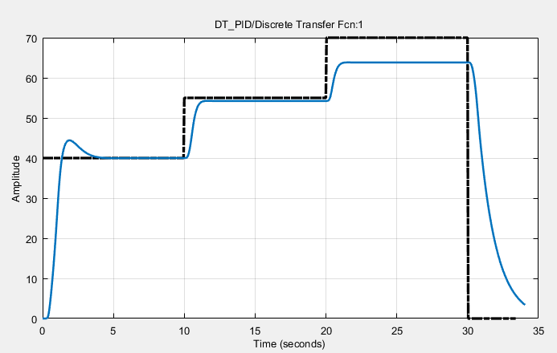

We repeated the process of running the system and re-optimizing several times, but couldn’t get better than this.

25) Include a screen shot after running your system with the new parameters and then running **DT_PID_driver.m**. Your model and real system response should be fairly close.

