**Subject: Results for Lab9**

**From: Eric Morse**

**Date: 2/12/19**

**PART A**

1. Include the plot showing the state variable model of the plant gives the same results as the transfer function model of the plant.



2) Include the sisotool plot of the root locus here.

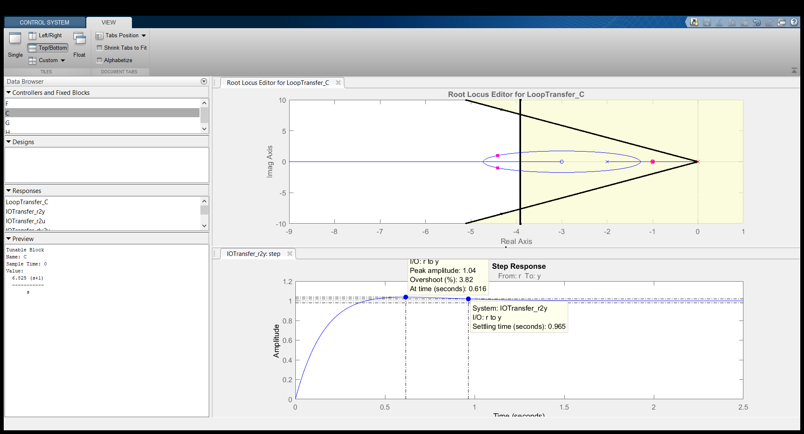

3) kp = ___6.825____

4) ki = __6.825____

**PART B**

5) Include plot showing results then the closed loop poles are at -10 and -15, and the final time is 1.0 seconds.



6) Include plot showing results when the closed loop poles are at -100 and -150, the final time is 0.1, and the second state is the output.



7) Include plot showing results when the closed loop poles are at -1 and -1.5, the final time is 5.0, and the second state is the output.



**PART C**

8) Include plot showing results for a type one system, the poles at -10, -20, -30 and the output is the second state.



**PART D**

9) Include plot showing the results for the observer when the observer poles are three times further from the imaginary axis than the state feedback poles.



10) Include plot showing the results when the second state is going to the observer and the first state is the output.



11) Include plot showing results when both states are sent to the observer, the observer poles are 10 times the state feedback poles, and the second state is the output.



**PART E**

12) Include plot showing results for combining the observer and type one system when the observer poles are at -30 and -60.



13) Include plot showing results for combining obverse and type one system when the observer poles are at -30 and -60, the output is the second state, and both states are sent to the observer.



14) Include a screen shot of your final Simulink model , which includes the observer and the type one system modifications (the Simulink model you used for part E)

