Subject: Results for Lab4
From: Eric Morse and Rahul Das
Date: 12/19/2018

PART B: Integral Control
- Include the output of DT_PID_driver.m for ki = 0.2, showing your model output and the measured output for a step of 75 radians/sec. The control effort will likely be out of phase as time goes on.
2) The estimated percent overshoot is: 3%
3) The estimated settling time is:6 seconds
4) Include the output of DT_PID_driver.m for ki = 0.4, showing your model output and the measured output for a step of 75 radians/sec. The control effort will likely be out of phase as time goes on.
5) The estimated percent overshoot is: 6%
6) The estimated settling time is: 6 seconds
PART C: PI Control
7) Include the output of DT_PID_driver.m for your PI controller designed using sisotool, showing your model output and the measured output for a step of 75 radians/sec. The control effort will likely be out of phase as time goes on.
8) The estimated percent overshoot is: 0%
9) The estimated settling time is:8 seconds
10) Include a screen shot of sisotool, showing root locus plot, step response plot, and control effort plot.
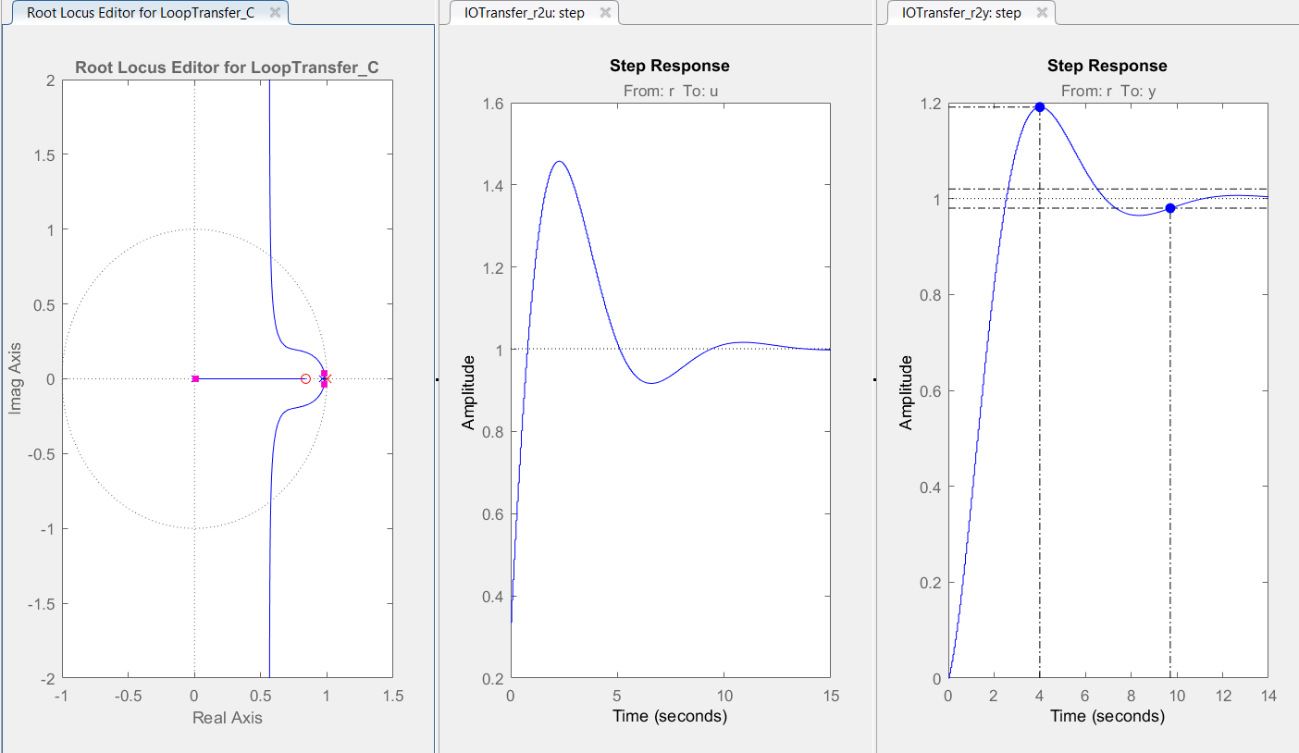
11) Include the output of PT_PID_driver.m, showing your model output and the measured output when the input is the pot using the parameters for the PID tuner that you determined from sisotool.
12) Include the output of DT_PID_driver.m for your PI controller designed using the PID Tuner, showing your model output and the measured output for a step of 75 radians/sec. The control effort will likely be out of phase as time goes on.
13) The estimated percent overshoot is: 0%
14) The estimated settling time is:10 seconds
15) Include a screen shot of the PID Tuner, showing (at least) the step response plot and control effort plots.
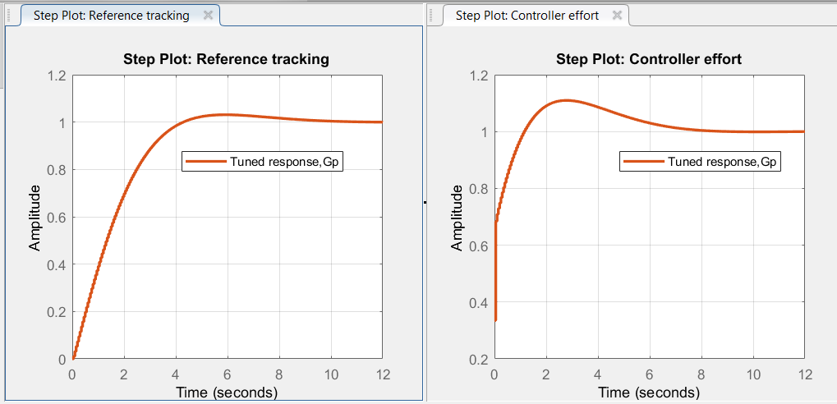
16) Include the output of DT_PID_driver.m, showing your model output and the measured output when the input is the pot using the parameters for the PID tuner that you determined from the PID Tuner.
.
PART D: PD Control
17) Include the output of DT_PID_driver.m for your PD controller, showing your model output and the measured output for a step of 75 radians/sec.
18) Include the output of DT_PID_driver.m for your PD controller, showing your model output and the measured output when the input is from the pot.
PART E: PID Control
19) Include the output of DT_PID_driver.m for your PID controller, showing your model output and the measured output for a step of 75 radians/sec.

20) Include the output of DT_PID_driver.m for your PID controller, showing your model output and the measured output when the input is from the pot.

