Assignment: PCB Test Plan

**Description:** You will first create three to five low-level requirements for your PCB that must be met in order for it to function correctly. Then you will write a test plan that will be used to verify that your PCB meets those requirements. You can have no more than one requirement that is verified by observation or demonstration. You shouldn’t have any requirements that are verified by simulation or modeling because you’ve already built your PCB. Once you completed fabricating your PCB, you should perform the test plan, collect data, and draw conclusions about whether your PCB is verified according to the specifications. A template follows. Your whole test plan and data collection should be approximately 3-5 pages.

Evaluation of your work will be based on the following rubrics:

|  |  |
| --- | --- |
| Item | What to look for |
| Introduction | Can clearly understand the purpose of the circuit |
| Schematic is readable and useful | * Easy to read * All parts are labeled * Important nodes are labeled |
| PCB Image | * PCB is populated * Important nodes are labeled on PCB image |
| Requirements | * Includes 3-5 requirements * All requirements are about system behavior, not debugging * Requirements are written in system shall language * The metric is adequate for the requirement * A verification method is provided for the requirement * Each requirement is testable * The requirement uses proper engineering language * At least some requirements must be evaluated by test |
| Test Plan | * Written in step-by-step fashion * Each step makes sense * Proper and sufficient equipment is listed * Experiment is adequate for evaluating the requirement * Tests for each requirement are presented. * Refers to nodes and parts that are labeled in the schematic * Sufficient detail is provided to carry out the test. * Proper engineering technique is used for each test |
| Results | * Results are presented in an easy to read fashion. * Each result determines if a requirement has been verified. * The results are adequate to verify the requirement |
| Conclusions | * The appropriate conclusions are drawn from the results about whether or not the PCB was verified * If the PCB was not verified, appropriate reasons are given |

Assignment: PCB Test Plan

1. **Introduction**

*Everyone is doing their own unique PCB design. I need to know what your circuit is supposed to do. Please describe it in terms of its input-output behavior. What do you put into the circuit, what comes out of the circuit, and what is your circuit doing. Include a schematic of your circuit and a photograph of your PCB with parts on it and the parts labeled the same as the schematic. Here is an example…*

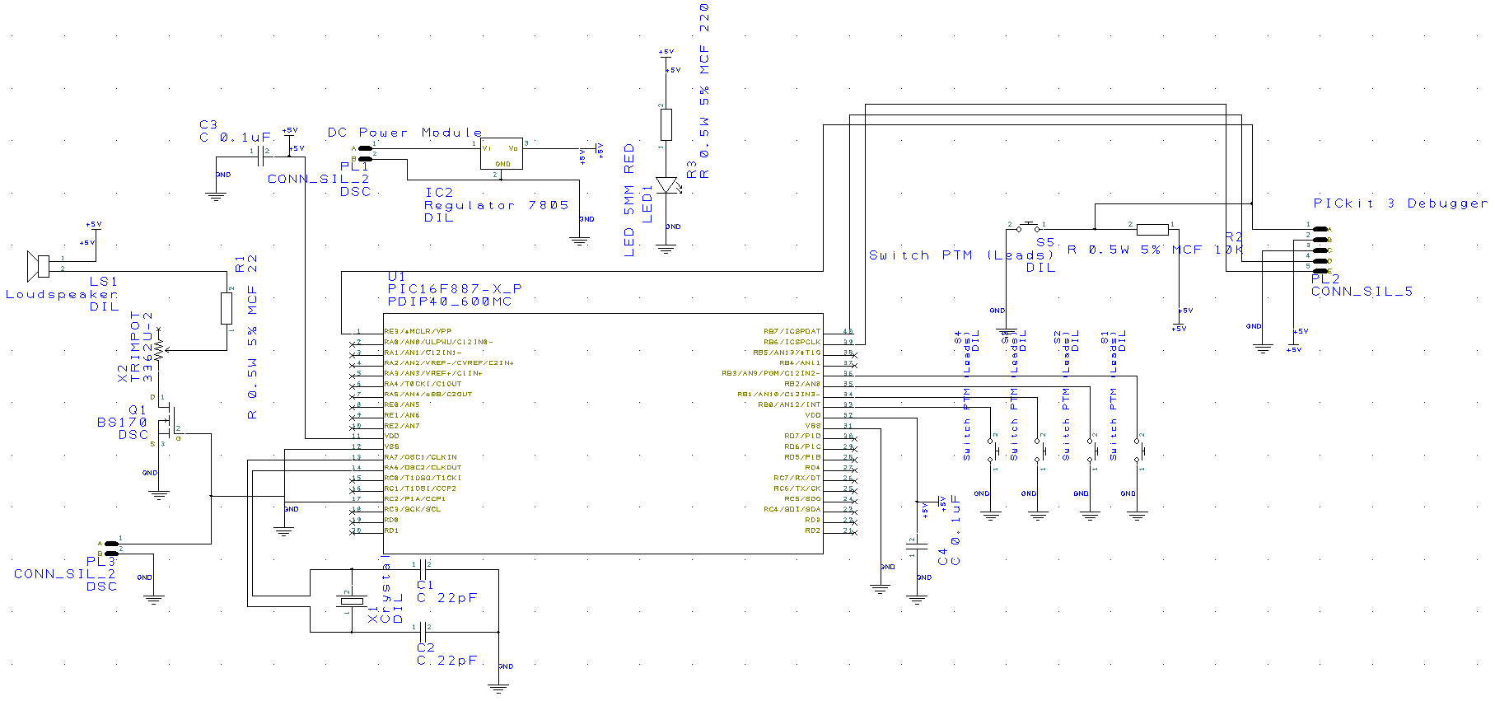

Figure 1: Schematic of the piano circuit.

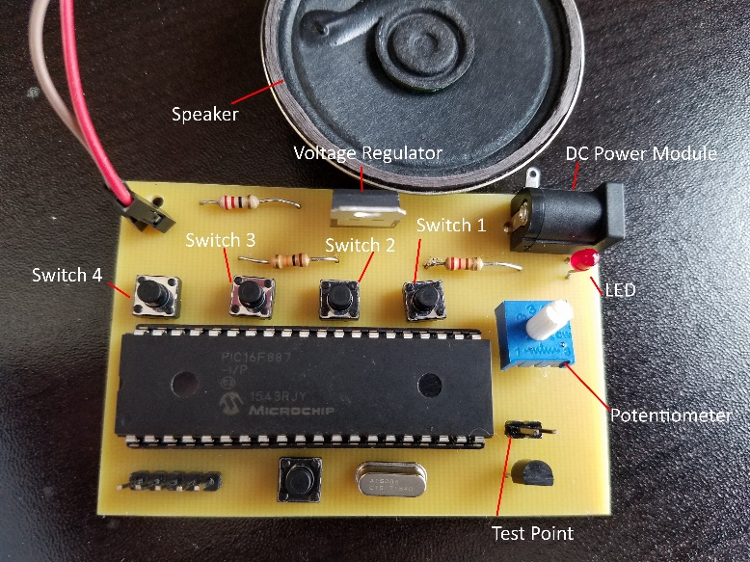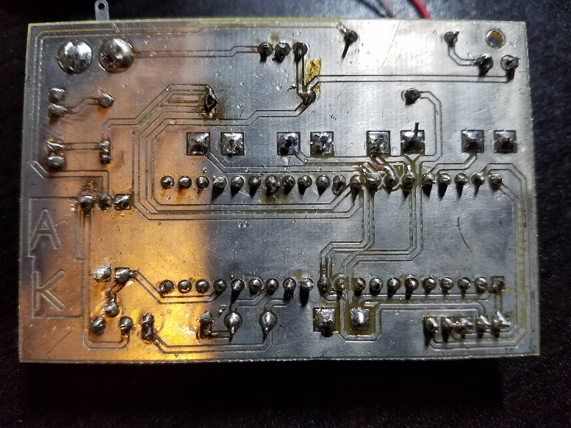

Figure 2: Images of the PCB from the top and bottom. When the push buttons (Switch 1-4) on the PCB are pressed they play a note through the speaker. The potentiometer controls the volume.

1. **Requirements**

You will need to come up with approximately three to five related requirements for your PCB. They should be related to system behavior, not about debugging. Each requirement should be written in a ***system shall*** format as shown below. You should include a method of verification for each requirement. At most one requirement can be verified by inspection or demonstration. The others should be verified by experimentation. We are not concerned at this point whether they are high-level or low-level requirements. The requirement must be written in such a way that there is a clear yes or no response to it’s verification

|  |  |  |
| --- | --- | --- |
| **ID** | **Requirement Description** | **Verified by** |
| PCB-1 | The *system shall* play tones with fundamental frequencies of A3=220Hz ± 5Hz for Switch 1, B3=246.94Hz ± 5Hz for Switch 2, C4=261.63Hz ± 5Hz for Switch 3, and D4=293.66Hz ± 5Hz for Switch 4. | Experiment |
| PCB-2 | The *system shall* scale the volume from off to loud enough to be easily heard by people with normal hearing in an open hallway with typical levels of background noise. | Demonstration |
| PCB-3 | The system *shall accept* standard AC US power at 120V AC 60Hz *and convert* it to 5V DC with max power rating of 500mW. | Experiment |

1. **Testing Procedure**

The testing procedure should have enough detail for a typical engineer to perform the tests without talking to you about them. You can assume basic working knowledge of how to use the equipment, but not where to connect it to your PCB or to what values or ranges to set the equipment. In other words, you don’t have to talk about how to turn the equipment on or how to adjust the oscilloscope, but you do have to discuss what frequency and amplitude to use, where to put the signal, and where to measure the outputs. Some things to discuss in your procedure are…

* Where to connect input signals
* Where to measure output signals
* In what environments to conduct the tests
* What the input signals should be
* Any equipment that will be used

Example Equipment List:

* Oscilloscope
* Wall outlet

Example procedure to verify Requirement PCB-1:

1. Connect the 120V to 10V power adapter to the PCB
2. Disconnect the speaker from the PCB
3. Connect the oscilloscope to the speaker terminal on the PCB with the ground of the probe going to the pin closest to the microcontroller.
4. Set the oscilloscope to measure square waves with frequencies in the range of 200-300Hz and amplitudes of approximately 5V peak to peak.
5. With the oscilloscope connected press down button Switch 1 and observe the signal on the oscilloscope. With the button pressed and looking at the oscilloscope trace, adjust the potentiometer until the amplitude is at max value.
6. Measure the frequency of the trace with only Switch 1 pressed, then with only Switch 2 pressed, then with only Switch 3 pressed, and finally with only Switch 4 pressed.
7. Record your data in the next section.
8. That’s the end of this test.

You would then need to include procedures for measuring the other two requirements. Note that to measure Requirement PCB-2, this is by demonstration. You would need to specify where you’re going to take the measurement such as a hallway or in the Union where you would find “typical background noise”. To verify Requirement PCB-3, you might want to do the experiment with the only voltage regulator and DC adapter connector on the PCB before you solder the other components. You might also want to specify a load resistance that would ensure the regulator has to supply at least 500mW while measuring the DC voltage.

1. **Data and Expected Results**

If you haven’t yet collected the data, then the measurements will be empty, but you should still provide the template and expected values for recording the data. Below is an example for recording the data for requirement PCB-1 above. If you already conducted the experiment, then you should have your data included in the empty cells.

|  |  |  |
| --- | --- | --- |
| Button Pressed | Measured Frequency | Requirement |
| Switch 1 |  | 215 – 225 Hz |
| Switch 2 |  | 241.94 – 251.94 Hz |
| Switch 3 |  | 256.63 – 266.64 Hz |
| Switch 4 |  | 288.66 – 298.66 Hz |

1. **Conclusions**

The frequencies measured are all within specified ranges. Therefore this system passes requirement PCB-1.

OR

The measured frequency related to Switch 1 was outside of the specified acceptable range. The other switches are within specification. Upon further review of the PCB, I narrowed the wire going to Switch 1 in order to fit it between two pins on another footprint. This increased the resistance going to this particular switch and changed the frequency. The system design needs to be redone in order to meet the specifications.