ZABBIX
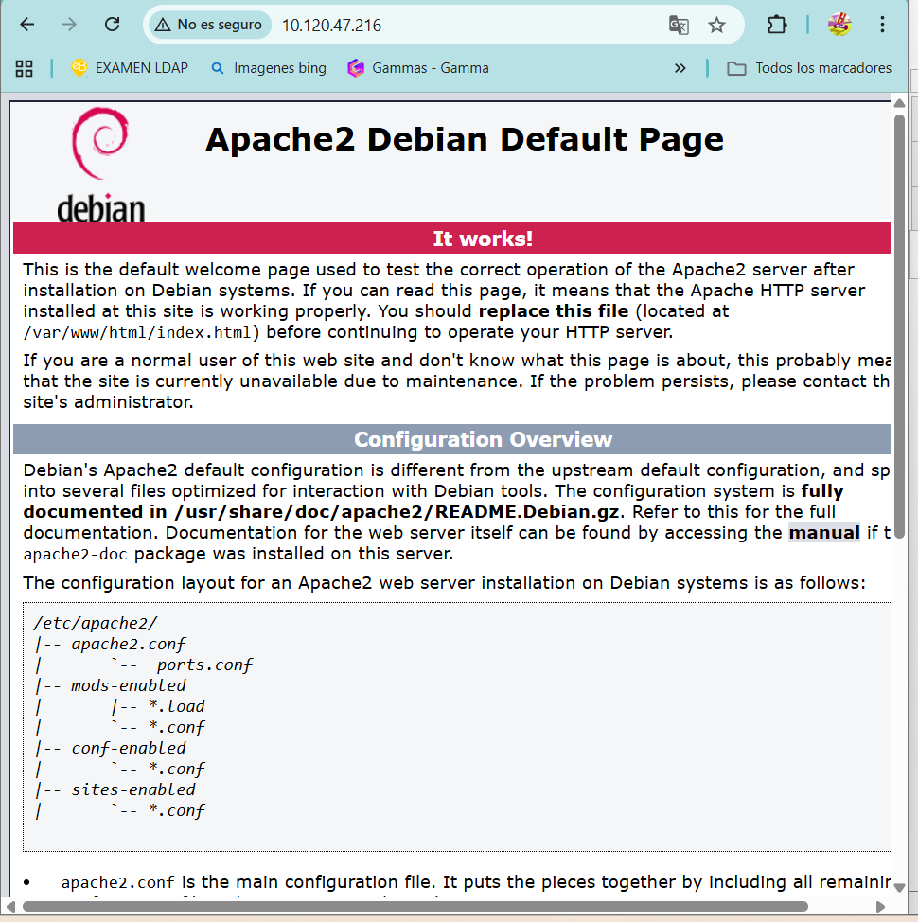

# Descarga el repo para Zabbix 7.0 (compatible con Debian 12)
wget https://repo.zabbix.com/zabbix/7.0/debian/pool/main/z/zabbix-release/zabbix-release_7.0-2+debian12_all.deb

# Instala el paquete del repo
sudo dpkg -i zabbix-release_7.0-2+debian12_all.deb

# Actualiza la lista de paquetes
sudo apt update

# Instala Zabbix server (con MySQL, frontend PHP y Apache, ajusta si usas PostgreSQL o Nginx)
sudo apt install zabbix-server-mysql zabbix-frontend-php zabbix-apache-conf zabbix-sql-scripts zabbix-agent

Intslar mariadb
iniciarla

crear base:

CREATE DATABASE zabbix CHARACTER SET utf8mb4 COLLATE utf8mb4_bin;
CREATE USER 'zabbix'@'localhost' IDENTIFIED BY 'password_segura';
GRANT ALL PRIVILEGES ON zabbix.* TO 'zabbix'@'localhost';
FLUSH PRIVILEGES;
EXIT;

