Augmented Reality Game

Test Plan

COP 4331C, Fall 2015

Team Name: Project Pals

Team Members:

* Eric Peralli - Eric.peralli@gmail.com
* Connor Heckman – Connor.heckman@me.com
* Clayton Cuteri – Cuteri.clayton@knights.ucf.edu

|  |  |  |  |
| --- | --- | --- | --- |
| Version | Date | Who | Comment |
| V0.0 | 10/28/15 | Clayton Cuteri | Initial Draft |
| V1.0 | 10/29/15 | Connor Heckman | Proofread |

**Contents of this Document**

High-Level Architecture

Design Issues

**High-level Architecture**

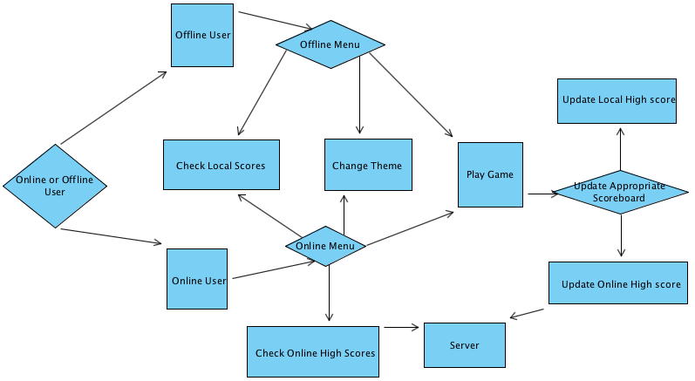

* Online or Offline User – This is anybody who downloads the game and opens it to play the game.
* Offline User – This user does not have any way of connecting to the Internet to play.
* Offline Menu – This menu will be displayed to an Offline User.
* Online User – This user has an Internet connection when playing a game.
* Online Menu – This menu will be displayed to an Online User.
* Check Local Scores – This will be where the user accesses their personal top scores.
* Check Online Scores – This is where the user accesses the online top scores.
* Change Theme – All users will have the ability to choose between multiple themes to play the same game with a different aesthetic feel to it.
* Play Game – All users will launch the game to play with their desired theme.
* Update Appropriate Scoreboard – If the user is offline, the app will update the local scoreboard. If online, the app will update the overall scoreboard.
* Update Local High score – Local high scoreboard is updated when a score is beat.
* Update Online High score – Overall online high scoreboard is update when a score is beat.
* Server – Holds all of the High Score information and is accessed when someone needs the Online High Scoreboard

**Design Issues**

**Reliability**

A few issues regarding reliability could arise.

One issue could be upon updating the scoreboard. The online scoreboard may face issues when multiple online users access it simultaneously. We will implement a personal server for our application but if this prototype server is unable to handle the strain of multiple online players we will pursue a third party option for our networking needs.

Another reliability issue would arise with the accuracy of a tap. We need to assure that every portion of an enemy’s sprite is considered a valid target area for the user.

**Reusability**

We will be creating our code from scratch so we have no concerns regarding reusability. The Source code created for the project has the potential to be reused for future game designs. The completed source code will be stored in the group git so that it will be available for reuse by group members in the future.

**Maintainability**

We are not worried about future updates thus after the conclusion of the class. We are not concerned with the maintainability associated with our application.

**Testability**

Testability will be relatively easy because our project does not have many variations or functions. The most time consuming portion of the testing phase will be assuring that all aspects of different theme implementations carry over to the gameplay environment. We will need to make sure that all themes respond to user touch in the same fashion.

**Performance**

The biggest concern we will encounter with performance is if the game will keep track of enemies off screen. When a user rotates the screen away from an active enemy, that enemy must remain a threat to the user’s health bar even though they are not displayed on the screen currently. Thus, our gaming environment is larger than the scope of the user’s camera.

**Portability**

There will be no portability issues. We are designing the game for Android only.

**Security**

Our application will require our user’s to provide permissions to access their camera (to display the game environment) as well as their accelerometer (to monitor the rotation of their camera). These permissions are essential to our application and so it will be impossible to play the game without granting them. We will talk with our gamer friends to see if they would be comfortable with granting these permissions to an Android application and thus get a better understanding of the portion of users who may chose to refuse these permissions.

**Safety**

Since the gameplay environment reflects your surroundings, users will actually be less likely to run into real world objects. The user may actually play this game while walking anywhere and not worry about looking up every minute.

A safety issue could arise if a user turns too quickly to look behind him. This jerking action may not only be dangerous for his ligaments and personal well-being, but for others standing beside them.