3GPP TS 38.401 V0.1.0 (2017-05)
Technical Specification
3rd Generation Partnership Project;
Technical Specification Group Radio Access Network;
NG-RAN;
Architecture description
(Release 15)


The present document has been developed within the 3rd Generation Partnership Project (3GPP TM) and may be further elaborated for the purposes of 3GPP.
The present document has not been subject to any approval process by the 3GPP Organizational Partners and shall not be implemented.
This Specification is provided for future development work within 3GPP only. The Organizational Partners accept no liability for any use of this Specification.
Specifications and reports for implementation of the 3GPP TM system should be obtained via the 3GPP Organizational Partners' Publications Offices.

Keywords
LTE, radio, access
3GPP
Postal address

3GPP support office address
650 Route des Lucioles - Sophia Antipolis
Valbonne - FRANCE
Tel.: +33 4 92 94 42 00 Fax: +33 4 93 65 47 16
Internet
http://www.3gpp.org
Copyright Notification
No part may be reproduced except as authorized by written permission.
The copyright and the foregoing restriction extend to reproduction in all media.

© 2017, 3GPP Organizational Partners (ARIB, ATIS, CCSA, ETSI, TSDSI, TTA, TTC).
All rights reserved.

UMTS™ is a Trade Mark of ETSI registered for the benefit of its members
3GPP™ is a Trade Mark of ETSI registered for the benefit of its Members and of the 3GPP Organizational Partners
LTE™ is a Trade Mark of ETSI registered for the benefit of its Members and of the 3GPP Organizational Partners
GSM® and the GSM logo are registered and owned by the GSM Association
Contents
Foreword 5
1 Scope 6
2 References 6
3 Definitions and abbreviations 6
3.1 Definitions 6
3.2 Abbreviations 6
4 General principles 7
5 General architecture 7
5.1 General 7
5.2 User plane 8
5.3 Control plane 8
6 NG-RAN architecture 9
6.1 Overview 9
6.2 NG-RAN identifiers 10
6.2.1 Principle of handling Application Protocol Identities 10
6.3 Transport addresses 11
6.4 UE associations in gNB 11
7 NG-RAN functions description 12
7.1 PWS Message Transmission Function 12
8 Overall procedures in gNB-CU/gNB-DU Architecture 12
8.1 UE Initial Access 12
8.2 Inter-DU Mobility 13
8.3 Mechanism of centralized retransmission of lost PDUs 13
9 Synchronization 13
9.1 gNB Synchronization 13
9.2 gNB and 5G-CN Synchronization 14
10 NG-RAN interfaces 14
10.1 NG interface 14
10.2 Xn interface 14
10.3 F1 interface 14
10.3.1 General aspects 15
10.3.2 Functions of the F1 interface protocols and functional split 15
10.3.2.1 General 15
10.3.2.2 F1-C functions 15
10.3.2.2.1 GTP-U tunnel management function (FFS) 15
10.3.2.2.2 F1 interface management function 15
10.3.2.2.3 gNB-DU management function (FFS) 15
10.3.2.2.4 System Information management function 15
10.3.2.2.5 gNB-DU and gNB-CU measurement reporting function (FFS) 15
10.3.2.2.6 Load management function (FFS) 15
10.3.2.2.7 Paging function (FFS) 16
10.3.2.2.8 F1 UE context management function 16
10.3.2.2.9 Bearer management function 16
10.3.2.2.10 Transfer of RRC message 16
10.3.2.3 F1-U functions 16
10.3.2.3.1 Transfer of user data 16
10.3.2.3.2 Flow control function 16
10.3.3 F1 interface protocols and protocol structure 16
10.3.3.1 F1 Control Plane Protocol (F1-C) 16
10.3.3.2 F1 User Plane Protocol (F1-U) 17

Foreword
This Technical Specification has been produced by the 3rd Generation Partnership Project (3GPP).
The contents of the present document are subject to continuing work within the TSG and may change following formal TSG approval. Should the TSG modify the contents of the present document, it will be re-released by the TSG with an identifying change of release date and an increase in version number as follows:
Version x.y.z
where:
x the first digit:
1 presented to TSG for information;
2 presented to TSG for approval;
3 or greater indicates TSG approved document under change control.
y the second digit is incremented for all changes of substance, i.e. technical enhancements, corrections, updates, etc.
z the third digit is incremented when editorial only changes have been incorporated in the document.

1 Scope
The present document describes the overall architecture of the NG-RAN, including internal interfaces and assumptions on the radio, NG, Xn and F1 interfaces.

2 References
The following documents contain provisions which, through reference in this text, constitute provisions of the present document.
- References are either specific (identified by date of publication, edition number, version number, etc.) or non-specific.
- For a specific reference, subsequent revisions do not apply.
- For a non-specific reference, the latest version applies. In the case of a reference to a 3GPP document (including a GSM document), a non-specific reference implicitly refers to the latest version of that document in the same Release as the present document.
[1] 3GPP TR 21.905: "Vocabulary for 3GPP Specifications".
[2] 3GPP TS 38.300: "NR; Overall description; Stage-2".

3 Definitions and abbreviations

3.1 Definitions
For the purposes of the present document, the terms and definitions given in TR 21.905 [1] and the following apply.
A term defined in the present document takes precedence over the definition of the same term, if any, in TR 21.905 [1].
gNB Central Unit (gNB-CU): a logical node hosting RRC, SDAP and PDCP protocols, and controls the operation of one or more gNB-DUs. The gNB-CU also terminates F1 interface connected with the gNB-DU.

Editor’s note: Whether to clarify the termination point (i.e., gNB-CU or gNB-DU) of NG interface is FFS.
Editor’s note: How many gNB-DUs can be operated by one gNB-CU is FFS.
gNB Distributed Unit (gNB-DU): a logical node hosting RLC, MAC and PHY layers, and its operation is partly controlled by gNB-CU. One gNB-DU supports one or multiple cells. One cell is supported by only one gNB-DU. The gNB-DU terminates F1 interface connected with the gNB-CU.

gNB: as defined in TS 38.300 [2].

3.2 Abbreviations
For the purposes of the present document, the terms and definitions given in TR 21.905 [1] and the following apply.
A term defined in the present document takes precedence over the definition of the same term, if any, in TR 21.905 [1].
gNB-CU gNB Central Unit
gNB-DU gNB Distributed Unit
GTP-U GPRS Tunnelling Protocol
IP Internet Protocol
O&M Operation and Maintenance
QoS Quality of Service
RNL Radio Network Layer
F1-U F1 User plane interface
F1-C F1 Control plane interface
F1AP F1 Application Protocol
SCTP Stream Control Transmission Protocol
TNL Transport Network Layer

4 General principles
Editor Note: This clause shows the general principles guiding the definition of NG-RAN architecture as well as the NG-RAN interfaces.
The general principles guiding the definition of NG-RAN architecture as well as the NG-RAN interfaces are the following:
- Logical separation of signalling and data transport networks.
- NG-RAN and 5GC functions are fully separated from transport functions. Addressing scheme used in NG-RAN and 5GC shall not be tied to the addressing schemes of transport functions. The fact that some NG-RAN or 5GC functions reside in the same equipment as some transport functions does not make the transport functions part of the NG-RAN or the 5GC.
- Mobility for RRC connection is fully controlled by the NG-RAN.
- When defining the NG-RAN interfaces the following principles were followed:
- The functional division across the interfaces shall have as few options as possible;
- Interfaces should be based on a logical model of the entity controlled through this interface;
- One physical network element can implement multiple logical nodes.

5 General architecture
Editor Note: This clause shows the general architecture e.g. C-Plane, U-Plane etc.

5.1 General
The protocols over Uu and NG interfaces are divided into two structures:
- User plane protocols
These are the protocols implementing the actual PDU Session service, i.e. carrying user data through the access stratum.
- Control plane protocols
These are the protocols for controlling the PDU Sessions and the connection between the UE and the network from different aspects (including requesting the service, controlling different transmission resources, handover etc.). Also a mechanism for transparent transfer of NAS messages is included.

5.2 User plane
The PDU Session service is offered from SAP to SAP by the Access Stratum. Figure 5.2-1 shows the protocols on the Uu and NG interfaces that linked together provide this PDU Session service.
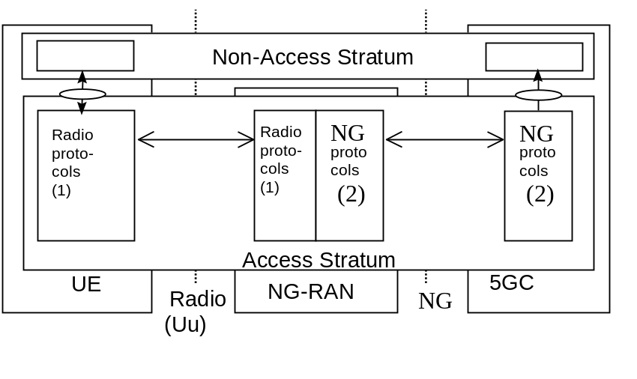
Note 1: The radio interface protocols are defined in 3GPP TS 38.2xx and TS 38.3xx.
Note 2: The NG interface protocols are defined in 3GPP TS 38.41x.

Figure 5.2-1: NG and Uu user plane

5.3 Control plane
Figure 5.3-1 shows the control plane (signalling) protocol stacks on NG and Uu interfaces.
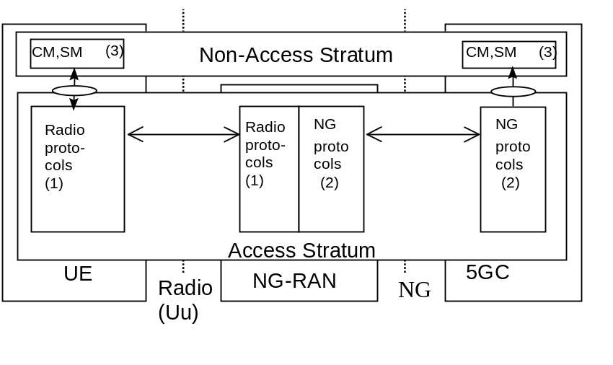
Note 1: The radio interface protocols are defined in 3GPP TS 38.2xx and TS 38.3xx.
Note 2: The protocol is defined in 3GPP TS 38.41x. (Description of NG interface).
Note 3: CM, SM: This exemplifies a set of NAS control protocols between UE and 5GC. The evolution of the protocol architecture for these protocols is outside the scope of the present document.

Figure 5.3-1: NG and Uu control plane

NOTE: Both the Radio protocols and the NG protocols contain a mechanism to transparently transfer NAS messages.

6 NG-RAN architecture

6.1 Overview
Editor Note: This subclause shows the overview of the NG-RAN architecture.
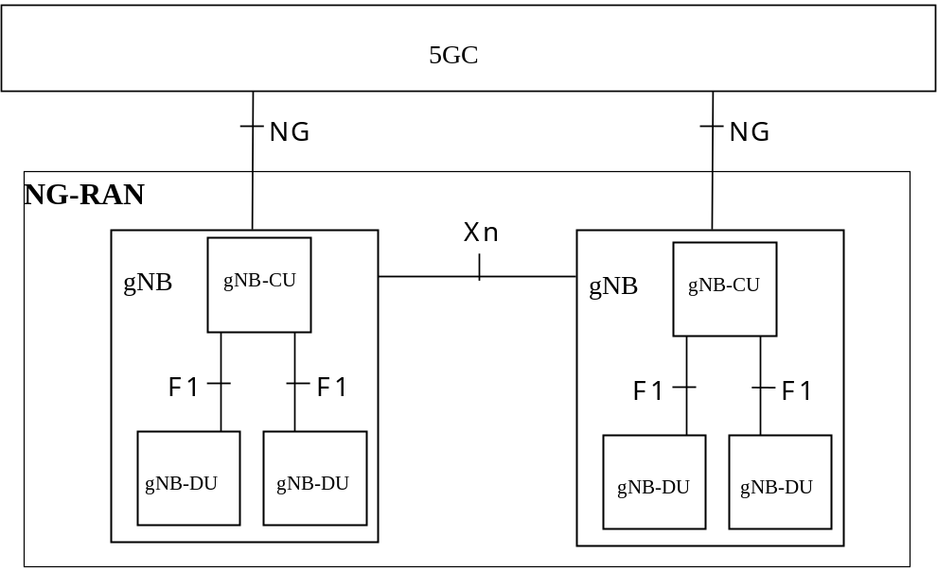
Figure 6.1-1 Overall architecture
Editor Note: The figure in overall architecture whether to show also gNB without gNB-CU/gNB-DU splitting is FFS.
The NG architecture can be further described as follows:
The NG-RAN consists of a set of gNBs connected to the 5GC through the NG.
An gNB can support FDD mode, TDD mode or dual mode operation.
gNBs can be interconnected through the Xn.
A gNB may consist of a gNB-CU and gNB-DUs. A gNB-CU and a gNB-DU is connected via F1 logical interface.
One gNB-DU is connected to only one gNB-CU.
NOTE: For resiliency, a gNB-DU may be connected to multiple gNB-CU by appropriate implementation.
NG, Xn and F1 are logical interfaces.
The NG-RAN is layered into a Radio Network Layer (RNL) and a Transport Network Layer (TNL).
The NG-RAN architecture, i.e. the NG-RAN logical nodes and interfaces between them, is defined as part of the RNL.
For each NG-RAN interface (NG, Xn, F1) the related TNL protocol and the functionality are specified. The TNL provides services for user plane transport, signalling transport.
In NG-Flex configuration, each gNB is connected to all 5GC nodes within a pool area. The pool area is defined in 3GPP TS 23.501 [x]. (FFS)
If security protection for control plane and user plane data on TNL of NG-RAN interfaces has to be supported, NDS/IP (3GPP TS 33.401 [x] shall be applied.

6.2 NG-RAN identifiers
Editor Note: This subclause shows those identifiers that are used in NG-RAN.

6.2.1 Principle of handling Application Protocol Identities
Editor Note: the description of APID need to check if duplication text with other specifications (FFS)
An Application Protocol Identity (AP ID) is allocated when a new UE-associated logical connection is created in either an gNB or an AMF. An AP ID shall uniquely identify a logical connection associated to a UE over the NG interface or Xn interface within a node (gNB or AMF). Upon receipt of a message that has a new AP ID from the sending node, the receiving node shall store the AP ID of the sending node for the duration of the logical connection. The receiving node shall assign the AP ID to be used to identify the logical connection associated to the UE and include it as well as the previously received new AP ID from the sending node, in the first returned message to the sending node. In all subsequent messages to and from sending node, both AP IDs of sending node and receiving node shall be included.
The definitions of AP IDs as used on NG interface or Xn interface or F1 interface are shown below:
gNB UE NGAP ID:
An gNB UE NGAP ID shall be allocated so as to uniquely identify the UE over the NG interface within an gNB. When an AMF receives an gNB UE NGAP ID it shall store it for the duration of the UE-associated logical NG-connection for this UE. Once known to an AMF this is included in all UE associated NG-AP signalling.
The gNB UE NGAP ID shall be unique within the gNB logical node.
AMF UE NGAP ID:
An AMF UE NGAP ID shall be allocated so as to uniquely identify the UE over the NG interface within the AMF. When an gNB receives AMF UE NGAP ID it shall store it for the duration of the UE-associated logical NG-connection for this UE. Once known to an gNB this ID is included in all UE associated NG-AP signalling.
The AMF UE NGAP ID shall be unique within the AMF logical node.
Old gNB UE XnAP ID:
An Old gNB UE XnAP ID shall be allocated so as to uniquely identify the UE over the Xn interface within a source gNB. When a target gNB receives an Old gNB UE XnAP ID it shall store it for the duration of the
UE-associated logical Xn-connection for this UE. Once known to a target gNB this ID is included in all UE associated Xn-AP signalling. The Old gNB UE XnAP ID shall be unique within the gNB logical node.
New gNB UE XnAP ID:
A New gNB UE XnAP ID shall be allocated so as to uniquely identify the UE over the Xn interface within a target gNB. When a source gNB receives a New gNB UE XnAP ID it shall store it for the duration of the
UE-associated logical Xn-connection for this UE. Once known to source gNB this ID is included in all UE associated Xn-AP signalling. The New gNB UE XnAP ID shall be unique within the gNB logical node.
MgNB UE XnAP ID:
A MgNB UE XnAP ID shall be allocated so as to uniquely identify the UE over Xn interface within a MgNB for dual connectivity. When a SgNB receives a MgNB UE XnAP ID it shall store it for the duration of the UE-associated logical Xn-connection for this UE. Once known to a SgNB this ID is included in all UE associated Xn-AP signalling. The MgNB UE XnAP ID shall be unique within the gNB logical node.
SgNB UE XnAP ID:
A SgNB UE XnAP ID shall be allocated so as to uniquely identify the UE over Xn interface within a SgNB for dual connectivity. When a MgNB receives a SgNB UE XnAP ID it shall store it for the duration of the UE-associated logical Xn-connection for this UE. Once known to a MgNB this ID is included in all UE associated Xn-AP signalling. The SgNB UE XnAP ID shall be unique within the gNB logical node.
gNB-CU UE F1AP ID:
Refer to TS 38.473 [xx]

6.3 Transport addresses
Editor Note: This subclause shows those principle of Transport Address that to be used in NG-RAN.
The transport layer address parameter is transported in the radio network application signalling procedures that result in establishment of transport bearer connections.
The transport layer address parameter shall not be interpreted in the radio network application protocols and reveal the addressing format used in the transport layer.
The formats of the transport layer addresses are further described in 3GPP TS 38.414 [x], 3GPP TS 38.424 [x] and 3GPP TS 38.474 [x].

6.4 UE associations in gNB
Editor Note: This subclause shows those principle of UE Associations in gNB e.g. gNB UE Association, UE Context etc.
There are several types of UE associations needed in the gNB: the "gNB UE context" used to store all information needed for a UE and the associations between the UE and the logical NG and Xn connections used for NG/Xn-AP UE associated messages. An "gNB UE context" exists for a UE in CM_CONNECTED, and may continue to exist after the UE transitions to CM_IDLE if the UE was enabled to use User Plane CIoT EPS Optimization (see TS 23.xxx [x]). (FFS for User Plane CIoT)
Definitions:
gNB UE context:
An gNB UE context is a block of information in an gNB associated to one UE. The block of information contains the necessary information required to maintain the NG-RAN services towards the active UE. An gNB UE context is established when the transition to active state for a UE is completed or in target gNB after completion of handover resource allocation during handover preparation, in which case at least UE state information, security information, UE capability information and the identities of the UE-associated logical NG-connection shall be included in the gNB UE context. If the UE is enabled to use User Plane CIoT 5GC Optimization (see TS 23.xxx [x]) the UE-associated logical NG-connection may be kept after the UE transitions to CM_IDLE. (FFS for the User Plane CIoT)
For Dual Connectivity an gNB UE context is also established in the SgNB after completion of SgNB Addition Preparation.
UE-associated logical NG-connection/ UE-associated logical Xn-connection / UE-associated logical F1-connection:
On the logical NG or Xn or F1 connection, control plane messages (NGAP, XnAP, F1AP) associated with the UE are sent.
This connection is established during the first NG/XnAP/F1AP message exchange between the NG/Xn/F1 peer nodes.
The connection is maintained as long as UE associated NG/XnAP/F1AP messages need to be exchanged over NG/Xn/F1.
The UE-associated logical NG-connection uses the identities AMF UE NGAP ID and gNB UE NGAP ID.
The UE-associated logical Xn-connection uses the identities Old gNB UE XnAP ID and New gNB UE XnAP ID, or MgNB UE XnAP ID and SgNB UE XnAP ID.
The UE-associated logical F1-connection uses the identities gNB-CU UE F1AP ID.
When a node (AMF or gNB) receives a UE associated NG/XnAP/F1AP message the node retrieves the associated UE based on the NG/XnAP/F1AP ID.
UE-associated signalling:
UE-associated signalling is an exchange of NG/XnAP/F1AP messages associated with one UE over the UE-associated logical NG/Xn/F1-connection.
NOTE: The UE-associated logical NG-connection may exist before the gNB UE context is setup in gNB.
The UE-associated logical Xn-connection may exist before the gNB UE context is setup in the target gNB.
The UE-associated logical F1-connection may exist before the gNB UE context is setup in the gNB-DU.(FFS including also description of UE Context in gNB-DU)

7 NG-RAN functions description
Editor Note: This subclause shows NG-RAN functions.
The list of functions refer to TS 38.300 [2].

7.1 PWS Message Transmission Function
This function provides the capability for the AMF to initiate and stop broadcasting of PWS warning messages to UEs related to alerts (earthquake, tsunami, etc..) to meet regional regulatory requirements, and provides the capability for the NG RAN to inform the AMF that ongoing PWS operation has failed for one or more areas.
Editor’s Note: The following sentence is FFS
ETWS, CMAS and the other warning services which use the same AS mechanisms as CMAS as described in 3GPP TS 38.300 [2] are the NG-RAN services related to warning deliveries.
Editor’s Note: Potential text on RAN sharing support (if needed) is FFS
Editor’s Note: Potential text for support of partial NG RAN node failure (if needed) is FFS

8 Overall procedures in gNB-CU/gNB-DU Architecture
Editor Note: This clause shows overall procedures including signalling flows in gNB-CU / gNB-DU architecture e.g. initial access from the UE, inter-DU mobility etc. The main focus is on gNB-CU and gNB-CU while also need to show UE and 5GC for understanding the interaction.

8.1 UE Initial Access
Editor Note: This subclause shows overall procedures for initial access from the UE.
Editor Note: The name of this subclaues is FFS.

8.2 Inter-DU Mobility
Editor Note: This subclause shows overall procedures for inter-DU mobility.
Editor Note: The name of this subclaues is FFS.

8.3 Mechanism of centralized retransmission of lost PDUs
Editor’s Note: whether this section could be captured in the same paragraph of mobility procedures is FFS.
This mechanism allows to perform the retransmission of the PDUs that were not delivered by a gNB-DU (gNB-DU1), e.g., because the radio link served by gNB-DU1 is subject to temporary outage, via another gNB-DU (gNB-DU2) with a well-functioning radio link toward the UE.
The gNB-DU1 shall detect the outage (e.g., based on measurement reports, CQI feedback, UL measurements, HARQ ACK/NACK ratios, RLC status reports). The gNB-DU1 shall send a notification to the gNB-CU about the outage.
Editor’s Note: how to define radio link outage is FFS.
Editor’s Note: whether the notification is over F1-C or F1-U is FFS.
Editor’s Note: whether new notification mechanism is needed is FFS.
Editor’s Note: whether the notification includes the PDCP PDU SNs corresponding to the RLC SDUs that have been either partially or totally undelivered in DU1 is FFS.
The gNB-CU shall decide on which gNB-DU (e.g. gNB-DU2) with well-functioning radio link to forward traffic to the UE. The gNB-CU may take this decision based on, e.g., previously recorded UE measurement reports. The gNB-CU shall forward to gNB-DU2 the incoming data traffic for the UE as well as PDCP PDUs with SNs potentially indicated by gNB-DU1. The gNB-CU may monitor the radio link served by gNB-DU1. If the radio link served by gNB-DU1 starts functioning, the gNB-CU may decide to start sending again data traffic through gNB-DU1.
Editor’s Note: how this mechanism is applied to dual/multi connectivity or single connectivity is FFS.

9 Synchronization

9.1 gNB Synchronization
Editor Note: This subclause shows logical synchronization in gNB.
The gNB shall support a logical synchronization port for phase-, time- and/or frequency synchronization.
Logical synchronization port for phase- and time-synchronization shall provide
1) accuracy that allows to meet the gNB requirements on maximum relative phase difference for all gNBs in synchronized TDD-unicast area and FDD/TDD-multicast MBSFN synchronization area; (FFS whether to remove MBSFN part)
2) continuous time without leap seconds traceable to common time reference for all gNBs in synchronized TDD-unicast area and FDD/TDD-multicast MBSFN synchronization area; (FFS whether to remove MBSFN part)
A logical synchronization port for phase- and time-synchronization may also be provided for e.g., all gNBs in FDD time domain inter-cell interference coordination synchronization area.
Furthermore common SFN initialization time shall be provided for all gNBs in synchronized TDD-unicast area and FDD/TDD-multicast MBSFN synchronization area. (FFS whether to remove MBSFN part)
Based on this information, the gNB may derive the SFN according to the following formula
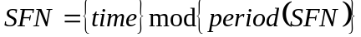,
where
time time adjusted by the common SFN initialization time, in units of 10 ms to match the length of radio frame and accuracy accordingly;
period(SFN) SFN period.
NOTE: When gNB is connected via TDM interfaces, these could be used to synchronize frequency the gNB.
The characteristics of these interfaces are described in 3GPP TS 25.411 [23].
In case gNB is connected via TDM interface, it may be used to synchronize frequency the gNB. The characteristics of the clock in the gNB shall be designed taking into account that the jitter and wander performance requirements on the interface are in accordance with network limits for output wander at traffic interfaces of either ITU-T Rec. G.823 [7], ITU-T Rec. G.824 [8] or network limits for the maximum output jitter and wander at any hierarchical interface of
ITU-T Rec. G.825 [9], whichever is applicable.
In case gNB is connected via Ethernet interface and the network supports Synchronous Ethernet, the gNB may use this interface to get frequency synchronization. In this case the design of the gNB clock should be done considering the jitter and wander performance requirements on the interface are as specified for output jitter and wander at EEC interfaces of ITU-T Rec. G.8261/Y.1361 [10], defined in clause 9.2.1. Further considerations on Synchronous Ethernet recommendations and architectural aspects are defined in clause 12.2.1 and Annex A of ITU-T Rec. G.8261/Y.1361 [10].
A configurable LTE TDD-offset of start frame shall be supported by all gNBs in synchronized TDD-unicast areas and/or TDD-multicast MBSFN synchronization areas in order to achieve interoperability in coexistence scenarios.
Editor Note: FFS for the synchronization for gNB-CU and gNB-DU.

9.2 gNB and 5G-CN Synchronization
Editor Note: This subclause shows gNB and 5G-CN synchronization.
When paging in extended Idle mode DRX, Hyper SFN synchronization requirements are specified in TS 23.xxx [x2].
(FFS for the Extended Idle Mode DRX in NR.)

10 NG-RAN interfaces

10.1 NG interface
Editor Note: This subclause shows overall NG interface e.g. function description. RAN3#96 meeting agreed that the function description for xxAP will go to 38.410/38.420/38.470, if nothing to be described here, then this subclause will be removed.

10.2 Xn interface
Editor Note: This subclause shows overall Xn interface e.g. function description. RAN3#96 meeting agreed that the function description for XnAP will go to 38.410/38.420/38.470, if nothing to be described here, then this subclause will be removed.

10.3 F1 interface
Editor Note: This subclause shows overall Fs interface e.g. function description. RAN3#96 meeting agreed that the function description for F1AP will go to 38.410/38.420/38.470. However, so far still keep the function description text here right now as the overall architecture discussion is still on going. If at the end agree to move all the text to 38.370, then this subclause will be removed.

10.3.1 General aspects
This clause captures the architecture for gNB-CU and gNB-DU, F1 interface principles.

10.3.2 Functions of the F1 interface protocols and functional split
Editor’s note: Naming of each function is FFS.

10.3.2.1 General
The following clauses describe the functions supported over F1-C and F1-U.

10.3.2.2 F1-C functions

10.3.2.2.1 GTP-U tunnel management function (FFS)
This function is used to establish and release GTP-U (3GPP TS 29.281 [x3]) tunnels between the gNB-CU and the gNB-DU upon a bearer service request. This involves assigning a tunnel identifier for each direction.
Editor’s note: Whether this section is kept or moved to bearer management function or removed is FFS.

10.3.2.2.2 F1 interface management function
The error indication function is used by the gNB-DU or gNB-CU to indicate to the gNB-CU or gNB-DU that an error has occurred.
The reset function is used to initialize the peer entity after node setup and after a failure event occurred. This procedure can be used by both the gNB-DU and gNB-CU.
The F1 setup (respectively the gNB-DU and gNB-CU configuration update) function allows to exchange (respectively update) application level data needed for the gNB-DU and gNB-CU to interoperate correctly on the F1 interface. The F1 setup is initiated by the gNB-DU (FFS).
Editor’s note: The space of NR Cell ID, and how/whether to map them in the gNB-CU are FFS.

10.3.2.2.3 gNB-DU management function (FFS)
Editor’s note: Whether gNB-DU is managed by O&M or by gNB-CU is FFS. The impact on F1 interface is FFS.

10.3.2.2.4 System Information management function
Scheduling of system broadcast information is carried out in the gNB-DU. The gNB-DU is responsible for transmitting the system information according to the scheduling parameters available.
Editor’s note: How to support this function is FFS.

10.3.2.2.5 gNB-DU and gNB-CU measurement reporting function (FFS)
The gNB-DU and gNB-CU measurement reporting functions are used to report the measurements of gNB-DU and and gNB-CU, respectively.

10.3.2.2.6 Load management function (FFS)
The load management function allows the gNB-CU and gNB-DU to request the reporting of load information to the gNB-DU and gNB-CU, respectively.

10.3.2.2.7 Paging function (FFS)
The gNB-DU is responsible for transmitting the paging information according to the scheduling parameters available.

10.3.2.2.8 F1 UE context management function
The F1 UE context management function supports the establishment of the necessary overall initial UE context.
The establishment of the F1 UE context is initiated by the gNB-CU and accepted or rejected by the gNB-DU based on admission control criteria (e.g., resource not available).
The F1 UE context management function also supports the release of the context previously established in the gNB-DU. The release of the context is triggered by the gNB-CU either directly or following a request received from the gNB-DU.
Editor’s note: What is UE context needs to be clarified.

10.3.2.2.9 Bearer management function
The bearer management function is responsible for triggering establishing, modifying and releasing radio bearer resources for user data transport once an F1 UE context is available in the gNB-DU. The establishment and modification of radio bearer resources are triggered by the gNB-CU and accepted/rejected by the gNB-DU based on resource reservation information and QoS information to be provided to the gNB-DU.
The mapping between QoS flows and radio bearers is performed by CU and the granularity of bearer management over F1 is radio bearer level.
Editor’s note: Whether mobility functions such as intra-CU/inter-DU handover can be supported by bearer management function is FFS.
Editor’s note: The relationship of bearer management and simultaneous transmission from two DUs is FFS.
Editor’s note: How to split and configure RRM functions between gNB-CU and gNB-DU is FFS.
Editor’s note: How to provide QoS information to gNB-DU is FFS.

10.3.2.2.10 Transfer of RRC message
This function allows to transfer RRC messages between gNB-CU and gNB-DU.
Editor’s note: Whether RRC message is transferred over F1-C or F1-U or both is FFS.

10.3.2.3 F1-U functions

10.3.2.3.1 Transfer of user data
This function allows to transfer of user data between gNB-CU and gNB-DU.

10.3.2.3.2 Flow control function
This function allows to control the downlink user data flow to the gNB-DU. The detailed protocol is specified in TS 38.475 [4x].
Editor’s note: Whether to support uplink flow control is FFS.

10.3.3 F1 interface protocols and protocol structure

10.3.3.1 F1 Control Plane Protocol (F1-C)
Figure 10.2.3.1-1 shows the protocol structure for F1-C. The TNL is based on IP transport, comprising the SCTP on top of IP. The application layer signalling protocol is referred to as F1AP (F1 Application Protocol).
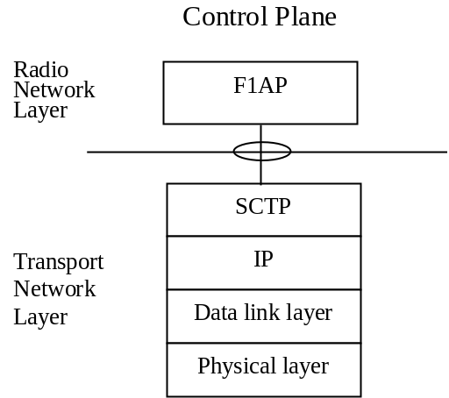
Figure 10.2.3.1-1: Interface protocol structure for F1-C
Editor’s note: Whether other protocol stacks are standardized for F1-C is FFS.

10.3.3.2 F1 User Plane Protocol (F1-U)
Figure 10.2.3.2-1 shows the protocol structure for F1-U. The TNL is based on IP transport, comprising the UDP and GTP-U on top of IP.
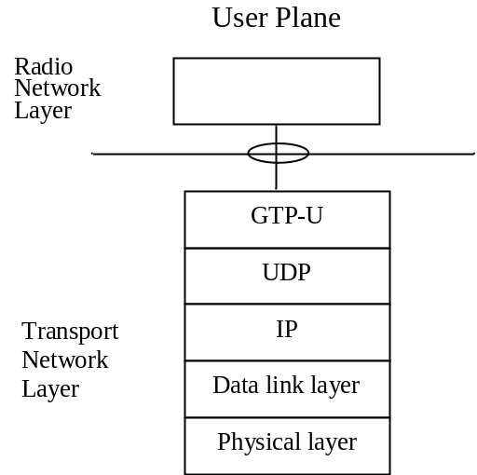
Figure 10.2.3.2-1: Interface protocol structure for F1-U
Editor’s note: Whether other protocol stacks are standardized for F1-U is FFS.

Change history
Date | Meeting | TDoc | CR | Rev | Cat | Subject/Comment | New version
2017-04 | RAN3#95bis | R3-171307 |  |  |  | First Draft | 0.0.1
2017-05 | RAN3#96 | R3-171962 |  |  |  | - Reflected agreed TP in RAN3#96.  - Added new Clause 8 for overall procedure for gNB-CU/DU architecture | 0.1.0

