3GPP TS 38.300 V0.1.0 (2017-03)
Technical Specification
3rd Generation Partnership Project;
Technical Specification Group Radio Access Network;
NG Radio Access Network;
Overall Description;
Stage 2
(Release 15 )


The present document has been developed within the 3rd Generation Partnership Project (3GPP TM) and may be further elaborated for the purposes of 3GPP..
The present document has not been subject to any approval process by the 3GPP Organizational Partners and shall not be implemented.
This Specification is provided for future development work within 3GPP only. The Organizational Partners accept no liability for any use of this Specification.
Specifications and Reports for implementation of the 3GPP TM system should be obtained via the 3GPP Organizational Partners' Publications Offices.

Keywords
3GPP, Radio, Architecture, Stage 2, 5G
3GPP
Postal address

3GPP support office address
650 Route des Lucioles - Sophia Antipolis
Valbonne - FRANCE
Tel.: +33 4 92 94 42 00 Fax: +33 4 93 65 47 16
Internet
http://www.3gpp.org
Copyright Notification
No part may be reproduced except as authorized by written permission.
The copyright and the foregoing restriction extend to reproduction in all media.

© 2017, 3GPP Organizational Partners (ARIB, ATIS, CCSA, ETSI, TSDSI, TTA, TTC).
All rights reserved.

UMTS™ is a Trade Mark of ETSI registered for the benefit of its members
3GPP™ is a Trade Mark of ETSI registered for the benefit of its Members and of the 3GPP Organizational Partners
LTE™ is a Trade Mark of ETSI registered for the benefit of its Members and of the 3GPP Organizational Partners
GSM® and the GSM logo are registered and owned by the GSM Association
Contents
Foreword 5
1 Scope 6
2 References 6
3 Abbreviations and Definitions 6
3.1 Abbreviations 6
3.2 Definitions 6
4 Overall Architecture and Functional Split 7
4.1 Overall Architecture 7
4.2 Functional Split 7
4.3 Network Interfaces 9
4.4 Radio Protocol Architecture 9
4.4.1 User Plane 9
4.4.2 Control Plane 9
5 Physical Layer 10
6 Layer Two 10
6.1 Overview 10
6.2 MAC Sublayer 12
6.2.1 Services and Functions 12
6.2.2 Logical Channels 12
6.2.3 Mapping to Transport Channels 12
6.2.4 HARQ 13
6.3 RLC Sublayer 13
6.3.1 Transmission Modes 13
6.3.2 Services and Functions 13
6.3.3 ARQ 13
6.4 PDCP Sublayer 14
6.4.1 Services and Functions 14
6.4.2 Duplication 14
6.5 SDAP Sublayer 14
6.6 L2 Data Flow 15
7 RRC 15
7.1 Services and Functions 15
7.2 Protocol States 16
7.3 System Information Handling 16
7.4 Access Control 17
7.5 UE Capability Retrieval framework 17
7.6 Transport of NAS Messages 17
8 NG Identities 18
9 Mobility 18
9.1 Overview 18
9.2 Intra-NR 18
9.2.1 Mobility in RRC-IDLE 18
9.2.1.1 Cell Selection 18
9.2.2.2 Cell Reselection 19
9.2.2 Mobility in RRC-INACTIVE 20
9.2.2.1 Cell Reselection 20
9.2.2.2 RAN-Based Notification Area 20
9.2.3 Mobility in RRC-CONNECTED 20
9.2.4 Measurements 21
9.2.5 Paging 21
9.2.6 Random Access Procedure 22
9.2.7 Radio Link Failure 23
9.3 Inter RAT 23
9.3.1 Cell Reselection 23
9.3.2 Handover 23
9.3.3 Measurements 23
10 Scheduling 23
10.1 Basic Scheduler Operation 23
10.2 Downlink Scheduling 24
10.3 Uplink Scheduling 24
10.4 Measurements to Support Scheduler Operation 24
10.5 Rate Control 24
11 UE Power Saving 24
12 QoS 24
13 Security 26
14 Network Interfaces 26
15 UE Capabilities 26
16 Verticals Support 26
16.1 Self-Configuration and Self-Optimisation 26
16.2 IMS Voice 26
16.3 Network Slicing 26
16.3 PWS 26
16.4 URLLC 26
Annex Z (informative): Change history 28

Foreword
This Technical Specification has been produced by the 3rd Generation Partnership Project (3GPP).
The contents of the present document are subject to continuing work within the TSG and may change following formal TSG approval. Should the TSG modify the contents of the present document, it will be re-released by the TSG with an identifying change of release date and an increase in version number as follows:
Version x.y.z
where:
x the first digit:
1 presented to TSG for information;
2 presented to TSG for approval;
3 or greater indicates TSG approved document under change control.
y the second digit is incremented for all changes of substance, i.e. technical enhancements, corrections, updates, etc.
z the third digit is incremented when editorial only changes have been incorporated in the document.

1 Scope
The present document provides an overview and overall description of the NG-RAN and focuses on the radio interface protocol architecture of NR connected to 5GC (LTE connected to 5GC is covered in the 36 series). Details of the radio interface protocols are specified in companion specifications of the 38 series.

2 References
The following documents contain provisions which, through reference in this text, constitute provisions of the present document.
- References are either specific (identified by date of publication, edition number, version number, etc.) or non-specific.
- For a specific reference, subsequent revisions do not apply.
- For a non-specific reference, the latest version applies. In the case of a reference to a 3GPP document (including a GSM document), a non-specific reference implicitly refers to the latest version of that document in the same Release as the present document.
[1] 3GPP TR 21.905: "Vocabulary for 3GPP Specifications".
[2] 3GPP TS 36.300: "Evolved Universal Terrestrial Radio Access (E-UTRA) and Evolved Universal Terrestrial Radio Access Network (E-UTRAN); Overall description; Stage 2".
[3] 3GPP TS 23.501: "System Architecture for the 5G System; Stage 2".

3 Abbreviations and Definitions

3.1 Abbreviations
For the purposes of the present document, the abbreviations given in 3GPP TR 21.905 [1], in 3GPP TS 36.300 [2] and the following apply. An abbreviation defined in the present document takes precedence over the definition of the same abbreviation, if any, in 3GPP TR 21.905 [1] and 3GPP TS 36.300 [2].
5GC 5G Core Network
AMF Access and Mobility Management Function
gNB NG-RAN NodeB
NG-RAN NG Radio Access Network
NR NR Radio Access
SDAP Service Data Adaptation Protocol
UPF User Plane Function

SDAP name to be confirmed by RAN2.

3.2 Definitions
For the purposes of the present document, the terms and definitions given in 3GPP TR 21.905 [1], in 3GPP TS 36.300 [2] and the following apply. A term defined in the present document takes precedence over the definition of the same term, if any, in 3GPP TR 21.905 [1] and 3GPP TS 36.300 [2].
N2: control plane interface between NG-RAN and 5GC.
N3: user plane interface between NG-RAN and 5GC.
Numerology: corresponds to one subcarrier spacing in the frequency domain. By scaling a basic subcarrier spacing by an integer N, different numerologies can be defined.
TTI duration: corresponds to a number of consecutive symbols in the time domain in one transmission direction. Different TTI durations can be defined when using different number of symbols.
Xn: network interface between gNBs.

4 Overall Architecture and Functional Split

4.1 Overall Architecture
The New Generation Access Network (NG-RAN) consists of gNBs and eNBs, providing the user plane and control plane protocol terminations towards the UE. The gNBs are interconnected with each other by means of the Xn interface. The gNBs are also connected by means of the N interfaces to the 5GC, more specifically to the AMF (Access and Mobility Management Function) by means of the N2 interface and to the UPF (User Plane Function) by means of the N3 interface (see 3GPP TS 23.501 [3]).
The NG-RAN architecture with gNBs is illustrated in Figure 4-1 below. The NG-RAN architecture with eNBs is depicted in 3GPP TS 36.300 [2].
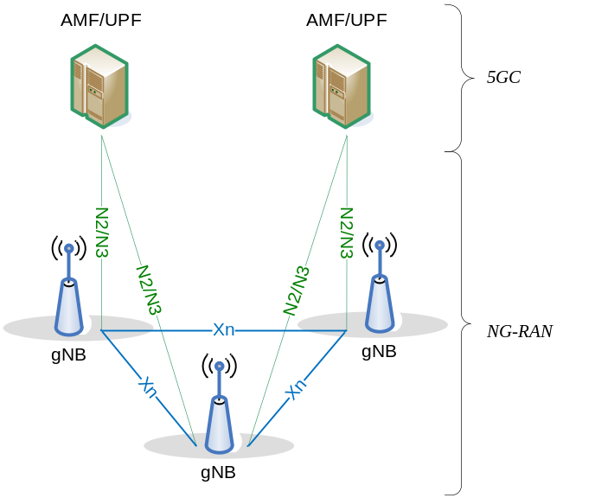
Figure 4-1: Overall Architecture

4.2 Functional Split
The gNB hosts the following functions:
- Functions for Radio Resource Management: Radio Bearer Control, Radio Admission Control, Connection Mobility Control, Dynamic allocation of resources to UEs in both uplink and downlink (scheduling);
- IP header compression and encryption of user data stream;
- Selection of an AMF at UE attachment when no routing to an AMF can be determined from the information provided by the UE;
- Routing of User Plane data towards UPF(s);
- Scheduling and transmission of paging messages (originated from the AMF);
- Scheduling and transmission of system broadcast information (originated from the AMF or O&M);
- Measurement and measurement reporting configuration for mobility and scheduling.
The AMF hosts the following main functions (see 3GPP TS 23.501 [3]):
- NAS signalling termination;
- NAS signalling security;
- AS Security control;
- Inter CN node signalling for mobility between 3GPP access networks;
- Idle mode UE Reachability (including control and execution of paging retransmission);
- Tracking Area list management (for UE in idle and active mode);
- AMF selection for handovers with AMF change;
- Access Authentication;
- Access Authorization including check of roaming rights.
The UPF hosts the following main functions (see 3GPP TS 23.501 [3]):
- Anchor point for Intra-/Inter-RAT mobility (when applicable);
- External PDU session point of interconnect to Data Network;
- Packet routing & forwarding;
- Packet inspection and User plane part of Policy rule enforcement;
- Traffic usage reporting;
- Uplink classifier to support routing traffic flows to a data network;
- Branching point to support multi-homed PDU session;
- QoS handling for user plane, e.g. packet filtering, gating, UL/DL rate enforcement;
- Uplink Traffic verification (SDF to QoS flow mapping);
- Transport level packet marking in the uplink and downlink;
- Downlink packet buffering and downlink data notification triggering.
The Session Management function (SMF) hosts the following main functions (see 3GPP TS 23.501 [3]):
- Session Management;
- UE IP address allocation and management;
- Selection and control of UP function;
- Configures traffic steering at UPF to route traffic to proper destination;
- Control part of policy enforcement and QoS;
- Downlink Data Notification.
This is summarized on the figure below where yellow boxes depict the logical nodes and white boxes depict the main functions.
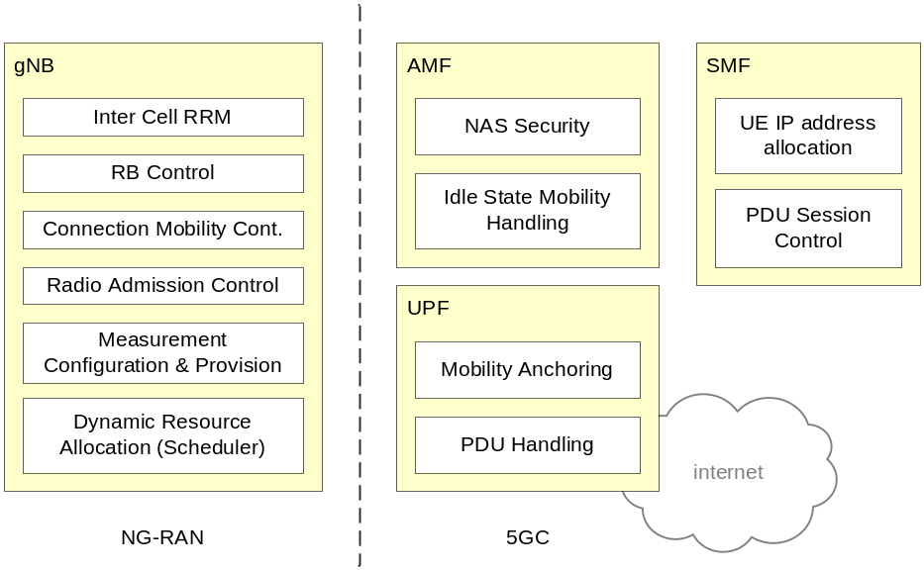
Figure 4.2-1: Functional Split between NG-RAN and 5GC

4.3 Network Interfaces
To be provided by RAN3. Should contain an overview of the network interfaces. Coordination with SA2 expected, but from RAN3 side.

4.4 Radio Protocol Architecture

4.4.1 User Plane
The figure below shows the protocol stack for the user plane, where SDAP, PDCP, RLC and MAC sublayers (terminated in gNB on the network side) perform the functions listed in subclause 7.
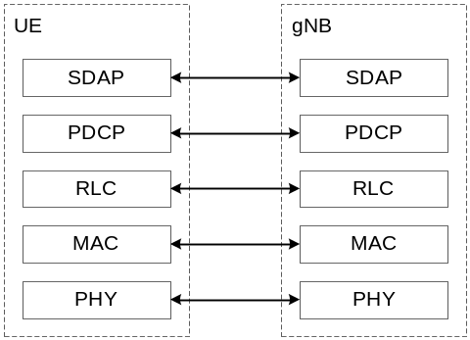
Figure 4.4.1-1: User Plane Protocol Stack

4.4.2 Control Plane
The figure below shows the protocol stack for the control plane, where:
- PDCP, RLC and MAC sublayers (terminated in gNB on the network side) perform the functions listed in subclause 7;
- RRC (terminated in gNB on the network side) performs the functions listed in subclause 8;
- NAS control protocol (terminated in AMF on the network side) performs the functions listed in 3GPP TS 23.501 [3]), for instance: authentication, mobility management, security control…
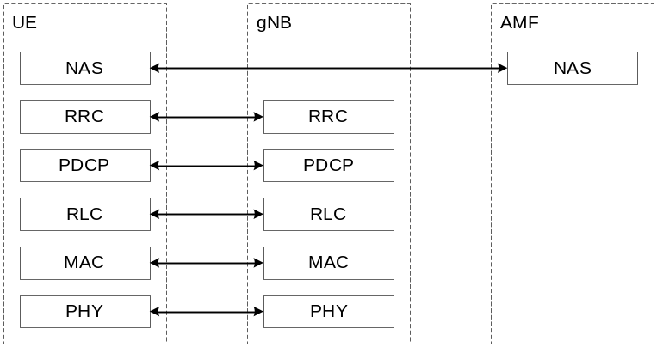
Figure 4.4.2-1: Control Plane Protocol Stack

5 Physical Layer
To be provided by RAN1. Should at least contain an overview of downlink & uplink transmission schemes, beam management, channel structure, transport channels, mapping between transport channels and physical channels, definition of slots...

6 Layer Two

6.1 Overview
The layer 2 is split into the following sublayers: Medium Access Control (MAC), Radio Link Control (RLC), Packet Data Convergence Protocol (PDCP) and SDAP (Service Data Adaptation Protocol). The two figures below depict the Layer 2 architecture for downlink and uplink, where:
- Service Access Points (SAP) for peer-to-peer communication are marked with circles at the interface between sublayers:
- The SAPs between the physical layer and the MAC sublayer provides the transport channels;
- The SAPs between the MAC sublayer and the RLC sublayer provide the logical channels;
- The SAPs between the RLC sublayer and the PDCP sublayer provide the RLC bearers;
- The SAPs between the PDCP sublayer and the SDAP sublayer provide the radio bearers;
- The SAPs between the SDAP sublayer and 5GC provide the QoS flows.
- Comp. refers to header compression and segm. to segmentation.
- Control channels (BCCH, PCCH are not depicted for clarity).
SAPs names to be confirmed by RAN2.
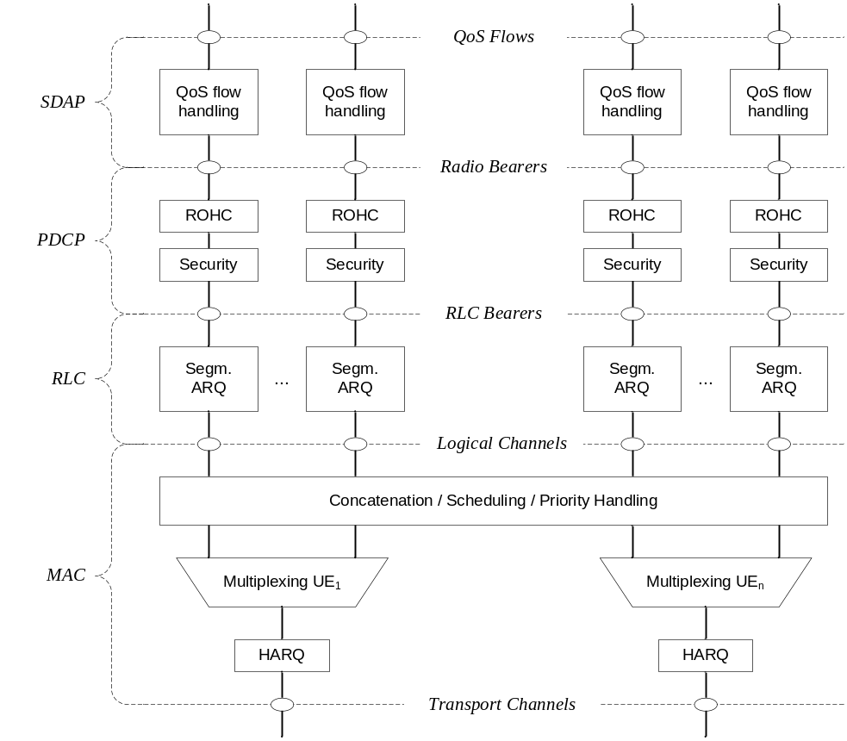
Figure 6.1-1: Downlink Layer 2 Structure
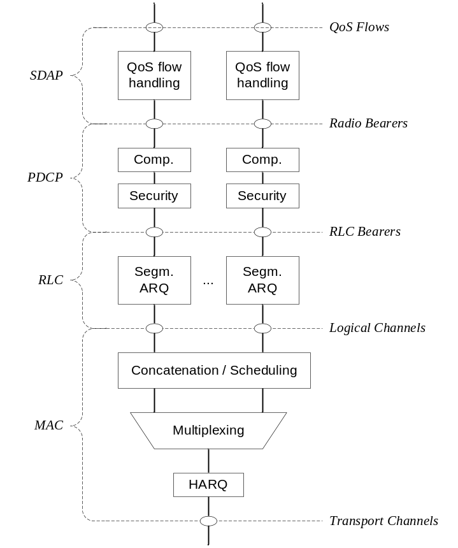
Figure 6.1-2: Uplink Layer 2 Structure

6.2 MAC Sublayer

6.2.1 Services and Functions
The main services and functions of the MAC sublayer include:
- Mapping between logical channels and transport channels;
- Multiplexing/demultiplexing of MAC SDUs belonging to one or different logical channels into/from transport blocks (TB) delivered to/from the physical layer on transport channels;
- Scheduling information reporting;
- Error correction through HARQ;
- Priority handling between UEs by means of dynamic scheduling;
- Priority handling between logical channels of one UE by means of logical channel prioritisation;
- Padding.
A single MAC entity can support one or multiple numerologies and/or TTI durations but in order for the mapping to be respected, logical channel prioritization procedure takes into account the mapping of one logical channel to one or more numerologies and/or TTI durations.

6.2.2 Logical Channels
Different kinds of data transfer services as offered by MAC. Each logical channel type is defined by what type of information is transferred. Logical channels are classified into two groups: Control Channels and Traffic Channels. Control channels are used for the transfer of control plane information only:
Names to be confirmed by RAN2.
- Broadcast Control Channel (BCCH): a downlink channel for broadcasting system control information.
- Paging Control Channel (PCCH): a downlink channel that transfers paging information and system information change notifications.
- Common Control Channel (CCCH): channel for transmitting control information between UEs and network. This channel is used for UEs having no RRC connection with the network.
To be clarified whether CCCH applies to RRC-Inactive.
- Dedicated Control Channel (DCCH): a point-to-point bi-directional channel that transmits dedicated control information between a UE and the network. Used by UEs having an RRC connection.
Traffic channels are used for the transfer of user plane information only:
- Dedicated Traffic Channel (DTCH): point-to-point channel, dedicated to one UE, for the transfer of user information. A DTCH can exist in both uplink and downlink.

6.2.3 Mapping to Transport Channels
In Downlink, the following connections between logical channels and transport channels exist:
- BCCH can be mapped to BCH;
- BCCH can be mapped to DL-SCH;
- PCCH can be mapped to PCH;
- CCCH can be mapped to DL-SCH;
- DCCH can be mapped to DL-SCH;
- DTCH can be mapped to DL-SCH.
DL mapping to be confirmed by RAN2.
In Uplink, the following connections between logical channels and transport channels exist:
- CCCH can be mapped to UL-SCH;
- DCCH can be mapped to UL- SCH;
- DTCH can be mapped to UL-SCH.
Uplink mapping to be confirmed by RAN2.

6.2.4 HARQ
The HARQ functionality ensures delivery between peer entities at Layer 1.
More details can be captured once agreed (RAN1 input required).

6.3 RLC Sublayer

6.3.1 Transmission Modes
The RLC sublayer supports three transmission modes:
- Transparent Mode (TM);
- Unacknowledged Mode (UM);
- Acknowledged Mode (AM).
The RLC configuration is per logical channel with no dependency on numerologies and/or TTI durations, and ARQ can operate on any of the numerologies and/or TTI durations the logical channel is configured with.

6.3.2 Services and Functions
The main services and functions of the RLC sublayer depend on the transmission mode and include:
- Transfer of upper layer PDUs;
- Sequence numbering independent of the one in PDCP;
- Error Correction through ARQ;
- Segmentation and re-segmentation;
FFS whether re-segmentation applies to PDU or SDU.
- Reassembly of SDU;
- RLC SDU discard;
- RLC re-establishment.

6.3.3 ARQ
The ARQ functionality provides error correction in AM mode, and has the following characteristics:
- ARQ retransmits RLC PDUs or RLC PDU segments based on RLC status reports;
- Polling for RLC status report is used when needed by RLC;
- RLC receiver can also trigger RLC status report after detecting a missing RLC PDU or RLC PDU segment.

6.4 PDCP Sublayer

6.4.1 Services and Functions
The main services and functions of the PDCP sublayer for the user plane include:
- Sequence Numbering;
- Header compression and decompression: ROHC only;
- Transfer of user data;
- Reordering and duplicate detection (if in order delivery to layers above PDCP is required);
FFS if reordering can be disabled.
- PDCP PDU routing (in case of split bearers);
- Retransmission of PDCP SDUs;
FFS when to perform retransmission.
- Ciphering and deciphering;
FFS whether integrity protection also applies to user plane.
- PDCP SDU discard;
- PDCP re-establishment and data recovery for RLC AM;
- Duplication of PDCP PDUs.
The main services and functions of the PDCP sublayer for the control plane include:
- Ciphering, deciphering and integrity protection;
- Transfer of control plane data;
- Duplication of PDCP PDUs.

6.4.2 Duplication
Duplication applies in case of multi-connectivity and carrier aggregation (CA). In case of CA, duplication to more than one logical channel is used for Carrier Aggregation so that the duplicated PDCP PDUs are sent over different carriers.
FFS whether the PDCP PDU duplication for CA is realised by a single or two MAC entities.

6.5 SDAP Sublayer
The main services and functions of a new AS sublayer include:
- Mapping between a QoS flow and a data radio bearer;
- Marking QoS flow ID in both DL and UL packets.
A single protocol entity of SDAP is configured for each individual PDU session.

6.6 L2 Data Flow
An example of the Layer 2 Data Flow is depicted on Figure 7.6-1, where a transport block is generated by MAC by concatenating two RLC PDUs from RB_{x} and one RLC PDU from RB_{y}. The two RLC PDUs from RB_{x} each corresponds to one IP packet (n and n+1) while the RLC PDU from RB_{y} is a segment of an IP packet (m).
NOTE: H depicts the headers and subheaders.
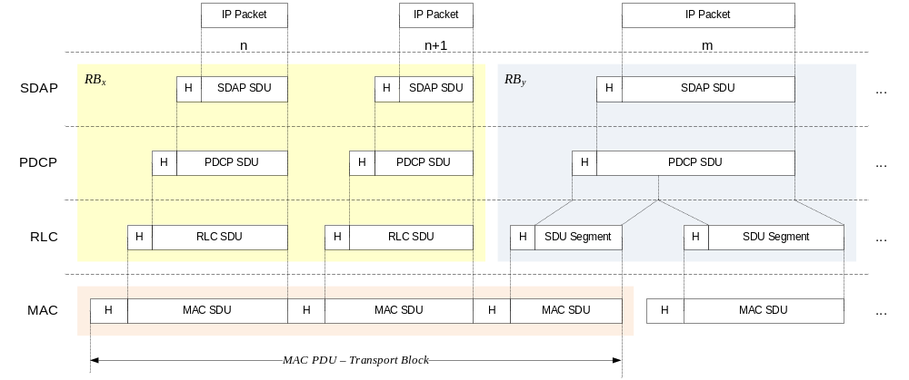
Figure 6.6-1: Data Flow Example

7 RRC

7.1 Services and Functions
The main services and functions of the RRC sublayer include:
- Broadcast of System Information related to AS and NAS;
- Paging initiated by 5GC or RAN;
- Establishment, maintenance and release of an RRC connection between the UE and RAN including:
- Addition, modification and release of carrier aggregation;
- Addition, modification and release of Dual Connectivity in NR or between LTE and NR.
- Security functions including key management;
- Establishment, configuration, maintenance and release of Signalling Radio Bearers (SRBs) and Data Radio Bearers (DRBs);
- Mobility functions including:
- Handover;
- UE cell selection and reselection and control of cell selection and reselection;
- Context transfer at handover.
- QoS management functions;
- UE measurement reporting and control of the reporting;
- NAS message transfer to/from NAS from/to UE.

7.2 Protocol States
RRC supports the following states which can be characterised as follows:
- RRC_IDLE:
- PLMN selection;
- DRX configured by NAS;
- Broadcast of system information;
- Cell re-selection mobility;
- Paging (initiated and area managed by 5GC);
FFS whether the UE AS context is not stored in any gNB or in the UE.
- RRC_INACTIVE:
- Cell re-selection mobility;
- 5GC - NG-RAN connection (both C/U-planes) established for UE;
- The UE AS context is stored in at least one gNB and the UE;
- Paging is initiated by NG-RAN;
- RAN-based notification area is managed by NG- RAN;
- NG-RAN knows the RAN-based notification area which the UE belongs to;
FFS if data transmission in possible in INACTIVE
- RRC_CONNECTED:
- The UE has an NG-RAN RRC connection;
- The UE has an AS context in NR;
- NG-RAN knows the cell which the UE belongs to;
- Transfer of unicast data to/from the UE;
- Network controlled mobility including measurements.

7.3 System Information Handling
System information is divided into Minimum SI and Other SI. Minimum SI is periodically broadcast and comprises basic information required for initial access and information for acquiring any other SI broadcast periodically or provisioned on-demand, i.e. scheduling information. The Other SI encompasses everything not broadcast in the Minimum SI and may either be broadcast, or provisioned in a dedicated manner, either triggered by the network or upon request from the UE as illustrated in Figure 8.3-1 below.
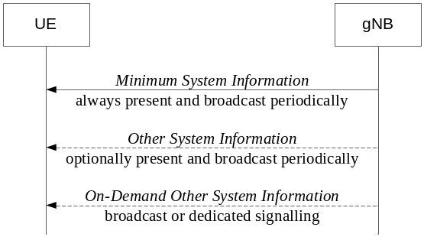
Figure 7.3-1: System Information Provisioning
For UEs in RRC_CONNECTED, dedicated RRC signalling can be used for the request and delivery of the Other SI. The Other SI may be broadcast at a configurable periodicity and for a certain duration. It is a network decision whether the other SI is broadcast or delivered through dedicated and UE specific RRC signalling.
Each cell on which the UE is allowed to camp broadcasts at least some contents of the Minimum SI, while there may be cells in the system on which the UE cannot camp and do not broadcast the Minimum SI.
For a cell/frequency that is considered for camping by the UE, the UE is not required to acquire the contents of the minimum SI of that cell/frequency from another cell/frequency layer. This does not preclude the case that the UE applies stored SI from previously visited cell(s).
If the UE cannot determine the full contents of the minimum SI of a cell (by receiving from that cell or from valid stored SI from previous cells), the UE shall consider that cell as barred.

7.4 Access Control
The NR system should support overload and access control functionality such as RACH back off, RRC Connection Reject, RRC Connection Release and UE based access barring mechanisms.
One unified access barring mechanism for NR should be introduced to address all the use cases and scenarios that LTE addressed with different specialized mechanisms. The unified access barring mechanism should be forward compatible in order to cope with future use cases/scenarios.
In NR, the unified access barring mechanism should be applicable for all RRC states in NR (RRC_IDLE, RRC_CONNECTED and RRC_INACTIVE).
These are only high level requirements, once the corresponding mechanisms are actually agreed, this subclause should be changed.

7.5 UE Capability Retrieval framework
The UE reports its UE radio access capabilities which are static at least when the network requests. The gNB can request what capabilities for the UE to report (e.g. similar band and band combination requests as in E-UTRAN). The change of UE capabilities is just to, temporarily (e.g. under network control), limit the availability of some capabilities, e.g. due to hardware sharing, interference or overheating. The temporary capability restriction should be transparent to 5GC. Namely, only static capabilities are stored in 5GC. The UE signals the temporary capability restriction request to the gNB.
Should statements require more work.

7.6 Transport of NAS Messages
To be captured once agreements are made.

8 NG Identities
Not discussed yet, need inputs from RAN1, RAN3 and SA2.

9 Mobility
FFS whether serving/non-serving cell may be termed 'serving/non-serving set of beam.
FFS how the cell in connected relates to the cell in idle.

9.1 Overview
Load balancing is achieved in E-UTRAN with handover, redirection mechanisms upon RRC release and through the usage of inter-frequency and inter-RAT absolute priorities and inter-frequency Qoffset parameters.
Measurements to be performed by a UE for mobility are classified in at least three measurement types:
- Intra-frequency measurements;
- Inter-frequency measurements;
- Inter-RAT measurements for E-UTRAN, UTRAN and GERAN;
Inter-RAT measurements for Inter-RAT measurements of CDMA2000 HRPD or 1xRTT frequencies omitted.
For each measurement type one or several measurement objects can be defined (a measurement object defines e.g. the carrier frequency to be monitored).
For each measurement object one or several reporting configurations can be defined (a reporting configuration defines the reporting criteria). Three reporting criteria are used: event triggered reporting, periodic reporting and event triggered periodic reporting.
The association between a measurement object and a reporting configuration is created by a measurement identity (a measurement identity links together one measurement object and one reporting configuration of same RAT). By using several measurement identities (one for each measurement object, reporting configuration pair) it is possible:
- To associate several reporting configurations to one measurement object and;
- To associate one reporting configuration to several measurement objects.
The measurements identity is as well used when reporting results of the measurements.
Measurement quantities are considered separately for each RAT.
Measurement commands are used by NG-RAN to order the UE to start measurements, modify measurements or stop measurements.

9.2 Intra-NR

9.2.1 Mobility in RRC-IDLE

9.2.1.1 Cell Selection
The principles of PLMN selection in NR are based on the 3GPP PLMN selection principles. Cell selection is required on transition from RM-DEREGISTERED to RM-REGISTERED and from CM-IDLE to CM-CONNECTED and is based on the following principles:
- The UE NAS layer identifies a selected PLMN and equivalent PLMNs;
- The UE searches the NR frequency bands and for each carrier frequency identifies the strongest cell. It reads cell system information broadcast to identify its PLMN(s):
- The UE may search each carrier in turn ("initial cell selection") or make use of stored information to shorten the search ("stored information cell selection").
- The UE seeks to identify a suitable cell; if it is not able to identify a suitable cell it seeks to identify an acceptable cell. When a suitable cell is found or if only an acceptable cell is found it camps on that cell and commence the cell reselection procedure:
- A suitable cell is one for which the measured cell attributes satisfy the cell selection criteria; the cell PLMN is the selected PLMN, registered or an equivalent PLMN; the cell is not barred or reserved and the cell is not part of a tracking area which is in the list of "forbidden tracking areas for roaming";
- An acceptable cell is one for which the measured cell attributes satisfy the cell selection criteria and the cell is not barred.
Transition to RRC_IDLE:
On transition from RRC_CONNECTED to RRC_IDLE, a UE should camp on the last cell for which it was in RRC_CONNECTED or a cell/any cell of set of cells or frequency be assigned by RRC in the state transition message.
Recovery from out of coverage:
The UE should attempt to find a suitable cell in the manner described for stored information or initial cell selection above. If no suitable cell is found on any frequency or RAT, the UE should attempt to find an acceptable cell.
Cell selection principles aligned with RAN2 agreements.
In multi-beam operations, measurement quantity of a cell is derived amongst the beams corresponding to the same cell.
FFS how to derive the cell level measurement quantity from multiple beams, which may or needs not be different for the one in RRC_CONNECTED.

9.2.2.2 Cell Reselection
A UE in RRC_IDLE performs cell reselection. The principles of the procedure are the following:
- The UE makes measurements of attributes of the serving and neighbour cells to enable the reselection process:
- There is no need to indicate neighbouring cells in the serving cell system information to enable the UE to search and measure a cell i.e. NR relies on the UE to detect the neighbouring cells;
- For the search and measurement of inter-frequency neighbouring cells, only the carrier frequencies need to be indicated;
- Measurements may be omitted if the serving cell attribute fulfils particular search or measurement criteria.
- Cell reselection identifies the cell that the UE should camp on. It is based on cell reselection criteria which involves measurements of the serving and neighbour cells:
- Intra-frequency reselection is based on ranking of cells;
- Inter-frequency reselection is based on absolute priorities where a UE tries to camp on the highest priority frequency available. Absolute priorities for reselection are provided only by the RPLMN and are valid only within the RPLMN; priorities are given by the system information and are valid for all UEs in a cell, specific priorities per UE can be signalled in the RRC Connection Release message. A validity time can be associated with UE specific priorities.
- Inter-frequency reselection can be also based on redistribution priority. A UE may be redistributed to a redistribution target (frequency or cell) and will consider the redistribution target (frequency or cell) as having the highest priority (i.e. higher than any network configured priority) for a period of time (i.e. validity timer). The redistribution parameters are defined in system information and can be triggered by Paging.
- For inter-frequency neighbouring cells, it is possible to indicate layer-specific cell reselection parameters (e.g., layer specific offset). These parameters are common to all neighbouring cells on a frequency;
- An NCL can be provided by the serving cell to handle specific cases for intra- and inter-frequency neighbouring cells. This NCL contains cell specific cell reselection parameters (e.g., cell specific offset) for specific neighbouring cells;
- Black lists can be provided to prevent the UE from reselecting to specific intra- and inter-frequency neighbouring cells;
- Cell reselection can be speed dependent;
- Cell reselection parameters are applicable for all UEs in a cell, but it is possible to configure specific reselection parameters per UE group or per UE.
Cell reselection principles aligned with RAN2 agreements.
- Service specific prioritisation;
FFS for which services the service specific prioritisation is applied and how it applies for the case of network slices.
In multi-beam operations, measurement quantity of a cell is derived from N best beams corresponding to the same cell where the value of N can be configured to 1 or more than 1.
FFS on details of filtering to be applied (E.g. for the case N = 1, the best beam is filtered by a single filter as the best beam changes) and whether to only consider beams above a threshold (good beams)

9.2.2 Mobility in RRC-INACTIVE

9.2.2.1 Cell Reselection
Can we assume the same principle as for RRC-INACTIVE?

9.2.2.2 RAN-Based Notification Area
A UE in the RRC_INACTIVE state can be configured with the RAN-based notification area, whereupon:
- a notification area can cover a single or multiple cells, and can be smaller than CN area;
- a UE does not send any "location update" indication when it stays within the boundaries of the notification area;
- leaving the area, a UE updates its location to the network.
There are several different alternatives on how the RAN-based notification area can be configured:
- List of cells;
- A UE is provided an explicit list of cells (one or more) that constitute the RAN-based notification area.
- RAN area.
- A UE is provided (at least one) RAN area ID;
- A cell broadcasts (at least one) RAN area ID in the system information so that a UE knows which area the cell belongs to.
FFS whether one alternative or both are agreed.

9.2.3 Mobility in RRC-CONNECTED
Network controlled mobility is applied for the UE in RRC_CONNECTED and is dealt with or without RRC. The RRC driven mobility is responsible for the cell level mobility, i.e. handover. Handover signalling procedures adopt the same principle as Rel-13 E-UTRAN as specified in TS 36.300 [2]. For inter-gNB handover, the signalling procedures consist of at least the following elemental components illustrated in Figure 10.2.3-1:
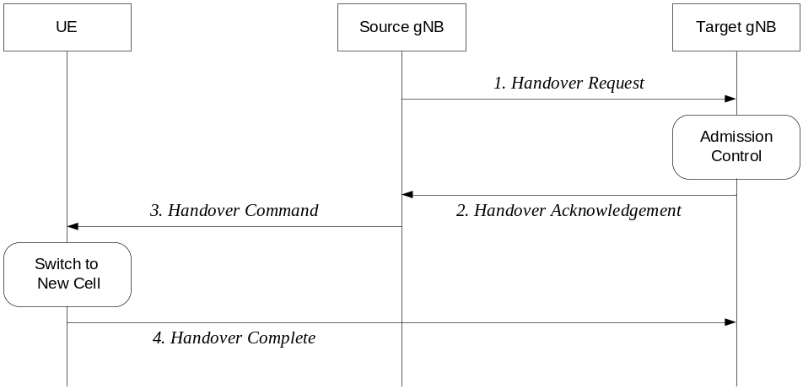
Figure 9.2.3-1: Inter-gNB handover procedures
1. The source gNB initiates handover and issues a Handover Request over the Xn interface.
2. The target gNB performs admission control and provides the RRC configuration as part of the Handover Acknowledgement.
3. The source gNB provides the RRC configuration to the UE in the Handover Command. The Handover Command message includes at least cell ID and all information required to access the target cell so that the UE can access the target cell without reading system information. For some cases, the information required for contention based and contention free random access can be included in the Handover Command message. The access information to the target cell may include beam specific information, if any.
4. The UE moves the RRC connection to the target gNB and replies the Handover Complete.
Further enhancements and modifications can be considered.
The handover mechanism driven by RRC requires the UE at least to reset the MAC entity. The handover with and without re-establishing the PDCP entity is supported, which is to be confirmed by SA3 whether handover without security key change is acceptable. In-sequence and lossless delivery without duplicates (from upper layer viewpoint) is supported for handover within NR.
FFS whether QoS flow can be remapped at handover and, if supported, whether the handover is lossless in this case.
For mobility without RRC, it is dealt with PHY and/or MAC on the beam or TRxP level. As such, intra-cell mobility can be handled by mobility without RRC. One gNB corresponds to one or many TRxPs.
FFS whether there may be cases for which intra-cell mobility needs to be handled by RRC.

9.2.4 Measurements
In the multi-beam operation, the UE in RRC_CONNECTED measures at least one or more individual DL beams. The gNB should have the mechanisms to consider the measurement results of those DL beams for handover. This mechanism is needed at least to trigger inter-gNB handover and to optimise handover ping-pong and failure. The UE should be able to distinguish between the beams from its serving cell and the beams from neighbour cells. The UE should be able to learn if a beam is coming from its serving cell. Cell level signalling quality for the DL RRM measurement can be derived from N best beams, if detected, where the value of N can be configured to 1 or more than 1. This does not preclude the DL RRM measurement on a single beam. Measurement report may contain the measurement results of the N best beams if the UE is configured to do so by the gNB.
Should statements must be converted once the corresponding mechanisms are agreed.

9.2.5 Paging
The UE in RRC_IDLE and RRC_INACTIVE states may use DRX in order to reduce power consumption. While in RRC_IDLE the UE monitors 5GC-initiated paging, in RRC_INACTIVE the UE is reachable via RAN-initiated paging and 5GC-initiated paging. RAN and 5GC paging occasions overlap and same paging mechanism is used. The UE monitors one paging occasion per DRX cycle for the reception of paging as follows:
- Paging DRX cycle length is configurable;
- A default DRX cycle for CN paging is configurable via system information;
- A UE specific DRX cycle for CN paging is configurable via UE dedicated signalling;
- A RAN node can configure a UE with a DRX cycle for RAN paging. This configuration can be UE specific.
- The number of paging occasions in a DRX cycle is configurable via system information;
- A network may distribute UEs to the paging occasions based on UE id when multiple paging occasions are configured in the DRX cycle.
- Paging occasion can consist of multiple time slots (e.g. subframe or OFDM symbol). The number of time slots in a paging occasion is configurable via system information.
- A network may transmit a paging using a different set of DL Tx beam(s) or repetitions in each time slot.
NOTE 1: FFS for the content of paging (e.g. paging message or paging indicator) when paging is transmitted using beam sweeping.
NOTE 2: Transmission mechanism of paging in each time slot is up to RAN1 decision.

9.2.6 Random Access Procedure
The random access procedure is triggered by a number of events, for instance:
- Initial access from RRC_IDLE;
- RRC Connection Re-establishment procedure;
- Handover;
- DL or UL data arrival during RRC_CONNECTED when UL synchronisation status is "non-synchronised".
Furthermore, the random access procedure takes two distinct forms: contention based and non-contention based as shown on Figure 9.2-1 below. Normal DL/UL transmission can take place after the random access procedure.
RAN2 should strive for as much commonality in random access procedure as possible across all use cases.
FFS whether the gNB can be provided with more information (compared to LTE) from the UE on the Msg.3 to provide.
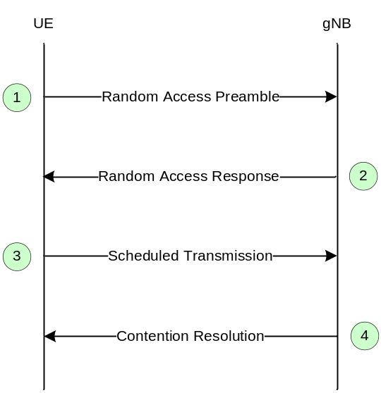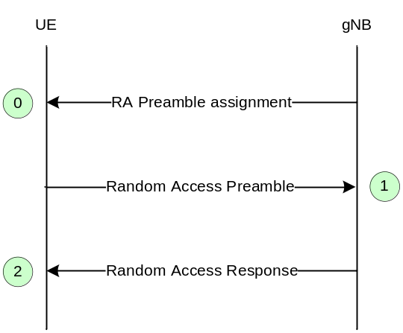
(a) Contention Based (b) Contention Free
Figure 9.2.5-1: Random Access Procedures
More details can be added like in LTE if required (once agreed).

9.2.7 Radio Link Failure
To be captured once agreements are made.

9.3 Inter RAT

9.3.1 Cell Reselection
Cell reselection is characterised by the following:
- Cell reselection between NR RRC_IDLE and E-UTRA RRC_IDLE is supported;

9.3.2 Handover
Inter RAT mobility is characterised by the following:
- Source RAT should be able to support and configure Target RAT measurement and reporting.
Inter RAT mobility within NG-RAN is characterised further by the following:
- The in-sequence and lossless handover as described in sub-clause 10.2.3 is supported for the handover between RAN nodes of NG-RAN (eNB and gNB).
Inter RAT mobility between 5GC and EPC is characterised further by the following:
- Both Xn and CN HO between LTE connected to 5GC and NR is supported. The target RAT receives the UE N2 context information and based on this information configures the UE with a complete RRC message and Full configuration (not delta). Whether the HO is over Xn or CN is transparent to the UE.
- The in-sequence and lossless handover as described in sub-clause 10.2.3 is supported for the handover between RAN nodes of NG-RAN (eNB and gNB).
Support for HO between NR and LTE connected to EPC depends on SA2 decisions and support of NGx with context mapping between 5GC and EPC. If supported, from RAN2 perspective, a “conventional” S1/NG based HO procedure is used where the target RAT receives the UE S1 context information and based on this information configures the UE with a complete RRC message and Full configuration (not delta).

9.3.3 Measurements
To be captured once agreements are made.

10 Scheduling

10.1 Basic Scheduler Operation
In order to utilise radio resources efficiently, MAC in gNB includes dynamic resource schedulers that allocate physical layer resources for the downlink and the uplink. In this subclause, an overview of the scheduler is given in terms of scheduler operation, signalling of scheduler decisions, and measurements.
Scheduler Operation:
- Taking into account the UE buffer status and the QoS requirements of each UE and associated radio bearers, schedulers assign resources between UEs;
- Schedulers may assign resources taking account the radio conditions at the UE identified through measurements made at the gNB and/or reported by the UE;
- Schedulers assign radio resources in a unit of TTI (e.g. one mini-slot, one slot, or multiple slots);
- Resource assignment consists of radio resources (resource blocks).
Signalling of Scheduler Decisions:
- UEs identify the resources by receiving a scheduling (resource assignment) channel.
Measurements to Support Scheduler Operation:
- Uplink buffer status reports (measuring the data that is buffered in the logical channel queues in the UE) are used to provide support for QoS-aware packet scheduling.
- The buffer reporting scheme used in uplink is flexible to support different types of data services. Constraints on how often uplink buffer reports are signalled from the limits the overhead from sending the reports in the uplink.

10.2 Downlink Scheduling
In the downlink, NR can dynamically allocate resources to UEs at each TTI. A UE always monitors the downlink in order to find possible allocation when its downlink reception is enabled (activity governed by DRX when configured). In addition, NR can periodically allocate semi-persistent downlink resources for the first HARQ transmissions to UEs via RRC.
More details on possible channel names, SPS and retransmission handling can be added if agreed/needed.

10.3 Uplink Scheduling
In the uplink, NR can dynamically allocate resources to UEs at each TTI. A UE always monitors the downlink in order to find possible allocation for uplink transmission when its downlink reception is enabled (activity governed by DRX when configured). In addition, NR can periodically allocate semi-persistent uplink resources for the first HARQ transmissions to UEs via RRC.
More details on possible channel names, SPS and retransmission handling can be added if agreed/needed.

10.4 Measurements to Support Scheduler Operation
To be captured once agreements are made. To cover BSR, PHR and CQI.

10.5 Rate Control
To be captured once agreements are made.

11 UE Power Saving
To be captured once agreements are made.

12 QoS
The QoS architecture in NG-RAN is depicted in the Figure 13-1 and described in the following:
- For each UE, 5GC establishes one or more PDU Sessions.
- For each UE, the RAN establishes one or more Data Radio Bearers (DRB) per PDU Session. The RAN maps packets belonging to different PDU sessions to different DRBs. Hence, the RAN establishes at least one default DRB for each PDU Session indicated by 5GC upon PDU Session establishment.
- NAS level packet filters in the UE and in the 5GC associate UL and DL packets with QoS Flows.
- AS-level mapping in the UE and in the RAN associate UL and DL QoS Flows with DRBs.
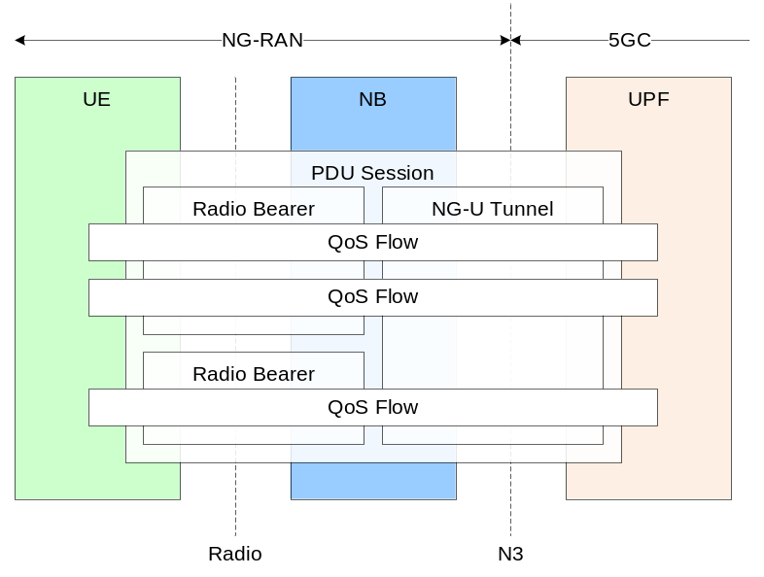
Figure 12-1: QoS architecture
NG-RAN and 5GC ensure quality of service (e.g. reliability and target delay) by mapping packets to appropriate QoS Flows and DRBs. Hence there is a 2-step mapping of IP-flows to QoS flows (NAS) and from QoS flows to DRBs (Access Stratum).
In NG-RAN, the data radio bearer (DRB) defines the packet treatment on the radio interface (Uu). A DRB serves packets with the same packet forwarding treatment. Separate DRBs may be established for QoS flows requiring different packet forwarding treatment. In the downlink, the RAN maps QoS Flows to DRBs based on NG3 marking (QoS Flow ID) and the associated QoS profiles. In the uplink, the UE marks uplink packets over Uu with the QoS flow ID for the purposes of marking forwarded packets to the CN.
In the uplink, the RAN may control the mapping of QoS Flows to DRB in two different ways:
- Reflective mapping: for each DRB, the UE monitors the QoS flow ID(s) of the downlink packets and applies the same mapping in the uplink; that is, for a DRB, the UE maps the uplink packets belonging to the QoS flows(s) corresponding to the QoS flow ID(s) and PDU Session observed in the downlink packets for that DRB. To enable this reflective mapping, the RAN marks downlink packets over Uu with QoS flow ID.
NOTE 1: It is FFS whether the marking with a QoS flow ID can be semi-statically configured (to not include the QOS flow ID when not needed).
- Explicit Configuration: besides the reflective mapping, the RAN may configure by RRC an uplink “QoS Flow to DRB mapping”.
NOTE 2: The precedence of the RRC configured mapping and reflective QoS is FFS (can reflective QoS update and thereby override an RRC configured mapping? Or does a configured QoS Flow ID to DRB mapping always take precedence over a reflective mapping?)
If an incoming UL packet matches neither an RRC configured nor a reflective “QoS Flow ID to DRB mapping”, the UE shall map that packet to the default DRB of the PDU session.
Within each PDU session, is up to RAN how to map multiple QoS flows to a DRB. The RAN may map a GBR flow and a non-GBR flow, or more than one GBR flow to the same DRB, but mechanisms to optimise these cases are not within the scope of standardization. The timing of establishing non-default DRB(s) between RAN and UE for QoS flow configured during establishing a PDU session can be different from the time when the PDU session is established. It is up to RAN when non-default DRBs are established.

13 Security
Security key refresh is not performed at every mobility procedure (i.e. handover), at least for the case of mobility where the PDCP anchor point is not changed.
It is to be confirmed by SA3 considering whether it has any implication on the inputs for key derivation, e.g. PCI.

14 Network Interfaces
To be provided by RAN3. Should contain an overview of the network interfaces. Coordination with SA2 expected, but from RAN3 side.

15 UE Capabilities
To be captured once agreements are made.

16 Verticals Support

16.1 Self-Configuration and Self-Optimisation
Requires discussions with RAN2, expected to include ANR.

16.2 IMS Voice
The WID limits the support to IMS voice. To be captured once agreements are made.

16.3 Network Slicing
Support of Network Slicing relies on the principle that traffic for different slices is handled by different PDU sessions. Network can realise the different network slices by scheduling and also by providing different L1/L2 configurations. UE should be able to provide assistance information for network slice selection in RRC message, if it has been provided by NAS.
NOTE 1: It is FFS whether it is possible to provide different PRACH, access barring and congestion control information for different slices.
NOTE 2: The above agreements and FFS are also applicable for LTE connected to NextGen Core.

16.3 PWS
To be captured once agreements are made.

16.4 URLLC
To provide an overview of the mechanisms agreed for URLLC.

Annex Z (informative):
Change history

Change history
Date | Meeting | TDoc | CR | Rev | Cat | Subject/Comment | Version
2017.03 | RAN297bis | R2-17xxxxx | - | - | - | First version. | 0.1.0

