3GPP TS 38.401 V0.4.1 (2017-10)
Technical Specification
3rd Generation Partnership Project;
Technical Specification Group Radio Access Network;
NG-RAN;
Architecture description
(Release 15)


The present document has been developed within the 3rd Generation Partnership Project (3GPP TM) and may be further elaborated for the purposes of 3GPP.
The present document has not been subject to any approval process by the 3GPP Organizational Partners and shall not be implemented.
This Specification is provided for future development work within 3GPP only. The Organizational Partners accept no liability for any use of this Specification.
Specifications and reports for implementation of the 3GPP TM system should be obtained via the 3GPP Organizational Partners' Publications Offices.

Keywords
LTE, radio, access
3GPP
Postal address

3GPP support office address
650 Route des Lucioles - Sophia Antipolis
Valbonne - FRANCE
Tel.: +33 4 92 94 42 00 Fax: +33 4 93 65 47 16
Internet
http://www.3gpp.org
Copyright Notification
No part may be reproduced except as authorized by written permission.
The copyright and the foregoing restriction extend to reproduction in all media.

© 2017, 3GPP Organizational Partners (ARIB, ATIS, CCSA, ETSI, TSDSI, TTA, TTC).
All rights reserved.

UMTS™ is a Trade Mark of ETSI registered for the benefit of its members
3GPP™ is a Trade Mark of ETSI registered for the benefit of its Members and of the 3GPP Organizational Partners
LTE™ is a Trade Mark of ETSI registered for the benefit of its Members and of the 3GPP Organizational Partners
GSM® and the GSM logo are registered and owned by the GSM Association
Contents
Foreword 4
1 Scope 5
2 References 5
3 Definitions and abbreviations 6
3.1 Definitions 6
3.2 Abbreviations 6
4 General principles 7
5 General architecture 7
5.1 General 7
5.2 User plane 7
5.3 Control plane 8
6 NG-RAN architecture 9
6.1 Overview 9
6.2 NG-RAN identifiers 10
6.2.1 Principle of handling Application Protocol Identities 10
6.2.2 gNB-DU ID 11
6.3 Transport addresses 11
6.4 UE associations in gNB 11
7 NG-RAN functions description 12
7.1 PWS Message Transmission Function 12
8 Overall procedures in gNB-CU/gNB-DU Architecture 12
8.1 UE Initial Access 13
8.2 Intra-gNB-CU Mobility 14
8.2.1 Intra-NR Mobility 14
8.2.1.1 Inter-gNB-DU Mobility 14
8.2.1.2 Intra-gNB-DU inter-cell mobility (FFS) 16
8.2.2 EN-DC Mobility 17
8.2.2.1 Inter-gNB-DU Mobility using MCG SRB 17
8.2.2.2 Inter-gNB-DU Mobility using SCG SRB 18
8.3 Mechanism of centralized retransmission of lost PDUs 18
8.3.1 Centralised Retransmission in Intra gNB-CU Cases 18
8.3.2 Centralised Retransmission in Inter gNB-CU Cases 19
8.4 Multi-Connectivity operation 20
8.4.1 Secondary Node Addition 20
8.4.1.1 EN-DC 20
8.4.2 Secondary Node Release (MN/SN initiated) 20
8.4.2.1 EN-DC 20
8.5 F1 Startup and cells activation 22
9 Synchronization 23
9.1 gNB Synchronization 23
10 NG-RAN interfaces 24
10.1 NG interface 24
10.2 Xn interface 24
10.3 F1 interface 24
Annex A (Informative): Deployment scenarios of NG RAN nodes 24

Foreword
This Technical Specification has been produced by the 3rd Generation Partnership Project (3GPP).
The contents of the present document are subject to continuing work within the TSG and may change following formal TSG approval. Should the TSG modify the contents of the present document, it will be re-released by the TSG with an identifying change of release date and an increase in version number as follows:
Version x.y.z
where:
x the first digit:
1 presented to TSG for information;
2 presented to TSG for approval;
3 or greater indicates TSG approved document under change control.
y the second digit is incremented for all changes of substance, i.e. technical enhancements, corrections, updates, etc.
z the third digit is incremented when editorial only changes have been incorporated in the document.

1 Scope
The present document describes the overall architecture of the NG-RAN, including internal interfaces and assumptions on the radio, NG, Xn and F1 interfaces.

2 References
The following documents contain provisions which, through reference in this text, constitute provisions of the present document.
- References are either specific (identified by date of publication, edition number, version number, etc.) or non-specific.
- For a specific reference, subsequent revisions do not apply.
- For a non-specific reference, the latest version applies. In the case of a reference to a 3GPP document (including a GSM document), a non-specific reference implicitly refers to the latest version of that document in the same Release as the present document.
[1] 3GPP TR 21.905: "Vocabulary for 3GPP Specifications".
[2] 3GPP TS 38.300: "NR; Overall description; Stage-2".
[3] 3GPP TS 23.501: "System Architecture for the 5G System; Stage 2".
[4] 3GPP TS 36.473: "NG Radio Access Network (NG-RAN); F1 application protocol (F1AP)".
[5] 3GPP TS 36.414: "NG Radio Access Network (NG-RAN); NG data transport ".
[6] 3GPP TS 36.424: "NG Radio Access Network (NG-RAN); Xn data transport ".
[7] 3GPP TS 36.474: "NG Radio Access Network (NG-RAN); F1 data transport ".
[8] 3GPP TS 25.411: "UTRAN Iu interface layer 1".
[9] ITU-T Recommendation G.823 (2000-03): "The control of jitter and wander within digital networks which are based on the 2048 kbit/s hierarchy".
[10] ITU-T Recommendation G.824 (2000-03): "The control of jitter and wander within digital networks which are based on the 1544 kbit/s hierarchy".
[11] ITU-T Recommendation G.825 (2001-08): "The control of jitter and wander within digital networks which are based on the synchronous digital hierarchy (SDH)".
[12] ITU-T Recommendation G.8261/Y.1361 (2008-04): "Timing and Synchronization aspects in Packet networks".
[13] 3GPP TS 29.281: "General Packet Radio Service (GPRS); Tunnelling Protocol User Plane (GTPv1-U)".
[14] 3GPP TS 37.340: "NR; Multi-connectivity; Overall description; Stage-2".
[15] 3GPP TS 33.501: "Security Architecture and Procedures for 5G System".
[16] 3GPP TS 38.410: "NG-RAN; NG general aspect and principles".
[17] 3GPP TS 38.420: "NG-RAN; Xn general aspects and principles"
[18] 3GPP TS 38.470: "NG-RAN; F1 general aspects and principles".

3 Definitions and abbreviations

3.1 Definitions
For the purposes of the present document, the terms and definitions given in TR 21.905 [1] and the following apply.
A term defined in the present document takes precedence over the definition of the same term, if any, in TR 21.905 [1].
gNB Central Unit (gNB-CU): a logical node hosting RRC, SDAP and PDCP protocols of the gNB or RRC and PDCP protocols of the en-gNB, and controls the operation of one or more gNB-DUs. The gNB-CU also terminates F1 interface connected with the gNB-DU.
gNB Distributed Unit (gNB-DU): a logical node hosting RLC, MAC and PHY layers of the gNB or en-gNB, and its operation is partly controlled by gNB-CU. One gNB-DU supports one or multiple cells. One cell is supported by only one gNB-DU. The gNB-DU terminates F1 interface connected with the gNB-CU.
Editor’s note: Whether it is possible that one cell spans over multiple DUs, potentially in an implementation specific way, is FFS. The reasons, conditions, and scenarios for this are also FFS.

gNB: as defined in TS 38.300 [2].
en-gNB: as defined in TS 37.340 [14]

3.2 Abbreviations
For the purposes of the present document, the terms and definitions given in TR 21.905 [1] and the following apply.
A term defined in the present document takes precedence over the definition of the same term, if any, in TR 21.905 [1].
5GC 5G Core Network
AMF Access and Mobility Management Function
AP Application Protocol
AS Access Stratum
CM Connection Management
CMAS Commercial Mobile Alert Service
ETWS Earthquake and Tsunami Warning System
F1-U F1 User plane interface
F1-C F1 Control plane interface
F1AP F1 Application Protocol
FDD Frequency Division Duplex
GTP-U GPRS Tunnelling Protocol
IP Internet Protocol
NAS Non-Access Stratum
O&M Operation and Maintenance
PWS Public Warning System
QoS Quality of Service
RNL Radio Network Layer
RRC Radio Resource Control
SAP Service Access Point
SCTP Stream Control Transmission Protocol
SFN System Frame Number
SM Session Management
SMF Session Management Function
TDD Time Division Duplex
TNL Transport Network Layer

4 General principles
Editor Note: This clause shows the general principles guiding the definition of NG-RAN architecture as well as the NG-RAN interfaces.
The general principles guiding the definition of NG-RAN architecture as well as the NG-RAN interfaces are the following:
- Logical separation of signalling and data transport networks.
- NG-RAN and 5GC functions are fully separated from transport functions. Addressing scheme used in NG-RAN and 5GC shall not be tied to the addressing schemes of transport functions. The fact that some NG-RAN or 5GC functions reside in the same equipment as some transport functions does not make the transport functions part of the NG-RAN or the 5GC.
- Mobility for RRC connection is fully controlled by the NG-RAN.
- When defining the NG-RAN interfaces the following principles were followed:
- The functional division across the interfaces shall have as few options as possible;
- Interfaces should be based on a logical model of the entity controlled through this interface;
- One physical network element can implement multiple logical nodes.

5 General architecture
Editor Note: This clause shows the general architecture e.g. C-Plane, U-Plane etc.

5.1 General
The protocols over Uu and NG interfaces are divided into two structures:
- User plane protocols
These are the protocols implementing the actual PDU Session service, i.e. carrying user data through the access stratum.
- Control plane protocols
These are the protocols for controlling the PDU Sessions and the connection between the UE and the network from different aspects (including requesting the service, controlling different transmission resources, handover etc.). Also a mechanism for transparent transfer of NAS messages is included.

5.2 User plane
The PDU Session service is offered from SAP to SAP by the Access Stratum. Figure 5.2-1 shows the protocols on the Uu and NG interfaces that linked together provide this PDU Session service.
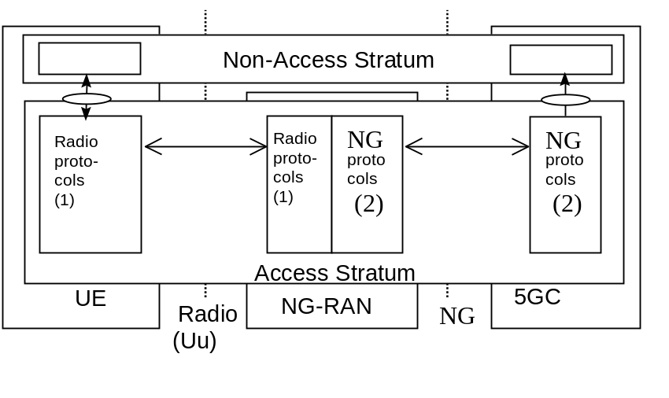
Note 1: The radio interface protocols are defined in 3GPP TS 38.2xx and TS 38.3xx.
Note 2: The NG interface protocols are defined in 3GPP TS 38.41x.

Figure 5.2-1: NG and Uu user plane

5.3 Control plane
Figure 5.3-1 shows the control plane (signalling) protocol stacks on NG and Uu interfaces.
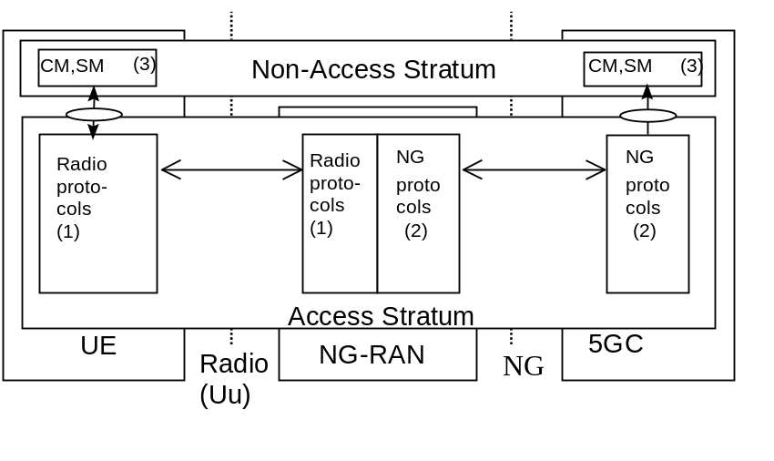
Note 1: The radio interface protocols are defined in 3GPP TS 38.2xx and TS 38.3xx.
Note 2: The protocol is defined in 3GPP TS 38.41x. (Description of NG interface).
Note 3: CM, SM: This exemplifies a set of NAS control protocols between UE and 5GC. The evolution of the protocol architecture for these protocols is outside the scope of the present document.

Figure 5.3-1: NG and Uu control plane

NOTE: Both the Radio protocols and the NG protocols contain a mechanism to transparently transfer NAS messages.

6 NG-RAN architecture

6.1 Overview
Editor Note: This subclause shows the overview of the NG-RAN architecture.

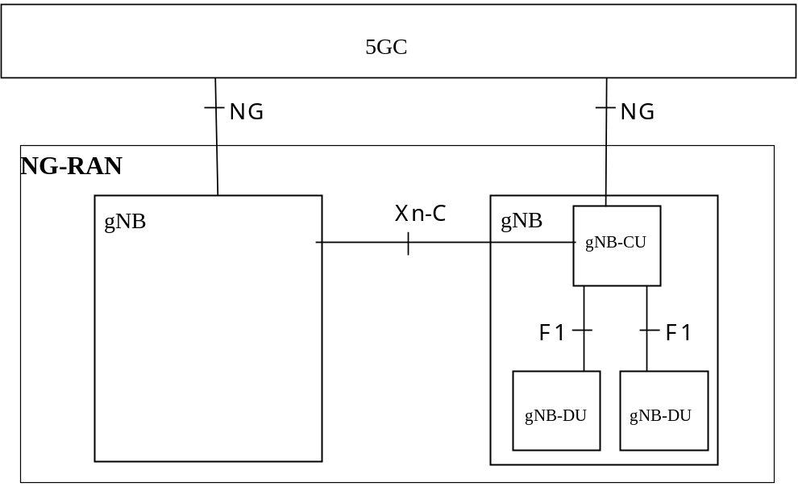
Figure 6.1-1 Overall architecture
The NG architecture can be further described as follows:
The NG-RAN consists of a set of gNBs connected to the 5GC through the NG.
An gNB can support FDD mode, TDD mode or dual mode operation.
gNBs can be interconnected through the Xn.
A gNB may consist of a gNB-CU and gNB-DUs. A gNB-CU and a gNB-DU is connected via F1 logical interface.
One gNB-DU is connected to only one gNB-CU.
NOTE: For resiliency, a gNB-DU may be connected to multiple gNB-CU by appropriate implementation.
NG, Xn and F1 are logical interfaces.
For NG-RAN, the NG and Xn-C interfaces for a gNB consisting of a gNB-CU and gNB-DUs, terminate in the gNB-CU. For EN-DC, the S1-U and X2-C interfaces for a gNB consisting of a gNB-CU and gNB-DUs, terminate in the gNB-CU. The gNB-CU and connected gNB-DUs are only visible to other gNBs and the 5GC as a gNB. A possible deployment scenario is described in Annex A.
Editor’s Note: Whether the statement above concerning EN-DC needs to be moved to another TS, e.g. 36.401 is FFS.
The NG-RAN is layered into a Radio Network Layer (RNL) and a Transport Network Layer (TNL).
The NG-RAN architecture, i.e. the NG-RAN logical nodes and interfaces between them, is defined as part of the RNL.
For each NG-RAN interface (NG, Xn, F1) the related TNL protocol and the functionality are specified. The TNL provides services for user plane transport, signalling transport.
In NG-Flex configuration, each gNB is connected to all AMFs within an AMF Region. The AMF Region is defined in 3GPP TS 23.501 [3].
If security protection for control plane and user plane data on TNL of NG-RAN interfaces has to be supported, NDS/IP (3GPP TS 33.501 [15] shall be applied.

6.2 NG-RAN identifiers
Editor Note: This subclause shows those identifiers that are used in NG-RAN.

6.2.1 Principle of handling Application Protocol Identities
An Application Protocol Identity (AP ID) is allocated when a new UE-associated logical connection is created in either an gNB or an AMF. An AP ID shall uniquely identify a logical connection associated to a UE over the NG interface or Xn interface within a node (gNB or AMF). Upon receipt of a message that has a new AP ID from the sending node, the receiving node shall store the AP ID of the sending node for the duration of the logical connection. The receiving node shall assign the AP ID to be used to identify the logical connection associated to the UE and include it as well as the previously received new AP ID from the sending node, in the first returned message to the sending node. In all subsequent messages to and from sending node, both AP IDs of sending node and receiving node shall be included.
The definitions of AP IDs as used on NG interface or Xn interface or F1 interface are shown below:
gNB UE NGAP ID:
An gNB UE NGAP ID shall be allocated so as to uniquely identify the UE over the NG interface within an gNB. When an AMF receives an gNB UE NGAP ID it shall store it for the duration of the UE-associated logical NG-connection for this UE. Once known to an AMF this is included in all UE associated NG-AP signalling.
The gNB UE NGAP ID shall be unique within the gNB logical node.
AMF UE NGAP ID:
An AMF UE NGAP ID shall be allocated so as to uniquely identify the UE over the NG interface within the AMF. When an gNB receives AMF UE NGAP ID it shall store it for the duration of the UE-associated logical NG-connection for this UE. Once known to an gNB this ID is included in all UE associated NG-AP signalling.
The AMF UE NGAP ID shall be unique within the AMF logical node.
Old gNB UE XnAP ID:
An Old gNB UE XnAP ID shall be allocated so as to uniquely identify the UE over the Xn interface within a source gNB. When a target gNB receives an Old gNB UE XnAP ID it shall store it for the duration of the
UE-associated logical Xn-connection for this UE. Once known to a target gNB this ID is included in all UE associated Xn-AP signalling. The Old gNB UE XnAP ID shall be unique within the gNB logical node.
New gNB UE XnAP ID:
A New gNB UE XnAP ID shall be allocated so as to uniquely identify the UE over the Xn interface within a target gNB. When a source gNB receives a New gNB UE XnAP ID it shall store it for the duration of the
UE-associated logical Xn-connection for this UE. Once known to source gNB this ID is included in all UE associated Xn-AP signalling. The New gNB UE XnAP ID shall be unique within the gNB logical node.
MgNB UE XnAP ID:
A MgNB UE XnAP ID shall be allocated so as to uniquely identify the UE over Xn interface within a MgNB for dual connectivity. When a SgNB receives a MgNB UE XnAP ID it shall store it for the duration of the UE-associated logical Xn-connection for this UE. Once known to a SgNB this ID is included in all UE associated Xn-AP signalling. The MgNB UE XnAP ID shall be unique within the gNB logical node.
SgNB UE XnAP ID:
A SgNB UE XnAP ID shall be allocated so as to uniquely identify the UE over Xn interface within a SgNB for dual connectivity. When a MgNB receives a SgNB UE XnAP ID it shall store it for the duration of the UE-associated logical Xn-connection for this UE. Once known to a MgNB this ID is included in all UE associated Xn-AP signalling. The SgNB UE XnAP ID shall be unique within the gNB logical node.
gNB-CU UE F1AP ID:
Refer to TS 38.473 [4]

6.2.2 gNB-DU ID
The gNB-DU ID is configured at the gNB-DU and used to uniquely identify the gNB-DU at least within a gNB-CU. The gNB-DU informs the gNB-CU of its gNB-DU ID during F1 Setup procedure. The gNB-DU ID is used only over F1AP procedures.

6.3 Transport addresses
Editor Note: This subclause shows those principle of Transport Address that to be used in NG-RAN.
The transport layer address parameter is transported in the radio network application signalling procedures that result in establishment of transport bearer connections.
The transport layer address parameter shall not be interpreted in the radio network application protocols and reveal the addressing format used in the transport layer.
The formats of the transport layer addresses are further described in 3GPP TS 38.414 [5], 3GPP TS 38.424 [6] and 3GPP TS 38.474 [7].

6.4 UE associations in gNB
Editor Note: This subclause shows those principle of UE Associations in gNB e.g. gNB UE Association, UE Context etc.
There are several types of UE associations needed in the gNB: the "gNB UE context" used to store all information needed for a UE and the associations between the UE and the logical NG and Xn connections used for NG/Xn-AP UE associated messages. An "gNB UE context" exists for a UE in CM_CONNECTED.
Definitions:
gNB UE context:
An gNB UE context is a block of information in an gNB associated to one UE. The block of information contains the necessary information required to maintain the NG-RAN services towards the active UE. An gNB UE context is established when the transition to active state for a UE is completed or in target gNB after completion of handover resource allocation during handover preparation, in which case at least UE state information, security information, UE capability information and the identities of the UE-associated logical NG-connection shall be included in the gNB UE context.
For Dual Connectivity an gNB UE context is also established in the SgNB after completion of SgNB Addition Preparation.
UE-associated logical NG-connection/ UE-associated logical Xn-connection / UE-associated logical F1-connection:
On the logical NG or Xn or F1 connection, control plane messages (NGAP, XnAP, F1AP) associated with the UE are sent.
This connection is established during the first NG/XnAP/F1AP message exchange between the NG/Xn/F1 peer nodes.
The connection is maintained as long as UE associated NG/XnAP/F1AP messages need to be exchanged over NG/Xn/F1.
The UE-associated logical NG-connection uses the identities AMF UE NGAP ID and gNB UE NGAP ID.
The UE-associated logical Xn-connection uses the identities Old gNB UE XnAP ID and New gNB UE XnAP ID, or MgNB UE XnAP ID and SgNB UE XnAP ID.
The UE-associated logical F1-connection uses the identities gNB-CU UE F1AP ID.
When a node (AMF or gNB) receives a UE associated NG/XnAP/F1AP message the node retrieves the associated UE based on the NG/XnAP/F1AP ID.
UE-associated signalling:
UE-associated signalling is an exchange of NG/XnAP/F1AP messages associated with one UE over the UE-associated logical NG/Xn/F1-connection.
NOTE: The UE-associated logical NG-connection may exist before the gNB UE context is setup in gNB.
The UE-associated logical Xn-connection may exist before the gNB UE context is setup in the target gNB.
The UE-associated logical F1-connection may exist before the gNB UE context is setup in the gNB-DU.
Editor Note: the description of UE Context in F1 interface is FFS.

7 NG-RAN functions description
Editor Note: This subclause shows NG-RAN functions.
The list of functions refer to TS 38.300 [2].

7.1 PWS Message Transmission Function
This function provides the capability for the AMF to initiate and stop broadcasting of PWS warning messages to UEs related to alerts (earthquake, tsunami, etc..) to meet regional regulatory requirements, and provides the capability for the NG RAN to inform the AMF that ongoing PWS operation has failed for one or more areas.
Editor’s Note: The following sentence is FFS
ETWS, CMAS and the other warning services which use the same AS mechanisms as CMAS as described in 3GPP TS 38.300 [2] are the NG-RAN services related to warning deliveries.
Editor’s Note: Potential text on RAN sharing support (if needed) is FFS
Editor’s Note: Potential text for support of partial NG RAN node failure (if needed) is FFS

8 Overall procedures in gNB-CU/gNB-DU Architecture
Editor Note: This clause shows overall procedures including signalling flows in gNB-CU / gNB-DU architecture e.g. initial access from the UE, inter-DU mobility etc. The main focus is on gNB-CU and gNB-CU while also need to show UE and 5GC for understanding the interaction.

8.1 UE Initial Access
Editor Note: This subclause shows overall procedures for initial access from the UE.
Editor Note: The name of this subclaues is FFS.
The signalling flow for UE Initial access is shown in Figure 8.1-1.

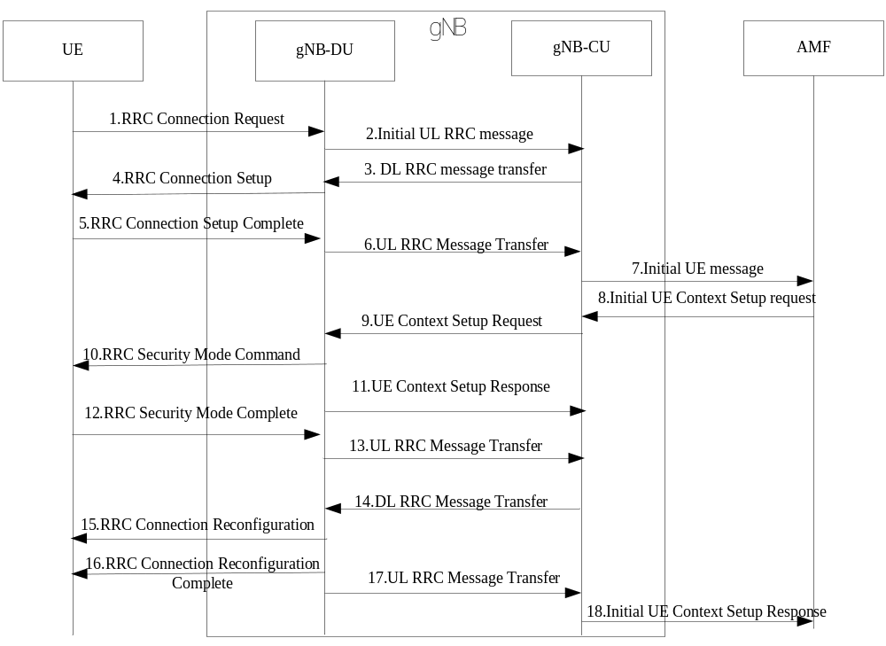
Figure 8.1-1: UE Initial Access procedure
Step1: UE sends RRC Connection Request message to the gNB-CU.
Step 2:The gNB-DU includes the RRC message in a non-UE associated F1-AP INITIAL UL RRC MESSAGE TRANSFER message and transfer to the gNB-CU. The INITAIL UL RRC MESSAGE TRANSFER message should include C-RNTI.
Step3: The gNB-CU allocates UE F1AP ID for the UE and generates RRC CONNECTION SETUP message towards UE.The RRC message is encapsulated in F1-AP DL RRC MESSAGE TRANSFER message.
Editor’s note: Alternative 2 is that gNB-CU initiates UE Context Setup procedure and includes RRC CONNECTION SETUP message in F1-AP UE CONTEXT SETUP REQUEST message.
Editor’s note: Alternative 3 is that UE Context Setup procedure is added between step 2 and step 3.
Editor’s note: It is FFS which alternative would be adopted.
Step4: The gNB-DU sends RRC CONNECTION SETUP message to UE.
Step5: UE sends RRC CONNECTION SETUP COMPLETE message to the gNB-CU.
Step6: The gNB-DU encapsulates the RRC message in F1-AP UL RRC MESSAGE TRANSFER message and send to gNB-CU.
Step7: The gNB-CU sends the INITIAL UE MESSAGE to the AMF.
Step8: The AMF sends INITIAL UE CONTEXT SETUP REQUEST message to the gNB-CU.
Step9:The gNB-CU sends UE CONTEXT SETUP REQUESTmessage to establish overall initial UE context in the gNB-DU.In this message,it may also encapsulate RRC SECURITY MODE COMMAND message.
Editor’s note: For alternative 2 and alternative 3, the UE context setup procedure in step 9 and step 11 is substituted by UE Context Modification procedure.
Editor’s note:It is FFS whether RRC SECURITY MODE COMMAND message could be sent via UE Context management procedure or use another separate F1-AP DL RRC MESSSAGE TRNASFER.
Step10: The gNB-DU sends RRC SECURITY MODE COMMAND message to UE.
Step11:The gNB-DU sends UE CONTEXT SETUP RESPONSE message to gNB-CU.
Step 12:UE responds with RRC SECURITY MODE COMPLETE message
Step 13:The gNB-DU encapsulates the RRC message in F1-AP UL RRC MESSAGE TRANSFER message and sends to gNB-CU.
Step14:The gNB-CU generates RRC CONNECTION RECONFIGURATION message and encapsulates it in F1-AP DL RRC MESSAGE TRANSFER message
Step 15: The gNB-DU sends RRC CONNECTION RECONFIGURATION message to UE.
Step 16: UE sends RRC CONNECTION RECONFIGURATION COMPLETE message to the gNB-DU.
Step 17:The gNB-DU encapsulates the RRC message in F1-AP UL RRC MESSAGE TRANSFER message and send to gNB-CU.
Step18: The gNB-CU sends Initial UE Context Setup Response message to the AMF.
Editor’s note: The name of the message is FFS.
Editor Note: Further check may be needed on the procedure.

8.2 Intra-gNB-CU Mobility
Editor Note: This subclause shows overall procedures for inter-DU mobility.
Editor Note: Further check may be needed on the procedures.
Editor Note: It is FFS whether to capture a signalling flow for inter-gNB-CU mobility case.

8.2.1 Intra-NR Mobility

8.2.1.1 Inter-gNB-DU Mobility
This procedure is used for the case the UE moves from one gNB-DU to another gNB-DU within the same gNB-CU during NR operation. Figure 8.2.1-1 shows the inter-gNB-DU mobility procedure for intra-NR.
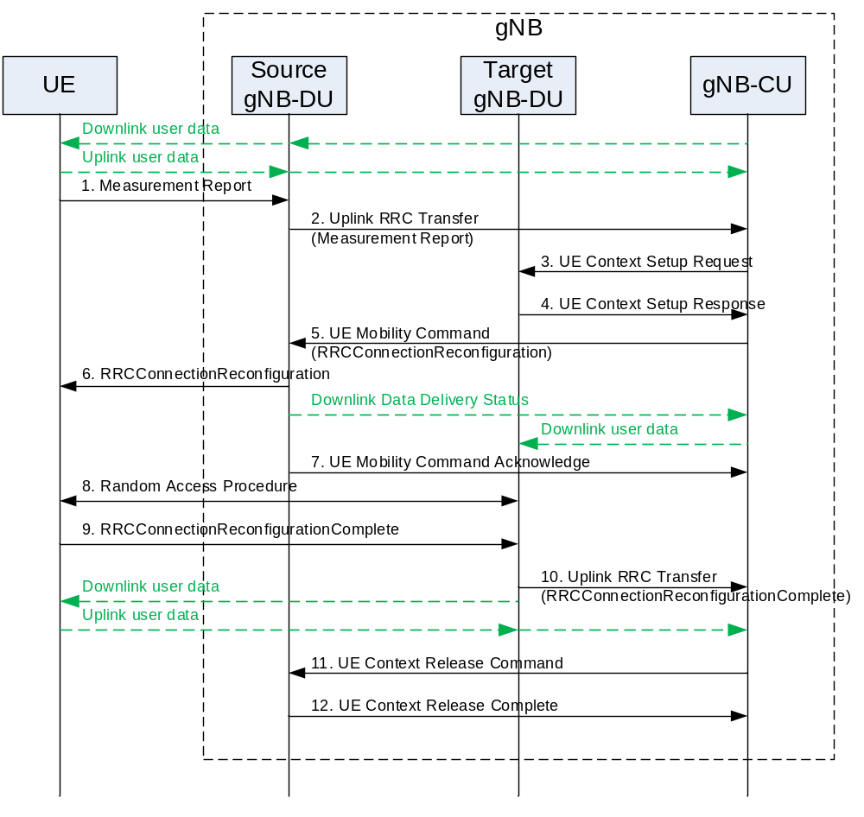
Figure 8.2.1.1-1: Inter-gNB-DU Mobility for intra-NR
1. The UE sends a Measurement Report message to the source gNB-DU.
2. The source gNB-DU sends an Uplink RRC Transfer message to the gNB-CU to convey the received Measurement Report.
3. The gNB-CU sends an UE Context Setup Request message to the target gNB-DU to create an UE context and setup one or more bearers, which contains Target Cell ID (FFS).
4. The target gNB-DU responds the gNB-CU with an UE Context Setup Response message, which contains MobilityControlInfo (FFS).
5. The gNB-CU sends a UE Mobility Command message, which includes a generated RRCConnectionReconfiguration message and indicates to stop the data transmission for the UE, to the source gNB-DU. The source gNB-DU also sends a Downlink Data Delivery Status frame to inform the gNB-CU about the unsuccessfully transmitted downlink data to the UE. Downlink packets, which may include PDCP PDUs not successfully transmitted in the source gNB-DU, are sent from the gNB-CU to the target gNB-DU.
Editor’s note: It is FFS whether the UE Mobility Command message contains the information on whether the handover is inter-CU or intra-CU.
6. The source gNB-DU forwards the received RRCConnectionReconfiguration to the UE.
7. The source gNB-DU responds the gNB-CU with UE Mobility Command Acknowledge message.
Editor’s note: It is FFS whether the UE Mobility Command Acknowledge may contain the information about the unsuccessfully delivered PDCP PDUs.
8. Random Access procedure is performed at the target gNB-DU.
Editor’s note: It is FFS whether the gNB-DU indicates the gNB-CU that UE has successfully attached.
9. The UE responds the target gNB-DU with an RRCConnectionReconfigurationComplete message.
10. The target gNB-DU sends an Uplink RRC Transfer message to convey the received RRCConnectionReconfigurationComplete to the gNB-CU. Downlink packets are sent to the UE. Also, uplink packets are sent from the UE, which are forwarded to the gNB-CU through the target gNB-DU.
11. The gNB-CU sends an UE Context Release Command message to the source gNB-DU.
12. The source gNB-DU releases the UE context and responds the gNB-CU with an UE Context Release Complete message.

8.2.1.2 Intra-gNB-DU inter-cell mobility (FFS)
Editor’s note: It is FFS whether to capture the following signalling flow..
This procedure is used for the case that UE moves from one cell to another cell within the same gNB-DU during NR operation. Figure 8.2.1.2-1 shows the intra-gNB-DU inter-cell mobility procedure for intra-NR.
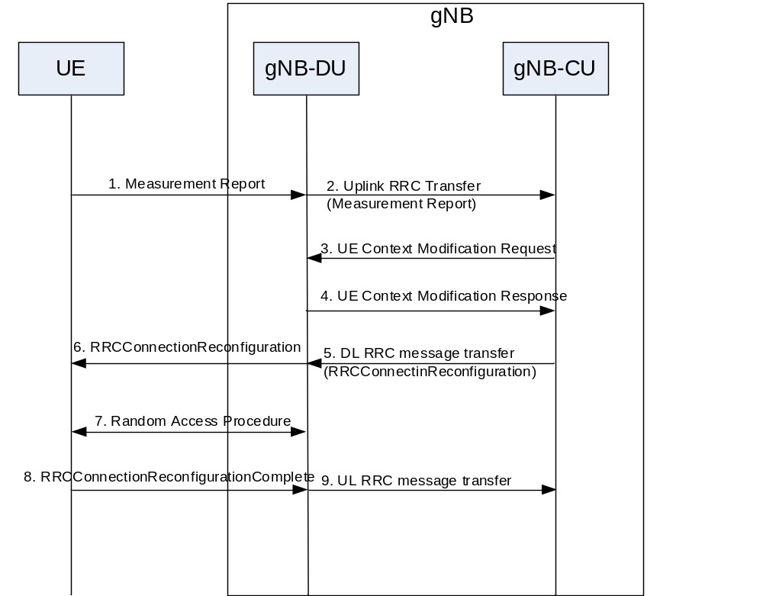
Figure 8.2.1.2-1: Signaling flow for intra-gNB-DU inter-cell mobility
        - Data transmission is ongoing.
        - The gNB-CU makes a handover decision.
        - The gNB-CU sends the UE Context Modification Request message to the gNB-DU, which contains Target Cell ID for handover (FFS).
        - The gNB-DU responds the gNB-CU with an UE Context Modification Response after resource preparation in target cell is finished, which contains MobilityControlInfo (FFS).
        - The gNB-CU sends a DL RRC message transfer which includes RRCConnectionReconfiguration to the gNB-DU.
        - The gNB-DU forwards the received RRCConnectionReconfiguration to the UE.
        - Random Access procedure is performed at the target cell of gNB-DU.
        - The UE responds the gNB-DU with an RRCConnectionReconfigurationComplete message.
        - The gNB-DU sends an Uplink RRC Transfer message to convey the received RRCConnectionReconfigurationComplete to the gNB-CU.

8.2.2 EN-DC Mobility

8.2.2.1 Inter-gNB-DU Mobility using MCG SRB
This procedure is used for the case the UE moves from one gNB-DU to another gNB-DU within the same gNB-CU when only MCG SRB is available during EN-DC operation. Figure 8.2.2.1-1 shows the inter-gNB-DU mobility procedure using MCG SRB in EN-DC.
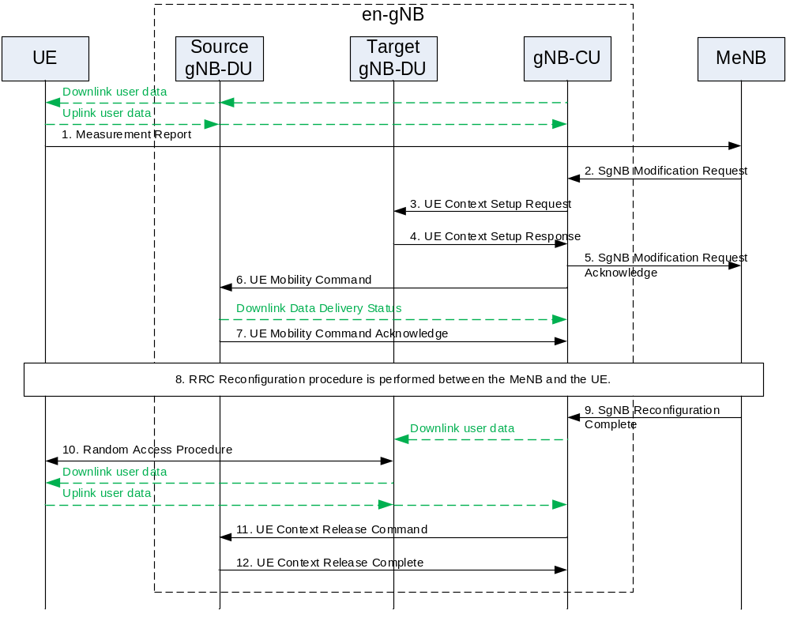
Figure 8.2.2.1-1: Inter-gNB-DU Mobility using MCG SRB in EN-DC
1. The UE sends a Measurement Report message to the MeNB.
2. The MeNB sends an SgNB Modification Request.
3. The gNB-CU sends an UE Context Setup Request message to the target gNB-DU to create an UE context and setup one or more bearers.
4. The target gNB-DU responds the gNB-CU with an UE Context Setup Response message.
5. The gNB-CU responds the MeNB with an SgNB Modification Request Acknowledge message.
6. The gNB-CU sends a UE Mobility Command message to the source gNB-DU indicating to stop the data transmission to the UE. The source gNB-DU also sends a Downlink Data Delivery Status frame to inform the gNB-CU about the unsuccessfully transmitted downlink data to the UE.
7. The source gNB-DU responds the gNB-CU with an UE Mobility Command Acknowledge message.
8. The MeNB and the UE perform RRC Reconfiguration procedure.
9. The MeNB sends an SgNB Reconfiguration Complete message to the gNB-CU. Downlink packets, which may include PDCP PDUs not successfully transmitted in the source gNB-DU, are sent from the gNB-CU to the target gNB-DU.
10. Random Access procedure is performed at the target gNB-DU. Downlink packets are sent to the UE. Also, uplink packets are sent from the UE, which are forwarded to the gNB-CU through the target gNB-DU.
Editor’s note: It is FFS whether the gNB-DU indicates the gNB-CU that UE has successfully attached.
11. The gNB-CU sends an UE Context Release Command message to the source gNB-DU.
12. The source gNB-DU releases the UE context and responds the gNB-CU with an UE Context Release Complete message.

8.2.2.2 Inter-gNB-DU Mobility using SCG SRB
This procedure is used for the case the UE moves from one gNB-DU to another gNB-DU when SCG SRB is available during EN-DC operation. The procedure is the same as inter-gNB-DU Mobility for intra-NR as defined in Section 8.2.1.1.

8.3 Mechanism of centralized retransmission of lost PDUs

8.3.1 Centralised Retransmission in Intra gNB-CU Cases
This mechanism allows to perform the retransmission of the PDCP PDUs that are not delivered by a gNB-DU (gNB-DU1) because the corresponding radio links toward the UE are subject to outage, When such outage occurs, the gNB-DU affected by outage informs the gNB-CU of such event. gNB-CU can switch transmission of data traffic, as well as retransmission of undelivered PDCP PDUs, from the gNB-DU affected by outage to other available gNB-DUs (e.g. gNB-DU2 in Figure 8.3.1-1) with a well-functioning radio link toward the UE.
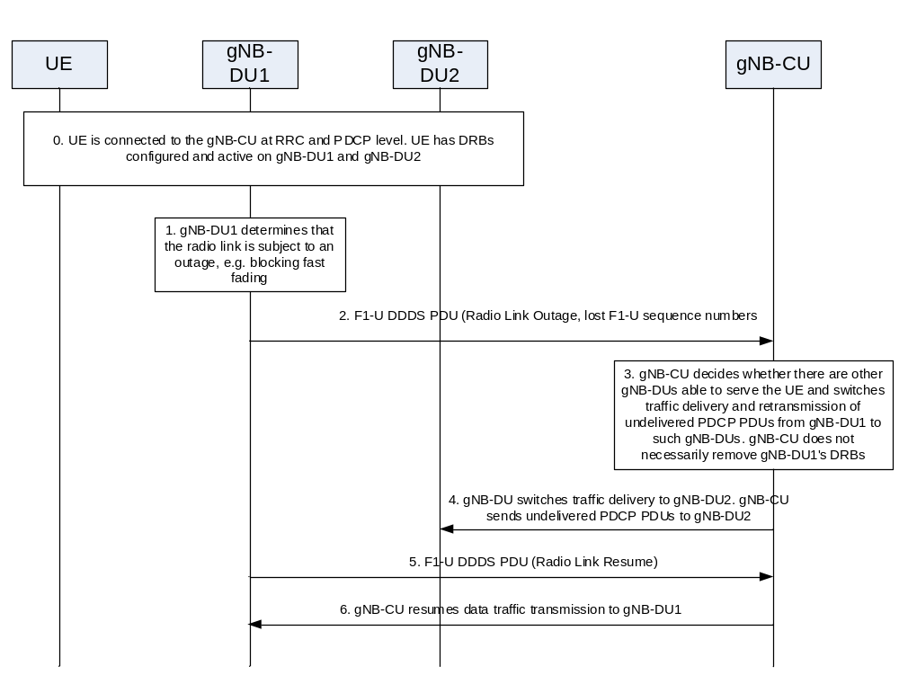
Figure 8.3.1-1 Procedure for centralised retransmission in intra gNB-CU scenarios
The mechanism is shown in Figure 8.3.1-x and targets the multi-connectivity scenario, where a UE is served by multiple DRBs established at least on two DUs, and it includes the following steps:
- The UE is connected and can transmit/receive data to/from gNB-DU1 and gNB-DU2.
- gNB-DU1 realizes that the radio link towards the UE is experiencing outage.
- gNB-DU1 sends the “Radio Link Outage” notification message to the gNB-CU over the F1-U interface, as part of the DDDS PDU. The message includes the Number of lost F1-U Sequence Number ranges reported corresponding to the PDCP PDUs partially (and/or totally) undelivered in gNB-DU1.
- gNB-CU decides to switch data traffic transmission and retransmission of PDCP PDUs that were undelivered in gNB-DU1 via gNB-DU2. gNB-CU stops sending downlink traffic to gNB-DU1. The radio leg between gNB-DU1 and the UE is not necessarily removed.
- gNB-CU starts sending traffic (namely new PDUs and potentially retransmitted PDUs) to gNB-DU2
- If gNB-DU1 realizes that the link toward the UE is back in normal operation, it sends a “Radio Link Resume” notification message as part of the DDDS PDU over the F1-U interface to inform the gNB-CU that the radio link can be used again.
- gNB-CU may start sending traffic (namely new PDUs and potentially retransmitted PDUs) via gNB-DU1 again.

8.3.2 Centralised Retransmission in Inter gNB-CU Cases
Editor’s Note: The content of this section and whether a notification over F1-C is needed in some cases is FFS.

8.4 Multi-Connectivity operation
Editor’s Note: the F1AP message name over F1 interface is FFS.

8.4.1 Secondary Node Addition

8.4.1.1 EN-DC
This section gives the SgNB addition procedure in EN-DC given that en-gNB consists of gNB-CU and gNB-DU(s), as shown in Figure 8.4.1.1-1.
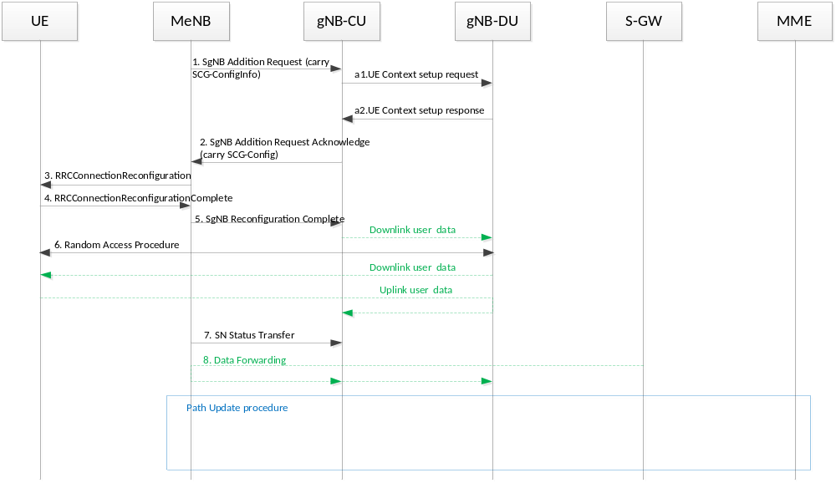
Figure 8.4.1.1-1 SgNB addition procedure in EN-DC

1~8: refer to TS 37.340[14]
a1: After receiving SgNB Addition Request message from MeNB, gNB-CU sends the UE Context Setup Request message to gNB-DU to create UE context
a2: gNB-DU responds to gNB-CU with UE Context Setup Response message

8.4.2 Secondary Node Release (MN/SN initiated)

8.4.2.1 EN-DC
This section gives the SgNB release procedure in EN-DC given that en-gNB consists of gNB-CU and gNB-DU(s).
MN initiated SN Release
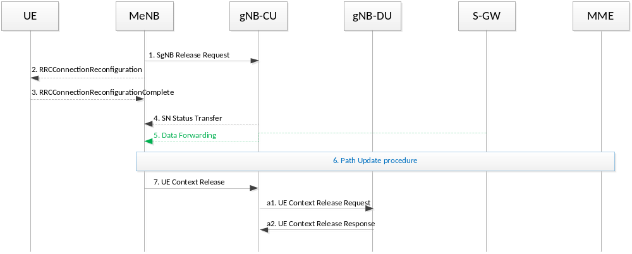
Figure 8.4.2.1-1 SgNB release procedure in EN-DC (MN initiated)
1~7: refer to TS 37.340 [14]
a1: After receiving UE Context Release message from MeNB, gNB-CU sends the UE Context Release Request message to gNB-DU to release UE context
a2: gNB-DU responds to gNB-CU with UE Context Release Response message.

SN initiated SN Release
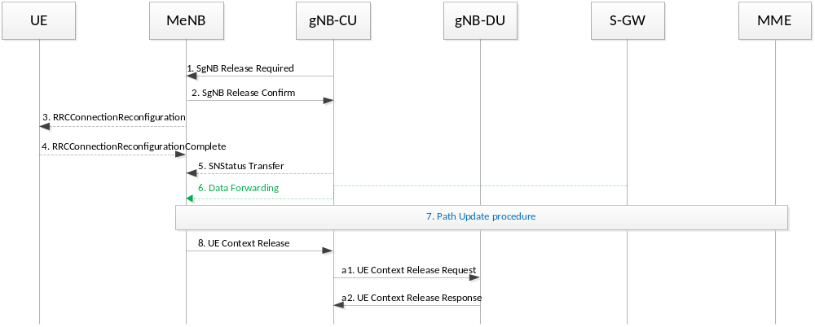
Figure 8.4.2.1-2 SgNB release procedure in EN-DC (SN initiated)

1~8: refer to TS 37.340 [14]
a1: After receiving UE Context Release message from MeNB, gNB-CU sends the UE Context Release Request message to gNB-DU to release UE context
a2: gNB-DU responds to gNB-CU with UE Context Release Response message.
Editor’s Note: Further check may be needed for MN/SN initiated SN release procedure, e.g., add UE Context Modification Request/Response after Step 1 for MN initiated, after Step 2 for SN initiated in order to stop the data transmission at the UE

8.5 F1 Startup and cells activation
This function allows to setup the F1 interface between a gNB-DU and a gNB-CU and it allows to activate the gNB-DU cells.
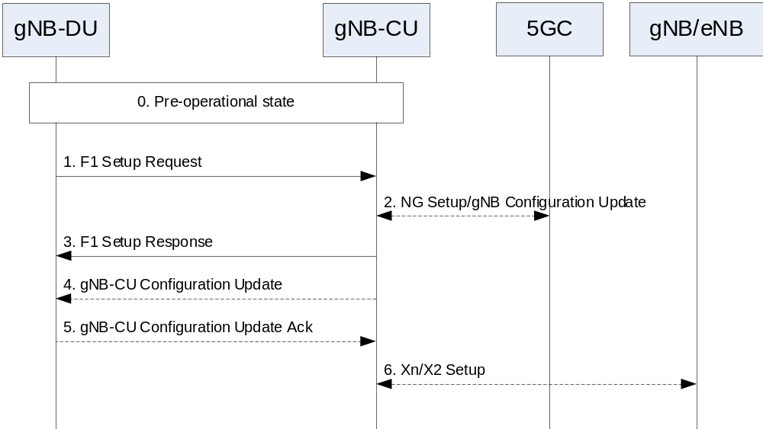
Figure 8.5-1: F1 startup and cell activation
- The gNB-DU and its cells are configured by OAM in the F1 pre-operational state. The gNB-DU has TNL connectivity toward the gNB-CU.
- The gNB-DU sends an F1 Setup Request message to the gNB-CU including a list of cells that are configured and ready to be activated.
- In NG-RAN, the gNB-CU ensures the connectivity toward the core network. For this reason, the gNB-CU may initiate NG Setup or gNB Configuration Update procedure towards 5GC.
- The gNB-CU sends an F1 Setup Response message to the gNB-DU that optionally includes a list of cells to be activated. If the gNB-DU succeeds to activate the cell(s), then the cells become operational. If the gNB-DU fails to activate some cell(s), the gNB-DU may initiate gNB-DU Configuration Update procedure towards the gNB-CU.
- The gNB-CU may send a gNB-CU Configuration Update message to the gNB-DU that optionally includes a list of cells to activated, e.g., in case that these cells were not activated using the F1 Setup Response message.
- The gNB-DU replies with a gNB-DU Configuration Update Acknowledge message that optionally includes a list of cells that failed to be activated.
- The gNB-CU may initiate Xn Setup or X2 Setup procedure towards the neighbor gNB or eNB, respectively.
NOTE: In case that the F1 Setup Response is not used to activate any cell, step 2 can be performed after step 3.

9 Synchronization

9.1 gNB Synchronization
Editor Note: This subclause shows logical synchronization in gNB.
The gNB shall support a logical synchronization port for phase-, time- and/or frequency synchronization.
Logical synchronization port for phase- and time-synchronization shall provide
1) accuracy that allows to meet the gNB requirements on maximum relative phase difference for all gNBs in synchronized TDD-unicast area
2) continuous time without leap seconds traceable to common time reference for all gNBs in synchronized TDD-unicast area
A logical synchronization port for phase- and time-synchronization may also be provided for e.g., all gNBs in FDD time domain inter-cell interference coordination synchronization area.
Furthermore common SFN initialization time shall be provided for all gNBs in synchronized TDD-unicast area
Based on this information, the gNB may derive the SFN according to the following formula
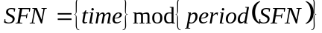,
where
time time adjusted by the common SFN initialization time, in units of 10 ms to match the length of radio frame and accuracy accordingly;
period(SFN) SFN period.
NOTE: When gNB is connected via TDM interfaces, these could be used to synchronize frequency the gNB.
The characteristics of these interfaces are described in 3GPP TS 25.411 [8].
In case gNB is connected via TDM interface, it may be used to synchronize frequency the gNB. The characteristics of the clock in the gNB shall be designed taking into account that the jitter and wander performance requirements on the interface are in accordance with network limits for output wander at traffic interfaces of either ITU-T Rec. G.823 [9], ITU-T Rec. G.824 [10] or network limits for the maximum output jitter and wander at any hierarchical interface of
ITU-T Rec. G.825 [11], whichever is applicable.
In case gNB is connected via Ethernet interface and the network supports Synchronous Ethernet, the gNB may use this interface to get frequency synchronization. In this case the design of the gNB clock should be done considering the jitter and wander performance requirements on the interface are as specified for output jitter and wander at EEC interfaces of ITU-T Rec. G.8261/Y.1361 [12], defined in clause 9.2.1. Further considerations on Synchronous Ethernet recommendations and architectural aspects are defined in clause 12.2.1 and Annex A of ITU-T Rec. G.8261/Y.1361 [12].
A configurable LTE TDD-offset of start frame shall be supported by all gNBs in synchronized TDD-unicast areas in order to achieve interoperability in coexistence scenarios.

10 NG-RAN interfaces

10.1 NG interface
3GPP TS 38.410 [16] specifies NG interface general aspect and principles.

10.2 Xn interface
3GPP TS 38.420 [17] specifies Xn interface general aspect and principles.

10.3 F1 interface
3GPP TS 38.470 [18] specifies F1 interface general aspect and principles.

Annex A (Informative): Deployment scenarios of NG RAN nodes
Figure A-1 shows logical nodes (CU-C, CU-U and DU), internal to a Logical NG-RAN Node. Protocol terminations of the NG and Xn interfaces are depicted as ellipses in Figure A-1. The terms “Central Entity” and “Distributed Entity” shown in Figure A-1 refer to physical network nodes.
Editor’s note: Node names are FFS, depending on the decision on NG-RAN node name.
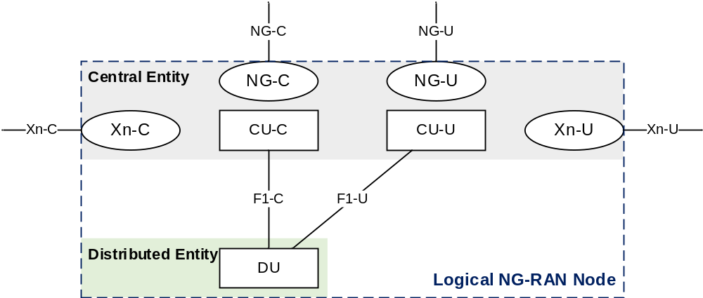
Figure A-1: Example deployment of an NG-RAN node

Change history
Date | Meeting | TDoc | CR | Rev | Cat | Subject/Comment | New version
2017-04 | RAN3#95bis | R3-171307 |  |  |  | First Draft | 0.0.1
2017-05 | RAN3#96 | R3-171962 |  |  |  | - Reflected agreed TP in RAN3#96.  - Added new Clause 8 for overall procedure for gNB-CU/DU architecture | 0.1.0
2017-06 | RAN3#NR Ad Hoc | R3-172634 |  |  |  | - Reflected agreed TP in RAN3#NR Ad Hoc in 2017-06 (Qingdao) | 0.2.0
2017-08 | RAN3#97 | R3-173449 |  |  |  | - Reflected agreed TP in RAN3#97 | 0.3.0
2017-10 | RAN3#97bis | R3-174237 |  |  |  | - Reflected agreed TP in RAN3#97bis | 0.4.0
2017-10 | RAN3#97bis | R3-174258 |  |  |  | - Removed subclauses under 10.3 (moved to 38.470) | 0.4.1

