3GPP TS 38.401 Vx.y.z (2017-04)
Technical Specification
3rd Generation Partnership Project;
Technical Specification Group Radio Access Network;
NG-RAN;
Architecture description
(Release 15)


The present document has been developed within the 3rd Generation Partnership Project (3GPP TM) and may be further elaborated for the purposes of 3GPP.
The present document has not been subject to any approval process by the 3GPP Organizational Partners and shall not be implemented.
This Specification is provided for future development work within 3GPP only. The Organizational Partners accept no liability for any use of this Specification.
Specifications and reports for implementation of the 3GPP TM system should be obtained via the 3GPP Organizational Partners' Publications Offices.

Keywords
LTE, radio, access
3GPP
Postal address

3GPP support office address
650 Route des Lucioles - Sophia Antipolis
Valbonne - FRANCE
Tel.: +33 4 92 94 42 00 Fax: +33 4 93 65 47 16
Internet
http://www.3gpp.org
Copyright Notification
No part may be reproduced except as authorized by written permission.
The copyright and the foregoing restriction extend to reproduction in all media.

© 2016, 3GPP Organizational Partners (ARIB, ATIS, CCSA, ETSI, TSDSI, TTA, TTC).
All rights reserved.

UMTS™ is a Trade Mark of ETSI registered for the benefit of its members
3GPP™ is a Trade Mark of ETSI registered for the benefit of its Members and of the 3GPP Organizational Partners
LTE™ is a Trade Mark of ETSI registered for the benefit of its Members and of the 3GPP Organizational Partners
GSM® and the GSM logo are registered and owned by the GSM Association
Contents
Foreword 5
1 Scope 6
2 References 6
3 Definitions and abbreviations 6
3.1 Definitions 6
3.2 Abbreviations 7
4 General principles 7
5 General architecture 7
6 NG-RAN architecture 7
6.1 Overview 7
6.2 NG-RAN identifiers 7
6.3 Transport addresses 7
6.4 UE associations in gNB 7
7 NG-RAN functions description 8
7.1 List of functions 8
7.2 Functions description 8
8 Mobility management 8
9 Synchronization 8
9.1 gNB Synchronization 8
9.2 gNB and 5G-CN Synchronization 8
10 NG-RAN interfaces 8
10.1 General protocol model for NG-RAN interfaces 8
10.1.1 Radio Network Layer (RNL) and Transport Network Layer (TNL) 9
10.1.2 Control plane 9
10.1.3 User plane 9
10.2 NG interface 9
10.3 Xn interface 9
10.2 F1 interface 9
10.2.1 General aspects 9
10.2.1.1 Architecture for gNB-CU and gNB-DU 9
10.2.1.2 F1 interface general principles 10
10.2.2 Functions of the F1 interface protocols and functional split 10
10.2.2.1 General 10
10.2.2.2 F1-C functions 10
10.2.2.2.1 GTP-U tunnel management function (FFS) 10
10.2.2.2.2 F1 interface management function 10
10.2.2.2.3 gNB-DU management function (FFS) 10
10.2.2.2.4 System Information management function 10
10.2.2.2.5 gNB-DU measurement reporting function (FFS) 11
10.2.2.2.6 Load management function (FFS) 11
10.2.2.2.7 Paging function (FFS) 11
10.2.2.2.8 F1 UE context management function 11
10.2.2.2.9 Bearer management function 11
10.2.2.2.10 Transfer of RRC message 11
10.2.2.3 F1-U functions 11
10.2.2.3.1 Transfer of user data 11
10.2.2.3.2 Flow control function 11
10.2.3 F1 interface protocols and protocol structure 12
10.2.3.1 F1 Control Plane Protocol (F1-C) 12
10.2.3.2 F1 User Plane Protocol (F1-U) 12

Foreword
This Technical Specification has been produced by the 3rd Generation Partnership Project (3GPP).
The contents of the present document are subject to continuing work within the TSG and may change following formal TSG approval. Should the TSG modify the contents of the present document, it will be re-released by the TSG with an identifying change of release date and an increase in version number as follows:
Version x.y.z
where:
x the first digit:
1 presented to TSG for information;
2 presented to TSG for approval;
3 or greater indicates TSG approved document under change control.
y the second digit is incremented for all changes of substance, i.e. technical enhancements, corrections, updates, etc.
z the third digit is incremented when editorial only changes have been incorporated in the document.

1 Scope
The present document describes the overall architecture of the E-UTRAN, including internal interfaces and assumptions on the radio, S1 and X2 interfaces.

2 References
The following documents contain provisions which, through reference in this text, constitute provisions of the present document.
- References are either specific (identified by date of publication, edition number, version number, etc.) or non-specific.
- For a specific reference, subsequent revisions do not apply.
- For a non-specific reference, the latest version applies. In the case of a reference to a 3GPP document (including a GSM document), a non-specific reference implicitly refers to the latest version of that document in the same Release as the present document.
[1] 3GPP TR 21.905: "Vocabulary for 3GPP Specifications".

[2] 3GPP TS 38.300: "NR; Overall description; Stage-2".

3 Definitions and abbreviations

3.1 Definitions
For the purposes of the present document, the terms and definitions given in TR 21.905 [1] and the following apply.
A term defined in the present document takes precedence over the definition of the same term, if any, in TR 21.905 [1].
gNB Central Unit (gNB-CU): a logical node hosting RRC, SDAP and PDCP protocols, and controls the operation of one or more gNB-DUs. The gNB-CU also terminates F1 interface connected with the gNB-DU.
Editor’s note: Definition and naming of gNB-CU are FFS.
Editor’s note: How SDAP is related to EN-DC is FFS.
Editor’s note: Whether to clarify the termination point (i.e., gNB-CU or gNB-DU) of NG interface is FFS.
Editor’s note: How many gNB-DUs can be operated by one gNB-CU is FFS.
gNB Distributed Unit (gNB-DU): a logical node hosting RLC, MAC and PHY layers, and its operation is partly controlled by gNB-CU. One gNB-DU supports one or multiple cells. The gNB-DU terminates F1 interface connected with the gNB-CU.
Editor’s note: Definition and naming of gNB-DU are FFS.
Editor’s note: Whether one gNB-DU can be connected with multiple gNB-CUs is FFS (e.g. by pooling concept).
Editor’s note: Whether one cell can be supported by multiple gNB-DUs is FFS.
gNB: as defined in TS 38.300 [2].

3.2 Abbreviations
For the purposes of the present document, the terms and definitions given in TR 21.905 [1] and the following apply.
A term defined in the present document takes precedence over the definition of the same term, if any, in TR 21.905 [1].
gNB-CU gNB Central Unit
gNB-DU gNB Distributed Unit
GTP-U GPRS Tunnelling Protocol
IP Internet Protocol
O&M Operation and Maintenance
QoS Quality of Service
RNL Radio Network Layer
F1-U F1 User plane interface
F1-C F1 Control plane interface
F1AP F1 Application Protocol
SCTP Stream Control Transmission Protocol
TNL Transport Network Layer

4 General principles
Editor Note: This clause shows the general principles guiding the definition of NG-RAN architecture as well as the NG-RAN interfaces.

5 General architecture
Editor Note: This clause shows the general architecture e.g. C-Plane, U-Plane etc.

6 NG-RAN architecture

6.1 Overview
Editor Note: This subclause shows the overview of the NG-RAN architecture.

6.2 NG-RAN identifiers
Editor Note: This subclause shows those identifiers that are used in NG-RAN.

6.3 Transport addresses
Editor Note: This subclause shows those principle of Transport Address that to be used in NG-RAN.

6.4 UE associations in gNB
Editor Note: This subclause shows those principle of UE Associations in gNB e.g. gNB UE Association, UE Context etc.

7 NG-RAN functions description
Editor Note: This subclause shows NG-RAN functions.

7.1 List of functions

7.2 Functions description

8 Mobility management
Editor Note: This subclause shows mobility management including mobility scenarios.

9 Synchronization

9.1 gNB Synchronization
Editor Note: This subclause shows logical synchronization in gNB.

9.2 gNB and 5G-CN Synchronization
Editor Note: This subclause shows gNB and 5G-CN synchronization.

10 NG-RAN interfaces
Editor Note: This subclause shows NG-RAN interfaces including general protocol model.

10.1 General protocol model for NG-RAN interfaces
Editor Note: This subclause shows general protocol model.
The general protocol model for NG-RAN interfaces is depicted in figure 11.1-1. (FFS)
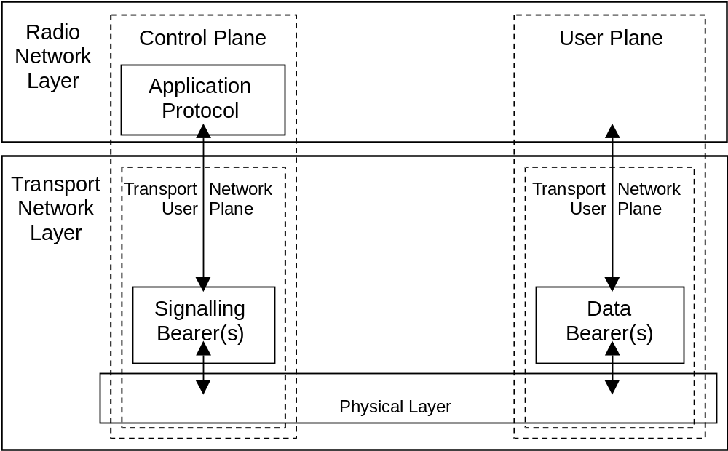
Figure 11.1-1: General protocol model for NG-RAN interfaces

10.1.1 Radio Network Layer (RNL) and Transport Network Layer (TNL)
Editor Note: This subclause shows protocol structure consists of RNL and TNL.

10.1.2 Control plane
Editor Note: This subclause shows general description of Application Protocol (AP).

10.1.3 User plane
Editor Note: This subclause shows general description of User Plane e.g. characterized by tunnelling protocol in the TNL.

10.2 NG interface
Editor Note: This subclause shows overall NG interface e.g. function description

10.3 Xn interface
Editor Note: This subclause shows overall Xn interface e.g. function description

10.2 F1 interface
Editor Note: This subclause shows overall Fs interface e.g. function description

10.2.1 General aspects
This clause captures the architecture for gNB-CU and gNB-DU, F1 interface principles.

10.2.1.1 Architecture for gNB-CU and gNB-DU
Editor’s note: Whether one gNB-DU can be connected with multiple gNB-CUs is FFS (e.g. by pooling concept), thus architecture for gNB-CU and gNB-DU is also FFS.

10.2.1.2 F1 interface general principles
The general principles for the specification of the F1 interface are as follows:
- the F1 interface shall be open;
- the F1 interface shall support the exchange of signalling information between the endpoints, in addition the interface shall support data transmission to the respective endpoints;
- from a logical standpoint, the F1 is a point-to-point interface between the endpoints.
NOTE: A point-to-point logical interface should be feasible even in the absence of a physical direct connection between the endpoints.
- the F1 interface shall support control plane and user plane separation;
- the F1 interface shall separate Radio Network Layer and Transport Network Layer;
- the F1 interface shall enable exchange of UE associated information and non-UE associated information;
- the F1 interface shall be future proof to fulfil different new requirements, support new services and new functions;
- One gNB-CU and set of gNB-DUs are visible to other logical nodes as a gNB. The gNB terminates X2, Xn, NG and S1-U interfaces.

10.2.2 Functions of the F1 interface protocols and functional split
Editor’s note: Naming of each function is FFS.

10.2.2.1 General
The following clauses describe the functions supported over F1-C and F1-U.

10.2.2.2 F1-C functions

10.2.2.2.1 GTP-U tunnel management function (FFS)
This function is used to establish and release GTP-U (3GPP TS 29.281 [x3]) tunnels between the gNB-CU and the gNB-DU upon a bearer service request. This involves assigning a tunnel identifier for each direction.
Editor’s note: Whether this section is kept or moved to bearer management function or removed is FFS.

10.2.2.2.2 F1 interface management function
The error indication function is used by the gNB-DU to indicate to the gNB-CU that a logical error has occurred.
The reset function is used to initialize the peer entity after node setup and after a failure event occurred. This procedure can be used by both the gNB-DU and gNB-CU.
The F1 setup (respectively the gNB-DU and gNB-CU configuration update) function allows to exchange (respectively update) application level data needed for the gNB-DU and gNB-CU to interoperate correctly on the F1 interface.
Editor’s note: The space of NR Cell ID, and how/whether to map them in the gNB-CU are FFS.

10.2.2.2.3 gNB-DU management function (FFS)
Editor’s note: Whether gNB-DU is managed by O&M or by gNB-CU is FFS. The impact on F1 interface is FFS.

10.2.2.2.4 System Information management function
Scheduling of system broadcast information is carried out in the gNB-DU. The gNB-DU is responsible for transmitting the system information according to the scheduling parameters available.
Editor’s note: How to support this function is FFS.

10.2.2.2.5 gNB-DU measurement reporting function (FFS)
The gNB-DU measurement reporting function is used to report the radio measurements of gNB-DU and UE associated measurements to the gNB-CU.

10.2.2.2.6 Load management function (FFS)
The load management function allows the gNB-CU to request the reporting of load information to the gNB-DU. The gNB-DU reports the result of load information to the gNB-CU.

10.2.2.2.7 Paging function (FFS)
The gNB-DU is responsible for transmitting the paging information according to the scheduling parameters available.

10.2.2.2.8 F1 UE context management function
The F1 UE context management function supports the establishment of the necessary overall initial UE context.
The establishment of the overall initial UE context is initiated by the gNB-CU.
The F1 UE context management function also supports the release of the context previously established in the gNB-DU. The release of the context is triggered by the gNB-CU either directly or following a request received from the gNB-DU.
Editor’s note: What is UE context needs to be clarified.

10.2.2.2.9 Bearer management function
The bearer management function is responsible for establishing, modifying and releasing radio bearer resources for user data transport once a UE context is available in the gNB-DU. The establishment and modification of radio bearer resources is triggered by the gNB-CU requires respective resource reservation information and QoS information to be provided to the gNB-DU.
Editor’s note: Whether mobility functions such as intra-CU/inter-DU handover can be supported by bearer management function is FFS.
Editor’s note: The relationship of bearer management and simultaneous transmission from two DUs is FFS.
Editor’s note: How to split and configure RRM functions between gNB-CU and gNB-DU is FFS.

10.2.2.2.10 Transfer of RRC message
This function allows to transfer RRC messages between gNB-CU and gNB-DU.
Editor’s note: Whether RRC message is transferred over F1-C or F1-U or both is FFS.

10.2.2.3 F1-U functions

10.2.2.3.1 Transfer of user data
This function allows to transfer of user data between gNB-CU and gNB-DU.

10.2.2.3.2 Flow control function
This function allows to control the downlink user data flow to the gNB-DU. The detailed protocol is specified in TS 38.475 [4x].
Editor’s note: Whether to support uplink flow control is FFS.

10.2.3 F1 interface protocols and protocol structure

10.2.3.1 F1 Control Plane Protocol (F1-C)
Figure 10.2.3.1-1 shows the protocol structure for F1-C. The TNL is based on IP transport, comprising the SCTP on top of IP. The application layer signalling protocol is referred to as F1AP (F1 Application Protocol).
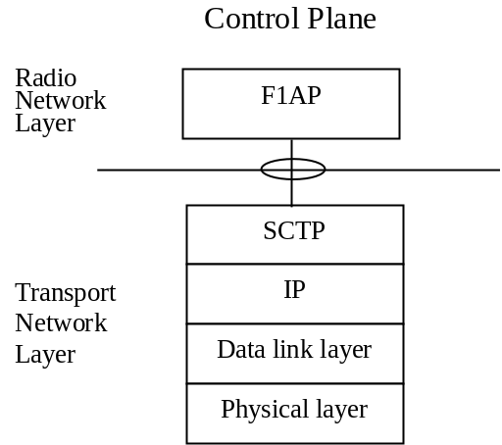
Figure 10.2.3.1-1: Interface protocol structure for F1-C
Editor’s note: Whether other protocol stacks are standardized for F1-C is FFS.

10.2.3.2 F1 User Plane Protocol (F1-U)
Figure 10.2.3.2-1 shows the protocol structure for F1-U. The TNL is based on IP transport, comprising the UDP and GTP-U on top of IP.
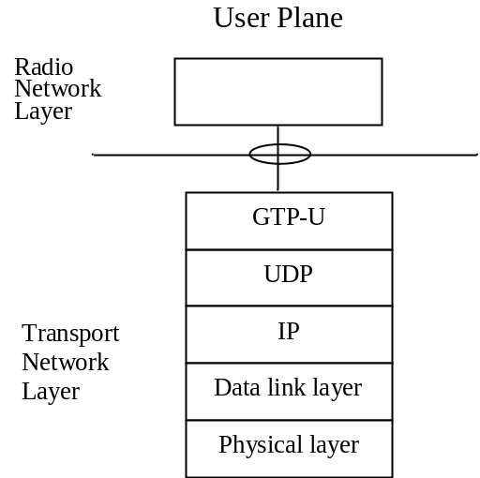
Figure 10.2.3.2-1: Interface protocol structure for F1-U
Editor’s note: Whether other protocol stacks are standardized for F1-U is FFS.

