# Blackjack Game

**GROUP: GATE**

**Date: 3/12/2020**

**Group members:**

**Eric Nogueira – 991436785**

**Tristen Hubert - 991590613**

**Gonzalo Jurado - 991303719**

**Amandeep Kaur 991576115**

# Table of contents

Contents

Blackjack Game 1

Table of contents 2

Use Cases 3

UML Class Diagram 4

Design Document 5

Project Background and Description 5

Design Considerations 5

Design Document continued 6

# Use Cases

**Main path:**

* Player starts game
* Player is given 2 cards by the system(dealer)
* Player is given 2 options
* Player uses the hit option which draws another card
* Players card values are compared with the dealer’s cards value
* Player is displayed if they won or bust
* Player is given option to play again

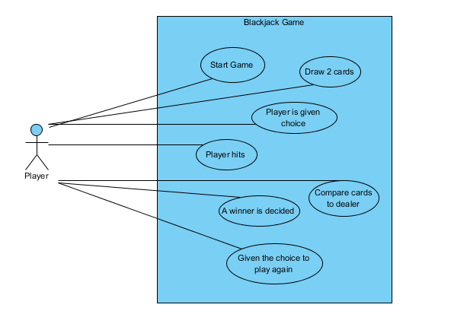

**Alternate path:**

* Player starts game
* Player is given 2 cards by the system(dealer)
* Player is given 2 options
* Player uses the stay option which does not draw another card
* Players card values are compared with the dealer’s cards value
* Player is displayed if they won or bust
* Player is given option to play again

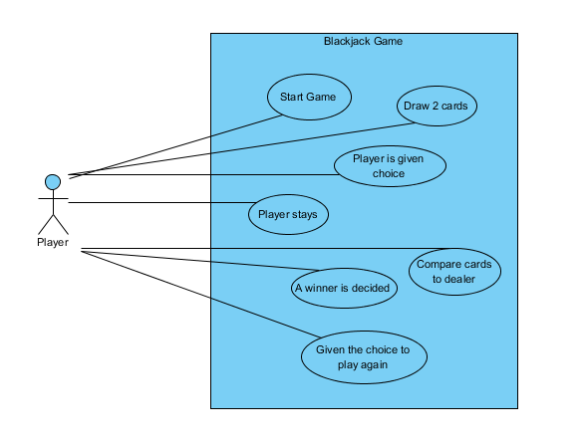

# UML Class Diagram

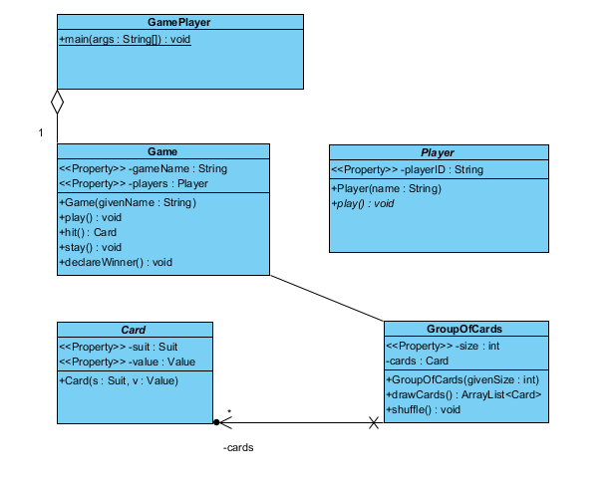

Figure 1.

# Design Document

## Project Background and Description

Elaborate on the game you chose and the Description provided in Deliverable 1 by providing more detail on the exact scope of your project (i.e. “the game will terminate after four rounds, giving each player a total score”).

-

The game will begin with both players drawing two cards. Upon drawing the two cards the total value will be displayed. For example, if you draw a king (which is worth 10) and a 3 it will show your total as 13. Then you will have the option to “Hit” or “Stay”, hit will draw you another card stay will keep your current cards. The goal is to get as close to 21 as possible without going over it and without allowing the other player to have a higher number than you. Once you decide to stay the two players card value totals will be compared and the one that has a higher value without going over 21 will win. Then you will have the option to play again or exit.

## Design Considerations

Describe the Class Diagram you delivered above (it should be descried as Figure 1 or Figure x if you have more than one Figure), explaining the associations and multiplicities depicted.

Comment on each of the following as it pertains to the class groupings you have decided upon and if you have included methods, modifiers and return types, comment on those here as well. You may wish to describe any data structures you wish to use (i.e an enumeration) when you are explaining your design choices. Be specific for full credit.

* Encapsulation
* Delegation
* Cohesion
* Coupling
* Inheritance
* Aggregation
* Composition
* Flexibility/Maintainability

# Design Document continued

# In figure one Player is the model in the model view controller

# In figure one the Game and GamePlayer have an aggregation association as seen by the delegation arrow

# In figure one as seen by the association arrow Card and GroupOfCards are associated.

# In figure one Game and GroupOfCards have an association seen by the line connecting them.