Problem 7: Reverse Integer

Given a 32-bit signed integer, reverse digits of an integer.

**Example 1:**

**Input:** 123

**Output:** 321

**Example 2:**

**Input:** -123

**Output:** -321

**Example 3:**

**Input:** 120

**Output:** 21

**Note:**  
Assume we are dealing with an environment which could only store integers within the 32-bit signed integer range: [−231,  231− 1]. For the purpose of this problem, assume that your function returns 0 when the reversed integer overflows.

Code in Python3 and C++ are in the same folder.

C++

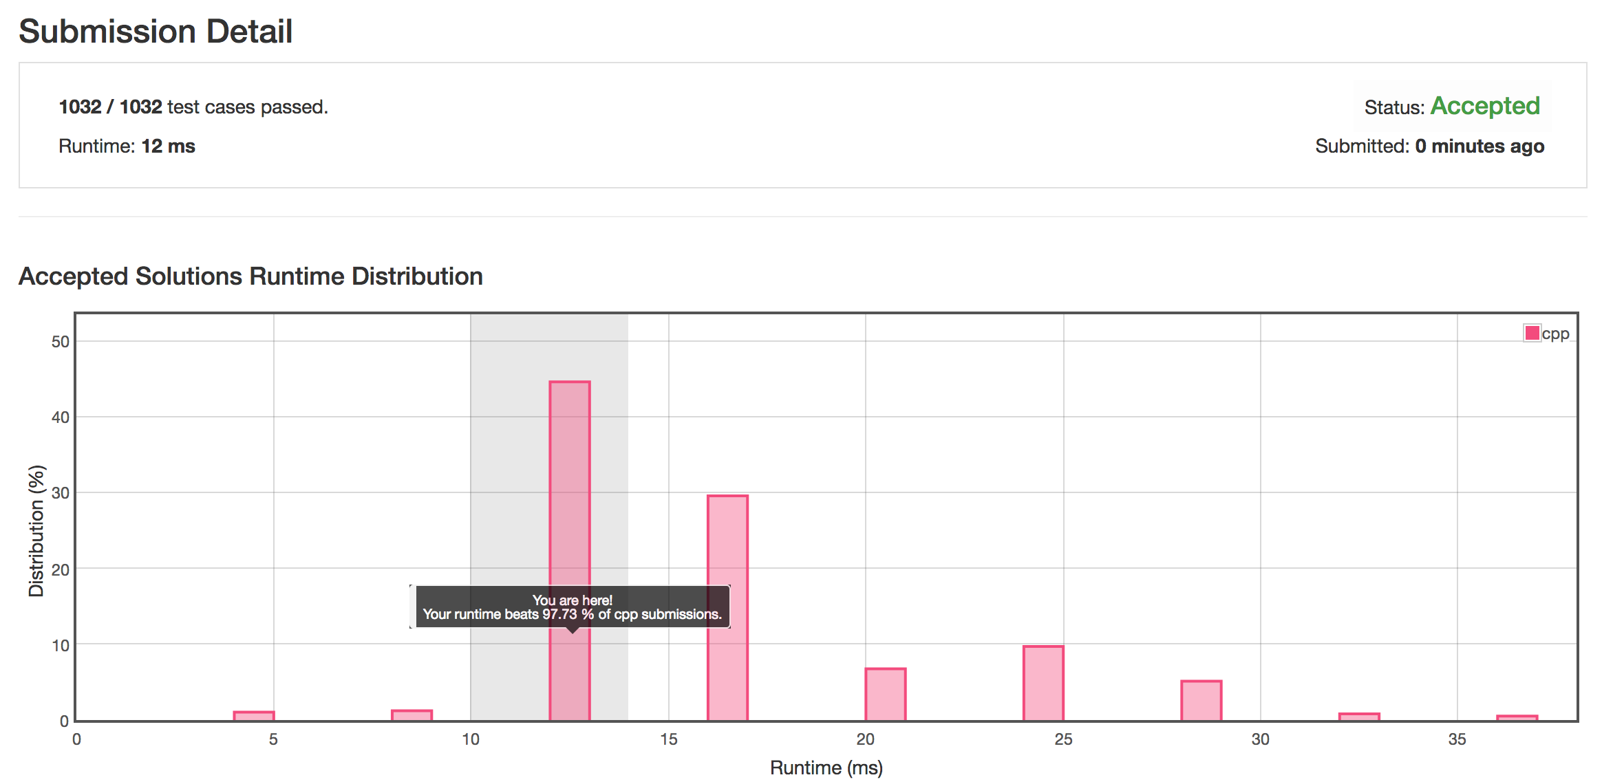

Python3  
