The title

|  |
| --- |
| First Author1 & Ernst-August Doelle1,2 |
|  |
| 1 Wilhelm-Wundt-University |
| 2 Konstanz Business School |
|  |

# Author note

Complete departmental affiliations for each author (note the indentation, if you start a new paragraph). Enter author note here.

Correspondence concerning this article should be addressed to First Author, Postal address. E-mail: [my@email.com](mailto:my@email.com)

# Abstract

Enter abstract here (note the indentation, if you start a new paragraph).

*Keywords:* keywords

Word count: X

# The title

There is a lot of important literature to cite (Button et al., 2013; Ioannidis, 2005). Sterne et al. (2011) have important things to say.

# Methods

We report how we determined our sample size, all data exclusions (if any), all manipulations, and all measures in the study.

## Participants

## Material

## Procedure

# Results

The mean length is 5.84. Table 1 shows some interesting results. Figure 1 shows an interesting plot.

Table 1 A table of the first 10 rows of the mtcars data.

|  |  |  |  |  |  |  |  |  |
| --- | --- | --- | --- | --- | --- | --- | --- | --- |
|  | mpg | cyl | disp | hp | drat | wt | qsec | vs |
| Mazda RX4 | 21.0 | 6 | 160.0 | 110 | 3.90 | 2.620 | 16.46 | 0 |
| Mazda RX4 Wag | 21.0 | 6 | 160.0 | 110 | 3.90 | 2.875 | 17.02 | 0 |
| Datsun 710 | 22.8 | 4 | 108.0 | 93 | 3.85 | 2.320 | 18.61 | 1 |
| Hornet 4 Drive | 21.4 | 6 | 258.0 | 110 | 3.08 | 3.215 | 19.44 | 1 |
| Hornet Sportabout | 18.7 | 8 | 360.0 | 175 | 3.15 | 3.440 | 17.02 | 0 |
| Valiant | 18.1 | 6 | 225.0 | 105 | 2.76 | 3.460 | 20.22 | 1 |
| Duster 360 | 14.3 | 8 | 360.0 | 245 | 3.21 | 3.570 | 15.84 | 0 |
| Merc 240D | 24.4 | 4 | 146.7 | 62 | 3.69 | 3.190 | 20.00 | 1 |
| Merc 230 | 22.8 | 4 | 140.8 | 95 | 3.92 | 3.150 | 22.90 | 1 |
| Merc 280 | 19.2 | 6 | 167.6 | 123 | 3.92 | 3.440 | 18.30 | 1 |

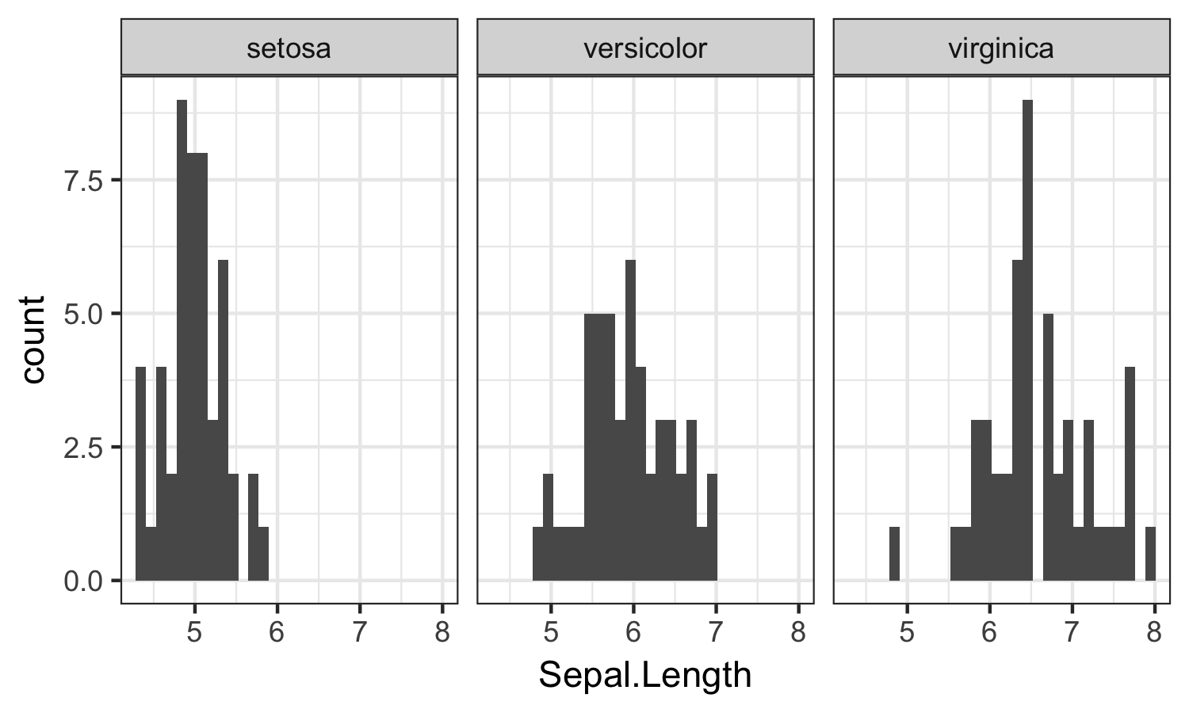

Figure 1 This is a figure.

# Discussion

# References

Button, K. S., Ioannidis, J. P., Mokrysz, C., Nosek, B. A., Flint, J., Robinson, E. S., & Munafò, M. R. (2013). Power failure: Why small sample size undermines the reliability of neuroscience. *Nature Reviews Neuroscience*, *14*(5), 365–376.

Ioannidis, J. P. (2005). Why most published research findings are false. *PLoS Medicine*, *2*(8), e124.

Sterne, J. A., Sutton, A. J., Ioannidis, J. P., Terrin, N., Jones, D. R., Lau, J., … Schmid, C. H. (2011). Recommendations for examining and interpreting funnel plot asymmetry in meta-analyses of randomised controlled trials. *Bmj*, *343*, d4002.