Project Plan Overview: Online Multiplayer Board Game Platform

1. Project Overview

Objective:
Design, develop, and test an Online Multiplayer Board Game Platform (OMG) using Agile methodologies.

Team Structure:
- Total Members: 25
- Sub-teams:
  - Game Logic Team
  - GUI Team
  - Networking Team
  - Authentication & Profile Team
  - Leaderboard & Matchmaking Team
  - Integration Team

2. Team Roles & Responsibilities

Sub-Team Breakdown:
Since we have 25 members total, we will split into 6 specialized teams. Each team has a team lead, which can be rotated each sprint (if necessary). Team leads are important to
Team | Members | Responsibilities | Lead
Game Logic Team (4-5 members) | [TBD] | Implement rules & logic for board games (Chess, Checkers, etc.) | [TBD]
GUI Team (4-5 members) | [TBD] | Create & integrate the user interface (UI) | [TBD]
Networking Team (4-5 members) | [TBD] | Handle multiplayer interactions | [TBD]
Authentication & Profile Team (3-4 members) | [TBD] | Implement user login, profiles, and authentication | [TBD]
Leaderboard & Matchmaking Team (3-4 members) | [TBD] | Implement ranking system and matchmaking algorithm | [TBD]
Integration Team (3-4 members) | [TBD] | Ensure smooth merging of all modules and resolve conflicts | [TBD]

3. Agile Scrum Methodology
We will follow Scrum, with the following structure: (TODO):

Scrum Artifacts & Meetings:
- Daily Stand-ups (15 mins): Each team updates on their progress.
- Sprint Planning (Day 1 of each sprint): Define what each team will deliver.
- Sprint Review (Last Day of Sprint): Demo completed features.
- Sprint Retrospective: Discuss what worked & improvements.

3. Project Phases
The project will be completed in 3 major iterations (sprints):(TODO):
Each sprint has specific milestones to ensure structured progress.(TODO):
Iteration | Timeframe | Focus | Milestones | Responsible Teams
Sprint 1 (Feb 24 - Mar 7) | 2 weeks | Planning & System Design | Complete system design & wireframes
Sprint 2 (Mar 8 - Mar 21) | 2 weeks | Prototype Development & Initial Implementation | Working prototype with UI, authentication, matchmaking
Sprint 3 (Mar 22 - Apr 11) | 3.5 weeks | Feature Completion, Integration & Testing | Fully integrated system with leaderboard & testing
Each sprint will be followed by a Sprint Review & Retrospective.(TODO):

4. Sprint Timeline and Task Breakdown

Sprint 1 (Feb 24 - Mar 7) - Initial Planning & Architecture

Objectives (TODO):
- Define architecture & system design
- Assign user stories to teams
- Establish core project structure in GitLab
- Create preliminary UI wireframes
- Develop initial game logic structure

Tasks & Team Assignments:
Group and Individual Deliverables Submission Deadline: March 7th

Project Iteration Group Deliverables #1

Task | Team | Git Repo? | Submit to: Private or Public Dropbox? | Deliverables | Completed? | Comments
Create Use Case Descriptions / Diagram | All Teams (?) | Not in Git Repo | Public Dropbox | use_case_descriptions.pdf | Not started | To be discussed
Set up GitLab Repository, create Gitlab text file | Any Team | Not in Git Repo | Private Dropbox | gitlab_link.txt  seng300-w25-project | In progress | Text file to be submitted to Group’s Private Dropbox
Create Team Document | Any Team | In Git Repo | Private Dropbox | team.md | In progress | Team doc to be submitted to Group’s Private Dropbox
Create Planning Docs (track milestones, task completion dates etc, for programming portion) | All Teams | Not in Git Repo - will be under “docs” folder  Create sprint_1/ Folder (?) | Public Dropbox | Possible Deliverables:  Sprint Task Breakdown  sprint_1/game_logic_tasks.pdf  Team Sprint Timeline  game_logic_timeline.pdf | In progress | Organize Planning Docs based on Team and Sprint Planning:  Sprint Task Breakdown - List of all tasks and assignments  Team Sprint Timeline - When each task should be done throughout project  (to be discussed)
Create Structure Diagrams | All Teams (?) | Not in Git Repo | Public Dropbox | Class_diagram.png  or  Class_diagram.svg | Not started | To be discussed
Create Additional Diagrams / Documentation | All Teams | Not in Git Repo | Public Dropbox | Possible Deliverables:  wireframes.png | Not started | To be discussed
Accountability Contract | All Teams | Not in Repo | Private Dropbox |  | Not started | Signed by all team members - to be submitted “before start of work on P2” - March 7th?

Project Iteration #1 Individual Deliverables

Task | Deliverables | Comments
Individual Worklog | [UCID]_worklog_p1.xlsx
Peer Evaluations | [UCID]_peer_evaluations_p1.xlsx

Sprint 2 (Mar 8 - Mar 21) - Prototype Development & Feedback Integration

Objectives (TODO):
- Develop basic UI & authentication system
- Implement initial game logic for 2 games
- Create matchmaking & leaderboard prototype
- Prepare documentation for feedback

Group and Individual Deliverables Submission Deadline: March 21st

Project Iteration Group Deliverables #2 (TODO):

Task | Team | Git Repo? | Submit to: Private or Public Dropbox? | Deliverables | Completed? | Comments
 |  |  |  |  | Not started
 |  |  |  |  | Not started
 |  |  |  |  | Not started
 |  |  |  |  | Not started
 |  |  |  |  | Not started
 |  |  |  |  | Not started

Sprint 3 (Mar 22 - Apr 11) - Refinement, Integration & Testing

Objectives (TODO):
- Fully integrate all system components
- Implement final set of game features
- Perform system testing & debugging
- Prepare final project documentation

Group and Individual Deliverables Submission Deadline: April 11th

Project Iteration Group Deliverables #3 (TODO):

Task | Team | Git Repo? | Submit to: Private or Public Dropbox? | Deliverables | Completed? | Comments
 |  |  |  |  | Not started
 |  |  |  |  | Not started
 |  |  |  |  | Not started
 |  |  |  |  | Not started
 |  |  |  |  | Not started
 |  |  |  |  | Not started

Project Iteration #3 Individual Deliverables (TODO):

Task | Deliverables | Comments

5. Team Organization (TODO):
Teams will keep organized through Sprint Task Breakdown and Team Sprint Timeline Documents:
- Sprint Task Breakdown
  - List of all tasks and assignments
  - Completed at the beginning of each Sprint cycle

- Team Sprint Timeline
  - When each task should be done throughout the project.
Sprint Task Breakdown document should include:
- Dependencies - lists which teams they need to collaborate with.
- Deadlines
- Priority
- Assignee(s)

Key Documents & Organization for Each Team
Document | Purpose | Where to Store
Sprint Task Breakdown | List of all tasks, assigned members, deadlines | docs/sprint_1/[team_name]_tasks.md
Team Sprint Timeline | Weekly schedule for each task | docs/sprint_1/[team_name]_timeline.md

Visual example (provided by ChatGPT):
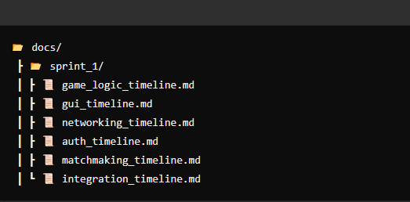

6. Risk Management (TODO):
We will track potential risks and mitigation strategies:
Risk | Impact | Mitigation Strategy
Merge conflicts | High | Frequent code commits & reviews
Team member inactivity | Medium | Accountability contract, peer reviews
Integration issues | High | Merge regularly & conduct integration testing

7. Development Workflow & Tools (TODO):
Gitlab will be used for version control with the following structure:
📂 GitLab Repository Structure (Visual provided by ChatGPT):
📦 seng300-w25-project
┣ 📂 frontend/ (UI & components)
┣ 📂 backend/ (Game logic, matchmaking, authentication)
┣ 📂 docs/ (Diagrams, reports, planning docs)
┣ 📂 tests/ (Unit tests, integration tests)
┗ README.md

Development Workflow (Git Flow)
- Main Branch: Stable releases only
- Development Branch: Ongoing implementation
- Feature Branches: One per task (e.g., feature/game_logic)
- Pull Requests: Required before merging

Git Branching Strategy:
Branches allow multiple people to work on different parts of the project without overwriting each other's code. Instead of everyone working on the same branch, we create separate branches for different tasks then merge them together when they are complete.
Branch Type | Purpose | Naming Convention
Main branch (main) | The final and stable release version | main
Team Branches (6)  (auth)  (gamelogic)  (gui)  (integration)  (leaderboard)  (networking) | The working versions where all features are integrated before going into main | auth  gamelogic  gui  integration  leaderboard  networking
Individual branches | Individual branches will be used to develop new features (UI, game logic, etc.) | name-feature/[task-name] (e.g., anica-feature/chess/)
Bug Fix branches  (bugfixing) | Used to fix specific bugs | bugfixing/[bug-name] (e.g., bugfixing/authentication-error)
Testing Branch
(testing)

Git Step-By-Step Guide:

- Clone the Repository (First-Time Setup)
Before making any changes, download (clone) the project to your local machine:
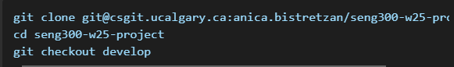
(only do this at the start of the project)
- Create a Feature Branch for your Task
Each developer works on a separate feature branch to prevent conflicts
EXAMPLE: Working on the login system:
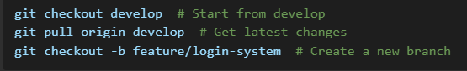

- Code and Save Your Changes Locally
After making some progress, save your work:

- Push Your Work to GitLab
Upload your branch to GitLab so others can see your changes:
This branch is now visible is GitLab
- Create a Merge Request (Pull Request)
Once your feature is complete and tested, merge it into develop:
- Go to GitLab → Repository → Merge Requests
- Click New Merge Request
- Set Source Branch: feature/login-system
- Set Target Branch: develop
- Add a short description of what your changes do
- Assign a team member to review it
- Click Create Merge Request
Good practice is to allow another team member to review your code before merging.
- Merging Feature Branch into develop
Once approved:
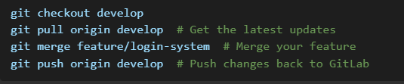

- Deploy final version to main
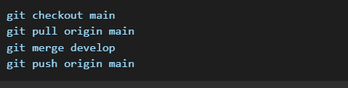
New version is now in main

