Project Plan Overview: Online Multiplayer Board Game Platform

1. Project Overview

Objective:
Design, develop, and test an Online Multiplayer Board Game Platform (OMG) using the Scrum framework.

Team Structure:
- Total Members: 25
- Sub-teams:
  - Game Logic Team
  - GUI Team
  - Networking Team
  - Authentication & Profile Team
  - Leaderboard & Matchmaking Team
  - Integration Team

2. Team Roles & Responsibilities

Overall Project Role Breakdown:
Project Coordinators - Anica and Maneet
- Facilitates team organization, structuring workflow, and ensuring Scrum practices are followed
- Responsible for team structure planning, maintaining organization across teams
- Help remove blockers, guides collaboration, and makes sure work stays on track
- Handles full-team logistics by organizing general meetings
- Ensures that everyone is aligned on overall project goals and deadlines
- Works closely with Project Coordinator to help coordinate sprints and major discussions

Team Leads
- Each team lead is responsible for overseeing their specific domain (Game Logic, GUI, Networking, etc)
- They ensure their sub-team completes sprint goals, resolves blockers, and meets at the end of the sprint to discuss progress
- Act as a point of contact between teams

Sub-Team Breakdown:
Since we have 25 members total, we will split into 6 specialized teams. Each team has a team lead, which can be rotated each sprint (if necessary). Team leads are important to maintain efficiency, ensure clear communication between teams, and help resolve blockers to keep development on track.
Each team is required to write their own Unit Tests and create their own Structure Diagrams.***
Team | Members | Responsibilities | Lead | Comments
Game Logic Team (4-5 members) | Anthony  Natasha  Croy  Oliver  Victor | - Implement the rules and mechanics for selected board games (Checkers, TicTacToe, Connect Four)  - Develop turn-based logic to ensure proper game flow and rule enforcement (such as managing player turns, game state updates, detecting game end conditions, communicating with the GUI team to visually update the board after each move, sending game state updates to the Networking Team for real time multiplayer interactions)  - Handle edge cases (illegal moves, draw conditions, forfeits, etc)  - Ensure synchronization of game states between players in multiplayer mode  - Write unit tests for game mechanics and validate correctness | Anthony
GUI Team (4-5 members) | Anica  Sam  Supan  Sourav  Eric | - Design and implement the user interface for the platform  - Develop visual representations of the game boards, pieces, and UI elements  - Integrate animations and responsive interactions to improve the user experience  - Implement user-friendly menus for login, profile management, and matchmaking  - Handle in-game chat and notifications for players  - Ensure UI remains responsive under different screen sizes and resolutions  - Work closely with Game Logic Team to ensure seamless interaction between UI and game mechanics | Supan
Networking Team (4-5 members) | Jed  JJ  Mikeljan  Kevin  Akshin | - Design and implement multiplayer communication using WebSockets or another networking protocol  - Manage real time updates between users (ex, player moves, chat messages)  - Handle game state synchronization across multiple users  - Implement a reconnection strategy in case of disconnections  - Work with Game Logic Team to ensure turn based mechanics work seamlessly in a networked environment | Kevin
Authentication & Profile Team (4-5 members) | Mahir  Boya  Michael  Maneet  Thomas | - Implement user registration, login, and authentication  - Develop a profile system where players can view and manage their game history, stats, and preferences  - Ensure security best practices (hashed passwords, session management)  - Implement authorization controls to restrict access to certain features  - Work with the GUI Team to integrate login and profile UI | Maneet
Leaderboard & Matchmaking Team (4-5 members) | Himanshu  Harjas  Tanishk  Surkhab  Punar | - Develop a ranking system to track player performance and display leaderboards  - Implement a matchmaking algorithm that pairs players based on skill level  - Design a matchmaking queue system where players can wait for available opponents  - Ensure real time updates for leaderboard rankings  - Work with Networking Team to enable dynamic matchmaking  - Develop test cases for ranking system calculations and matchmaking fairness | Himanshu
Integration Team (4-5 members) | Team Leads:  Anthony  Supan  Mikeljan  Maneet  Himanshu | - Merge components from all sub-teams into a unified, functional system  - Resolve integration conflicts between different modules (game logic, UI, networking, authentication, etc)  - Ensure all APIs and internal modules communicate correctly  - Conduct end-to-end testing to verify smooth functionality across components  - Work with each sub team to fix integration issues  - provide documentation on system architecture and dependencies | Anthony  Supan  Mikeljan  Maneet  Himanshu

3. Agile Scrum Methodology
We will be following the Scrum framework (required for Project).
- What is Scrum?
  - Scrum is an Agile framework used for managing and completing complex projects. It focuses on incremental and iterative development, meaning work is done in short cycles (called Sprints) rather than all at once.
- Scrum helps teams:
  - Break down large projects into smaller, manageable tasks
  - Work in short development cycles (Sprints) to deliver usable features quickly
  - Adapt to feedback and make changes as needed
  - Encourage collaboration and continuous improvement

Key Components of Scrum
- Product Backlog
  - A list of all the features, tasks, and fixes the team needs to work on. Such items are ranked by priority.
- Sprint Backlog
  - A subset of the Product Backlog, containing the tasks planned for the current Sprint

Scrum Meetings and Workflow
- Sprint Planning (Before Sprint / Day 1 of each sprint)
  - The Team selects tasks from the Product Backlog to complete for the upcoming Sprint
  - The goal is to determine what can realistically be completed in the time frame
  - Work is broken down into small, achievable tasks
- Daily Stand-ups (15 mins, each day):
  - A short 15 minute meeting where each team member answers:
    - What did I do yesterday?
    - What am I working on today?
    - Do I have any blockers (issues preventing progress)?
- Sprint Review (Last Day of Sprint):
  - The team demonstrates the completed work to other teams
  - Feedback is gathered for improvements
- Sprint Retrospective (Last Day of Sprint):
  - The team reflects on the Sprint to discuss:
    - What went well?
    - What could be improved?
    - How can we work better for the next Sprint?

Structuring our Project Using Scrum
- Divide Project into Sprints
  - 3 Sprints total leading up to the deadline (April 11th)
  - Each Sprint will focus on Main Objectives

- Create Product Backlog (individual teams)
  - Each team to list out all major features and tasks for the duration of the Project (Note: We could call it something like “[insert your team name here] Backlog” or “[insert your team name here] timeline” instead)
  - Prioritize listed items so that the most important ones get completed first
  - Once completed, Team Leads can then push their team’s Backlog/Timeline to the Git Repo
  - Note: This is also a Group Deliverable for Project Iteration 1 that is due March 7th

- Hold Sprint Planning Meetings (individual teams)
  - Before each Sprint, each team decides what tasks will be completed. Assign them to team members
  - Team Leads can then push their Sprint plan to the Git Repo

- Conduct Daily Standups (individual teams)
  - Keep Standups short and focused (just quick updates)
  - Makes sure that everyone is aligned and on the same page
  - Note: each team can conduct their own 10-15 standup session and decide whether they want to do it daily or every other day, etc.
    - Good practice for Standup involves Team Leads (or whoever) taking notes to ensure that everyone is aligned, and to track team progress
    - Any “road blocks” that are identified can be taken by Team Leads to discuss with the Project Coordinators

- End with a Sprint Review and Retrospective (All Teams)
  - Showcases what each team worked on/built
  - Gather feedback and discuss what to improve for the next Sprint
  - Keeps the whole team aligned on the bigger picture without daily overhead
  - Allows for teams to discuss potential dependencies/conflicts

4. Project Phases
The project will be completed in 3 major iterations (Sprints):
Each sprint has specific milestones to ensure structured progress.
Milestones are key progress checkpoints in a project. Unlike regular tasks, which are ongoing, a milestone is a specific event that signals a transition or completion of an important objective.

Sprint | Timeframe | Objectives | Milestones | Key Deliverables
Sprint 1: Planning & Initial Development | Feb 24 - March 7  (2 weeks) | - Define architecture and system design  - Establish core project structure  - Create UI wireframes  - Implement initial game logic structure  - Set up authentication and multiplayer frameworks | Project Plan Finalized  Initial System Architecture Defined  Game Logic and UI Prototypes Created | - Project Planning Document  - Use Case Descriptions and Diagrams  - Structure Diagrams  - GitLab Repository Set Up  - Preliminary Game Logic and UI wireframes
Sprint 2:  Core Feature Development & Internal Testing | March 8 - Mar 21  (2 weeks) | - Implement core gameplay features  - Develop UI and multiplayer interactions  - Integrate authentication and matchmaking  - Conduct initial play testing | Functional Prototype Built  Multiplayer Gameplay Implemented  Matchmaking System Functional | - Fully implemented Game Logic  - Playable UI Prototype  - Working Multiplayer Networking  - Authentication and Profile System  - Leaderboard and Matchmaking System
Sprint 3  Refinement, Integration, & Final Testing | Mar 22 - April 11  (3.5 weeks) | - Fully integrate all system components  - Implement final set of game features  - Perform system testing and debugging  - Prepare final project doc | Full Integration Complete  Bug-Free Multiplayer System  Final Deliverables Submitted | - Fully Functional Prototype  - Testing Suite - End to End Testing Report (includes unit tests and integration tests)  - UI and Performance Optimizations (refining visual design, improving usability, reducing UI lag, etc)  - Final Project Demonstration Videos
Each sprint will be followed by a Sprint Review & Retrospective.

5. Sprint Timeline and Task Breakdown

Sprint 1 (Feb 24 - Mar 7) - Planning and Initial Development

(NOTE: each Project Iteration Group and Individual Deliverable tables could be reviewed with each team at the beginning of Sprint Planning)

Objectives:
- Define architecture and system design
- Establish core project structure
- Set up Gitlab Repo
- Create preliminary UI wireframes
- Set up authentication and multiplayer frameworks
- Start developing initial game logic structure

Tasks & Team Assignments:
Group and Individual Deliverables Submission Deadline: March 7th

Project Iteration Group Deliverables #1

Task | Team | Git Repo? | Submit to: Private or Public Dropbox? | Deliverables | Completed? | Comments
Create Use Case Descriptions / Diagram | All Teams (?) | Not in Git Repo | Public Dropbox | use_case_descriptions.pdf | Completed | Use case descriptions and documentation to be completed by each team
Set up GitLab Repository, create Gitlab text file | Any Team | Not in Git Repo | Private Dropbox | gitlab_link.txt  seng300-w25-project | Completed | Text file to be submitted to Group’s Private Dropbox
Create Team Document | Any Team | In Git Repo | Private Dropbox | team.md | Completed | Team doc to be submitted to Group’s Private Dropbox
Create Planning Docs (track milestones, task completion dates etc, for programming portion) | All Teams | Not in Git Repo - will be under “docs” folder  Create sprint_1/ Folder (?) | Public Dropbox | Possible Deliverables:  Sprint Task Breakdown  sprint_1/game_logic_tasks.pdf  Team Backlog/Timeline  game_logic_timeline.pdf | Completed | Organize Planning Docs based on Team and Sprint Planning:  Sprint 1 Task Breakdown - List of all tasks and assignments for the specified sprint (Sprint 1 in this case)  Team Backlog/Timeline - When each task should be done throughout project
Create Structure Diagrams | All Teams (?) | Not in Git Repo | Public Dropbox | Class_diagram.png  or  Class_diagram.svg | Completed | Each team does their own structure diagrams
Create Additional Diagrams / Documentation | All Teams | Not in Git Repo | Public Dropbox | Possible Deliverables:  wireframes.png | Completed | GUI team will be completing wireframes as an additional form of documentation
Accountability Contract | All Teams | Not in Repo | Private Dropbox |  | In progress | Signed by all team members - to be submitted “before start of work on P2” - by Sunday, March 9th

Project Iteration #1 Individual Deliverables

Task | Deliverables | Comments
Individual Worklog | [UCID]_worklog_p1.xlsx
Peer Evaluations | [UCID]_peer_evaluations_p1.xlsx

Sprint 2 (Mar 8 - Mar 21) - Prototype Development & Feedback Integration

Objectives:
- Develop basic UI & authentication system
- Implement initial game logic for 2 games
- Create matchmaking & leaderboard prototype
- Prepare documentation for feedback

Group and Individual Deliverables Submission Deadline: March 21st

Project Iteration Group Deliverables #2:

Task | Team | Git Repo? | Submit to: Private or Public Dropbox? | Deliverables | Completed? | Comments
 |  |  |  |  | Not started
 |  |  |  |  | Not started
 |  |  |  |  | Not started
 |  |  |  |  | Not started
 |  |  |  |  | Not started
 |  |  |  |  | Not started

Sprint 3 (Mar 22 - Apr 11) - Refinement, Integration & Testing

Objectives:
- Fully integrate all system components
- Implement final set of game features
- Perform system testing & debugging
- Prepare final project documentation

Group and Individual Deliverables Submission Deadline: April 11th

Project Iteration Group Deliverables #3:

Task | Team | Git Repo? | Submit to: Private or Public Dropbox? | Deliverables | Completed? | Comments
 |  |  |  |  | Not started
 |  |  |  |  | Not started
 |  |  |  |  | Not started
 |  |  |  |  | Not started
 |  |  |  |  | Not started
 |  |  |  |  | Not started

Project Iteration #3 Individual Deliverables

Task | Deliverables | Comments

6. Team Organization
Teams will keep organized through Sprint Task Breakdown and Team Backlog/Timeline Documents:
- Sprint Task Breakdown
  - List of all tasks and assignments to be completed during a specific Sprint
  - Completed at the beginning of each Sprint cycle by teams

- Team Sprint Timeline
  - Provides an overall structure as to when each task should be done throughout the project, organized into Sprints
Each Team’s Sprint Task Breakdown document should include:
- Dependencies - lists which teams they need to collaborate with.
- Deadlines
- Priority
- Assignee(s)

Each Team’s Backlog/Timeline document should establish:
- Key Deliverables, overall Objectives, and even their own team Milestones (this will help fine tune the Project Phases and will accurately reflect each team’s timeline)

Key Documents & Organization for Each Team
Document | Purpose | Where to Store
Sprint Task Breakdown | List of all tasks, assigned members, deadlines | docs/sprint_[sprint number]/[team_name]_tasks.md
Team Sprint Timeline | Weekly schedule for each task, establish priorities, | docs/sprint_1/[team_name]_timeline.md

Visual example (provided by ChatGPT):
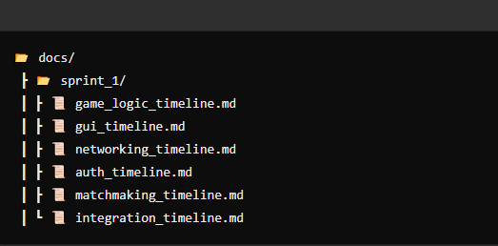

7. Development Workflow & Tools
Gitlab will be used for version control with the following structure:
📂 GitLab Repository Structure
📦 seng300-w25-project
┣ 📂 gui/ (UI & components)
┣ 📂 gamelogic/ (Game logic)
┣ 📂 auth/ (authorization)
┣ 📂 integration/ (integration)
┣ 📂 leaderboard/ (leaderboard)
┣ 📂 networking/ (networking)
┣ 📂 docs/ (Diagrams, reports, planning docs)
┣ 📂 tests/ (Unit tests, integration tests)
┗ README.md

Development Workflow (Git Flow)
- Main Branch (main)
Holds the final, stable version of the project
- Who commits here?: Only the Integration Team after all features have been tested and merged
- When is it updated?: At the end of each Sprint or when a major milestone is reached
- Process:
  - The Integration Team pulls all team branches (gamelogic, gui, etc.) and tests them together.
  - After successful testing, they merge into main, creating an updated stable version.
- Team Branches ( gamelogic gui auth networking leaderboard integration)
The main working branch where all new features are merged before going to main
- Each team has their own working branch where they develop and test their features before merging into the main branch
- Who commits here?: Team Leads (after reviewing Merge Requests from individual branches)
- When is it updated?: When a new feature is tested and ready to be integrated
- Individual Branches: Individual developers create branches from their team’s branch to work on specific features.
- When ready, the developer creates a Merge Request to their team’s branch for review
- Bug Fix Branch: used for fixing issues without interfering with ongoing development
- Testing Branch: a temporary branch where the Integration Team tests all features together before finalizing the main branch

Git Branching Strategy:
Branches allow multiple people to work on different parts of the project without overwriting each other's code. Instead of everyone working on the same branch, we create separate branches for different tasks then merge them together when they are complete.
Branch Type | Purpose | Naming Convention
Main branch (main) | The final and stable release version | main
Team Branches (6)  (auth)  (gamelogic)  (gui)  (integration)  (leaderboard)  (networking) | The working versions where all features are integrated before going into main | auth  gamelogic  gui  integration  leaderboard  networking
Individual branches | Individual branches will be used to develop new features (UI, game logic, etc.) | name-feature/[task-name]  (e.g., if Anica was working on Chess logic, she creates: anica-feature/chess-moves)  (e.g., if Bob was designing a login UI, they create: bob-feature/login-ui)
Bug Fix branch  (bugfixing) | Used to fix specific bugs  Once fix is tested, it merges into the team’s branch and eventually into main | bugfixing/[bug-name] (e.g., bugfixing/login-error)
Testing Branch  (testing) | Temporary Branch where Integration Team tests all features before finalizing into main branch  Integration Team pulls code from all sub-team branches  Once system is stable, testing merges into main | testing/[ ]

Git Step-By-Step Guide:
This guide provides a standardized Git workflow for all team members working on the Online Multiplayer Board Game Platform (OMG) in GitLab. It includes detailed steps based on different actions a developer might need to perform.

- Clone the Repository (First-Time Setup)
Before making any changes, download (clone) the project to your local machine:
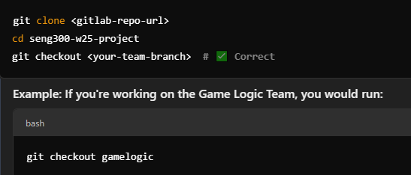
***(only do this at the start of the project)***
*** Replace <gitlab-repo-url> with the actual repository URL
“checkout” switches to the team branch you are working on
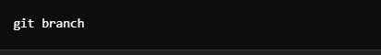
“git branch” allows you to verify if you are on the correct branch
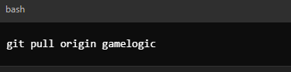
“pull” the latest updates before you start working

- Creating a New Feature Branch (For Individual Work)

- Each developer should create a branch based on their team’s branch
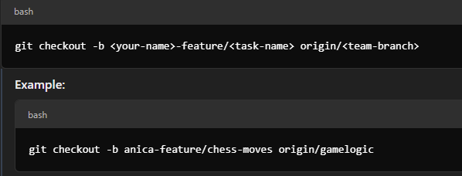
- Then make changes, add files, and commit:
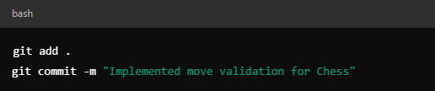
- Push your branch to GitLab:
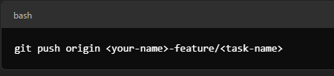

- Updating Your Branch with the Latest Code (Sync with main)
Before working on your branch, fetch the latest changes from main:
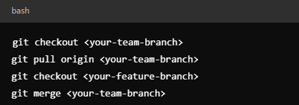
***General Rule:***
- If you're working on a feature branch (yourname-feature/task-name) → Always update from your team’s branch (gamelogic, gui, etc.).
- If you're on a team branch (gamelogic, gui, auth, etc.) → Update from main.

Scenario 1: You’re working on a Feature Branch

- update your feature branch (yourname-feature/task-name) from your team's branch (gamelogic, gui, etc.).
- This keeps your branch aligned with other teammates' work before merging your changes.

Steps to Update Your Feature Branch:

- Switch to your team’s branch and pull the latest changes from Gitlab:

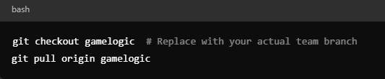
This ensures you have the latest updates from other developers working in gamelogic

- Switch back to your feature branch and merge the latest term branch updates:
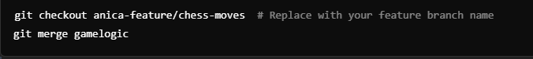
This brings in any new changes from gamelogic into your feature branch

- Resolve merge conflicts if any appear, then commit the changes
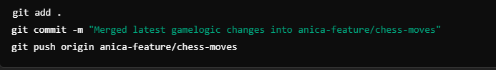

Scenario 2: You’re Working on a Team Branch

- Team Branches (gamelogic, gui, etc.) should stay updated with main to prevent large merge conflicts later
- If you are a Team Lead managing a team branch, you should regularly update it from main

Steps to Update Your Team Branch:
- Switch to main and pull the latest stable version:
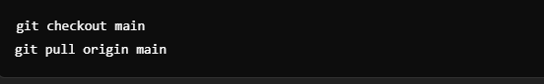
This ensures you have the latest approved changes from other teams.

- Switch to your team’s branch and merge main into it:

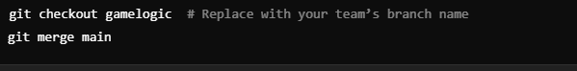
This brings in updates from main, such as new API changes, authentication updates, or networking improvements.

- Resolve conflicts if needed, commit and push:
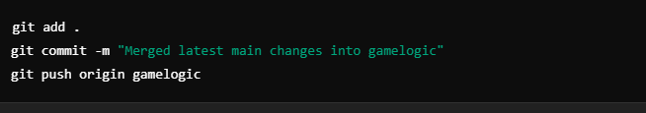
Now your team branch has the latest updates and is in sync with main.

- Submitting Work (Creating a Merge Request)
Once your feature is complete and tested, create a Merge Request (MR):
- Go to GitLab → Repository → Merge Requests
- Click New Merge Request
- Set:
  - Source Branch = <your-name>-feature/<task-name>
  - Target Branch = <your-team-branch>
- Add a short description of what your changes do
- Assign a team member to review the request
- Click Create Merge Request

- Reviewing and Merging a Feature Branch into a Team Branch
After a Merge Request is submitted:
- A Team Lead or another developer reviews the code in GitLab
- If approved, merge the request:
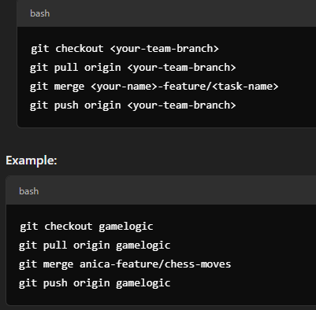

- Merging a Team Branch into main (Handled by Integration Team):
At the end of a sprint, the Integration Team merges all team branches into main:
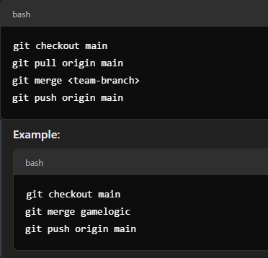

- Fixing a Bug (Using Bug Fix Branches)
When working on a bug fix:
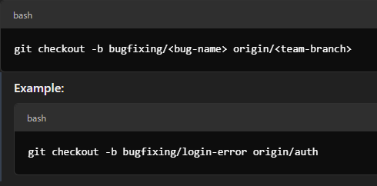
Make fixes, commit, and push:
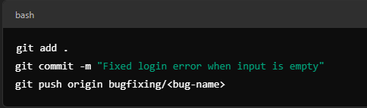
Then create a Merge Request into your team’s branch

- Handling Merge Conflicts
If Git shows a merge conflict, open the conflicting file and manually edit the conflicting lines.
Then run:
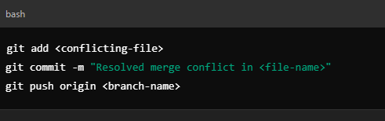

Visual Workflow Diagram -
Here is a simplified flow of how branches interact:
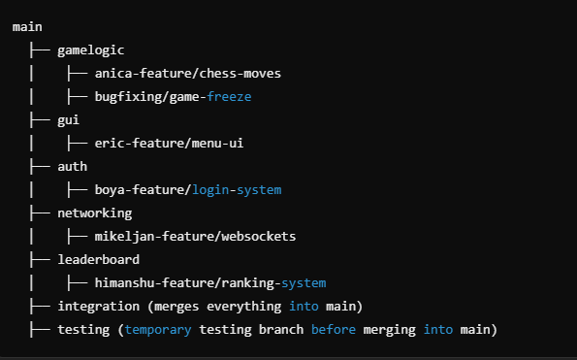

***Best Practices:***
- Commit Often – Small commits help track progress and debug issues.
- Use Descriptive Messages – Every commit should explain what and why.
- Follow Naming Conventions – Stick to yourname-feature/task-name.
- Always Pull Before Pushing – Avoid conflicts by syncing with the latest version.
- Use Merge Requests – Never push directly to main or team branches.

