USE CASE DIAGRAM AND DESCRIPTIONS - CHECKERS
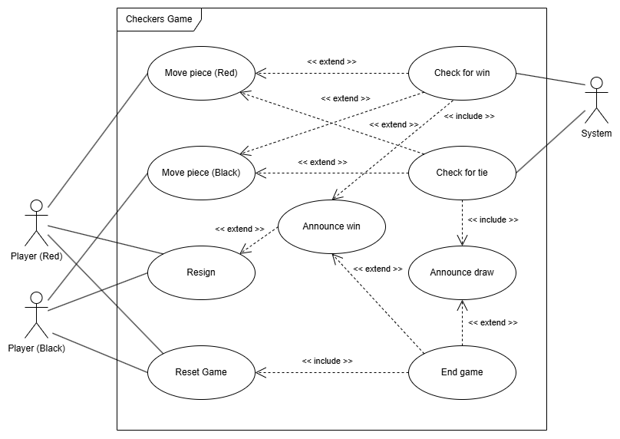
Start Game
Diagram notes: we do not need to change <<extend>> to <<include>> for [check for win] as we can check for wins only during captures, not every move as suggested.
Also leaving move piece as different colours still keeps clarity, as only the red player can move red pieces and vice versa.

Use case: Move piece
Primary Actor: Player
Goal in context: Allow the player to select one of their pieces and move it to an available space on the board
Preconditions:
- It is the player’s turn
- There are available spaces for a selected piece to move
Trigger: Player wants to make a move
Scenario:
- Player selects a piece of their colour that they would like to move
- Player chooses an available location to move the piece
- Piece moves to the new square
Post conditions: Piece is displayed in its new location on the board
Exceptions:
- Game is over
Priority: High
Frequency of use: Many times per game
Channel to actor: GUI
Secondary actors: N/A
Channel to secondary actors: N/A
Open issues: N/A

Use case: Resign
Primary Actor: Player
Goal in context: Allow player to end the game
Preconditions:
- The game has not yet ended
Trigger: Player wants to stop playing
Scenario:
- Player presses resign option
- Game announces that opponent has won
Post conditions: Game has ended
Exceptions:
- The game has already ended
Priority: Medium
Frequency of use: Once per game
Channel to actor: GUI
Secondary actors: N/A
Channel to secondary actors: N/A
Open issues: N/A

Use case: Reset Game
Primary Actor: Player
Goal in context: Allow player to request rematch
Preconditions:
- The game has ended
Trigger: Player wants to have a rematch
Scenario:
- Player selects rematch option
- System announces that player has requested rematch
- Opponent selects rematch option
Post conditions: Game returns to starting state
Exceptions:
- Game is not over
Priority: Low
Frequency of use: Once per match
Channel to actor: GUI
Secondary actors: N/A
Channel to secondary actors: N/A
Open issues: N/A

Use case: Check for win
Primary Actor: System
Goal in context: Allow system to check if a player has won the game
Preconditions:
- The game has not ended yet
Trigger: Player makes a move
Scenario:
- System checks if opponent can make a move
- System checks if player can make a move
Post conditions: Game announces winner or continues to opponent turn
Exceptions:
- Game is over
Priority: High
Frequency of use: Many times per game
Channel to actor: N/A
Secondary actors: Player
Channel to secondary actors: GUI
Open issues: N/A

Use case: Check for tie
Primary Actor: System
Goal in context: Allow system to check if there is a draw
Preconditions:
- The game has not ended yet
Trigger: Player makes a move
Scenario:
- System checks if opponent can still move
- System checks if player can still move
- System checks if positions have repeated
- System checks if there have been no captures for 40 moves
Post conditions: Game announces draw or continues to next turn
Exceptions:
- Game is over
Priority: High
Frequency of use: Many times per game
Channel to actor: N/A
Secondary actors: Player
Channel to secondary actors: GUI
Open issues: N/A

Use case: Announce win
Primary Actor: System
Goal in context: Allow system to announce the winner of the game
Preconditions:
- The game has not ended yet
Trigger: System has detected that a player can no longer move, or a player resigns
Scenario:
- System announces which player has won the game
Post conditions: Game ends
Exceptions:
- Game is over
Priority: High
Frequency of use: Once per game
Channel to actor: N/A
Secondary actors: N/A
Channel to secondary actors: N/A
Open issues: N/A

Use case: Announce draw
Primary Actor: System
Goal in context: Allow system to announce that there is a draw
Preconditions:
- The game has not ended yet
Trigger: System has checked that one of three draw conditions have been fulfilled
Scenario:
- System announces that there is a draw
Post conditions: Game ends
Exceptions: N/A
Priority: High
Frequency of use: Once per game
Channel to actor: N/A
Secondary actors: N/A
Channel to secondary actors: N/A
Open issues: N/A

Use case: End game
Primary Actor: System
Goal in context: Allow system to stop the current game between players
Preconditions:
- A player has won, or a draw has occurred
Trigger: System announces either a win or a draw
Scenario:
- System stops the game and does not go to the next turn
Post conditions: Game can no longer be played, rematch option is available
Exceptions: N/A
Priority: High
Frequency of use: Once per game
Channel to actor: N/A
Secondary actors: N/A
Channel to secondary actors: N/A
Open issues: N/A

USE CASE DIAGRAM AND DESCRIPTIONS - CONNECT 4
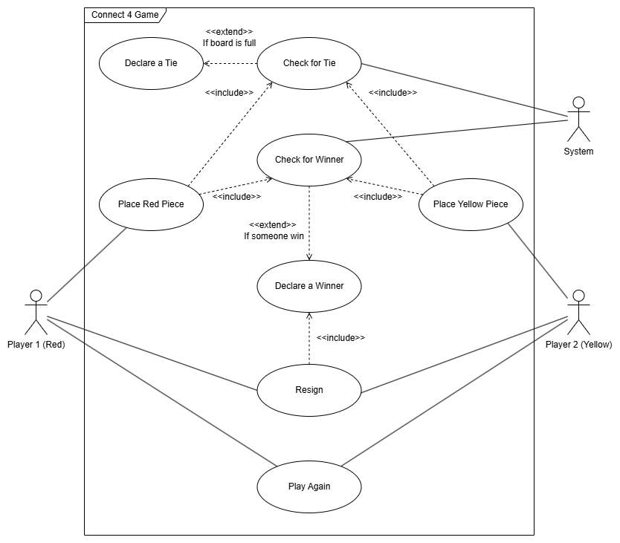
If board is full
If board is full

Start Game
Diagram notes: I do no think there is a need to add a use case for checking if the board is full if we just include that in the <<include>> notes
Use Case: Place Red Piece/Yellow Piece
Primary Actor: Player 1/ Player 2
Goal in context: Place a Red piece onto board
Preconditions:
- It is player 1 turn
- Placement is valid
- Board is not full
Trigger: It's player 1 turn to place a piece
Scenario:
- Player 1 selects valid(not full) columns by clicking onto that columns
- The image of the Red Piece will appear on the selected column
- Red Piece is now placed onto the board
Post conditions: Red Piece is placed on the board, the game will end if Player 1 get 4 in a row, otherwise the game continue
Exceptions:
- Game is over
- Board/Column is full
Priority: High
Frequency of use: Many times per game
Channel to actor: GUI Team
Secondary actors: N/A
Channel to secondary actors: N/A
Open issues: N/A

Use Case: Declare Tie
primary Actor: Game System
Goal in context: Check and Declare a Tie
Preconditions: There is at least one piece placed on the board
Trigger: Board is full and Neither player won
Scenario:
- Player placed a piece
- The system check if any player have 4 in a row
- Then the system check if every column is full
- If the player hasn't won and the board if full, declare a Tie
Post Conditions: The game ended; the system record it to match history
Exceptions:
- Player 1 or Player 2 win before the board is full
- Both Player agrees to a draw
Priority: High
Frequency of use: Often
Channel to actor: GUI Team
Secondary actors: N/A
Channel to secondary actors: N/A
Open issues: N/A

Use Case: Declare Winner
primary Actor: Game System
Goal in context: Check and Declare a Winner
Preconditions:
- Game not end
Trigger: Player 1 have 4 in a row
Scenario:
- Player 1 placed a piece
- The system check if the player has won by checking if Player 1 has a 4 in a row in any direction(horizontal, vertical, diagonal)
- The system detected that Player 1 had 4 in a row
- The system declared that Player 1 is the Winner
Post Conditions: The game ended; system records game to match history
Exceptions:
- Board is full and neither player win
- Both Players agree to a draw
Priority: High
Frequency of use: Very Frequent
Channel to actor: GUI Team
Secondary actors: N/A
Channel to secondary actors: N/A
Open issues: N/A

Use Case: Resign
primary Actor: Player 1/2
Goal in context: Player 1/2 is trying to resign
Preconditions:
- Game not end
Trigger: Player 1/2 selected the resign option
Scenario:
- Player 1 open the game menu through clicking the menu button
- Player 1 clicked resign option
- The game system announced Player 2 won by display text
Post Conditions: The game ended, system records game to match history
Exceptions: N/A
Priority: High
Frequency of use: Often
Channel to actor: GUI Team
Secondary actors: N/A
Channel to secondary actors: N/A
Open issues: What happen if two player resigned simultaneously?

Use Case: Play Again
primary Actor: Player 1
Goal in context: Player 1 wants a rematch with Player 2
Preconditions:
- Game Ended
Trigger: Player 1 decided to rematch with Player 2
Scenario:
- Player 1 open the game menu through clicking the menu button
- Player 1 selects "Rematch" option
- The game system send a notification to Player 2 and wait for a response
- Player 2 agree to Player 1 offer and selects "accept" on Player 1 request
Post Conditions: New Game Started
Exceptions:
- Player 2 rejects Player 1 offer
- Player 2 didn't response to Player 1 within a certain amount of time
Priority: Medium
Frequency of use: Sometimes
Channel to actor: GUI Team
Secondary actors: Player 2
Channel to secondary actors: Need Confirmation from Player 2 in order to rematch
Open issues: N/A
USE CASE DIAGRAM AND DESCRIPTIONS - TIC-TAC-TOE
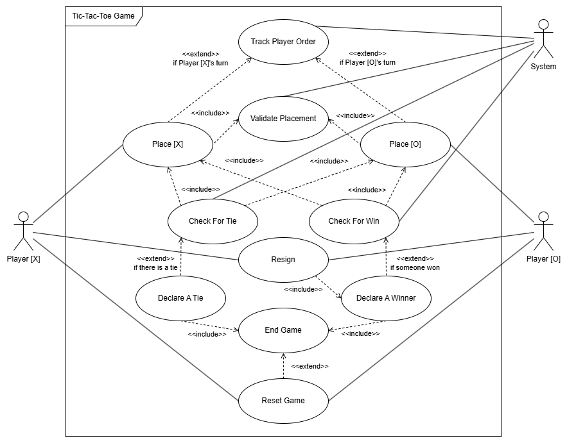
Start Game
Diagram notes: comments on changes for Tic-Tac-Toe did not load properly, so we cannot make changes to this other than a Start Game

Use Case: Place [X] / Place [O]
Primary Actor: Player [X] / Player [O]
Goal in context: Place symbol onto board
Preconditions:
- It is the current player’s turn
- Placement is valid
Trigger: Player is ready to place symbol
Scenario:
- Player selects valid location to place symbol
- Symbol is placed onto the board
Post conditions: Symbol is placed onto the board
Exceptions:
- Game is over
Priority: High
Frequency of use: Several times per game
Channel to actor: GUI
Secondary actors: N/A
Channel to secondary actors: N/A
Open issues: N/A

Use Case: Track Player Order
Primary Actor: System
Goal in context: Track which player goes first
Preconditions:
- Game has started
Trigger: Constant tracking
Scenario:
- Check to see if player has moved
- Once player has moved, switch tracking to other player
Post conditions: Current player’s turn is shown
Exceptions:
- At initial match start, pick random player
Priority: High
Frequency of use: Constant during the game
Channel to actor: N/A
Secondary actors: N/A
Channel to secondary actors: N/A
Open issues: N/A

Use Case: Validate Placement
Primary Actor: System
Goal in context: Check to see if piece placement is valid
Preconditions:
- The game is currently in progress
Trigger: The player has selected the board cell to place piece in
Scenario:
- The player selects a cell to place their respective piece in
- The game checks to see if the cell is already filled with another piece
- The game returns a boolean to say if the cell is filled or not
Post conditions: The system returns a boolean saying if the placement is valid or not
Exceptions:
- If the player clicks outside the board, do not check
Priority: High
Frequency of use: Once per piece placement selection
Channel to actor: N/A
Secondary actors: N/A
Channel to secondary actors: N/A
Open issues: N/A

Use Case: Check For Win
Primary Actor: System
Goal in context: Check to see if a player has won the game
Preconditions:
- The game has not ended
- No player has resigned
Trigger: A player’s piece placement was validated
Scenario:
- Check lines that contain the piece just placed
- If there exists a 3 in a row of the same placed piece, declare that player a winner, else do nothing
Post conditions: Declare if that player has won the game or not
Exceptions: N/A
Priority: High
Frequency of use: Once after a piece has been placed
Channel to actor: N/A
Secondary actors: N/A
Channel to secondary actors: N/A
Open issues: N/A

Use Case: Check For Tie
Primary Actor: System
Goal in context: Check to see if the game has tied
Preconditions:
- Game has not ended
- The board is full
Trigger: The player places the last piece that causes the board to be filled
Scenario:
- Check entire board to see if there exists a 3 in a row of the current player’s piece
- Return true if the player has no 3 in a row, else return false
Post conditions: The system gets a boolean stating if the game has ended in a tie or not
Exceptions:
- Do not check for a tie if a player resigns when the board gets filled
Priority: High
Frequency of use: Every time the board is filled
Channel to actor: N/A
Secondary actors: N/A
Channel to secondary actors: N/A
Open issues: N/A

Use Case: Resign
Primary Actor: Player [O] / Player [X]
Goal in context: Let a player declare their defeat
Preconditions:
- The game has not ended already
Trigger: Player presses the resign button
Scenario:
- Player presses the resign button
- Game asks to make sure of their choice
- If they confirm it, then they have resigned the game
Post conditions: The player has resigned and has lost the game
Exceptions:
- Do not let player resign when the other player already resigned
Priority: Low
Frequency of use: Dependent on the players
Channel to actor: GUI
Secondary actors: N/A
Channel to secondary actors: N/A
Open issues: N/A

Use Case: Declare A Winner
Primary Actor: N/A
Goal in context: Announce if a player has won the game
Preconditions:
- No player has been declared winner at this point
- There is a win (3 in a row) present on the board
- OR there a player has resigned from the game
Trigger: One player places their piece on the board
Scenario:
- Check to see if that placement completes a 3 in a row
- If it does, then declare that player the winner
Post conditions: One player is declared the winner of this match
Exceptions:
- If a player leaves mid-game, then the other player automatically wins do matter the current state of the board
Priority: High
Frequency of use: Often
Channel to actor: N/A
Secondary actors: N/A
Channel to secondary actors: N/A
Open issues: N/A

Use Case: Declare A Tie
Primary Actor: N/A
Goal in context: Announce that there has been a tie and that no player wins
Preconditions:
- No player has been declared winner at this point
- The board is almost filled completely
Trigger: The current player fills the board
Scenario:
- Check to see if neither player has won
- If this is the case, then declare a tie
Post conditions: Neither player is declared the winner of this match
Exceptions:
- If a player has won when the board is full, then that takes precedence over calling a tie game
Priority: High
Frequency of use: Often
Channel to actor: N/A
Secondary actors: N/A
Channel to secondary actors: N/A
Open issues: N/A

Use Case: End Game
Primary Actor: N/A
Goal in context: End the game so that no player can continue doing moves on the board
Preconditions:
- A game had been in progress
Trigger: The game has announced someone has won or that there is a tie
Scenario:
- Block player placement inputs
- Show game end screen
Post conditions: Players learn that the game has ended
Exceptions: N/A
Priority: High
Frequency of use: Often
Channel to actor: N/A
Secondary actors: N/A
Channel to secondary actors: N/A
Open issues: N/A

Use Case: Reset Game
Primary Actor: Player [O] and Player [X]
Goal in context: If both players accept to play another game, then the current game is reset
Preconditions:
- The game has ended
Trigger: Both players agree to a new match
Scenario:
- Both players press a “Rematch” button on their client
- The board gets cleared
- A new game has started
Post conditions: A new game will be started
Exceptions:
- If a player does not choose to call a rematch within a certain time, then no reset occurs and players should be sent straight back to the lobby
Priority: Low
Frequency of use: Dependant on the players
Channel to actor: Button for a rematch
Secondary actors: N/A
Channel to secondary actors: N/A
Open issues: N/A

Updated Class Structure Diagram:
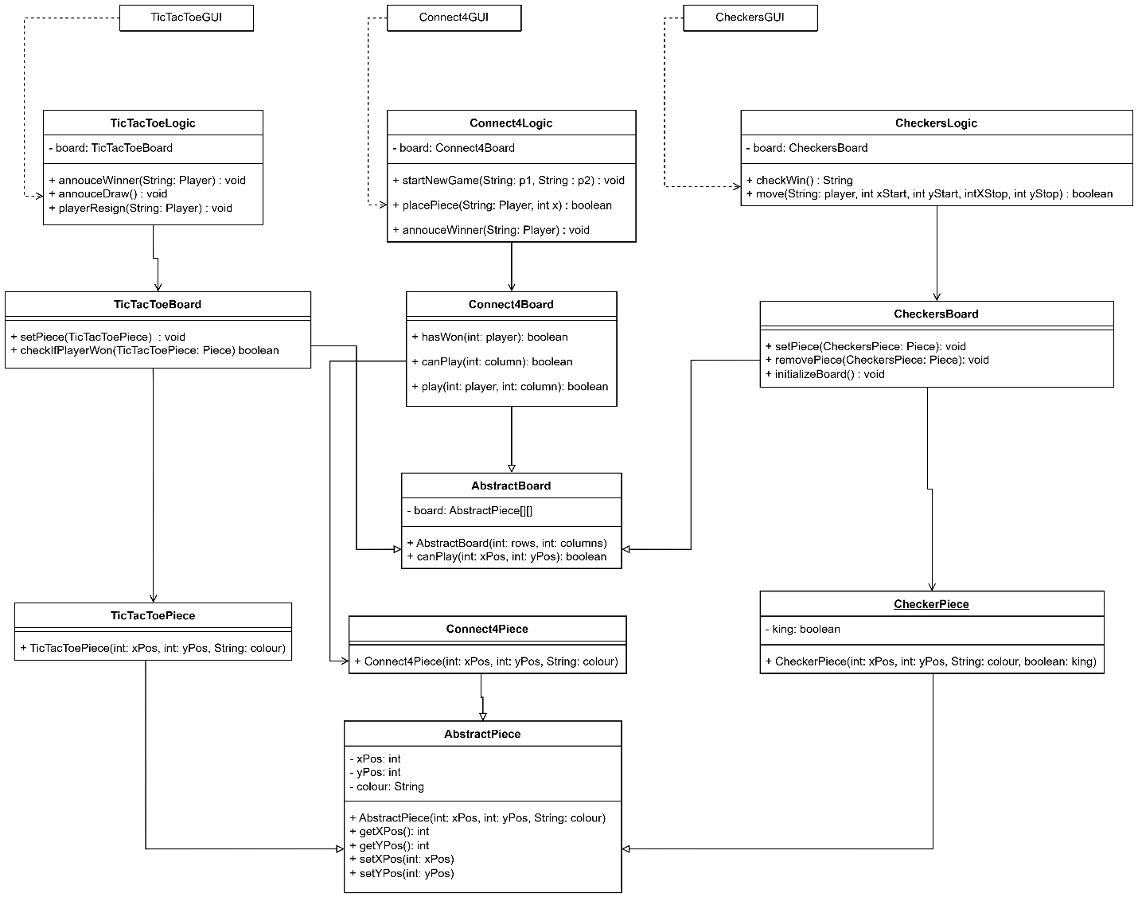
Added Feature:
Each Logic Section now includes a Turn Timer method to keep track of the time spend by each player for their turn. In Tic-Tac-Toe and Connect 4, each turn is 30 seconds long and if that runs out, then a random move is made by default and the next player goes. If this occurs 3 times then they are automatically resigned from the game. For Checkers, each player gets 10 minutes of gametime for all of their moves. If that runs out then they lose automatically. This feature was requested during project iteration 2.

