

Our Lady of Bethlehem Childcare Enrollment System User Guide

April 2017

Version 2.0

Document Revisions

|  |  |  |
| --- | --- | --- |
| **Date** | **Version Number** | **Document Changes** |
| Jan 30, 2016 | 1.0 | Initial Draft |
| April 24, 2017 | 2.0 | 2017 Project Improvements – Forecasts, etc. |
|  |  |  |
|  |  |  |

Table of Content

|  |  |
| --- | --- |
| Introduction | 3 |
| Scope and purpose | 3 |
| Process Overview | 3 |
| Approving/Declining Applications | 4 |
| Application Form | 5 |
| Waitlist | 6 |
| List Default Order | 6 |
| Color Codes | 6 |
| Actions | 6 |
| Waitlist Enroll Modal | 7 |
| Waitlist/Classroom Edit Modal | 7 |
| Classroom | 8 |
| Action Items | 9 |
| Student Detail | 10 |
| User Accounts | 11 |
| Profile | 11 |
| Settings | 12 |

## Introduction

### Scope and purpose

This application is designed for the Our Lady of Bethlehem School and Childcare to manage their enrollment and post enrollment processes.

This application will significantly enhance the client’s efficiency and is very easy to use. It will be replacing the current pen and paper or excel sheet maintainability method and will bring online requests and handling of all enrollments.

This guide is designed to help you learn about this application and what it has to offer to better assist you when using this application. In this document, all functionality and workflows are explained. Using this site will require **no prior technical knowledge** of any sort.

### Process Overview

This software is programed to managed and help with all the processes from after the parents have toured the facilities and want to fill out an application for consideration until the child is graduating from Our Lady of Bethlehem School and Childcare.

You would be interacting with this application only through the website. This is the main flow of the application for a typical user:

1. Logging into the website
2. Sending Application to Parent
3. Approving/Declining Filled Out Application
4. Enrolling Children from the Waitlist
5. Transitioning the Student When Necessary

Other workflows include:

* Parents Filling Out Applications
* Partially Enrolling Students
* Completing the Enrollment for Partially Enrolled Students
* Communicating using Action Items
* Updating Student Information When Necessary
* Re-ordering the Waitlist as See Fit
* Creating Authorized Users
* Forecasting classroom transitions
* Editing Staff email that receives application confirmations
* Adding Student directly to classroom

## Approving/Declining Applications

From the main navigation menu on the top, click on the ‘Applications’ tab. You will be able to view applications that have been submitted by the parents in this page. The application can either be accepted by clicking the which will put the student on the waitlist in their appropriate position, or declined by clicking the which will delete the application from the system. 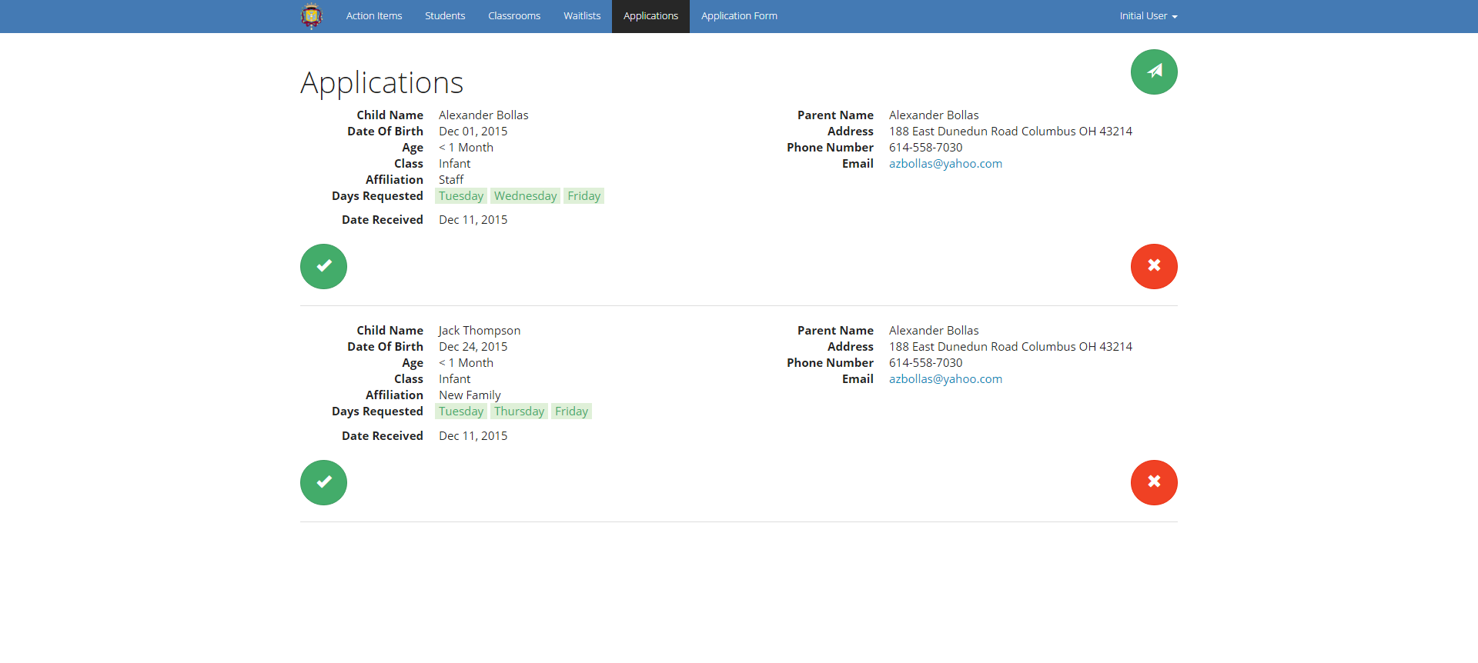

You can send the application out to parents by clicking the button in the top right. You will then need to enter the email address and the type of applicant. By clicking ‘Send Application’, an email is sent to the specified email address with a link to the application. The client will have 2 days to finish the application and submit the application.

After the application is submitted, the user does not have access to the application to edit or resubmit the application. Also, once the application is submitted, a staff email will be notified, and there will be a red icon that shows on the applications tab, signaling a pending application.

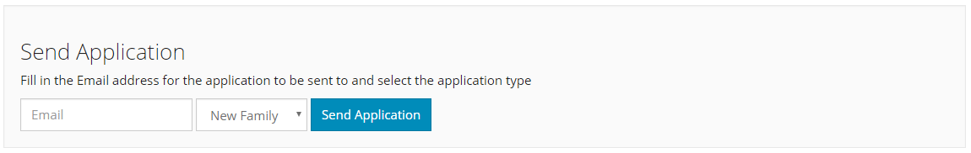

## Application Form

The application form will allow parents to fill out this the application when emailed to them and submit, which will automatically put the application info in the applications page. You will then have access to all the submitted applications from the Applications page.

When filling out the application, if any of the required fields are not filled out appropriately, red error messages will appear on screen telling the user what the problem is.

Parent will have the ability to add one or two parents information in the application. They will be able to add the second parent by simply clicking on the ‘Add Another Parent’, and fill out the newly added fields in the form.

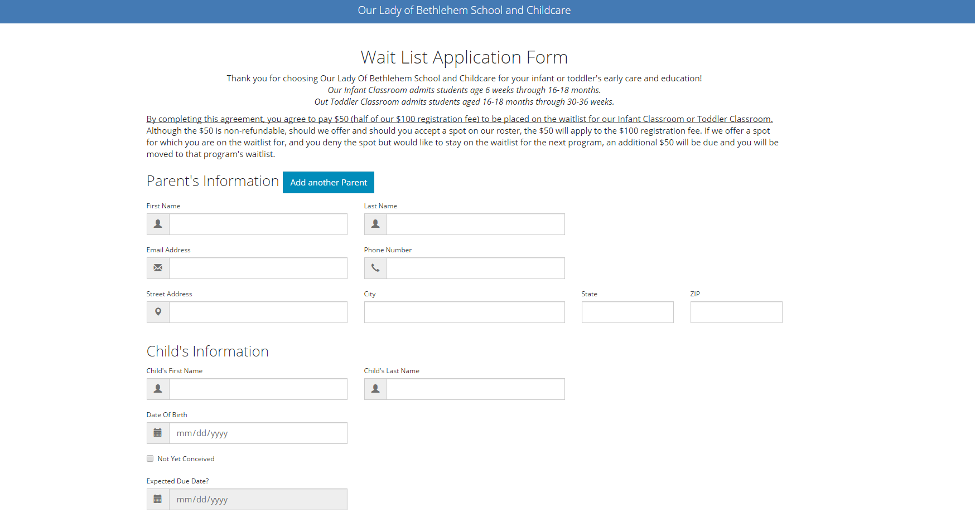

## Waitlist

One of the most important pages of the application is the waitlist page. In this page, you will see all the applications that have been approved and were moved to the waitlist. Each row represent one student.

### List Default Order

By default the waitlist is sorted in a way that there is staff applications, current families, and then new families. The order of the waitlisted students can be changed by simply dragging and dropping the row to where you would like them to be.

### Color Codes

There are some color coding in this list:

1. Days that are marked orange indicate that the parent are flexible about which days they want to be enrolled, while the green indicates that they are not.
2. A light blue background over all the students info indicates that they are partially enrolled. This means that they are enrolled in a class for some days, but still waitlisted for others.

### Actions

Each row in this list has an ‘Action’ column where you can take actions about that student.waitlist-action-enroll.PNG

1. will enroll the student. (This button will open a modal window)waitlist-action-edit.PNG
2. will edit the student information (This button will open a modal window)waitlist-action-delete.PNG
3. will delete the student information (This button will open confirmation modal)

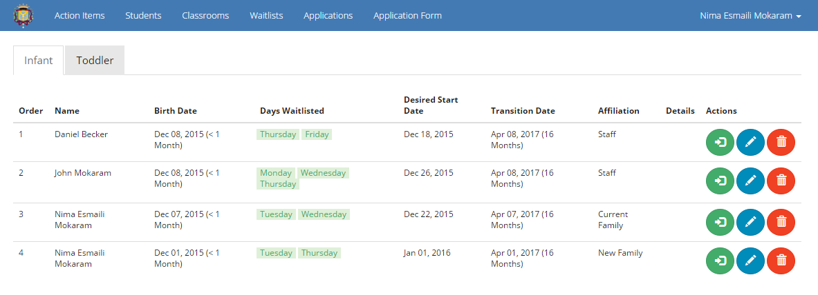

### Waitlist Enroll Modal

This is the modal shown when you click the enroll button. Its shows the days that are requested and automatically checks the appropriate boxes. You can override this however and check or uncheck other boxes to enroll the student for the desired days. If you do override the days that the student is going to be enrolled, and there will still be days left for the student to be enrolled, you will first get a confirmation modal and after confirming, the student becomes partially enrolled with the light blue background as explained before.

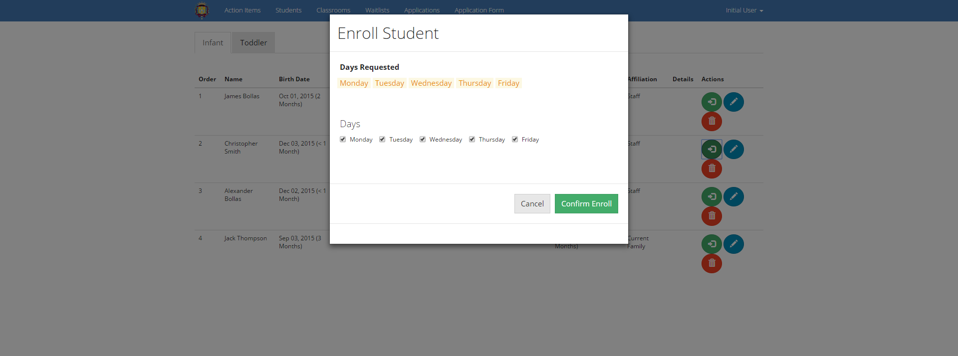

### Waitlist/Classroom Edit Modal

This modal is shown when you click the edit button on the waitlist page (or from the classroom page). Using this modal, you will be able to edit and view the student and parent information.

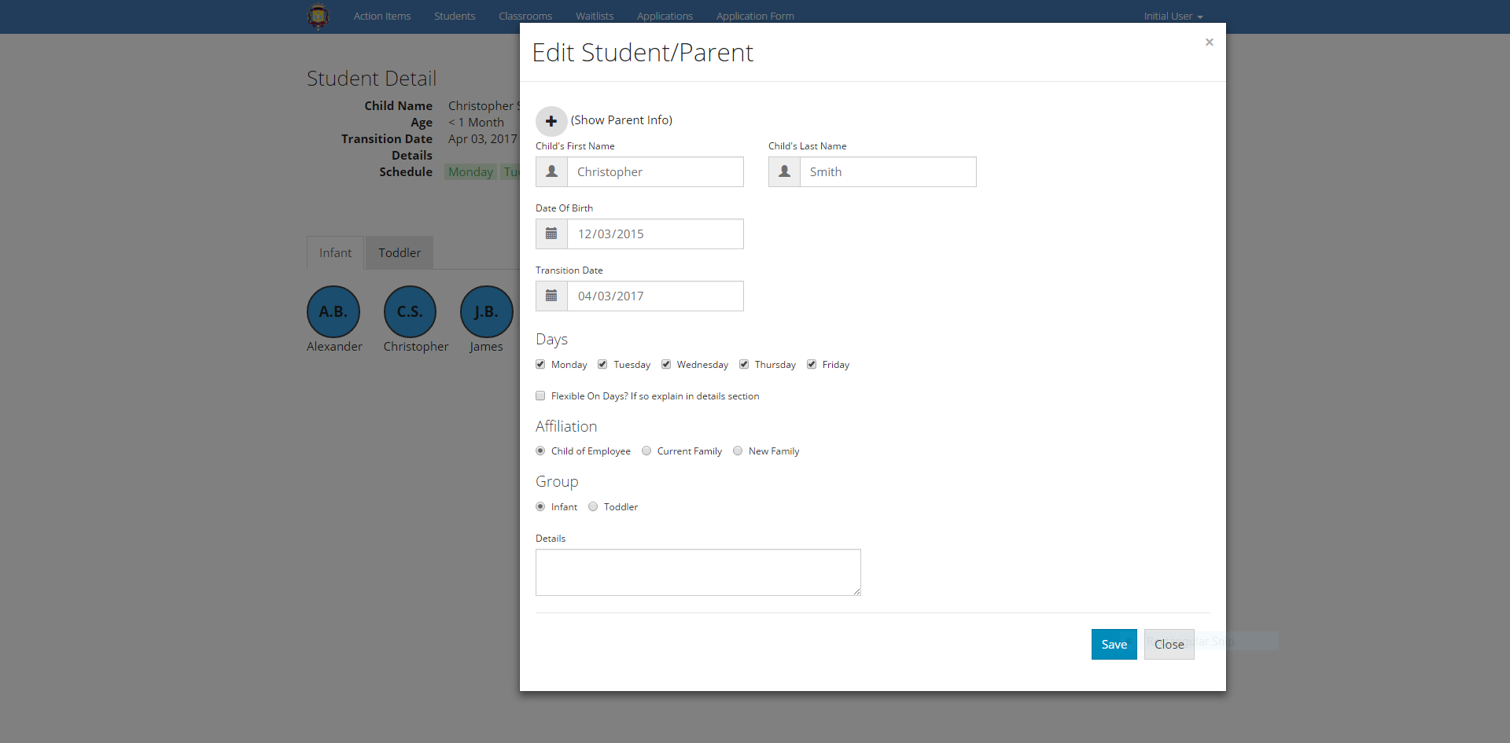

## Classroom

In the classroom page, you will be able to see a list of all students enrolled in that class. Each row will have the student name, their expected transition date, and the days that they are enrolled/waitlisted.

This table similar to other tables is color coded. The blue color (potential to change) indicates that the student is enrolled in that day. The red color (potential to change) indicates that the student is still waitlisted for that day. Such student with the red color cells is partially enrolled.

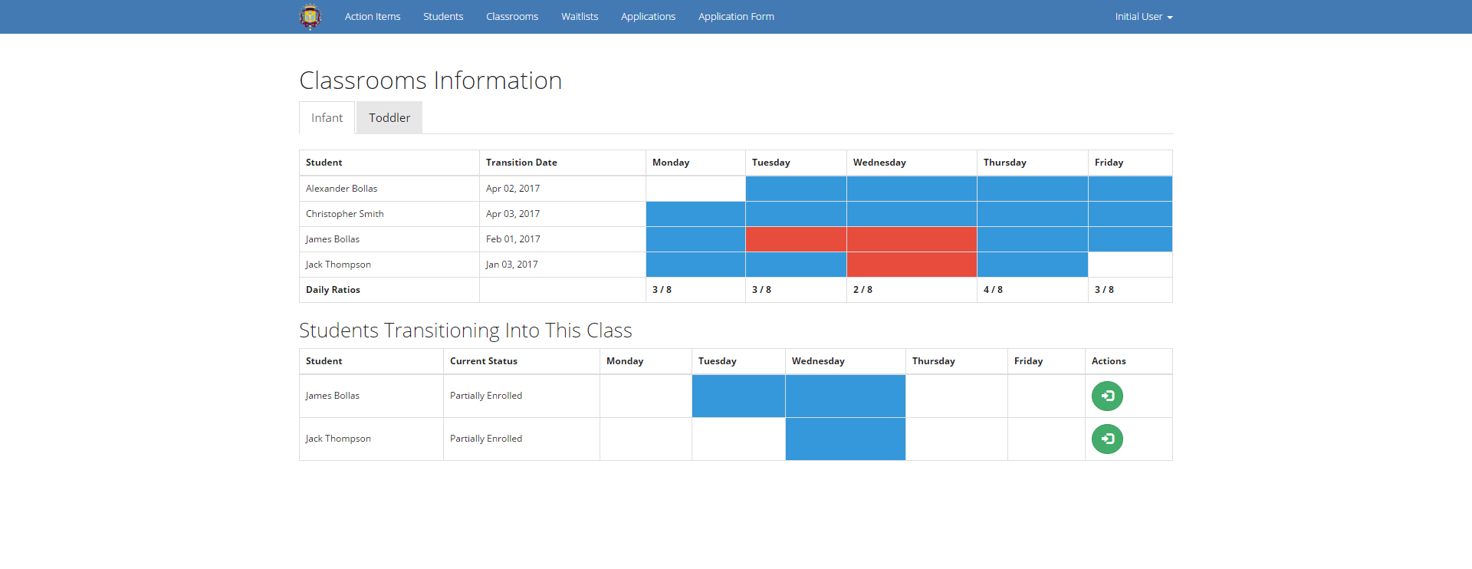

In the bottom section of the page, you will see all the students that are going to be transitioning to this class. This could include the students that are partially enrolled in the class or the ones that are simply in the waitlist and their start date is coming soon. It could also include the students that are going to be transitioning from one class to another (infant to toddler). waitlist-action-enroll.PNG

In the transitioning section of the page, you will be able to enroll the student using the button in the action section. This button will open a modal window that will allow you select the days you want to enroll the student.

On the classroom page, you will also see an “Add Student” button directly below the page header. Using this button, you will be given a pop-up form which allows users to directly add a new student to a given classroom, bypassing the waitlist and application form.

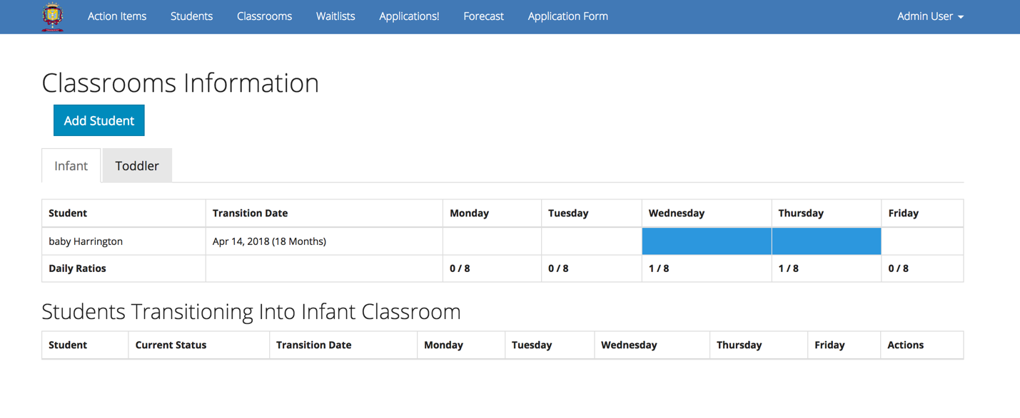

By appropriately filling out the given form and pressing “Add Student”, the new student will successfully be added to a classroom directly.

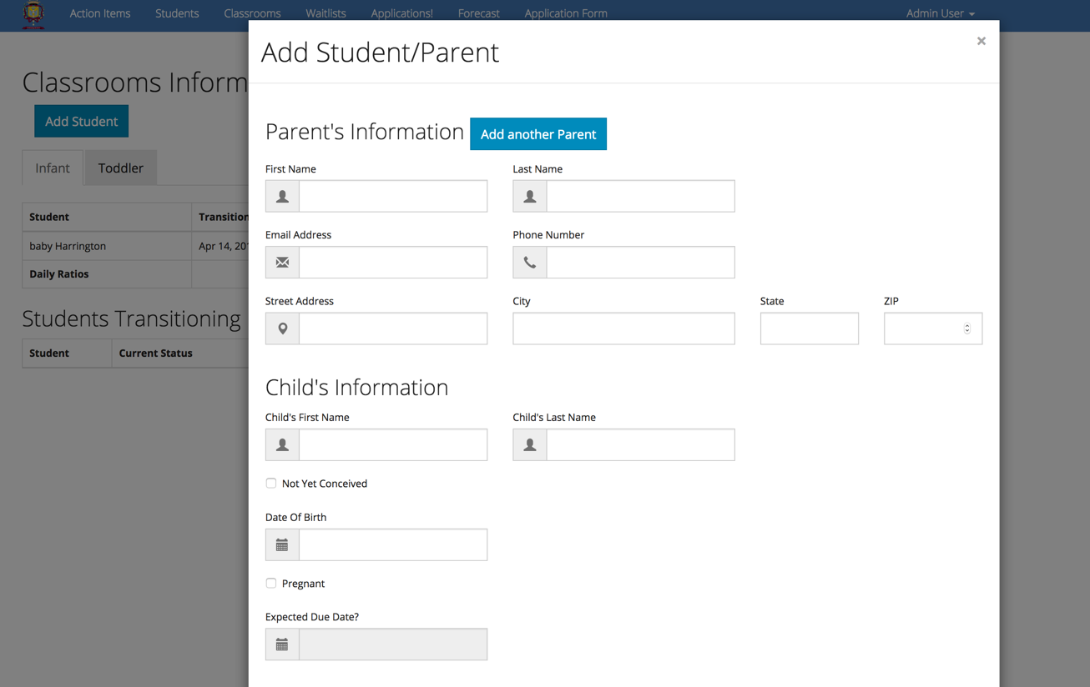

## Action Items

In the action items page, you will be able to create action items for things that are supposed to be done by you in the future or by others. Each action item can be associated with the infants, toddlers, and miscellaneous.

Each action item will then record the time and your name once you click the ‘Add Task’ button. Then the newly created action item will be listed in the corresponding category in the bottom of the page.

When viewing the list of the action items, you will have the option to complete an action item using the button. Similarly, you will be able to delete an action item using the button.action-items-complete-button.PNGaction-items-delete-button.PNG

You can also see more detail about the action item in the bottom of the page in the ‘Action Item Detail’ section.

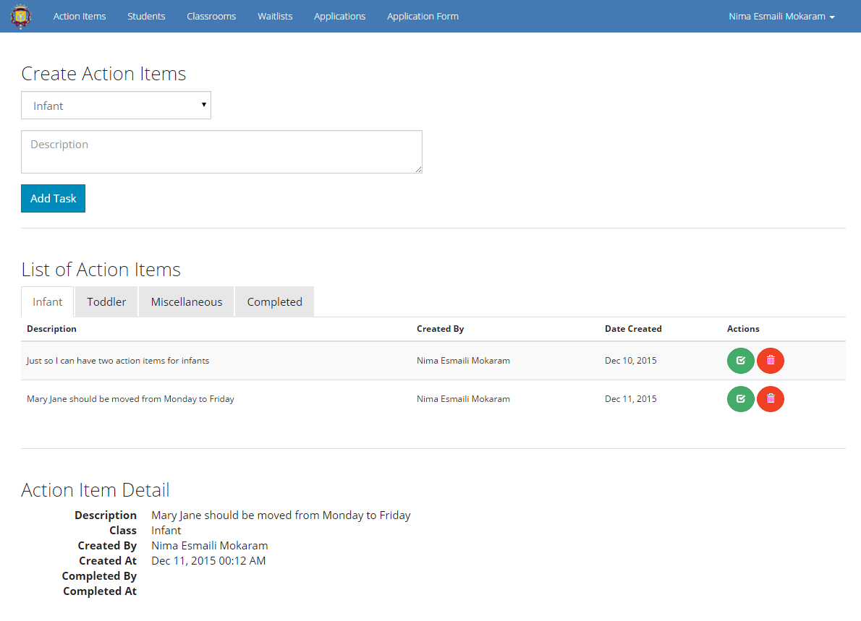

## Student Detail

In the student details section, you get information that is similar to the information listed in the Classroom page. In this page, you see all the students as circles. Students are in their classroom which is indicated with the different tabs. Clicking on each of the circle for any student will give you more information about them. That includes

* Full Name
* Age (in months)
* Transition Date
* Detail (if any)
* Days Enrolled
* Their Parents Information

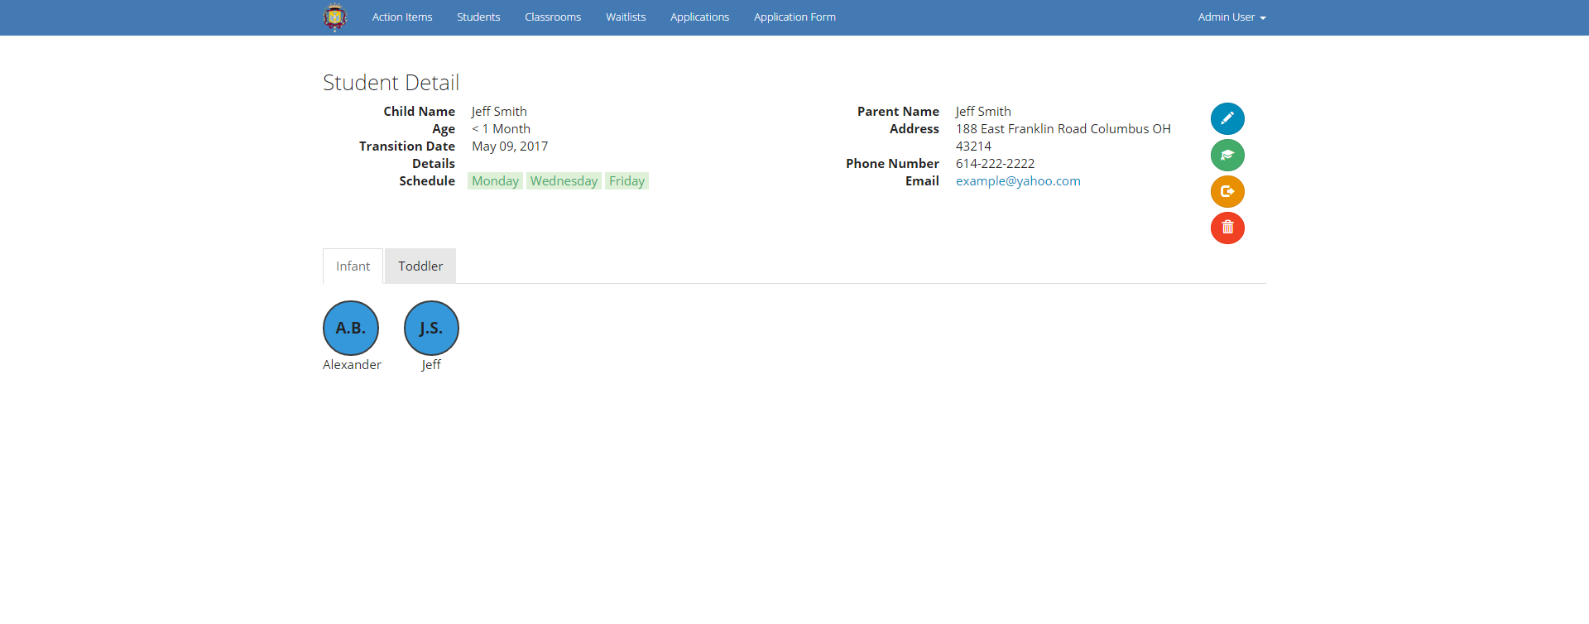

On the right side of the student detail side, you will see few round buttons that each will do something for the selected student.waitlist-action-edit.PNG

* Will open the modal window to edit Student/Parent informationstudent-detail-graduate-button.PNG
* Will move the student to the Toddler class (only available for infants)student-detail-waitlist-button.PNG
* Will move the student back to the waitlist (For when the class is full)action-items-delete-button.PNG
* Will remove the student from the system (Confirmation modal opens)

## Forecast

On the Forecast page, you can receive information on what students will be transitioning, leaving, or entering a class in a given forecast timeframe.

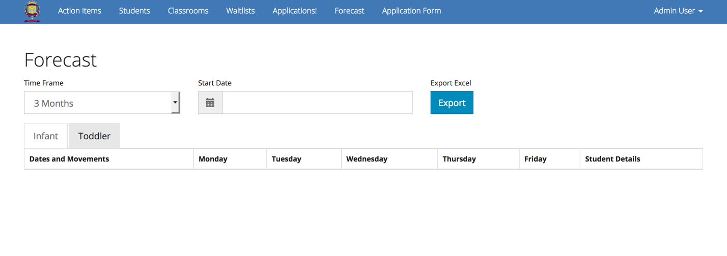

At the top of the page, you will notice 3 labeled fields. The first, labeled “Time Frame” is a drop-down with various options on how far in time you would like your Forecast to cover. The available timeframe selections include 3, 6, 12, 18, 24, and 30 months from the current day. The second field, labeled “Start Date”, allows users to define on what specific day the forecast should begin. For this field, you must enter a date in a valid format, i.e. YYYY-MM-DD. Finally, there is an “Export Excel” button, allowing users to save a local copy of their current forecast in the form of a Microsoft Excel File.

Similar to the “Classrooms” page, there are two tabs located on the Forecast window, one for each classroom. Changing tabs will automatically change the classroom in which the forecast is running on.

On the Forecast table itself, there exist seven columns. The columns are as follows:

* “Dates and Movements” – The student that is moving in/out of the selected classroom, as well as the approximate date of the move.
* “Monday” – The estimated classroom counts of Monday after the move.
* “Tuesday” – The estimated classroom counts of Tuesday after the move.
* “Wednesday” – The estimated classroom counts of Wednesday after the move.
* “Thursday” – The estimated classroom counts of Thursday after the move.
* “Friday” – The estimated classroom counts of Friday after the move.
* “Student Details” – any details already entered about said student.

## User Accounts

From the right side of the navigation bar, if you click on your name, a dropdown menu opens and then you can select one of the three available options:

### Profile

This option will open a modal window with one button to change your password. After clicking the button, you will be rerouted to the Change Password page where you can change your password.

In order to that, you will have to enter your current password and your new password. You also will have to confirm your new password on the same page. If all of these information is correct, your password will be changed to the new password. Otherwise, you will get an error.

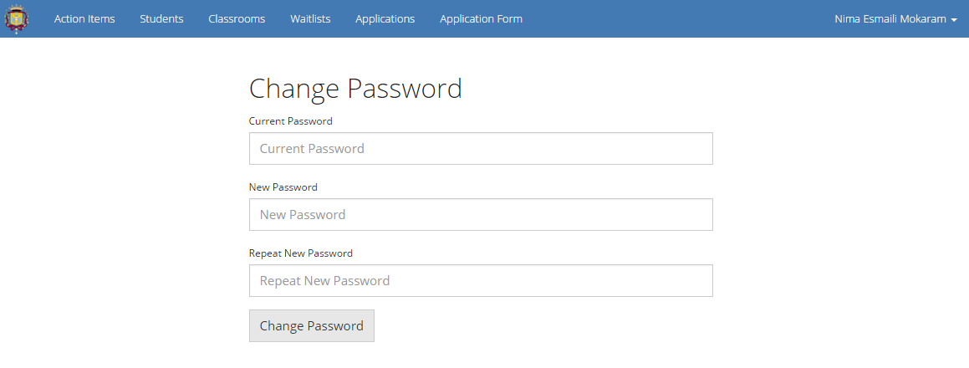

### 

### Settings

This option will open a modal window that contains three buttons. The ‘Add New User’ button will take you to a page that you can create new users. The ‘Delete User’ button will similarly take you to a page and will allow you to remove users. In the ‘Remove User’ page, you will have to write the email address associated with that user to be able to remove them from the system. Lastly, the “Change Staff Email” button will redirect you to a page where you can change the email address that receives notifications every time a new application is submitted into the system.

